Grants awarded by year
This file has an alt text attribute containing a single space character. It passes a naive presence check but conveys nothing.
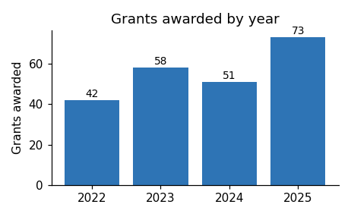
Applications for the next round open in March.

