Grants awarded by year
This file has alt text in the title attribute on wp:docPr, with no descr attribute at all. Older versions of Word exposed Title as a separate field alongside Description, and documents made then still carry text here.
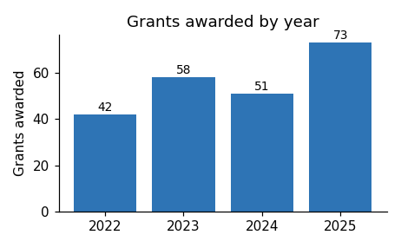
Applications for the next round open in March.

