Grants awarded by year
This file has alt text set to the image filename. It passes a presence check but tells a reader nothing about the chart.
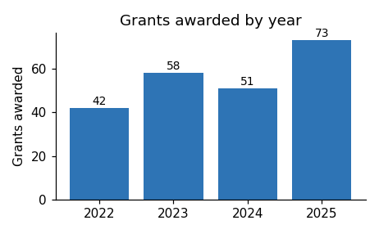
Applications for the next round open in March.

