Grants awarded by year
This file has alt text that Word generated automatically. The string ends with a line break followed by the phrase Description automatically generated, which is the tell.
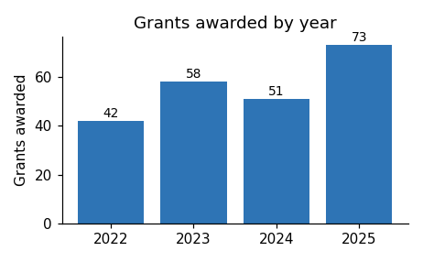
Applications for the next round open in March.

