Grants awarded by year
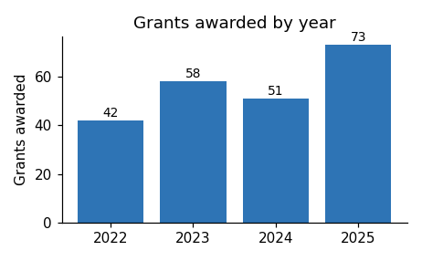
This image floats with square text wrapping, so it sits inside a wp:anchor element rather than a wp:inline element. The alt text is present and meaningful. A parser that matches only on wp:inline will not see this image at all.
The grants program has run since 2022. Numbers rose sharply in 2025 following changes to the eligibility rules, which opened the program to organisations as well as individuals.
Applications for the next round open in March.

