Grants awarded by year
The image in this file sits inside a table cell, so the drawing is nested inside w:tbl, w:tr and w:tc before you reach the paragraph. It has no alt text. A parser that walks only top level paragraphs will miss it.
Summary | Chart
Grants awarded rose from 42 in 2022 to 73 in 2025. | 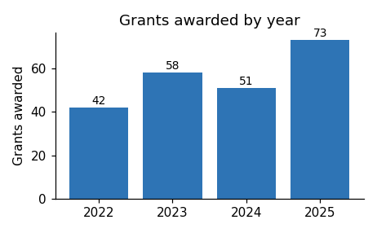
Applications for the next round open in March.

