Grants awarded by year
The table below is being used for layout, not data. It has one row and two columns, no borders and no header row, and it exists only to put the chart beside the text. In the markup it is indistinguishable from a data table that is missing its headers.
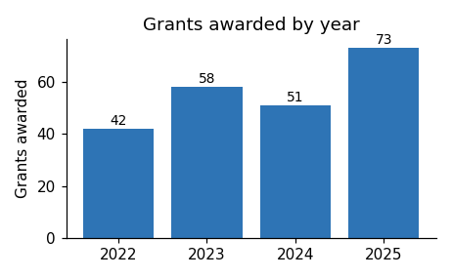 | Grants awarded rose from 42 in 2022 to 73 in 2025. The sharp rise in the final year followed changes to the eligibility rules, which opened the program to organisations as well as individuals.

