# Assignment 5

**csem** – C semantic analyzer

This assignment is designed by **Prof. Whalley** in FSU Computer Science, Tallahassee and revised by Gang-Ryung Uh, Ph.D at FSUPC Computer Science

* ***csem*** reads a C program (actually a subset of C) from its standard input and compiles it into a list of intermediate language quadruples on its standard output. The form of the quadruple operators appears below:

*x* **:=** *y op z* operate on *y* and *z* and place result in *x*

**bt** *x lab* branch to *lab* iff *x* is true

**br** *lab* branch to *lab*

*x* **:= global** *name* yield address of global identifier *name x* **:= local** *name**n* yield address of local *n*

*x* **:= param** *name n* yield address of parameter *name* *n*

*x* **:=** *c* yield value of constant value *c*

*x* **:=** *s* yield address of character string *s*

**formal** *name**n* allocate the formal *name* having *n* bytes

**alloc** *name type n* allocate the global *name* of *type* (either int or double)having *n* bytes

**localloc** *name**n* allocate the local *name* having *n* bytes

**func** *name type* begin function *name with* type – 1 for int type and 2 for double type

**fend** end function

*lab***=***y* define *lab* to be *y*

**bgnstmt** *n* beginning of statement at line *n*

* ***name*** denotes an identifier from the C program. ***n*** denotes an integer. ***c*** denotes a C integer constant. ***s*** denotes a string enclosed by double quotes. ***x, y,*** and ***z*** denote quadruple temporaries. ***lab*** denotes the location of a quadruple or a reference to a symbol defined later by a "**lab=y**" command. ***op*** denotes any of the C operators below:

**== != <= >= < > = | ˆ & << >> + - * / %**

operate on *x* and *y*

**˜** invert *x*

**-** negate *x*

**@** dereference *x*

**cv** convert *x*

**f** call function *y* with *n* arguments

**arg** pass *x* as an argument

**ret** return *x*

**[]** index *z* into *y*

followed by ***i*** (for the integer version of the operator) or by ***f*** (for the floating-point version). *y* is omitted for unary operators. You should assume all bitwise operators (**| ˆ & << >> ˜**) and **%** only operate on integer values.

* For example,

**double m[6];**

**scale(double x) {**

**int i;**

**if (x == 0) return 0;**

**for(i = 0; i < 6; i += 1) m[i] *= x;**

**return 1;**

**}**

compiles into the intermediate operations below (actually only one column)

* Your assignment is to write the semantic actions for the csem program to produce the desired intermediate code. The following files, which will comprise part of your program, are in the https://github.com/gangryunguh/csem-student-template.git

cc.h. - include file

cgram.y. - yacc grammar for subset of C

scan.c. - lexical analyzer

scan.h. - defines prototypes for scan routines sem.h. - defines prototypes for routines in

**semdum.c**

semutil.c - utilitity routines for the semantic actions semutil.h - defines prototypes for semutil routines

sym.c - symbol table management

sym.h - defines prototypes for routines in sym.c

* Submit only the file **semdum.c** to Canvas course assignment link.

Another Example

This example shows the intermediate code generation for a test function with multiple formal parameters, locals, and actual arguments.

**test(int a, int b)**

**{**

**double d;**

**int i;**

**printf("%d %f %d %d\n", i, d, a, b);**

**}**

compiles into

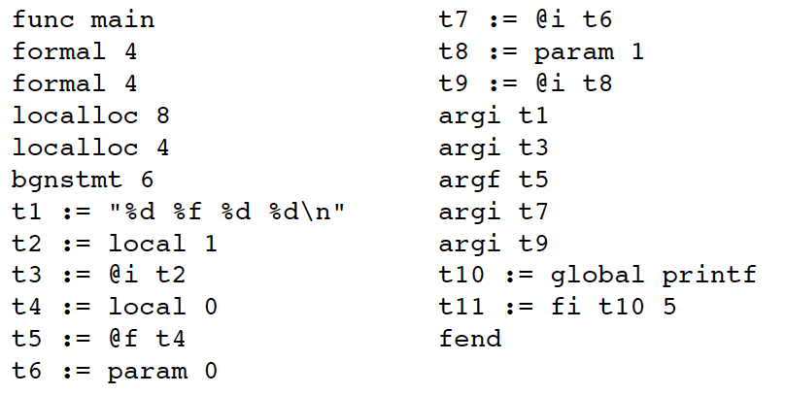

* Below is the order in which I recommend you implement the semantic routines.

**fname**

**fhead**

**ftail**

**bgnstmt**

**id**

**string**

**op1**

**exprs**

**call**

**-------------- enough to get through the second example**

**con**

**m**

**doret**

**set**

**op2**

**index**

**ccexpr**

**rel**

**n**

**backpatch**

**doif**

**dofor**

**-------------- enough to get through the first example**

**doifelse dowhile**

**dodo**

**ccand**

**ccor**

**ccnot**

**opb**

**startloopscope endloopscope docontinue**

**dobreak**

**labeldcl**

**dogoto**