Mark Dougherty

2023.01.29

Homework 1:

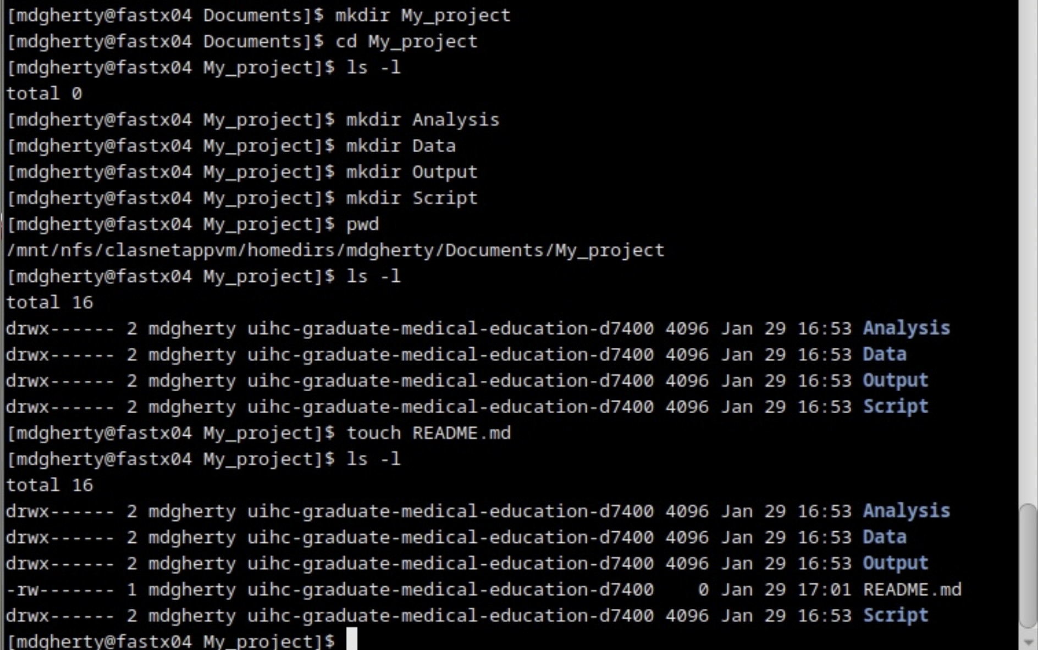

Homework 2:

