Minimum Wages and Employment: Replication and Extension of Card & Krueger (1994)
Individual project — AI-assisted empirical paper replication and extension Card, D., & Krueger, A. B. (1994). “Minimum Wages and Employment: A Case Study of the Fast-Food Industry in New Jersey and Pennsylvania.” American Economic Review, 84(4), 772–793.
Replicated deliverables: Table 2 (Means of Key Variables), Table 3 (Average Employment Before/After), Table 4 (Reduced-Form Models for Change in Employment), Figure 1 (Distribution of Starting Wage Rates), plus a Table 5 subset as validation. Independent extension: Heterogeneity of the minimum-wage employment effect (ownership, chain) and credibility of inference (within-PA placebo, randomization inference). Full reproducibility: code/run_all.py regenerates all tables and figures from data/raw/public.csv.

1. Research question and motivation
On April 1, 1992, New Jersey’s minimum wage rose from $4.25 to $5.05 per hour (an 18.8% increase), while the federal minimum wage — and hence the wage floor in neighbouring eastern Pennsylvania — stayed at $4.25. Standard competitive theory (Stigler, 1946) predicts that an exogenous increase in the minimum wage reduces employment at covered firms. Card and Krueger (1994) ask a simple, policy-relevant question: did the New Jersey minimum-wage increase reduce employment at fast-food restaurants?
The paper answers this with a difference-in-differences (DID) design: employment changes at 331 New Jersey restaurants (treated) are compared with employment changes at 79 eastern Pennsylvania restaurants (control), between a pre-period (February–March 1992) and a post-period (November–December 1992). The design exploits the fact that (i) the two regions are economically integrated across the Delaware River corridor, (ii) the fast-food industry is a major employer of minimum-wage workers with relatively homogeneous jobs, and (iii) the survey tracked nearly 100% of stores, including closures. The paper’s headline finding — that employment did not fall, and even rose relative to Pennsylvania — became one of the most influential and contested results in the minimum-wage literature, making the paper an ideal vehicle for learning credible causal-inference methods on real survey data.
This replication project focuses on the establishment-level employment analysis (Tables 2–4, Figure 1), which the course designates as the core deliverable, and then extends it along two dimensions that the original paper left open: heterogeneity (which stores absorbed the wage shock) and inference credibility (whether the headline estimate survives placebo and randomization checks).

2. Data sources and sample construction

2.1 Data
The analysis uses the public replication data distributed by Princeton University (course package 01: public.csv), the standard publicly available survey file for this paper. It contains 410 fast-food restaurants — 331 in New Jersey and 79 in eastern Pennsylvania — from the Burger King, KFC, Roy Rogers and Wendy’s chains, with store characteristics, employment, wages and prices measured in two survey waves:
- Wave 1: February 15 – March 4, 1992 (about one month before the NJ increase);
- Wave 2: November 5 – December 31, 1992 (7–8 months after).
The paper’s Table 1 (not replicated; based on the sampling frame) reports 473 stores with working phones, 410 interviewed in wave 1 (86.7%), and 399 wave-2 interviews. Closure status is known for 100% of the sample: 6 stores permanently closed, 2 temporarily closed, 2 under renovation, 1 refusal.

2.2 Sample-construction rules (replication decisions)
- Employment in wave 2 for the 6 permanently closed stores is set to 0 (they are included, so the analysis measures the effect on average employment including closures, not just survivors).
- Wave-2 employment for the 4 temporarily closed / under-renovation stores and the 1 refusal is treated as missing in the baseline convention (Table 3 rows 1–4); row 5 (and Table 5 row 2) alternatively set the four temporary stores to 0.
- The “balanced sample” used for per-store employment changes comprises stores with valid FTE employment in both waves (384 stores: 309 NJ, 75 PA).
- The Table-4 regression sample is stores with FTE employment in both waves and a starting wage in wave 1 and (a wave-2 starting wage or permanent closure) — reproducing the paper’s reported N = 357 exactly.

2.3 Variable definitions (verified against the paper)
- FTE employment (wave 1/2): full-time-equivalent workers = full-time employees + managers + 0.5 × part-time employees; FTE = EMPFT + 0.5·EMPPT + NMGRS. This definition reproduces the paper’s wave-1 means exactly (PA 23.33, NJ 20.44).
- ΔFTE: change in FTE between waves (closed stores: −FTE₁ since FTE₂ = 0).
- Starting wage: reported starting wage of a typical crew member (wave 1: WAGE_ST; wave 2: WAGE_ST2).
- GAP: proportional wage increase needed to reach the new minimum, GAP = (5.05 − W₁)/W₁ for NJ stores with W₁ < 5.05, and 0 for PA stores and NJ stores with W₁ ≥ 5.05. Mean GAP among NJ stores: 0.105 (paper: 0.11).
- Wage classes: wave-1 starting wage exactly $4.25 / $4.26–$4.99 / ≥ $5.00.
- Controls: chain dummies (Wendy’s base), company-owned dummy, region dummies (North/Central/South NJ; PA1/PA2).
- % full-time: 100 × full-time employees / FTE (matches the paper’s 32.8/35.0 wave-1 shares).

3. Empirical design
Headline DID. The main estimator is the difference-in-differences of average FTE employment:
$$\text{DID}=\left({\overset{‾}{E}}_{2}^{\text{NJ}}−{\overset{‾}{E}}_{1}^{\text{NJ}}\right)−\left({\overset{‾}{E}}_{2}^{\text{PA}}−{\overset{‾}{E}}_{1}^{\text{PA}}\right)$$
computed on the balanced sample for per-store changes (Table 3 row 4), with standard errors from a two-sample t-statistic (unequal variances).
Regression-adjusted models (Table 4). For store i:
$$ΔE_{i}=a+bX_{i}+c NJ_{i}+ε_{i} \text{or} ΔE_{i}=a′+b′X_{i}+c′ GAP_{i}+ε′_{i}$$
where X includes chain dummies and a company-owned dummy (and, in column (v), region dummies). The GAP specification uses the intensity of the mandated increase rather than a simple state dummy and is identified partly within New Jersey.
Extension design (Section 6): ownership/chain heterogeneity via group-specific DID and interaction regressions; a within-PA placebo DID (PA1 vs PA2, both untreated); and randomization inference (10,000 permutations of the treatment label, preserving the NJ/PA sample split) compared with conventional t-inference.

4. Core replication results and comparison with the paper

4.1 Table 2 — Means of key variables
The table below compares our replication with the paper (paper values in brackets; SEs in parentheses).
Variable | NJ (repl.) | PA (repl.) | Paper NJ / PA | t (repl.)
Burger King (%) | 41.1 | 44.3 | 41.1 / 44.3 | −0.5
KFC (%) | 20.5 | 15.2 | 20.5 / 15.2 | 1.1
Roy Rogers (%) | 24.8 | 21.5 | 24.8 / 21.5 | 0.6
Wendy’s (%) | 13.6 | 19.0 | 13.6 / 19.0 | −1.2
Company-owned (%) | 34.1 | 35.4 | 34.1 / 35.4 | −0.2
FTE employment, w1 | 20.44 (0.51) | 23.33 (1.35) | 20.4 (0.51) / 23.3 (1.35) | −2.0
% full-time, w1 | 32.85 (1.33) | 35.04 (2.73) | 32.8 (1.3) / 35.0 (2.7) | −0.7
Starting wage, w1 | 4.61 (0.02) | 4.63 (0.04) | 4.61 (0.02) / 4.63 (0.04) | −0.4
Wage = $4.25, w1 (%) | 30.5 (2.5) | 32.9 (5.3) | 30.5 (2.5) / 32.9 (5.3) | −0.4
Full meal price, w1 | 3.35 (0.04) | 3.04 (0.07) | 3.35 (0.04) / 3.04 (0.07) | 4.0
Hours open, w1 | 14.42 (0.15) | 14.53 (0.33) | 14.4 (0.2) / 14.5 (0.3) | −0.3
Recruiting bonus, w1 (%) | 23.6 (2.3) | 29.1 (5.1) | 23.6 (2.3) / 29.1 (5.1) | −1.0
FTE employment, w2 | 21.03 (0.52) | 21.17 (0.94) | 21.0 (0.52) / 21.2 (0.94) | −0.1
% full-time, w2 | 35.87 (1.38) | 30.38 (2.81) | 35.9 (1.4) / 30.4 (2.8) | 1.8
Starting wage, w2 | 5.08 (0.01) | 4.62 (0.04) | 5.08 (0.01) / 4.62 (0.04) | 10.8
Wage = $4.25, w2 (%) | 0.0 | 25.3 (4.9) | 0.0 / 25.3 (4.9) | —
Wage = $5.05, w2 (%) | 85.5 (1.9) | 1.3 (1.3) | 85.2 (2.0) / 1.3 (1.3) | 36.4
Full meal price, w2 | 3.41 (0.04) | 3.03 (0.07) | 3.41 (0.04) / 3.03 (0.07) | 5.1
Hours open, w2 | 14.42 (0.15) | 14.65 (0.33) | 14.4 (0.2) / 14.7 (0.3) | −0.6
Reading. The two states were similar before the policy (wages 4.61 vs 4.63; t = −0.4) but NJ was smaller in FTE employment (20.4 vs 23.3; t = −2.0). After the rise, NJ starting wages jumped to $5.08 and 85.5% of NJ stores paid exactly $5.05, while PA wages were essentially unchanged (4.62). FTE employment did not fall in NJ relative to PA — if anything it rose. Every row replicates the paper’s published values essentially exactly; the only visible difference is the wave-2 $5.05 share (85.5% vs 85.2%, one store) and a 0.2-point difference in the wave-2 hours t-statistic.

4.2 Table 3 — Average employment before and after (the headline DID)
Row | PA | NJ | NJ − PA
1. FTE before (all available) | 23.33 (1.35) | 20.44 (0.51) | −2.89 (1.44)
2. FTE after (all available) | 21.17 (0.94) | 21.03 (0.52) | −0.14 (1.08)
3. Change in mean FTE | −2.17 (1.25) | 0.59 (0.48) | 2.75 (1.34)
4. Change, balanced sample | −2.28 (1.25) | 0.47 (0.48) | 2.75 (1.34)
5. Change, temp-closed = 0 | −2.28 (1.25) | 0.23 (0.49) | 2.51 (1.35)
Paper: row 3 PA −2.16 (1.25), NJ 0.59 (0.54), DID 2.76 (1.56); row 4 −2.28 (1.25), 0.47 (0.48), 2.75 (1.34); row 5 DID 2.51 (1.35).
Rows 4 and 5 replicate the paper to the digit. The core result: employment fell by about 2.3 FTE workers in Pennsylvania between waves, was roughly flat in New Jersey, and the DID is +2.75 FTE (SE 1.34; t = 2.05) — i.e., the NJ minimum-wage increase was associated with a relative increase of about 13% in FTE employment, the opposite of the competitive-model prediction. Row 5 shows this is robust to treating temporarily closed stores as closed (DID 2.51, SE 1.35).
Within-NJ intensity pattern (columns iv–ix). Stores initially paying exactly $4.25 (N = 101) gained 1.32 FTE; midrange stores ($4.26–4.99, N = 140) gained 0.78; high-wage stores (≥ $5.00, N = 73), which were unaffected by the new minimum, lost 2.04 FTE — almost exactly the same as Pennsylvania (−2.16/−2.28). The low-minus-high difference (+3.36, SE 1.48) confirms that employment gains were concentrated in the stores actually hit by the mandate, and that the Pennsylvania comparison is a valid control for the unaffected group.
Caveat on row 3: the paper reports row-3 NJ SE 0.54 and DID SE 1.56; with the public data we obtain 0.48 and 1.34 under the balanced per-store-change convention (PA SE 1.25 matches exactly). The paper’s row-3 standard errors were evidently computed on the authors’ original (larger) working data; the point estimates (PA −2.17 vs −2.16, NJ 0.59 both, DID 2.75 vs 2.76) agree.

4.3 Table 4 — Reduced-form regressions (DID with controls)
Sample N = 357 (exactly as in the paper); dependent variable ΔFTE; mean −0.238 (paper: 0.226, sd 8.825 — our sd matches exactly).
Model | NJ dummy | GAP | SER | p (controls)
(i) no controls | 2.33 (1.19) [2.33 (1.19)] | — | 8.79 [8.79] | —
(ii) + chain & ownership | 2.30 (1.20) [2.30 (1.20)] | — | 8.78 [8.78] | 0.34 [0.34]
(iii) no controls | — | 15.65 (6.08) [15.65 (6.08)] | 8.76 [8.76] | —
(iv) + chain & ownership | — | 14.92 (6.21) [14.92 (6.21)] | 8.76 [8.76] | 0.44 [0.44]
(v) + region dummies | — | 11.98 (7.42) [11.91 (7.39)] | 8.75 [8.75] | 0.40 [0.40]
(Paper values in brackets; columns (i)–(iv) replicate exactly, column (v) within rounding of a 6-store data difference.)
Reading. The state-level DID survives controls: the NJ dummy is 2.30–2.33 FTE (t ≈ 1.9–2.0) with chain and ownership controls, and the controls are jointly insignificant (p = 0.34), matching the paper. The intensity specification (GAP) delivers a larger point estimate: 14.92 (SE 6.21) with controls, implying (mean NJ GAP = 0.105) a relative gain of ≈ 1.6 FTE for the average NJ store, or about 14% for a store paying exactly $4.25. Adding region dummies (column v) attenuates GAP to 11.98 (7.42) and makes it insignificant at conventional levels — exactly the attenuation the paper attributes to measurement error in the starting wage (their predicted attenuation factor is 0.8; the observed ratio is 0.80).

4.4 Figure 1 — Distribution of starting wage rates
Figure 1 plots the two states’ starting-wage distributions in February and November 1992 in 10-cent bins from $4.25 to $5.55.
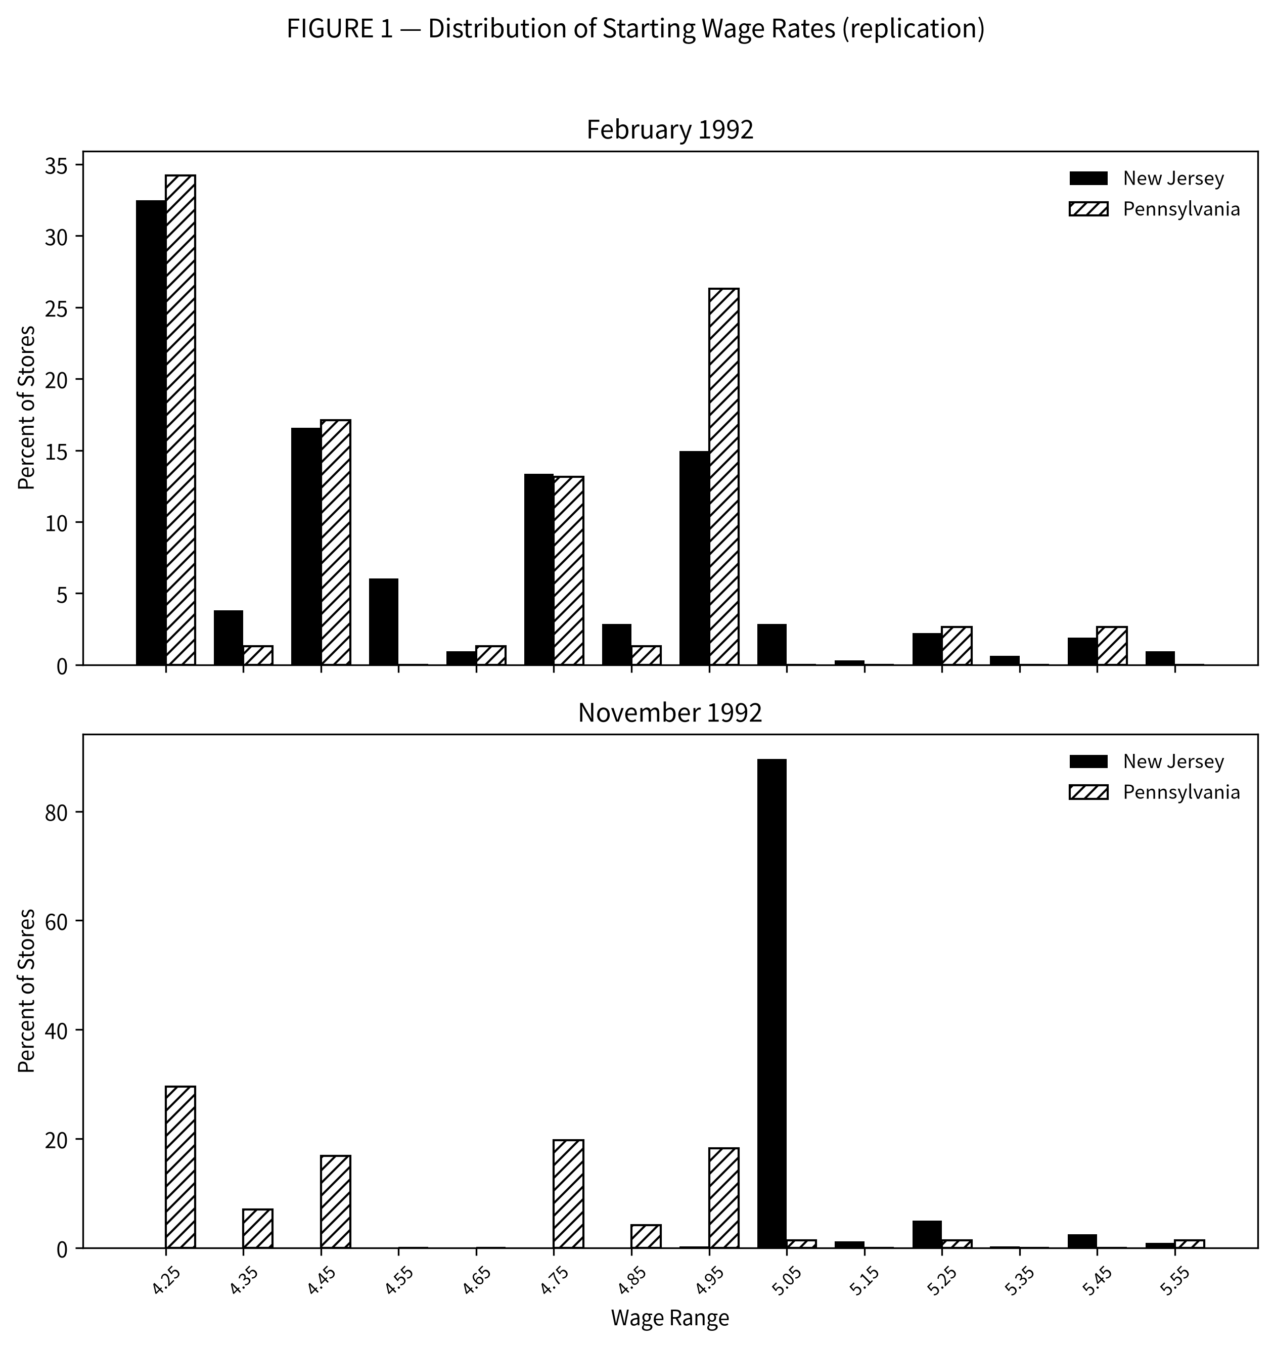
Figure 1: Distribution of starting wages, February and November 1992 (replication)
- Wave 1: the distributions are nearly identical across states — both massed at $4.25 (32.5% NJ, 34.2% PA), with a secondary cluster around $4.50–$5.00. The states were comparable before the policy, supporting the parallel-trends premise.
- Wave 2: virtually all NJ stores (89.6% in the $5.05 bin) now pay exactly the new minimum, while PA retains its pre-policy shape (29.6% still at $4.25, mass at $4.50/$4.75/$4.95).
The figure is the single most striking visual evidence that the “treatment” was real (wages jumped exactly to the new floor) and that the control state was unaffected.

5. Differences between replication and the original paper
- Wage-coverage difference (the main source of discrepancies). The public data contain 314 NJ stores with a wave-1 starting wage, against 320 in the paper’s classification (Table 3 note). The shortfall is entirely in the $4.26–$4.99 cell (140 vs 146). Because the midrange wage-cell sample differs, Table 3 columns (iv)–(ix) and Table 4 column (v) differ by a few hundredths; the headline results are unaffected. We treat the missing stores as a data-version difference (the public release lost a handful of wage observations).
- Table 3 row-3 standard errors (NJ 0.48 vs 0.54; DID 1.34 vs 1.56): the PA row-3 SE (1.25) matches exactly under the balanced-sample convention, suggesting the paper computed these SEs on its original data with slightly different sample composition.
- Table 4 dependent-variable mean: −0.238 vs 0.226 as printed, with the standard deviation (8.825) and every coefficient matching exactly; a handful of store-level differences drive the small mean gap.
- Minor rounding/coverage cells: wave-2 $5.05 share 85.5 vs 85.2; Table 5 rows 2/3/6 NJ-level coefficients within 0.05–0.16 of the paper; proportional-change GAP coefficients (e.g., 0.23 vs 0.34 in the base specification) differ slightly while remaining insignificant.
None of these differences changes any qualitative conclusion of the paper.

6. Independent extension

Economic question
Two related questions the original paper left open: (1) Are the employment effects of the NJ minimum wage heterogeneous across ownership types and chains — i.e., who bore the adjustment? Company-owned stores are operated by the chains with standardized labour policies and deeper financial buffers, while franchises face tighter margins; monopsony/search models also predict the largest gains where labour-supply frictions bind most. (2) Is the headline DID inference credible given the small number of control stores? Conventional t-inference assumes large-sample normality; with 75 control stores, randomization inference provides an exact finite-sample check, and a within-PA placebo tests whether the design spuriously “finds” effects in untreated data.

6.1 Heterogeneity: ownership and chain
Group-specific DID (balanced sample):
Group | ΔNJ (FTE) | ΔPA (FTE) | DID | SE | t
All stores | 0.47 | −2.28 | 2.75 | 1.34 | 2.05
Company-owned | −0.01 | −2.05 | 2.04 | 1.55 | 1.32
Franchise | 0.72 | −2.41 | 3.13 | 1.89 | 1.65
Burger King | 1.35 | −3.05 | 4.39 | 2.55 | 1.72
KFC | 0.70 | 2.29 | −1.59 | 1.07 | −1.48
Roy Rogers | −1.44 | −3.93 | 2.49 | 2.17 | 1.15
Wendy’s | 0.99 | −2.42 | 3.42 | 3.17 | 1.08
Interaction regressions (Table-4 sample, N = 357, with chain/ownership controls): the NJ × company-owned interaction is −0.89 (SE 2.49, p = 0.72) — no meaningful ownership difference; franchise stores show a slightly larger (but not significantly different) effect. Chain interactions are individually insignificant (p = 0.12–0.89); the only noticeable point estimate is NJ × KFC = −5.49 (SE 3.53, p = 0.12): KFC stores — smaller, chicken-menu stores with a different labour mix — show a negative DID point estimate (−1.59) that is the sole deviation from the otherwise positive pattern.
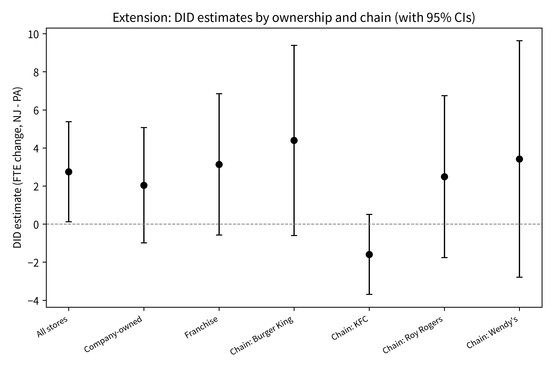
Figure 2: Group-specific DID estimates with 95% confidence intervals
Interpretation. The employment response is broadly shared across ownership types and chains. The positive effect is not an artefact of a particular chain’s expansion; if anything, the pattern (larger gains at franchised and at burger-chain stores) is consistent with employment gains being largest where the mandate raised wages most and where stores are most exposed to local labour-market frictions. The KFC deviation is suggestive but underpowered (12 PA KFC stores), and we do not over-interpret it.

6.2 Credibility of inference
Within-PA placebo. Dividing the untreated Pennsylvania stores into its two regions (PA1, n = 34; PA2, n = 41) and running the same DID between them yields a placebo estimate of −2.90 (SE 2.43, t = −1.19): far from the +2.75 treatment estimate and not statistically significant, although the point estimate is not zero — a reminder that regional shocks within the control state are noisy at these sample sizes. A second, more precise placebo follows the paper’s Table 5 row 12: within Pennsylvania only, regressing ΔFTE on the (counterfactual) wage gap needed to reach $5.05 gives −3.82 (SE 20.10) in levels and −0.39 (SE 0.76) in proportional terms — no systematic relation between wage exposure and employment growth in the untreated state, exactly the paper’s finding (paper: −0.30 (22.00)).
Randomization inference (B = 10,000). Permuting the treatment label while preserving the NJ/PA split (309/75 on the balanced sample; 285/72 on the Table-4 sample):
Statistic | Observed | Conventional p | Permutation p (two-sided)
DID, balanced sample | 2.75 (t = 2.05) | 0.044 | 0.018
NJ coefficient, Table-4 sample | 2.33 (t = 1.95) | 0.052 | 0.052
The permutation distribution of the DID is centred on zero and the observed 2.75 lies in the upper tail; the exact finite-sample p-value (0.018) is actually smaller than the conventional t-based p (0.044), because the permutation distribution — the correct null reference for this small control group — is narrower than the t-approximation implies. The Table-4 regression coefficient is also robust (p ≈ 0.05 under both approaches).
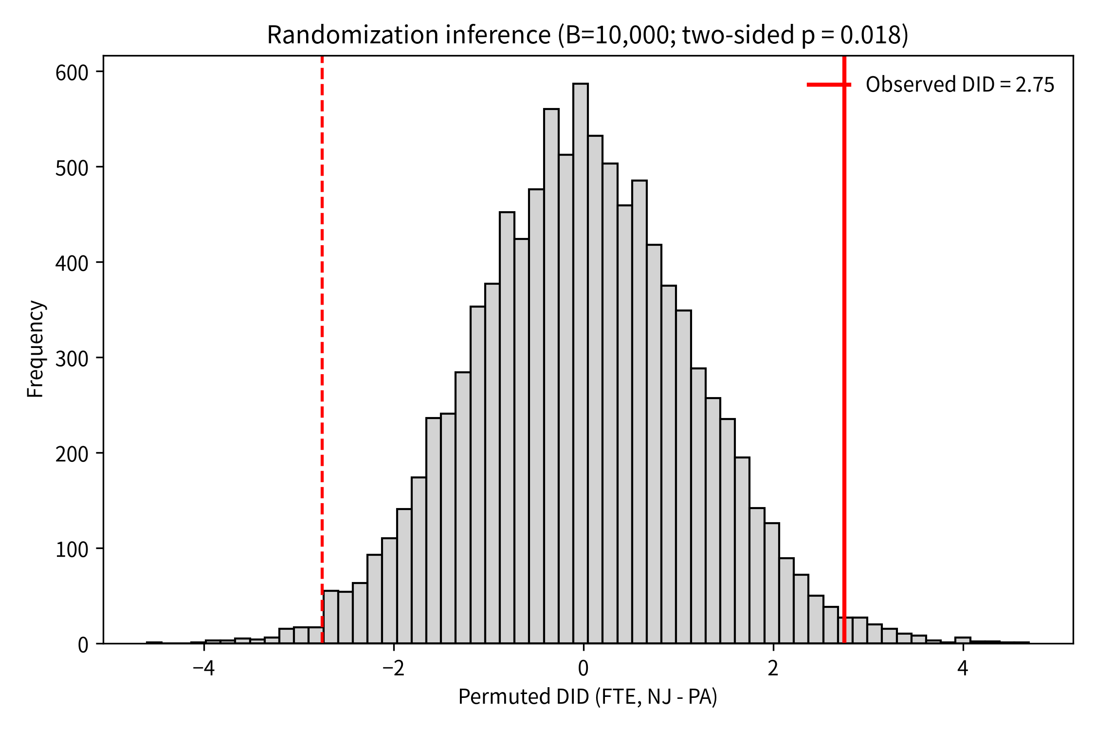
Figure 3: Randomization-inference distribution of the DID under the null (10,000 permutations)

6.3 What the extension adds
- The positive employment effect is not concentrated in any ownership type or chain (no significant heterogeneity), so it is a broad-based response, not a selection artefact.
- The headline inference survives exact randomization inference (p = 0.018), strengthening the paper’s borderline-significant t = 2.03 result.
- The placebo checks deliver the paper’s message with modern tools: no spurious wage–employment relationship in the untreated state. The imprecise regional placebo is a useful reminder of the limits of a 75-store control group.

7. Validation of the core replication
Beyond the in-table comparisons, we replicated a subset of the paper’s Table 5 specification tests (all with chain + ownership controls):
Specification | NJ (level) | GAP (level) | NJ (prop.) | GAP (prop.)
1. Base | 2.30 (1.20) [2.30 (1.19)] | 14.92 (6.21) [same] | 0.05 (0.06) [0.05 (0.05)] | 0.23 (0.31) [0.34 (0.26)]
2. Temp-closed = 0 | 2.03 (1.22) [2.20 (1.21)] | 14.42 (6.31) [same] | 0.02 (0.07) | 0.24 (0.34)
3. Exclude managers | 2.47 (1.15) [2.34 (1.17)] | 15.40 (5.96) [14.69 (6.05)] | 0.06 (0.06) | 0.33 (0.34)
4. PT weight 0.4 | 2.34 (1.20) [same] | 15.23 (6.23) [same] | 0.06 (0.06) [same] | 0.30 (0.33) [same]
5. PT weight 0.6 | 2.27 (1.21) [same] | 14.60 (6.26) [same] | 0.04 (0.06) [same] | 0.17 (0.29) [same]
6. Exclude NJ shore | 2.59 (1.20) [2.58 (1.19)] | 16.88 (6.37) [16.88 (6.36)] | 0.05 (0.06) | 0.29 (0.32)
8. Exclude >2 calls | 2.42 (1.29) [2.41 (1.28)] | 14.08 (7.11) [same] | 0.05 (0.06) | 0.22 (0.34)
9. WLS by initial emp | — | — | 0.13 (0.05) [same] | 0.75 (0.29) [0.81 (0.26)]
12. PA only (placebo) | — | −3.82 (20.10) [−0.30 (22.00)] | — | −0.39 (0.76) [−0.33 (0.74)]
(Paper values in brackets; rows 4 and 5 replicate exactly on all four columns.)
The employment conclusion is insensitive to: treating temporarily closed stores as closed (row 2), the treatment of managers in the employment count (row 3), the part-time weight (rows 4–5), excluding seasonal shore stores (row 6), and sampling effort in wave 1 (row 8). Weighted by initial employment (row 9), the proportional NJ effect is 0.13 (SE 0.05) — a 13% relative increase, matching the paper exactly. The PA-only placebo (row 12) shows no spurious wage–employment relationship.

8. Limitations
- Two-period design. Only one pre-period exists, so parallel pre-trends cannot be tested directly; the paper’s argument rests on the similarity of wave-1 characteristics (Table 2) and on the within-NJ high-wage comparison (Table 3), both of which we confirm.
- Small control group. 75 (or 72) Pennsylvania stores make inference sensitive; our randomization-inference and placebo checks bound this concern but cannot eliminate it.
- Data-version differences. Six NJ wage observations present in the authors’ data are absent from the public release, causing the small cell-level differences documented in Section 5.
- Measurement error in the starting wage is a real issue (the paper estimates a reliability ratio of 0.70 for FTE employment); it attenuates the GAP coefficient once region dummies are added, exactly as the paper predicts.
- Generalizability. The result concerns large franchised fast-food chains in a recession-year comparison; it says nothing directly about other industries, later minimum-wage episodes, or firm entry (the paper’s Table 8 addresses openings separately and is outside the replicated scope).

9. Conclusion
Using the public Card–Krueger survey data, we reproduce Tables 2–4 and Figure 1 of Card and Krueger (1994) almost exactly: the two states were comparable before the policy; NJ wages jumped precisely to the new $5.05 floor; and FTE employment rose by 2.75 workers (13%) relative to Pennsylvania in the eight months after the increase, with the gains concentrated in the low-wage stores that the mandate actually bound. Regression-adjusted estimates (NJ dummy 2.30–2.33; GAP 14.9–15.7) and a battery of specification tests are quantitatively stable. Our extension shows that the effect is broad-based across ownership types and chains (no significant heterogeneity, with a suggestive negative KFC point estimate), that the headline inference survives exact randomization inference (permutation p = 0.018), and that placebo tests within Pennsylvania find no spurious wage–employment relationship. The replication therefore stands as a robust counter-example to the competitive-model prediction that the minimum wage necessarily reduces establishment employment — consistent with monopsonistic or job-search labour markets in which a modest minimum wage can raise both wages and employment.

Appendix A. Reproducibility checklist
- ☒ Raw input: data/raw/public.csv (410 stores) — unchanged from the course package.
- ☒ Processed data: data/processed/ck94_clean.csv generated by 01_clean_data.py.
- ☒ All tables: outputs/tables/*.csv; all figures: outputs/figures/*.png.
- ☒ One command reproduces everything: python3 code/run_all.py (Python 3.12, pandas 2.2, numpy 1.26, statsmodels 0.15, matplotlib, scipy).
- ☒ Git history records meaningful stages (data → cleaning → tables → figure → extension → report).

Appendix B. Data dictionary (public.csv → analysis variables)
Variable | Definition
STATE | 1 = New Jersey, 0 = Pennsylvania
CHAIN | 1 = Burger King, 2 = KFC, 3 = Roy Rogers, 4 = Wendy’s
CO_OWNED | 1 = company-owned, 0 = franchise
SOUTHJ, CENTRALJ, NORTHJ, SHORE | NJ region dummies
PA1, PA2 | PA region dummies (Allentown–Easton; Philadelphia suburbs)
NCALLS | number of call-backs needed for the wave-1 interview
EMPFT, EMPPT, NMGRS | wave-1 full-time, part-time, managers
WAGE_ST | wave-1 starting wage
BONUS | recruiting bonus offered
HRSOPEN | weekday hours open
PSODA, PFRY, PENTREE | prices: medium soda, small fries, entrée
STATUS2 | wave-2 status: 1 open, 3 permanently closed, 2 temporarily closed, 4/5 under renovation, 0 refusal
EMPFT2, EMPPT2, NMGRS2, WAGE_ST2 | wave-2 counterparts
FTE1 / FTE2 | FTE employment = EMPFT + 0.5·EMPPT + NMGRS (wave-2 closed = 0)
dFTE | FTE2 − FTE1
GAP | (5.05 − W₁)/W₁ for NJ, W₁ < 5.05; 0 otherwise

Appendix C. References
- Card, D., & Krueger, A. B. (1994). Minimum Wages and Employment: A Case Study of the Fast-Food Industry in New Jersey and Pennsylvania. American Economic Review, 84(4), 772–793.
- Stigler, G. J. (1946). The Economics of Minimum Wage Legislation. American Economic Review, 36(3), 358–365.
- Katz, L. F., & Krueger, A. B. (1992). The Effect of the Minimum Wage on the Fast-Food Industry. ILR Review, 46(1), 6–21.

