Software Requirements Specification

for

Group 3’s Email Client

**Version 1.0 approved**

**Prepared by Spurthi B., Shelton E., David P., Rishav S.**

**Intro to SE Group 3**

**9/2/2020**

# **Introduction**

## **Purpose**

*Email Client version 1.0, an e-messaging program that will allow a user to log in to perform the following function: access emails; compose, edit, and send emails to other users; search and forward emails to other users; send attachments along with an email.*

## **Document Conventions**

*This SRS is typed in size 11 italicized Arial font. Section and subsection headers are typed in size 18 and size 14 Times font, respectively. Priorities for higher-level requirements are assumed to be inherited by more detailed requirements. Each requirement statement is to have its own priority.*

## **Intended Audience and Reading**

*This document is intended for developers, project managers, marketing staff, users, testers, and documentation writers as an informative piece to describe the product as a whole as well as any requirements that need to be met. This SRS document is broken into sections detailing description, features, and any remaining requirements not listed elsewhere in the document. Reading the document in order of section is recommended.*

## **Product Scope**

*This software will allow the send and retrieval of electronic mail, with the additional goals of being able to search and forward messages, as well as to send attachments (images, files, etc.) along with a message. The intent here is to first work towards the high-priority functional requirements, then expand to other goals once it is functional.*

## **References**

* *D. Mooloo and T. P. Fowdur, "An SSL-based client-oriented anti-spoofing email application," 2013 Africon, Pointe-Aux-Piments, 2013, pp. 1-5, doi: 10.1109/AFRCON.2013.6757757.*

* *K. Ratecki, B. Sakowicz, M. Wojtowski and A. Napieralski, "Configurable Client Email Application Working as Web Page," 2006 International Conference - Modern Problems of Radio Engineering, Telecommunications, and Computer Science, Lviv-Slavsko, 2006, pp. 460-463, doi: 10.1109/TCSET.2006.4404586.*

# **Overall Description**

## **Product Perspective**

*The product being developed is Email Client. In today’s world email is a basic form of communication between people and organizations. An Email Client is a web application that allows users to login into their account, access their emails, compose new emails with/without attachments, and search inbox etc. The below interfaces are supported by the Email Client system*

*User Interface: The user interface will be compatible with any browser such as Mozilla, Edge, Chrome etc. by which users can access the system.*

*Hardware Interface: The application runs over the internet, hence the hardware interface for the system will be all the hardware that is required to connect to the internet such as Modem, router, ethernet cable etc.*

*Software Interface: The SMTP protocol is used to send emails and POP3 service is used to retrieve emails.*

## **Product Functions**

*The Email Client contains the following key features:*

* *Register into the system by providing user id and password.*
* *Login using user id and password and access emails.*
* *Compose, edit and send emails to others.*
* *Search and forward emails to others.*
* *Send attachments such as files, images etc. along with an email.*

## **User Classes and Characteristics**

*The main users of the system will be End users.*

*End Users: They are the users who use the application to send and receive emails, check and search emails, send attachments and forward emails.*

*Apart from the end users, there are developers. Developers will develop the application, test the application and release it for end users to use it.*

## **Operating Environment**

*The application shall be accessible from any web browser.*

*Software Requirements:*

*· Windows 7, Windows 10*

*· SQL*

*· Visual studio*

*Hardware Components:*

*· Processor – i3*

*· Hard Disk – 5 GB*

*· Memory – 1GB RAM*

## **Design and Implementation Constraints**

*The size of the attachments is limited to 5 MB. There are no additional constraints at this point of time for the Email Client system.*

# **System Features**

## **Login/ Logout**

*3.1.1 Description and Priority*

*The user will be able to access their own account by typing in their username/email*

*and password. This is high priority.*

*3.1.2 Stimulus/Response Sequences*

*Upon loading the page, the user will be prompted with two input fields. One for their*

*username/e-mail and one for their account’s password. Then the user will click login*

*to submit the username/ email and password. If the two fields are correct, the user*

*will be forwarded to another page that has their received and sent emails.*

*3.1.3 Functional Requirements*

*HOM-1: Need a home page to display login input boxes*

*ERR-1: Need error message upon incorrect password or username/e-mail*

*DB-2: The web-app’s database must contain user’s password and username/e-mail*

## **Write and Send** Emails

###### 3.2.1 Description and Priority

*The user will be able to write, edit, and send emails to other users with any other*

*email provider. This is high priority.*

*3.2.2 Stimulus/Response Sequences*

*The user can select to write an email and be prompted with a larger input box to write an email and a smaller input box for the recipient. After completing the e-mail, the user can then click send and*

*3.2.3 Functional Requirements*

*INT-1: Need a page after login with an intuitive user interface that is easy to*

*navigate.*

*ERR-2: Should produce an error if an attachment is not supported or is too big to send.*

## **Search and Forward** Emails

*3.3.1 Description and Priority*

*The user will be able to search for emails, preferably by sender, recipient, or e-mail content. This is high priority.*

*3.3.2 Stimulus/Response Sequences*

*The user should be presented with a search bar in which to put the name or content that they are searching for. After committing the search, they should be presented with the correct results.*

*3.3.3 Functional Requirements*

*REQ-1: The user’s request must be put through a query to return results if receiving from a database.*

*DB-1: The web-application must be connected to a database holding the user’s emails.*

## **Send Attachments**

*3.3.1 Description and Priority*

*The user should be able to click an option to attach an image to send to the recipient. This is high priority.*

*3.3.2 Stimulus/Response Sequences*

*While the user is drafting an email, there should be a button that can be pressed that will provide a pop-up. The pop-up will give the user an option to use an attachment. The user will be directed to their files where they can choose a supported file type.*

*3.3.3 Functional Requirements*

*ERR-3: Error is needed in case the user tries an unsupported filetype*

*OS-1: Need integration to allow users to input files from their computer’s operating system*

# **Other Nonfunctional Requirements**

## **Performance Requirements**

*First, our system should be able to connect to the internet server using a Wi-Fi or the internet ethernet port. After connecting with the server, we will be able to login to the email and check it.*

## **Safety Requirements**

*As we are building a simple email where we log in to the system, we do not have any safety requirements.*

## **Security Requirements**

*Security requirement that we be having in our email is:*

*a) As someone enters a password for more than 5 attempts, the email gets locked.*

## **Software Quality Attributes**

*a) speed*

*b) reliability*

*c) reusability*

*d) maintainability*

*e) correctness*

*f) flexibility*

# **Other Requirements**

**5.1 Database Requirements**

*The database must be able to run a query that separates all emails in the system by user. A query must be run after the user successfully provides their username/email address and password.*

**Appendix A: Glossary**

*Operating System (OS) - Refers to the software that supports the basic functions of the computer e.g. Windows 10, Windows 7, Linux, MacOS*

*Simple Mail Transfer Protocol (SMTP) - protocol used to send emails*

*Post Office Protocol version 3 (POP3) - protocol used to receive mail*

**Appendix B: Analysis Models**

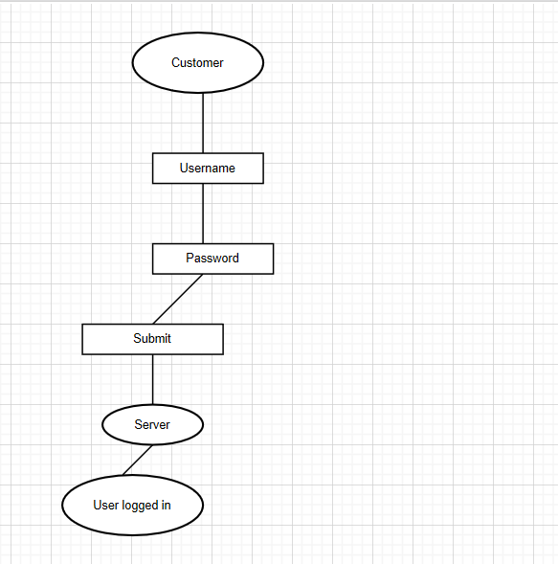

**Appendix C: To Be Determined List**

1. *Make sure that the username and password while logging into the account is in correct format. While building the software we have to build the frontend first and backend last.*