1. 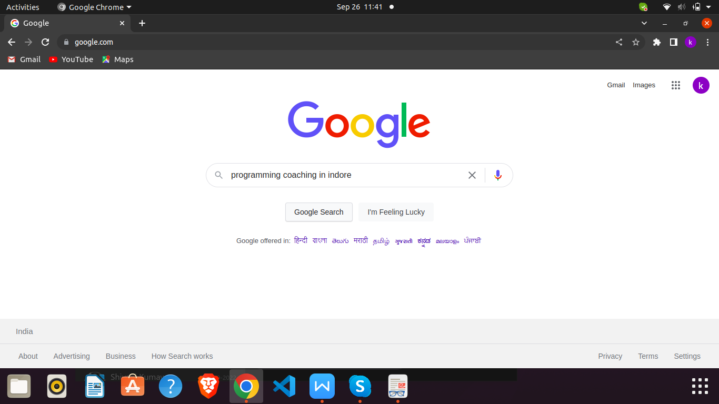Open **“Google”** in the browser and search **“Programming Coaching in Indore”.** And then search it by Click or Enter button and then maximize it.
2. Click the button of “**More places”** on search result which is circle by red color. And then get the **Title** name, **Website** url, and **Direction** url which are circle by black color and then insert this all in a CSV file.

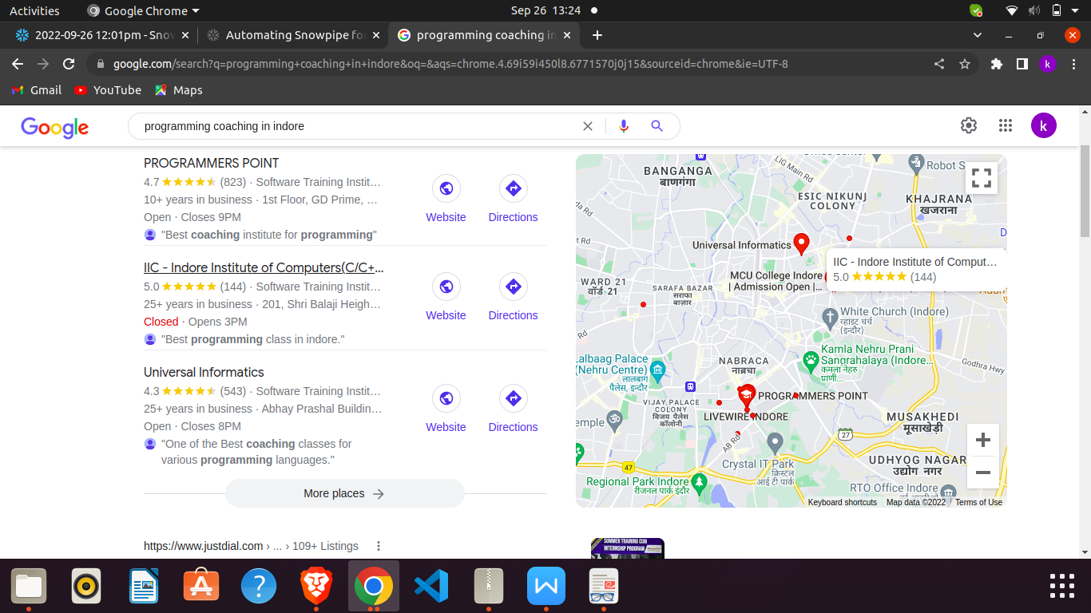

1. After that Click on the **Title** name for open a popup which is red circle and your task is that find the text of **title**, **address** and **phone** number from popup bar those are in black boxes. And insert these all in the csv file.

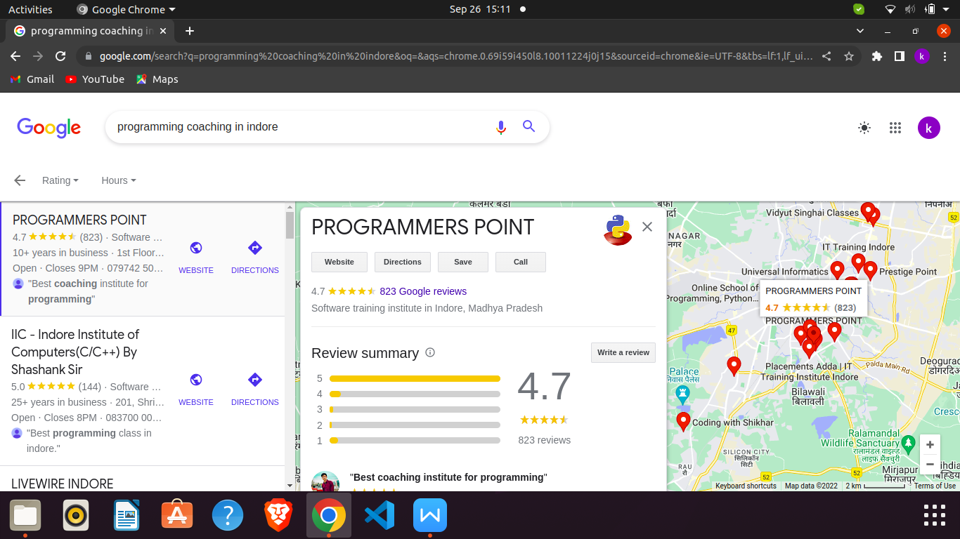

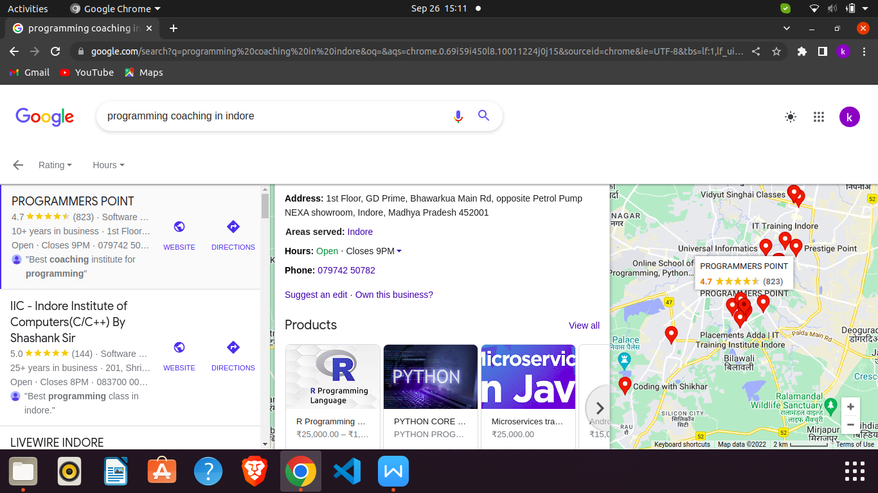

1. Go to next page by clicking and follow same things of point number 3. this all all work continuously until the end of the page. And insert all data you got in csv.

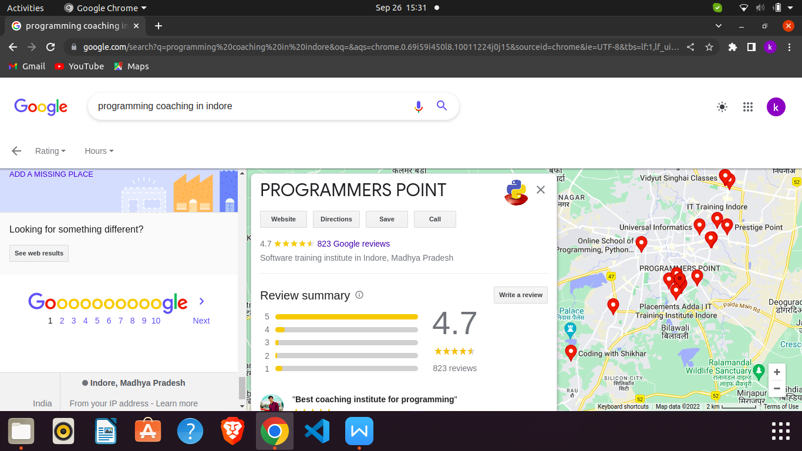 ***Pagination***