**Introduction**

In this tutorial you will learn how to model a push button using the inventone board. We would be using the inventone development board to create a form of digital pushbutton to control an LED.

**List of Component**

LED

Push button

2x resistors

Bread board

Connecting wires

InventOne dev. Board

**NB:** You can get most of the components from any online store (aliexpress, Hub360) click the link below to order for your inventone board.

**Tutorial**

The image below shows the circuit connection using fritzing. Take note of the pin numbers when making your connection. Here we are powering the LED using 3.3V from the inventone board, hence we need a resistor to safeguard the LED from getting damaged. Next one of the legs of the push button is connected to 3.3V and the other leg is connected to ground through a resistor, this ensures that we don’t mistakenly have a high voltage level on the inventone pin. When the push button is pressed, all the legs of the push button are connected together this will allow a high voltage level appear on the inventone pin. The board has been programed such that when a high voltage level appears on the button’s pin, it writes a high to the leg of the LED turning it ON in the process. See code section for more info on the program running on the 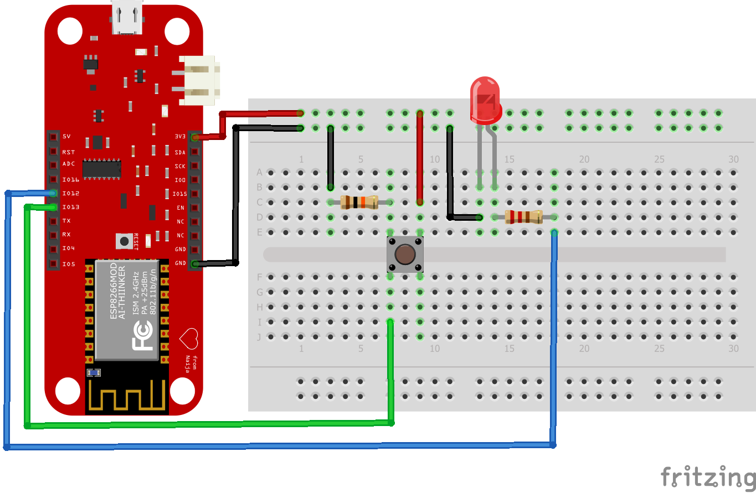board.

*Fritzing circuit diagram*

**Code**

We define the LED and Button using:

int LED = 12;

int Button = 13;

In the setup, we establish the nature of the pin, LED is an output while Button is an input. Using Serial.begin(9600); we begin serial communication with the serial monitor at a speed of 9600 bps.

The loop handles reading the button’s output, checking if it is a high or low, if it is high, we write a high to the LED leg and print *“LED is ON”* on the serial monitor. Else, we ensure the LED doesn’t come ON by writing a low to it and we print *“LED is OFF”* on the serial monitor. Since we want the board to respond pretty fast to whatever voltage level appears on the button pin, we set no delay and allow the board to constantly read the buttons leg.

**Notes:**

For more info on the working principle of the push button check out Wikipedia.