1. **Introduction**

The ability to determine the distance of an obstacle is quite an awesome tool, it has applications in self-navigating cars, automatic doors, obstacle avoiding robots and the likes. As humans we use our sight to estimate the distance of an object but the use of ultrasonic sounds to determine objects is more accurate and that makes us meta-humans.

1. **Material List**
2. InventOne board
3. Connecting wires
4. Bread board
5. Ultrasonic Sensor
6. **Pictures & Labels of Components**

**Ultrasonic sensor

**InventOne board

**Bread board

**Connecting wires

1. **Wiring**

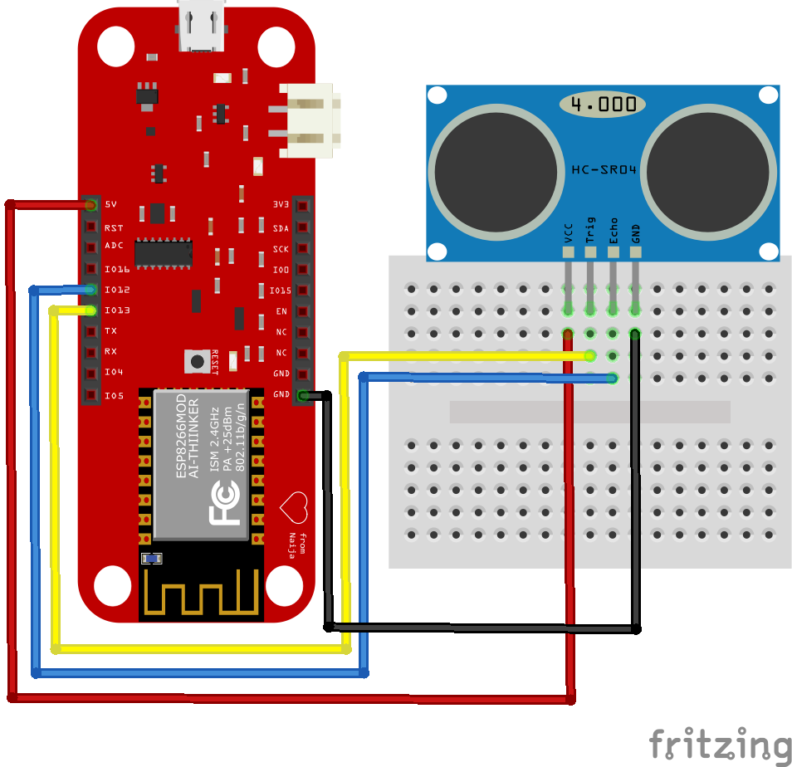

Implement the above circuit, following each wiring to the letter. You can change the Trigger and Echo pins just make sure you adjust the code to accommodate your new connection.

1. **Code**
2. Download code from this github repo <http://github.com/inventone/turing>
3. Unzip code into any folder of your choice preferably your Arduino sketch folder.
4. Open the code in your Arduino IDE, add your Wi-Fi name and password in the code.
5. Put on the hotspot of your phone or laptop or use a router if you have one. Ensure it has the same name and password as the one in the Arduino code.
6. Upload code to the board, you can check out this tutorial on how to upload code to the InventOne board.
7. Once you are done, open the Arduino IDE serial monitor to view the boards IP address. Type that IP address into the browser of your device (smart phone or laptop). You should see the distance being read by the sensor, reload the page to get the latest distance the sensor is reading.

**You can probably include the code here, your choice but make sure you retain the color format of the code.