1. **Introduction**

Let’s do some magic with technology. Get ready to be blown away!!!

1. **Material List**
2. InventOne board
3. Relay
4. Connecting wire
5. Bulb or LED
6. Plug
7. **Pictures & Labels of Components**

**InventOne board

**Connecting wires

**Relay

**Bulb

**LED

**Plug (AC)

1. **Wiring**

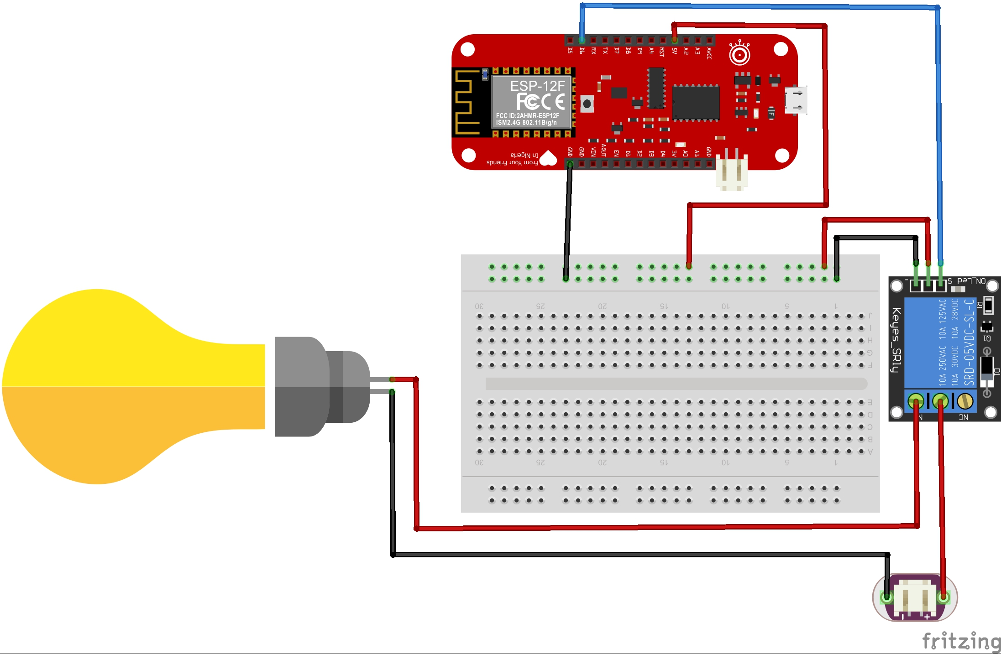

Implement the above circuit, you can use an LED in place of the bulb if you don’t want to play around with AC current. When using LED you wouldn’t be needing the plug and you can power the LED with the inventone board.

1. **Code**
2. Download code from this github repo <http://github.com/inventone/turing>
3. Unzip code into any folder of your choice preferably your Arduino sketch folder.
4. Open the code in your Arduino IDE, add your Wi-Fi name and password in the code.
5. Put on the hotspot of your phone or laptop or use a router if you have one. Ensure it has the same name and password as the one in the Arduino code.
6. Upload code to the board, you can check out this tutorial on how to upload code to the InventOne board.
7. Once you are done, open the Arduino IDE serial monitor to view the boards IP address. Type that IP address into the browser of your device (smart phone or laptop).
8. When the page loads you’d see two buttons “relayOn” and “relayOff” they do exactly what they say!