1. **Introduction**

Having control of our devices over the Internet, a local network is something not less than magic. Not until the advent of IoT, device control required the physical presence of the controller. As of today you can be as far as china and put on the light in your 3-bedroom flat in California if you’d ask me I would say that is witchcraft.

1. **Material List**
2. InventOne board
3. Connecting wires
4. LED
5. **Pictures & Labels of Components**

**InventOne board

**Connecting wires

**LED

1. **Wiring**

All you need do here is connect the LED pins to your inventone board, you can actually do this without connecting wires we have included them here for convenience.

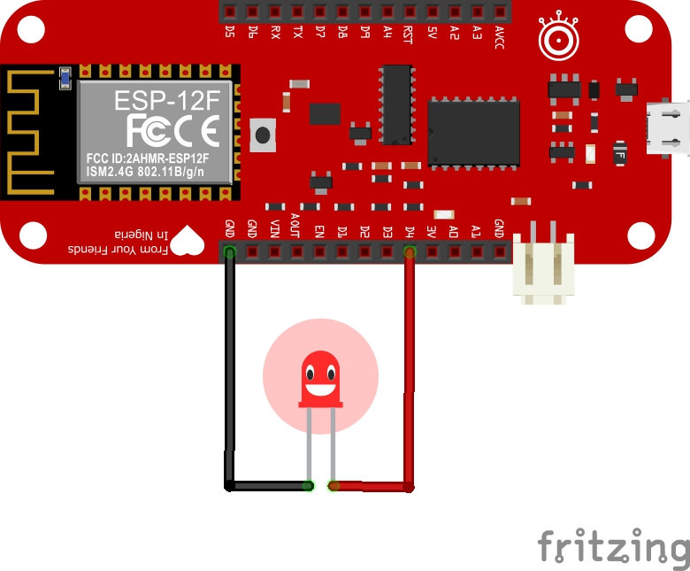

1. **Code**
2. Download code from this github repo <http://github.com/inventone/turing>
3. Unzip code into any folder of your choice preferably your Arduino sketch folder.
4. Open the code in your Arduino IDE, add your Wi-Fi name and password in the code.
5. Next you need to upload the web page code into your file system, you’d see a great tutorial on how to do this here.
6. Upload the Arduino code to the board, you can check out this tutorial on how to upload code to the InventOne board.
7. When you’ve successfully uploaded both the Arduino sketch and the web page code, put on the hotspot of your phone or laptop or use a router if you have one. Ensure it has the same name and password as the one in the Arduino code.
8. Once you are done, open the Arduino IDE serial monitor to view the boards IP address. Type that IP address into the browser of your device (smart phone or laptop).
9. When the page loads, you’d see a gauge, use the gauge to vary the brightness of your LED.