**IoT Temperature System**

1. **Introduction**

Temperature & Humidity are essential parameters to our very existence. Imagine you could build a system that automatically regulates the temperature & humidity in your home or you being able to control the temperature on a farm so as to keep your livestock healthy. The application of temperature & humidity sensors are endless.

1. **Material List**
2. InventOne board
3. DHT11 / DHT22 Sensor
4. 1k Resistor
5. Breadboard
6. **Pictures & Labels Of Components Here**

**DHT11

**DHT22

**Resistor

**InventOne Board

**Bread board

1. **Wiring**

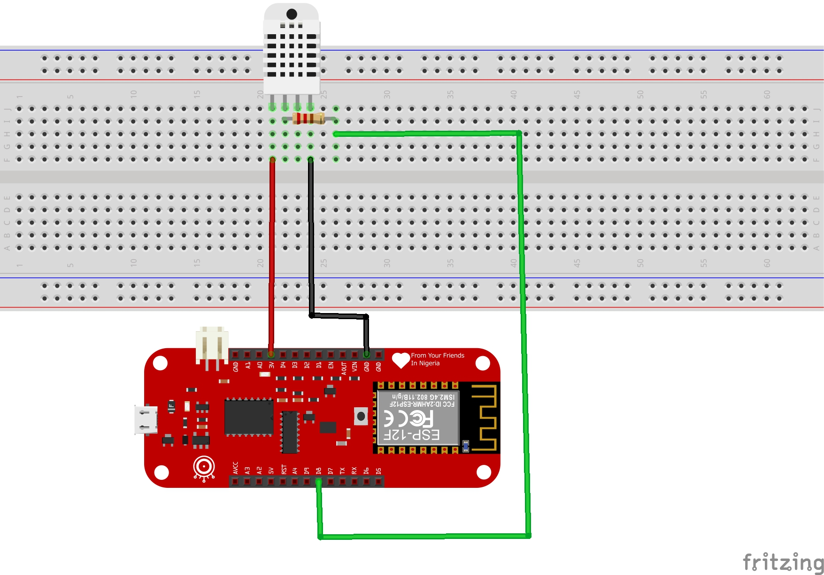

The circuit above is sufficient to implement an IoT temperature measuring system. Ensure you include the resistor its good for proper communication between the sensor and the board.

1. **Code**
2. Download the appropriate code from this github repo <http://github.com/inventone/turing>.
3. Unzip the code into any folder of your choice and open in your Arduino IDE.
4. Add your Wi-Fi name and password in the SSID and Password section in the Arduino code.
5. Upload the code to the board. You can check out this tutorial on how to upload code to the InventOne board.
6. Once you are done, open the Arduino IDE serial monitor to view the boards IP address. Type that IP address into your browser and you should see the current temperature of your environment.

**You can probably include the code here, your choice but make sure you retain the color format of the code.