TECHNICAL PROPOSAL
Online Moulding Catalogue Platform
Prepared for Garrison Industries

Prepared by: InvenTech Info Solutions
Document type: Technical Proposal
Version: 1.0 (Draft for review)
Date: [DD Month YYYY]
Proposal reference: [INV-GAR-YYYY-NNN]
Classification: Confidential, for evaluation by Garrison Industries only

Table of Contents
- Executive Summary
- Understanding of the Requirement
- Project Objectives
- Proposed Solution Overview
- Catalogue Experience
- Product Information Framework
- Dynamic Attribute & Dimension Framework
- Categories, Styles & Collections
- Search & Filtering
- Product Detail Experience
- Combinations & Product Relationships
- Catalogue Administration & Publishing
- Initial Catalogue Population
- External Catalogue Sources & Content Rights
- UX/UI Approach
- Technical Architecture
- Logical Data Model
- Functional Requirements Matrix
- Non-Functional Requirements
- User Roles & Permissions
- SEO & Website Integration
- Security
- Testing & Quality Assurance
- Implementation Methodology
- Project Timeline
- Deliverables
- Roles & Responsibilities
- Assumptions
- Dependencies
- Risks & Mitigation
- Conclusion

1. Executive Summary
Garrison Industries intends to modernise its website by replacing the current mouldings page with a comprehensive, structured and user-friendly online moulding catalogue.
InvenTech Info Solutions proposes to design and develop a reusable, scalable Online Moulding Catalogue Framework for Garrison Industries, together with an initial populated catalogue ready for immediate use.
The solution is not a collection of static product pages. Every moulding profile will be maintained as a structured product record capturing category, style, product code, technical profile drawings, dimensions, materials, finishes, available lengths, descriptions, images, related products and moulding combinations. The level of detail will be comparable to leading industry catalogues such as Brenlo, which Garrison has identified as a benchmark.
The framework will be populated initially with Garrison’s existing moulding range and with approved additional profiles identified from publicly available industry sources. A secure administration interface will allow authorised Garrison users to add, modify, review, publish and maintain future moulding profiles using the same standardised product structure, without software development changes.
Key outcomes for Garrison:
Outcome | Benefit
Structured, searchable catalogue | Customers find profiles by category, style, code or dimension
Configurable product framework | New categories and products added without redesign or code changes
Initial populated dataset | Catalogue is useful from launch day
Self-service administration | Garrison controls content, publishing and growth
Content provenance and rights control | External references are tracked and published only with confirmed rights
SEO-ready product pages | Every profile is discoverable through search engines

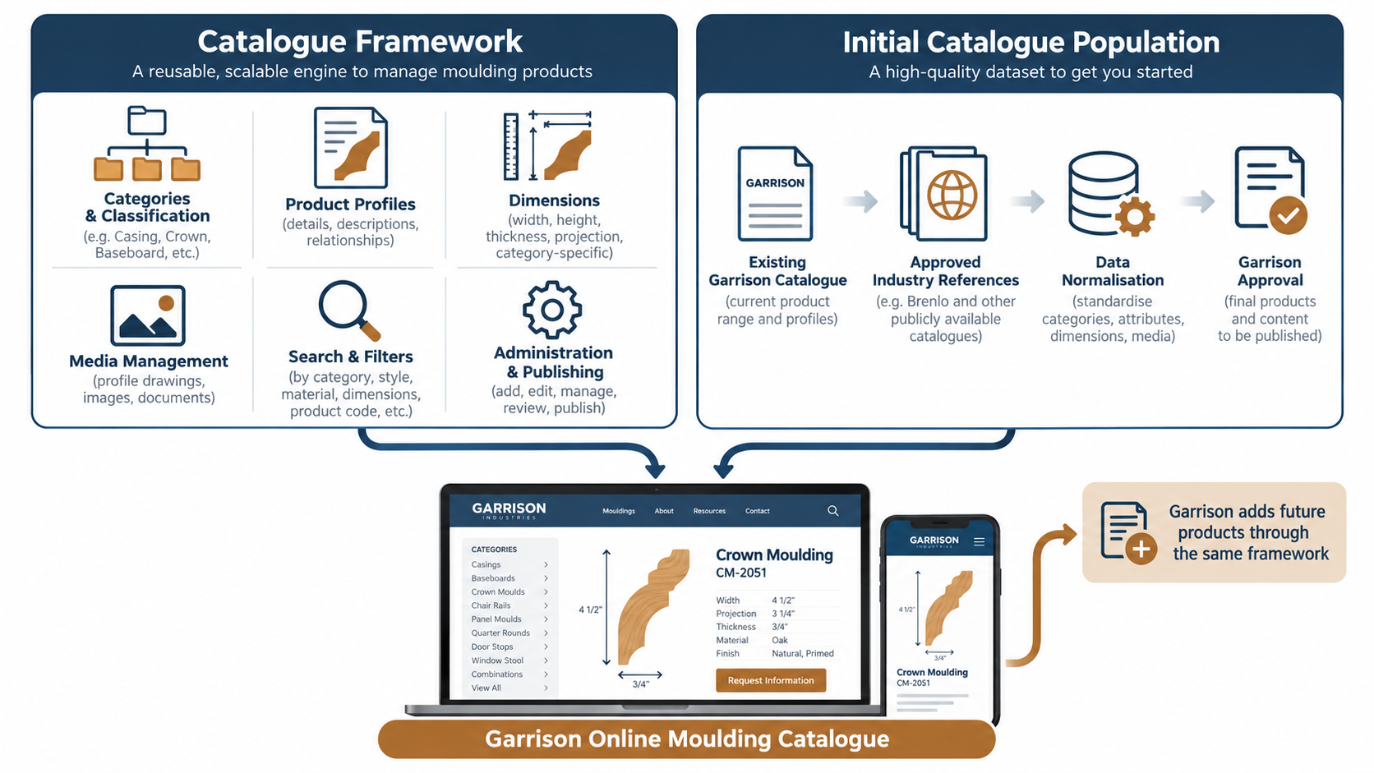
Figure 1: Solution at a glance

2. Understanding of the Requirement
We understand the requirement as two related deliverables.

2.1 Reusable Catalogue Framework
A flexible platform through which Garrison can continuously maintain its moulding catalogue, covering categories, product profiles, technical attributes, dimensions, images and drawings, materials, finishes, combinations, related products, search and filters, and publishing.

2.2 Initial Populated Catalogue
The framework will initially be populated with:
- Existing Garrison moulding profiles
- Relevant profile information from approved public sources
- Additional moulding profiles identified during the catalogue discovery exercise
- Structured product information prepared according to the new catalogue template
The project is therefore more than a catalogue website. It is to build the catalogue engine and populate it with a high-quality initial dataset.

2.3 Source Material
The existing Garrison catalogue (approximately 38 pages) is a primary source for the initial population. It includes technical profile information, codes, dimensions, architectural installation photographs and combinations across the following categories:
Casings, Back Bands, Plinth and Corner Blocks, Baseboards, Crown Moulds, Chair Rails, Door Stops, Panel Moulds, Quarter / Half Rounds, Brick Moulds, Window Stool, Tongue & Groove Paneling and Combinations.

2.4 Scope Interpretation
Garrison’s requirement refers to the “full range of publicly available moulding profiles”. Because this is an open-ended and continually changing set, we propose to define the scope as:
“A comprehensive range of moulding profiles drawn from Garrison’s existing portfolio and approved publicly available industry sources, with Garrison determining the final products and content to be published.”

This keeps the platform scope fixed and makes the catalogue population effort measurable against an agreed product count.

3. Project Objectives
- Replace the existing mouldings page with a modern, structured online catalogue integrated with the Garrison website.
- Represent every moulding as a structured product record with technical detail comparable to leading industry catalogues.
- Support both discovery-oriented browsing and specification-oriented searching.
- Allow Garrison to add new categories, attributes and products without database redesign or code changes.
- Deliver an initial catalogue populated with Garrison’s range and approved additional profiles.
- Maintain source and content-rights information for externally referenced products.
- Provide SEO-friendly product and category pages that improve organic discovery.
- Provide a controlled review and publishing workflow for catalogue content.

4. Proposed Solution Overview
The solution comprises a public-facing catalogue, an administration portal, and a structured catalogue data layer.
Layer | Purpose
Online Catalogue (public) | Browse, search, filter, view product and combination pages, submit enquiries
Administration Portal | Manage products, taxonomy, attributes, media, relationships, sources and publishing
Catalogue Services | Product, search, media and enquiry services exposed through a catalogue API
Catalogue Data | Products, categories, attribute templates, dimensions, media, combinations, sources

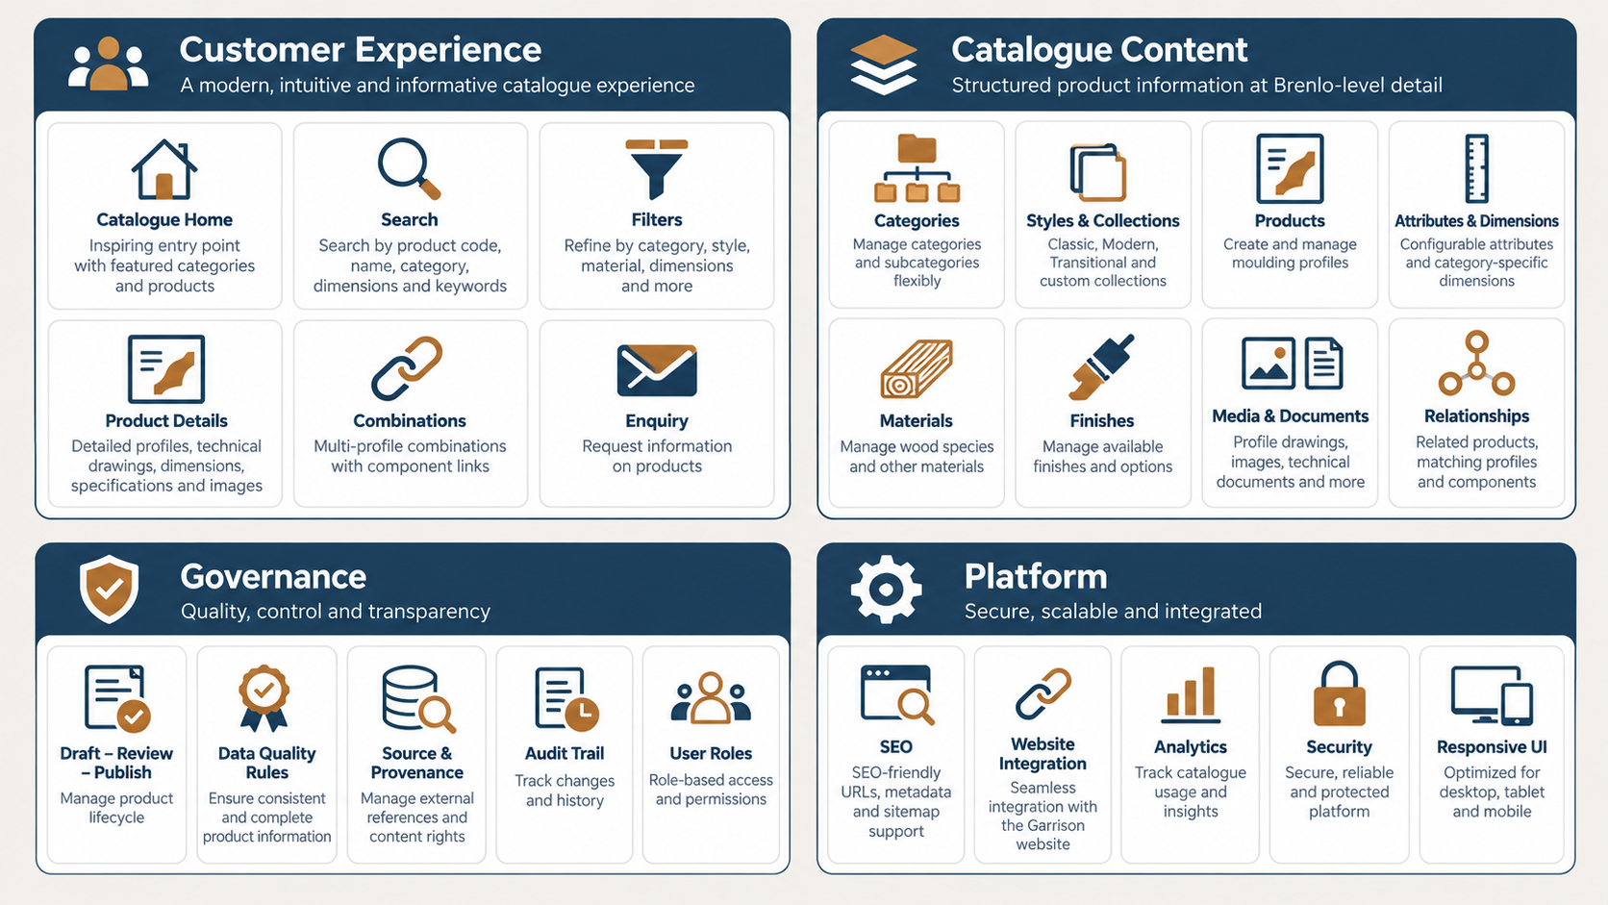
Figure 2: Catalogue framework capability map

5. Catalogue Experience

5.1 Customer Journey
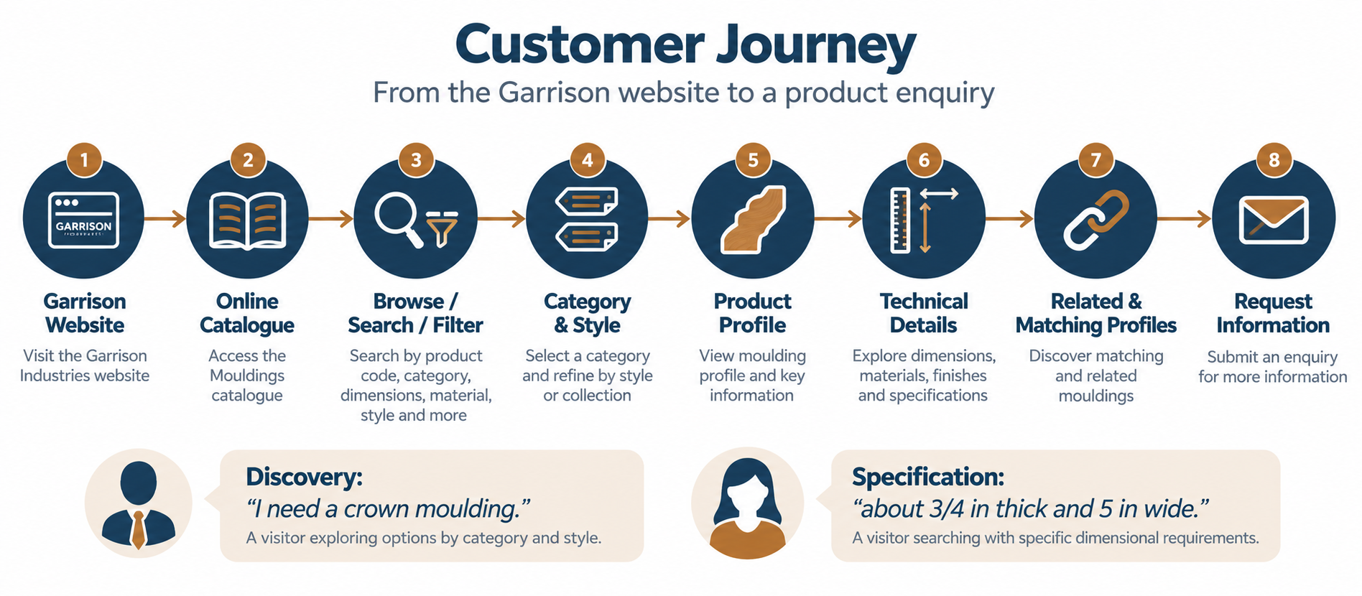
Figure 3: Customer journey

5.2 Two Ways to Find a Profile
Mode | Example need | How the catalogue supports it
Discovery-oriented browsing | “I need a crown moulding.” | Category and style navigation, curated collections, imagery
Specification-oriented searching | “I need a moulding about 3/4 inch thick and 5 inches wide.” | Structured dimension attributes, numeric filters, code search

Structured product attributes make specification-oriented search possible. This is a core reason for the structured product model described in Section 6.

5.3 Responsive Experience
Device | Experience focus
Desktop | Rich filtering, side-by-side detail, technical drawings at full size
Tablet | Optimised browsing and readable technical information
Mobile | Search-first and filter-first discovery, with tap-to-enquire

The catalogue will match the visual identity of the existing Garrison website while providing a modern product-discovery experience.

6. Product Information Framework
Every moulding is represented as a structured Product Profile.

6.1 Core Product Information
Field | Description
Product ID | Internal unique identifier
Product Code | Garrison or source profile number
Product Name | Display name
Category | Casing, Crown, Baseboard, etc.
Sub-category | Optional classification
Collection / Style | Classic, Modern, Transitional, etc.
Status | Draft / In Review / Approved / Published / Archived
Short Description | Catalogue summary
Detailed Description | Full description
Featured Product | Yes / No

6.2 Technical Profile Information
The existing Garrison catalogue presents products primarily through technical profile drawings and dimensions, not product photographs alone. Each product therefore supports:
- Profile drawing and profile image
- Cross-sectional illustration
- Dimension drawing
- Technical document (PDF)
- High-resolution image
- Additional product images

6.3 Media Structure
Media type | Use
Primary image | Listing and hero display
Profile drawing | Technical cross-section
Dimension drawing | Annotated measurements
Installed / application image | Design inspiration
Gallery images | Additional views
Technical PDF | Downloadable specification
Additional documents | Supporting material

This allows the catalogue to provide both technical information and design inspiration, as the existing Garrison catalogue does by combining installation photographs with profile drawings.

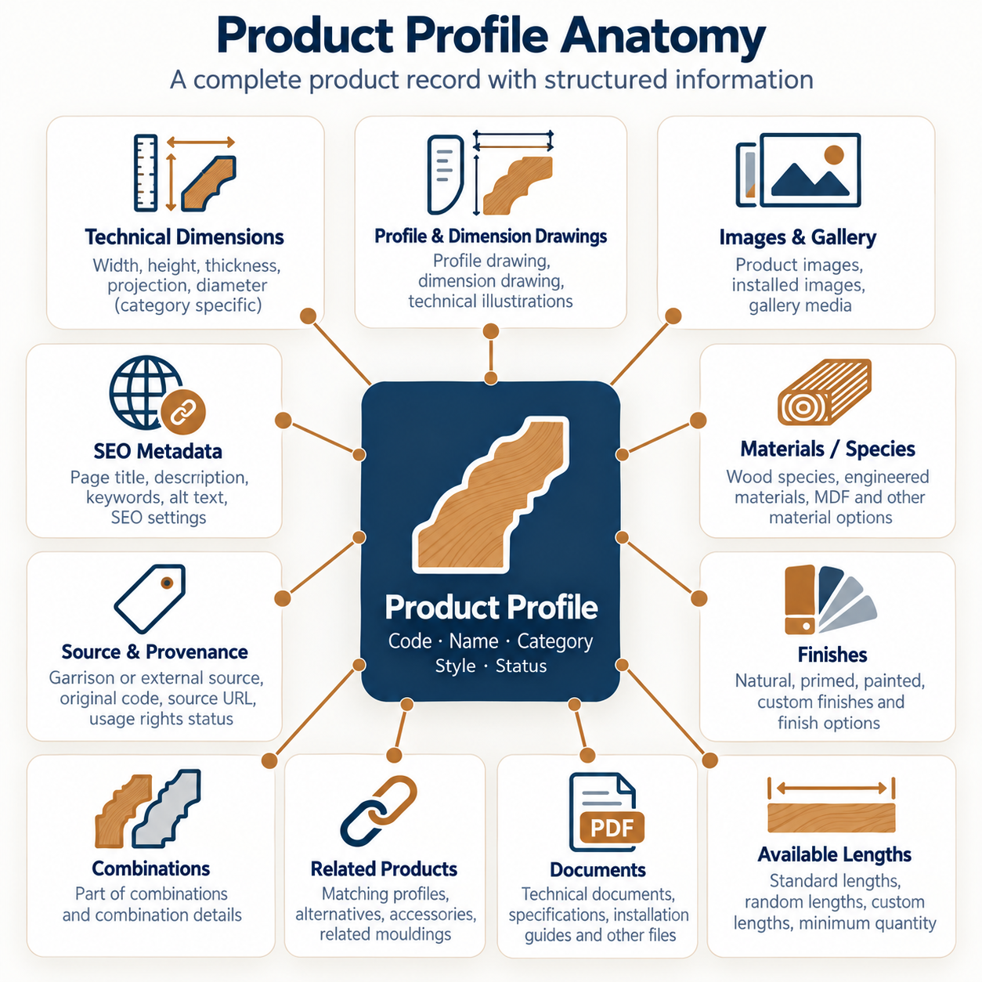
Figure 4: Product profile anatomy

7. Dynamic Attribute & Dimension Framework

7.1 Why Dimensions Must Be Configurable
Different moulding categories are measured differently. A single hard-coded dimension model would force irrelevant fields onto products and block future categories.
Category | Typical dimensions
Casing | Width, Height / Thickness, Projection
Crown | Projection, Height, Thickness
Panel Mould | Width, Thickness, Projection
Half Round | Diameter, Length

7.2 How It Works
Category → Category Attribute Template → Product → Applicable Dimensions & Attributes
Each category carries an attribute template defining which attributes apply, which are mandatory, their units and permitted values. When an administrator creates a product, the system presents only the fields relevant to the selected category.
This allows Garrison to introduce a new product category in future without database redesign or application code changes.

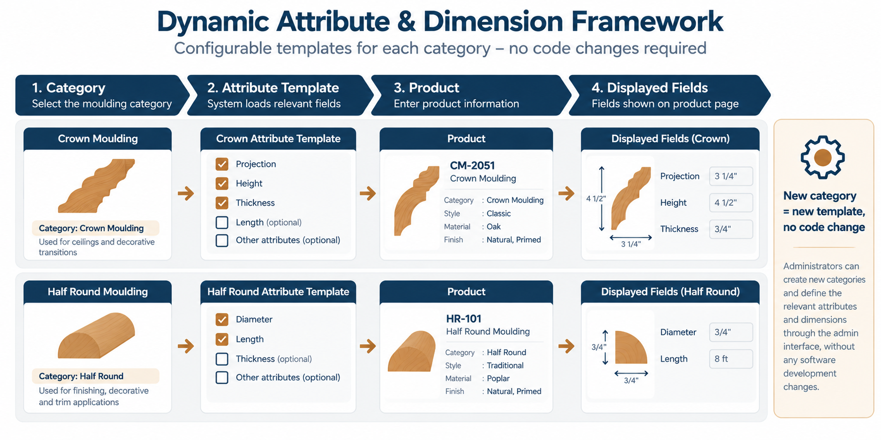

Figure 5: Dynamic attribute and dimension framework

7.3 Attribute Groups
Group | Attributes
Classification | Category, Sub-category, Style, Collection
Technical | Width, Height, Thickness, Projection, Diameter, Length, other category-specific dimensions
Material | Species, Wood type, Engineered material, MDF, Other
Finish | Natural, Primed, Painted, Custom, Other approved finishes
Commercial / Availability | Available length, Standard / random length, Minimum quantity, Special-order indicator

Not every attribute applies to every product. The catalogue shows only the attributes configured for each category.

8. Categories, Styles & Collections

8.1 Categories
Initial categories will be based on the existing Garrison catalogue: Casings, Back Bands, Plinth Blocks, Corner Blocks, Baseboards, Crown Moulds, Chair Rails, Door Stops, Panel Moulds, Quarter Rounds, Half Rounds, Brick Moulds, Window Stool, Tongue & Groove Paneling and Combinations.
Categories are configurable, so Garrison can add, rename, reorder or retire them through the administration portal.

8.2 Styles and Collections
Style and collection form a separate classification layer from category and material. Examples include Classic, Modern, Transitional and other Garrison-defined styles.
Dimension of classification | Example value
Category | Crown
Style | Traditional
Collection | Heritage
Material | Oak

Keeping these separate means “Traditional”, “Crown” and “Oak” are never treated as the same kind of data. This keeps filtering accurate and the taxonomy easy to maintain.

9. Search & Filtering

9.1 Global Search
Visitors can search by product code, product name, category, style, material, dimensions and keywords, for example “2051” or “5 inch crown”. The exact search behaviour, such as ranking, partial matches and unit handling, will be refined during UX design.

9.2 Advanced Filtering
Filters are driven by catalogue configuration, so new attributes can become filters without development.
Filter | Example options
Category | Crown, Casing, Baseboard, Chair Rail
Style | Classic, Modern, Transitional
Material | Oak, Maple, Pine, MDF
Thickness | 1/2", 3/4", 7/8"
Width | 3", 4", 5", 6"

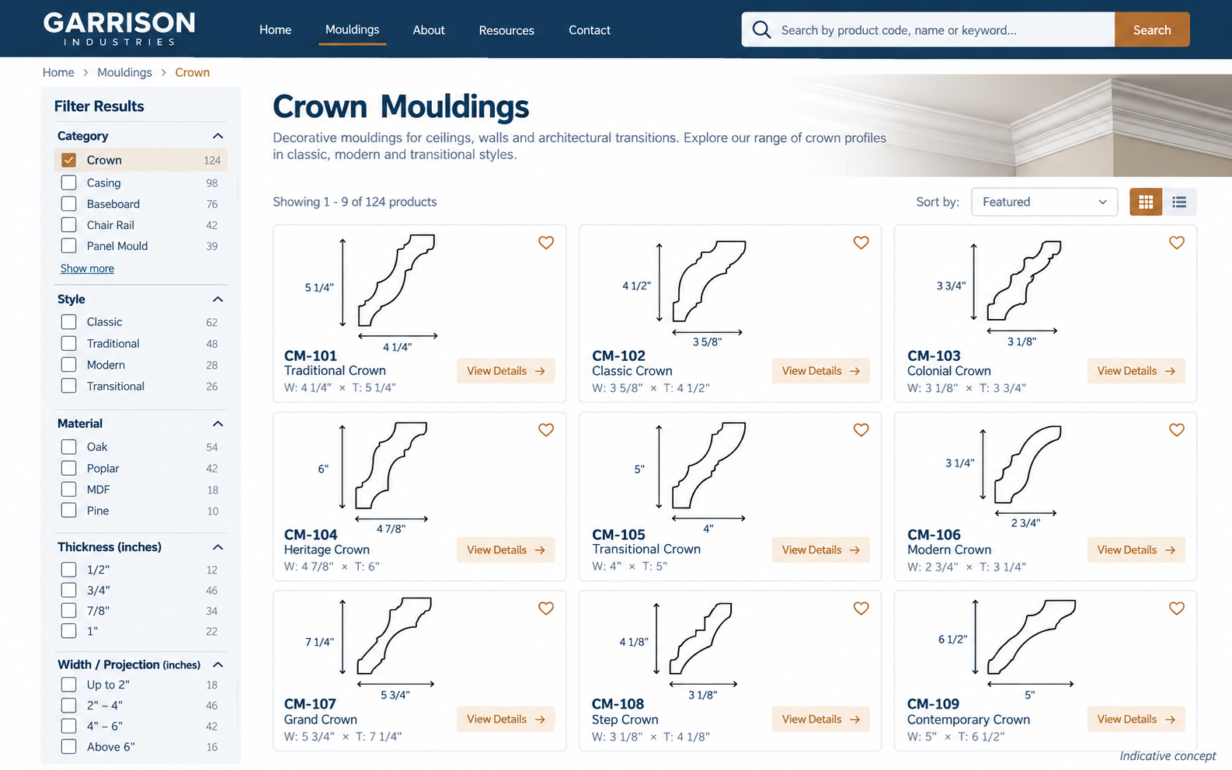
Figure 6: Catalogue listing page concept (indicative)

10. Product Detail Experience
Each published product has its own detail page. The indicative content order is:
- Product name, product code, category and style
- Profile / technical drawing
- Dimensions (width, height, thickness and projection, as applicable)
- Description
- Material / species
- Finish options
- Available lengths
- Applications
- Related products
- Combinations in which the profile is used
- Request Information button
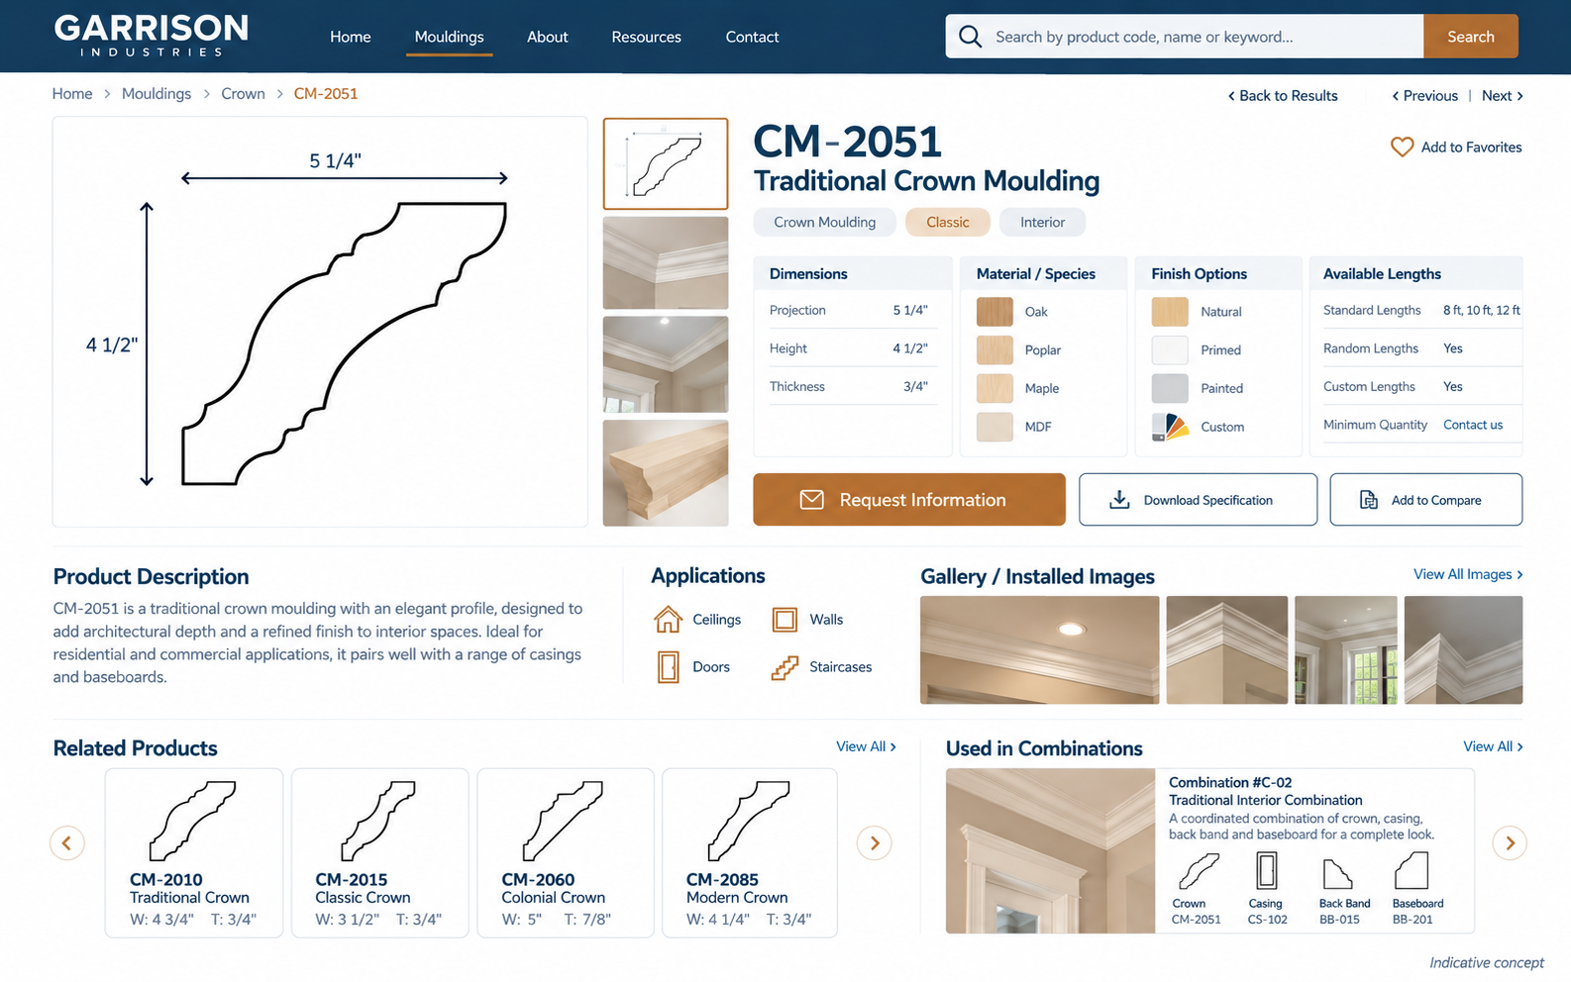
Figure 7: Product detail page concept (indicative)

11. Combinations & Product Relationships

11.1 Product Relationships
The catalogue supports typed relationships between profiles:
Relationship type | Example use
Related product | General cross-sell
Matching casing / matching crown | Coordinated room trim
Alternative profile | Substitute when unavailable
Similar product | Visually comparable profile
Component of combination | Profile used inside a combination

11.2 Combination Catalogue
The existing Garrison catalogue includes dedicated combination sections where several profiles are assembled together. Combinations will be managed as a separate catalogue entity, not as free-text descriptions.
A combination page shows the combination image or drawing, its name and code, the component profiles with links, the overall dimensions and a description.

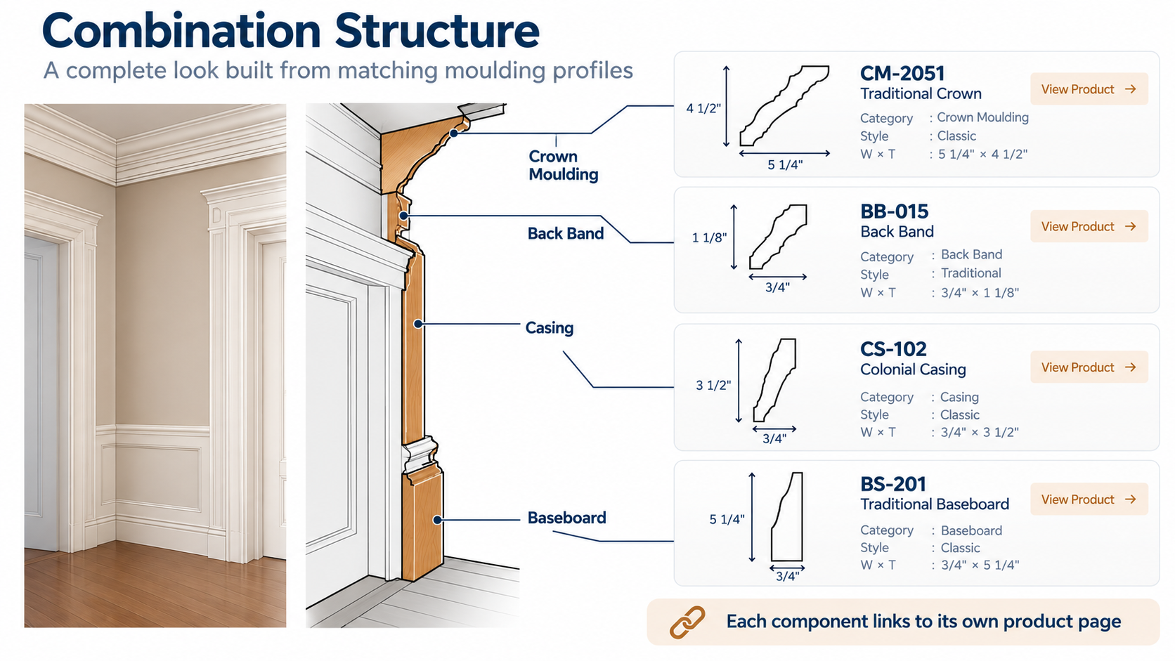
Figure 8: Combination structure

12. Catalogue Administration & Publishing

12.1 Administration Functions
Area | Functions
Products | Add, edit, duplicate, archive, preview, publish / unpublish
Taxonomy | Manage categories, sub-categories, styles, collections
Masters | Manage materials, finishes, attributes and attribute templates
Relationships | Manage related products and combinations
Media | Manage images, drawings and technical documents
Sources | Record external source and content-rights status
Governance | Review queue, approval history, audit log

12.2 Adding a New Moulding
- Select category
- The system loads the category template
- Enter product information
- Enter applicable dimensions
- Upload profile drawing
- Add images
- Select material(s)
- Select finish(es)
- Add related products / combinations
- Add source information (for external references)
- Preview
- Submit for review, then publish
Garrison can add product 001 today, product 500 next year and product 2,000 later using the same framework.

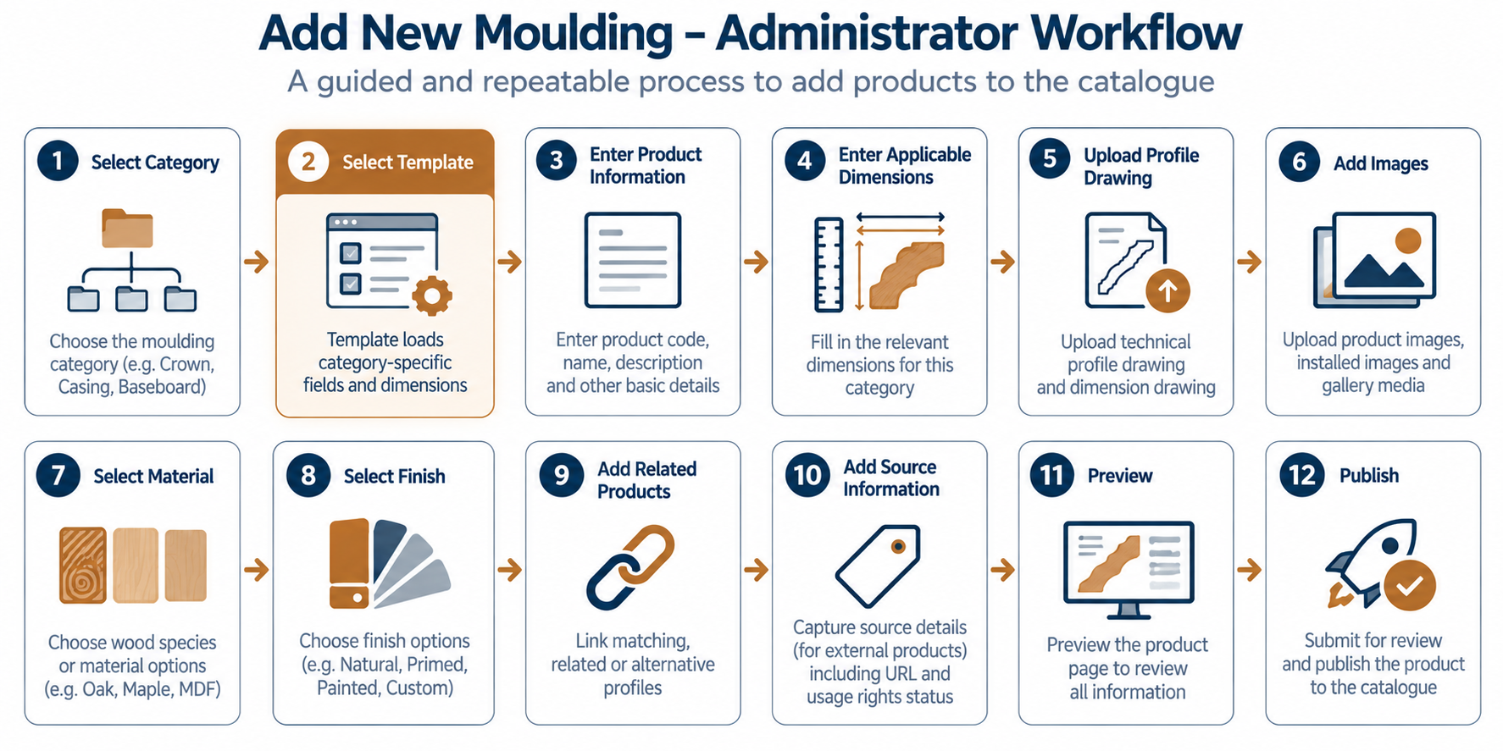
Figure 9: Add new moulding workflow

12.3 Review & Publishing Workflow
Draft → In Review → Approved → Published (with Changes Requested returning to Draft, and Archived for retired products).
This is particularly valuable when several people are preparing catalogue data.

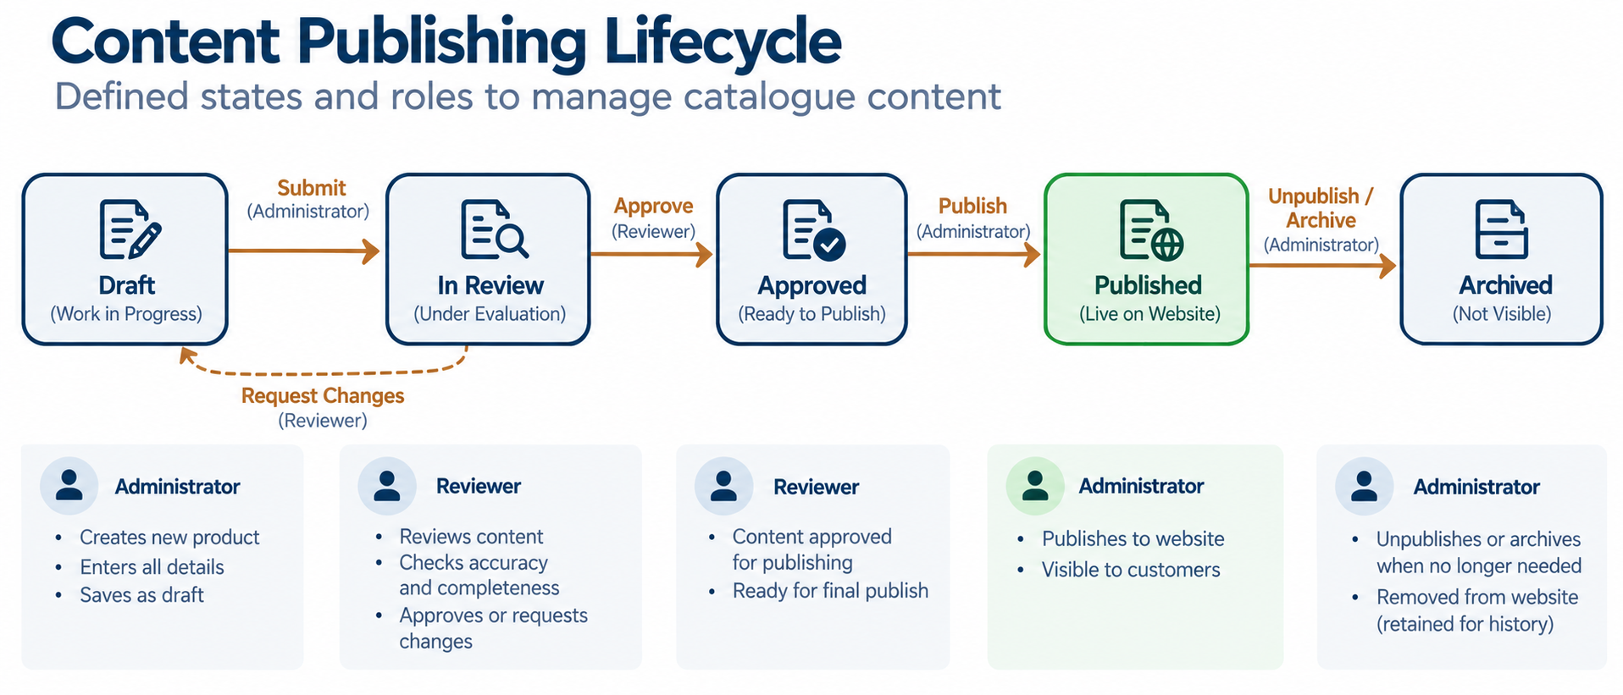

Figure 10: Content publishing lifecycle

12.4 Product Data Quality Rules
Mandatory baseline
Information | Requirement
Product Code | Mandatory
Product Name | Mandatory
Category | Mandatory
Profile Image / Drawing | Mandatory where available
Description | Mandatory
Applicable Dimensions | Mandatory (per category template)
Source | Mandatory for external products
Source Reference | Mandatory for external products

Conditional: material, finish, length, applications, related products and technical documents become mandatory where the category template requires them.
Products failing completeness rules cannot be submitted for review.

13. Initial Catalogue Population
Initial catalogue population is delivered as a dedicated workstream, running in parallel with platform development.

13.1 Sources
Source | Content
Existing Garrison catalogue | Profile codes, categories, technical drawings, dimensions, combinations, general information
Approved external catalogues | Additional profiles identified for inclusion (for example, Brenlo), subject to Section 14

13.2 Data Preparation Process
Source Catalogue → Profile Identification → Data Extraction → Data Normalisation → Category Mapping → Attribute Mapping → Image / Drawing Preparation → Quality Review → Garrison Approval → Catalogue Import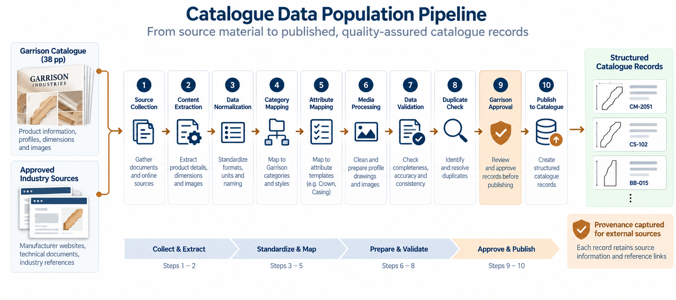

Figure 11: Catalogue data population pipeline

13.3 Population Phases
Phase | Activity
1. Existing Garrison data | Convert the current catalogue into structured records
2. Catalogue expansion | Identify additional relevant profiles from approved sources
3. Data standardisation | Normalise categories, codes, dimensions, units, materials, styles and terminology
4. Quality review | Garrison reviews and approves the initial dataset
5. Publishing | Approved records are published

The number of products in the initial population will be agreed during discovery. This number will form the basis of the commercial estimate for catalogue population.

14. External Catalogue Sources & Content Rights

14.1 Third-Party Catalogue and External Content Clarification
Garrison Industries has indicated that the new catalogue should include relevant moulding profiles and information available through publicly accessible external catalogues, including Brenlo.
Such external catalogues will be treated as reference sources for product discovery, industry classification, catalogue structure, technical attributes and user-experience benchmarking. The solution will maintain source and provenance information for every externally referenced product.
Public accessibility of a website or catalogue does not, by itself, establish rights to reproduce or redistribute its proprietary product descriptions, photographs, technical drawings, profile artwork, catalogue graphics or other protected content. Accordingly, reproduction of third-party content within the Garrison catalogue will be subject to Garrison confirming the appropriate rights, permissions or licences. Where such rights are not available, the source may be used for research and classification purposes only, or alternative Garrison-owned content may be created or provided.
Final inclusion of third-party products and associated content is subject to Garrison’s approval and confirmation of applicable usage rights.

14.2 Reference Use versus Content Reproduction
Reference / research (in scope) | Content reproduction (requires confirmed rights)
Identify moulding categories and common profile types | Product descriptions
Understand industry classification | Product photographs
Identify technical attributes | Technical drawings and profile images
Benchmark catalogue UX | Catalogue graphics and artwork
Determine useful filters and search criteria | Proprietary product data

Where rights are not available, the team can use the source as reference only, capture generic product attributes where legally permissible, create Garrison-owned representations, link to the original source where appropriate, or exclude restricted content until authorisation is obtained.

14.3 Provenance Captured per External Product
Field | Purpose
Source Name | For example, Brenlo
Source URL | Original public source
Source Catalogue | Catalogue / series name
Original Product Code | Source identifier
Source Category | Original classification
Data Usage Status | Approved / Pending / Restricted
Content Rights Status | Confirmed / To be confirmed
Date Verified | Last verification date
Garrison Product Status | Reference / Garrison / Other

Products with a rights status of “To be confirmed” or a usage status of “Restricted” cannot be published with third-party media.

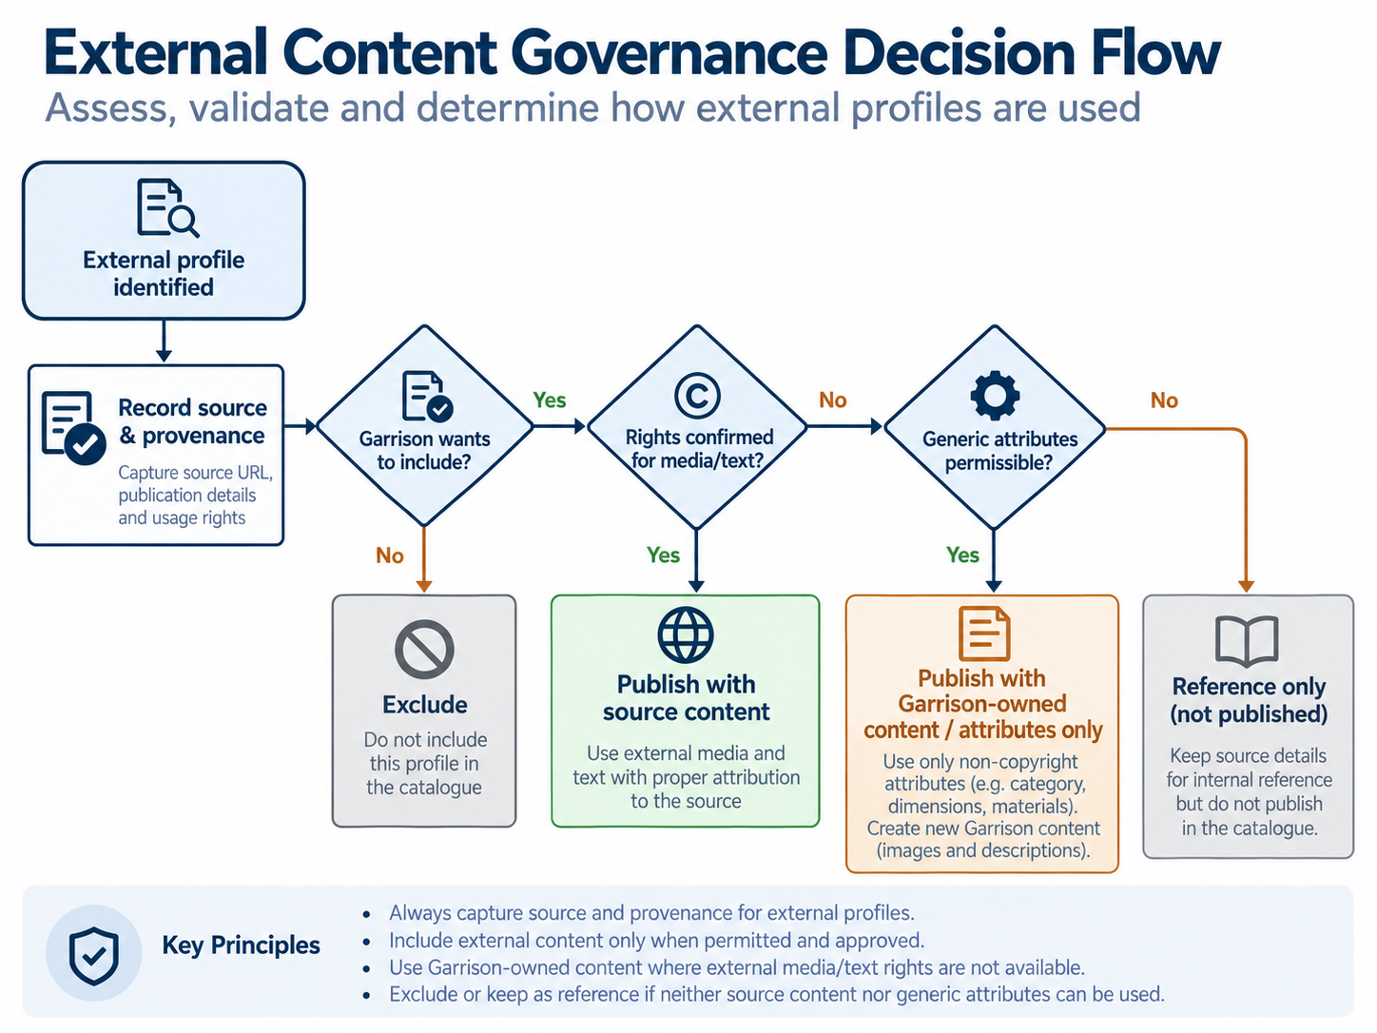
Figure 12: External content governance decision flow

15. UX/UI Approach
- Discovery & benchmarking: review the current Garrison site, existing catalogue and benchmark catalogues (including Brenlo) for navigation, filtering and profile presentation patterns.
- Information architecture: confirm taxonomy, navigation, filter set and page templates with Garrison.
- Wireframes: catalogue home, category listing, search results, product detail, combination detail, enquiry and key admin screens.
- Visual design: apply Garrison branding and produce high-fidelity designs for desktop and mobile.
- Design approval: Garrison signs off the designs before the public catalogue is built.
Benchmark catalogues inform structure and usability principles only. Data, design, terminology and branding remain Garrison’s own.

16. Technical Architecture
The architecture is technology-neutral at this proposal stage. The final technology stack will be aligned with Garrison’s existing website and hosting environment after technical discovery.
Component | Responsibility
Online Catalogue UI | Public browsing, search, filters, product and combination pages
Admin Portal | Catalogue management, workflow, sources, media
Catalogue API | Single access layer for UI and admin
Product Service | Products, taxonomy, attributes, relationships, combinations
Search Service & Index | Fast keyword, code and attribute search with faceted filters
Media Store / CDN | Optimised images, drawings and documents
Product Database | Structured catalogue data and audit history
Enquiry handling | Capture and route product enquiries to Garrison

Architecture principles: content-driven (no developer effort per product), configurable taxonomy and attributes, search-optimised, media-optimised, secure administration, and integration with the existing Garrison website.
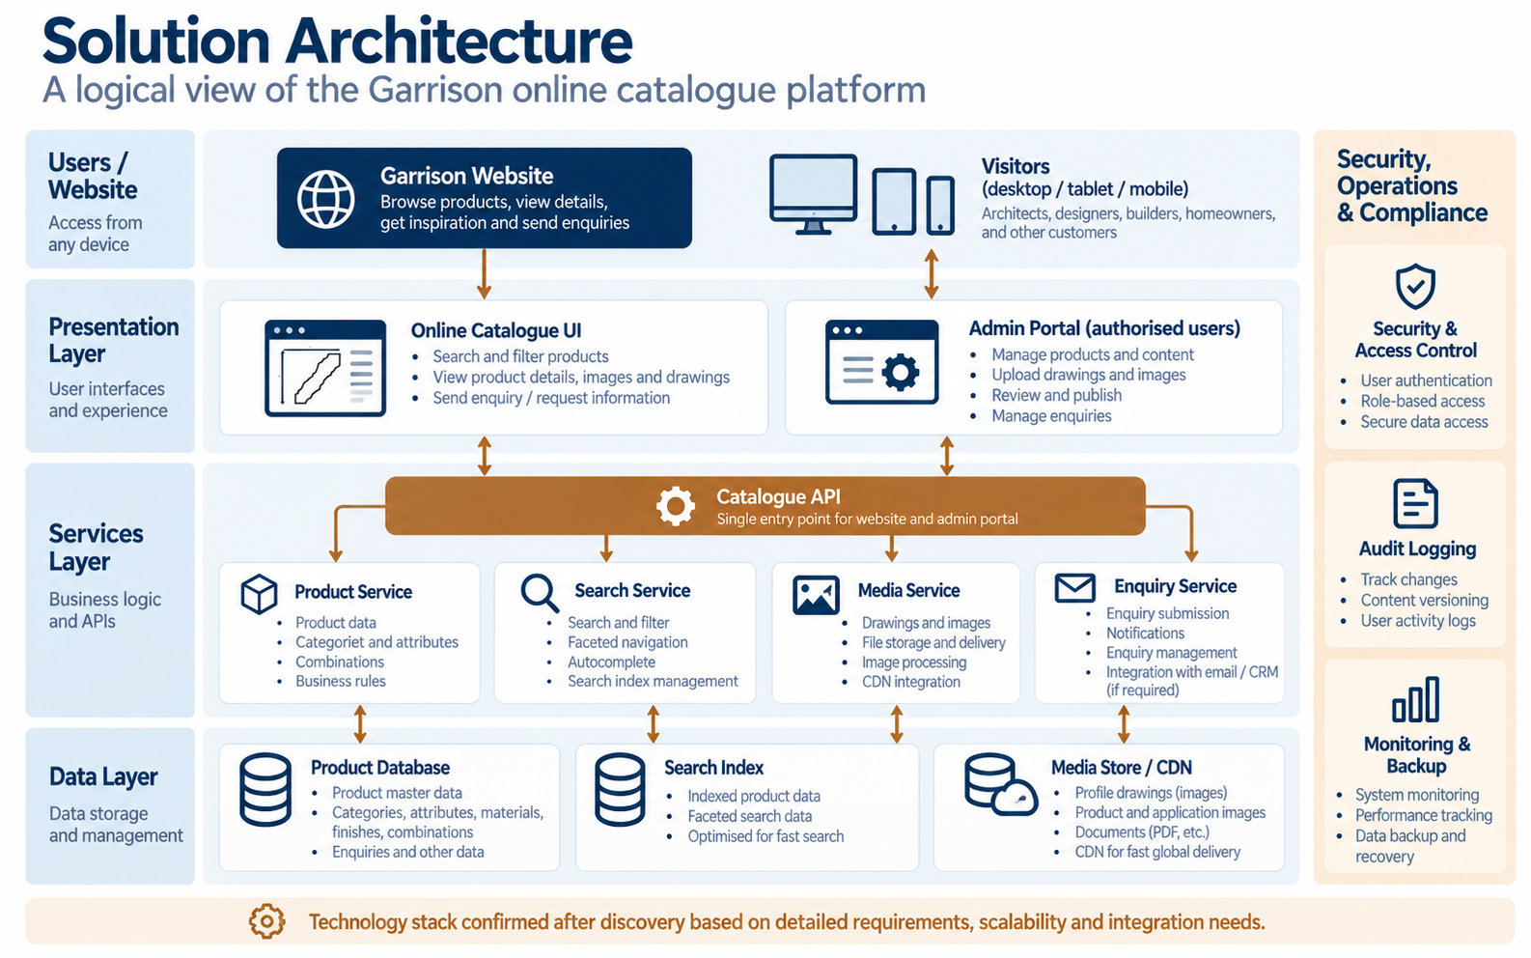
Figure 13: Solution architecture (logical)

17. Logical Data Model
The logical model centres on Category, Product and Attribute Template.
Entity group | Entities
Taxonomy | Category, SubCategory, Collection, Style
Product | Product, Attribute Template, Attribute, AttributeValue, ProductAttribute
Masters | Material, Finish
Content | Media, Document
Relationships | ProductRelationship, Combination, CombinationComponent
Provenance | Source, CatalogueReference
Engagement | Enquiry
Administration | User, Role, AuditLog

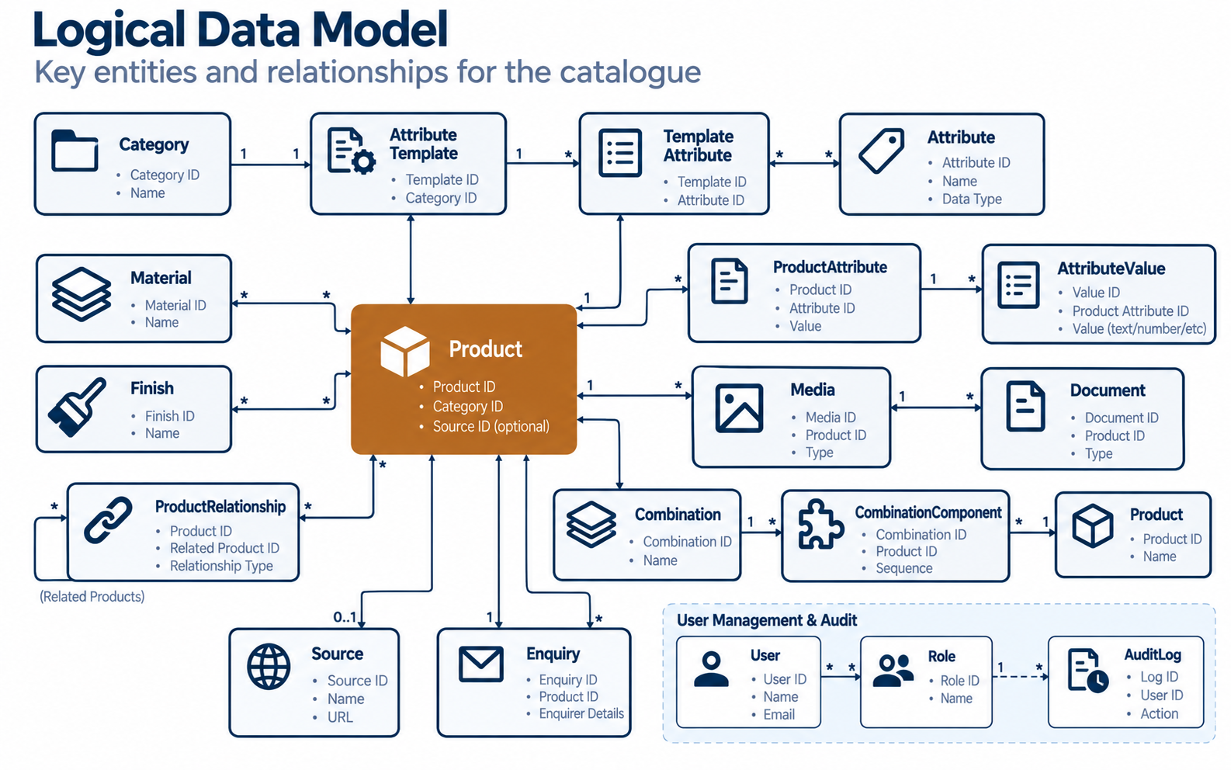
Figure 14: Logical data model

18. Functional Requirements Matrix
Ref | Module | Requirement
FR-01 | Catalogue Home | Catalogue landing page with category entry points and featured products
FR-02 | Category Management | Configure categories and sub-categories with ordering and status
FR-03 | Product Management | Create, edit, duplicate, archive and preview product profiles
FR-04 | Attribute Management | Configure attributes and category attribute templates
FR-05 | Dimension Management | Capture category-specific technical dimensions with units
FR-06 | Media Management | Upload, optimise and order images, drawings and documents
FR-07 | Material Management | Maintain material / species master
FR-08 | Finish Management | Maintain finish master
FR-09 | Combination Management | Create combinations with linked component profiles
FR-10 | Relationship Management | Define typed product relationships
FR-11 | Search | Search by code, name, category, style, material, dimensions and keywords
FR-12 | Filters | Configurable attribute-based faceted filters
FR-13 | Product Details | Detailed product and combination pages
FR-14 | Admin Portal | Secure role-based catalogue administration
FR-15 | Publishing | Draft → Review → Approve → Publish workflow with history
FR-16 | External Source Management | Capture source, provenance and content-rights status
FR-17 | Enquiry | Product enquiry form routed to Garrison
FR-18 | SEO | SEO-friendly URLs, metadata, sitemap, structured data
FR-19 | Analytics | Catalogue usage tracking via website analytics
FR-20 | Audit | Track administrative changes with user and timestamp
FR-21 | Data Quality | Enforce mandatory and conditional completeness rules
FR-22 | Data Import | Import prepared initial catalogue records

19. Non-Functional Requirements
Area | Requirement
Performance | Fast catalogue loading, optimised images, pagination or lazy loading, and search optimised for large volumes
Scalability | Growth from about 100 to 1,000 and then 10,000+ products without redesigning the product model
Availability | Production deployment suited to Garrison’s hosting environment, with a backup strategy, monitoring and error logging
Usability | Responsive across desktop, tablet and mobile, and consistent with Garrison branding
Accessibility | Designed with reference to WCAG 2.1 AA good practice (alt text, contrast, keyboard navigation)
Maintainability | Content-driven, with no developer effort needed to add products, categories or attributes
Browser support | Current versions of Chrome, Edge, Safari and Firefox

20. User Roles & Permissions
Capability | Super Administrator | Catalogue Administrator | Catalogue Reviewer | Content Administrator
Create / edit products | ✓ | ✓ | — | Content fields
Manage categories & attributes | ✓ | ✓ | — | —
Manage images, documents, SEO content | ✓ | ✓ | — | ✓
Review / approve / request changes | ✓ | — | ✓ | —
Publish / unpublish | ✓ | ✓ | — | —
Manage sources & rights status | ✓ | ✓ | View | —
Manage users & roles | ✓ | — | — | —
View audit log | ✓ | View | View | —

Role permissions are configurable and will be confirmed during discovery.

21. SEO & Website Integration

21.1 SEO Foundation
- SEO-friendly URLs, for example /mouldings/crown/CM-001 and /mouldings/casing/C-123
- Editable page titles and meta descriptions
- Product structured data where appropriate
- Category page SEO content
- Search-engine-readable product information
- XML sitemap integration and canonical URLs
- Image alt text
- Social sharing metadata

21.2 Website Integration
The catalogue will be integrated into the existing Garrison website navigation (replacing the current mouldings page), using consistent header, footer and branding. The integration method (sub-path, sub-domain or embedded module) will be confirmed after technical discovery of the current website platform.

22. Security
- Secure administrator authentication with strong password policy
- Role-based access control for all administration functions
- HTTPS for all public and admin traffic
- Input validation and protection against common web vulnerabilities (OWASP Top 10)
- File-upload validation (type, size, content checks)
- Audit logging of administrative changes
- Spam protection on the enquiry form
- Regular backups and controlled restore procedure

23. Testing & Quality Assurance
Test type | Scope
Functional testing | All functional requirements in Section 18
Data validation | Completeness rules, unit normalisation, duplicate detection on imported records
Responsive & browser testing | Desktop, tablet, mobile across supported browsers
Performance testing | Listing, search and product page response with representative data volume
Security testing | Authentication, authorisation, input and upload validation
SEO checks | URLs, metadata, sitemap, canonical tags
User Acceptance Testing | Garrison-led UAT with agreed scenarios and sign-off

Defects are logged, prioritised and resolved before go-live. Release takes place only after UAT sign-off.

24. Implementation Methodology
The project follows a phased, iterative approach with Garrison review points at each stage.
Stage | Key activities | Garrison checkpoint
Discovery | Requirements confirmation, catalogue analysis, taxonomy draft, product count, hosting review | Discovery sign-off
Design | Information architecture, wireframes, visual design | Design approval
Build | Framework, admin, catalogue UI, search & filters in iterative sprints | Sprint demos
Populate | Data extraction, normalisation and review in parallel with build | Dataset approval
Integrate | Website integration and SEO | Staging review
Test | QA and UAT | UAT sign-off
Launch | Production deployment and handover | Go-live approval

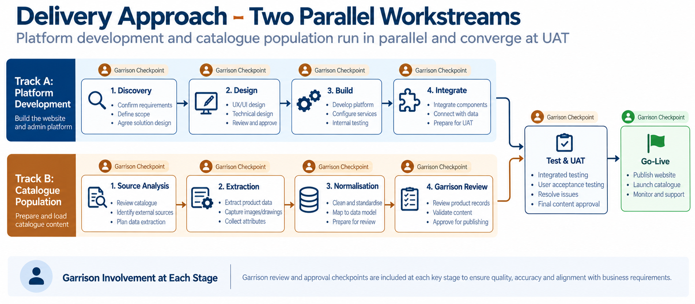

Figure 15: Delivery approach

25. Project Timeline
Indicative duration: 10–12 weeks, subject to the confirmed initial product count and external data volume.
Phase | Indicative duration | Indicative weeks
Discovery & catalogue analysis | 1 week | Week 1
UX/UI design | 1–2 weeks | Weeks 2–3
Catalogue framework & data model | 1 week | Weeks 3–4
Admin & catalogue development | 3 weeks | Weeks 4–6
Search & filtering | 1 week | Week 7
Product & combination experience | 1 week | Week 8
Initial data population (parallel) | 2–4 weeks | Weeks 4–9
Website integration & SEO | 1 week | Week 9
Testing & UAT | 1–2 weeks | Weeks 10–11
Production deployment | 2–3 days | Week 12

Software development and catalogue population are scheduled as separate, parallel workstreams so content preparation does not delay platform build.

26. Deliverables
Platform
- Responsive online catalogue integrated with the Garrison website
- Catalogue database and dynamic attribute framework
- Product, category, material, finish and attribute management
- Search and configurable filtering
- Product detail and combination pages
- Related-product management
- Media management
- Administration portal with review and publishing workflow
- External source and provenance management
- Product enquiry capability
- SEO foundation
Data
- Existing Garrison catalogue converted into structured records
- Approved additional profiles populated (up to the agreed quantity)
- Categories, attributes and templates configured
- Product relationships and combinations configured
- Source / provenance information captured
Documentation
- Technical architecture document
- Catalogue data model document
- Administrator / user guide
- Deployment documentation
- Basic maintenance documentation

27. Roles & Responsibilities
Activity | InvenTech | Garrison
Confirm final catalogue scope and product count | Support | Owner
Provide / approve Garrison product information | Support | Owner
Confirm naming, taxonomy and classification | Propose | Approve
Approve external products for inclusion | Propose | Approve
Confirm third-party content rights / permissions | — | Owner
Build catalogue framework, admin and data model | Owner | Review
Configure categories and attributes | Owner | Approve
Perform agreed initial data population and normalisation | Owner | Review
Develop search, filters, product pages and responsive UI | Owner | Review
Provide brand assets | — | Owner
Provide website and hosting access | — | Owner
Website integration and deployment | Owner | Support
Testing | Owner | UAT
Review and approve populated catalogue | Support | Owner

28. Assumptions
- The initial objective is a digital product catalogue, not a transactional e-commerce platform.
- Garrison will provide access to its existing website and hosting environment.
- Garrison will approve the final product and category taxonomy.
- Garrison will approve which external profiles are included.
- Garrison will confirm rights / permissions for third-party content where required.
- Product information supplied by Garrison or approved sources will be available in a usable form.
- The number of initial catalogue products will be finalised during discovery.
- Initial data population effort will be based on the confirmed product count.
- Hosting and infrastructure requirements will be finalised after technical discovery.
- Payment, inventory and ERP functionality are outside the current scope.
- Content will be prepared in a single language (English) unless otherwise agreed.
- Garrison will nominate a single point of contact and provide timely reviews and approvals.

29. Dependencies
Dependency | Needed by
Access to existing website platform and hosting | Discovery (Week 1)
Existing catalogue in highest available quality (PDF / source files) | Population start (Week 4)
Brand guidelines and assets | Design (Week 2)
Confirmed initial product count and external source list | End of Discovery
Content-rights confirmation for external material | Before publication of external content
Timely Garrison reviews at each checkpoint | Throughout
Enquiry routing details (recipients / email) | Build phase

Delays in dependencies may affect the timeline. Any impact will be raised promptly and agreed with Garrison.

30. Risks & Mitigation
Risk | Impact | Mitigation
Large number of external profiles | Population effort and timeline grow | Confirm the product count before commercial commitment, with a per-product rate beyond the agreed quantity
Third-party content rights | Content cannot be published | Garrison confirms permissions, with provenance tracking and Garrison-owned alternatives
Inconsistent source data | Poor catalogue quality | Data normalisation rules and unit standards
Different dimension models | Rigid, confusing product data | Dynamic attribute framework
Future catalogue growth | Performance or redesign needs | Scalable product architecture and search index
Poor product data quality | Incomplete product pages | Mandatory / conditional completeness rules
Duplicate profiles | Confusing catalogue | Product matching and duplicate validation
Unclear categorisation | Inconsistent navigation | Garrison-approved taxonomy at discovery
Large images and drawings | Slow pages | Media optimisation and CDN / storage strategy
Ongoing maintenance burden | Dependence on developers | Admin-driven catalogue management

31. Conclusion
InvenTech Info Solutions will deliver both a populated online moulding catalogue for immediate use and a reusable catalogue management platform that enables Garrison Industries to expand and maintain its moulding portfolio independently.
By combining a configurable product framework, structured technical data, controlled publishing, content-rights governance and an SEO-ready customer experience, the solution positions Garrison’s catalogue alongside leading industry catalogues while keeping full ownership of its data, design and brand.
We welcome the opportunity to discuss this proposal and to begin discovery at Garrison’s convenience.
Contact
Name | [Name]
Designation | [Designation]
Email | [email@inventech.example]
Phone | [+00 00000 00000]

InvenTech Info Solutions | Confidential

