SOFTWARE ENGINEERING LAB

PROJECT SYNOPSIS
GAMING ESTATE

Submitted by: Submitted to:
Kunwar Ubaid Zafar Khan (20103217, B8) Dr Shweta Rani
Lakshaya Arora (20103218, B8) Dr Ashish Singh Parihar
Mohammad Ibrahim (20103221, B8) Dr Bhawna Saxena

Software Requirements Specification
(Gaming Estate)

Table of contents:

1.0 Introduction
1.1 Purpose of this Document
1.2 Scope of the Development Project
1.3 Definitions, Acronyms and Abbreviations
1.4 References
1.5 Overview of Document

2.0 General Description
2.1 User Personas and Characteristics
2.2 Product Perspective
2.3 Overview of Functional Requirement
2.4 Other Requirements
2.5 Non Functional Requirements
2.6 Overview of Data Requirements
2.7 General Constraints, Assumptions, Dependencies and Guidelines
2.8 User View of Product Use

3.0 Specific Requirements
3.1 External Interface Requirements
3.2 Detailed Description of Functional Requirements
3.2.1 Template for describing functional requirements
3.2.2 Registration Page
3.2.3 Login Page
3.2.4 Intro Page
3.2.5 Product Introduction Page
3.2.6 Main Game Page
3.2.7 Final Score Page
3.2.8 Rewards Page
3.2.9 Payment Page
3.3 Performance Requirements
3.4 Quality Attributes
3.5 Other requirements

1.0 Introduction

1.1 Purpose of this Document

The purpose of this SRS document is to provide a detailed overview of our software product, its parameters and goals. This document describes the project’s target audience and its user interface, hardware and software requirements. It defines how our client, team and audience see the product and its functionality.

1.2 Scope of the Development Project

Our project goals are to create a computer game which aims to develop brainstorming skills and win exciting rewards . The game helps in leveling skills and to be appreciated by playing our game which aims for attracting more people to .Our product is a computerized game that is a three-level game where the user will be given three games and if the user passes all the games then they will be receiving astonishing goodies. We use the Visual Studio Code environment to develop the product, which allows the product and Firebase environment to deploy our product that easily run from a web browser or by itself on a variety of computer systems. Flash also provides simple methods of incorporating sound, graphics and animation into the product which means that it will be relatively easy for us to create an exciting program for children to use for fun and learning.

1.3 Definitions, Acronyms and Abbreviations

●Visual Studio Code -Visual Studio Code is a streamlined code editor
with support for development operations like debugging, task
running, and version control. It aims to provide just the tools a
developer needs for a quick code-build-debug cycle and leaves more
complex workflows to fuller featured IDEs, such as Visual Studio IDE.
● Flash - A browser-independent animation technology. Developers can use Flash to draw animations or import other images. Flash animation is created using Macromedia Inc.’s Flash animation application.
● HTML - A markup language used to create Web documents.
● HTTP - Hypertext Transfer Protocol.
● SDS - Software Design Specification
● SRS - Software Requirements Specification
● Universal Resource Locator (URL). A URL is an address which
identifies the location of a file on the internet or on the user’s computer’s hard drive.
● Web-based application - Any software program that is executed using
the World Wide Web.
● World Wide Web (WWW)- All the resources and users on the Internet using Hypertext Transfer Protocol (HTTP).

1.4 References
- CLRS (Cormen, Leiserson, Rivest, Stein)

1.5 Overview of Document

The remaining sections of this document provide a general description,
including characteristics of the users of this project, the product’s
hardware, and the functional and data requirements of the product.
General description of the project is discussed in section 2 of this
document.Section 2 gives the functional requirements, data requirements and constraints and assumptions made while designing the game.It also gives the user viewpoint of product use.Section 3 gives the specific requirements of the product. Section 3.0 also discusses the external interface requirements and gives detailed description of functional requirements.

2.0 General Description

2.1 User Personas and Characteristics

Gaming Estate is a game application that provides an entertaining and challenging experience for users. It features three levels of different games: Snake and Ladders, Mastermind, and The Knights move. To proceed to the next level, users must complete the previous one successfully. The application maintains records of top winners and rewards them with online goodies. Gaming Estate will be developed using the Agile model and C++ programming language, with the goal of providing a user-friendly and engaging gaming experience.
The target audience for Gaming Estate are casual gamers who enjoy playing games for leisure and entertainment. The target audience belongs to every age group but the most active are the ones who are tech-savvy, aged between 13 to 35, and have a basic understanding of the English language. They enjoy challenges and seek to improve their skills by participating in games.

2.2 Product Perspective

Gaming Estate is a standalone application that runs on various devices and platforms, including desktops, tablets, laptops and smartphones. It is developed using C++ programming language and uses a backend database to store user data. The application is designed to be user-friendly and provide an engaging gaming interface and experience.

From a user perspective, Gaming Estate provides a platform for playing three different games- Snake and Ladders, Mastermind, and The Knights move. The user needs to complete the first game level (Snake and Ladders) to unlock the subsequent levels. The application records and displays the scores and rankings of the users, and the top performers get online goodies as rewards.

From a market perspective, Gaming Estate competes with other game applications in the market. However, it offers a unique set of games, which are not commonly available in other game applications. The application has the potential to attract users who are looking for different gaming
experiences beyond traditional games such as racing, shooting, or puzzles.

Overall, the product perspective of Gaming Estate is that it is a standalone game application that offers a unique set of games and provides a smooth and enjoyable gaming experience to users. It has the potential to attract a niche market segment that is looking for different gaming experiences.

2.3 Overview of Functional Requirement

Level 1 - Snake and Ladders

●The game should follow the standard rules of Snake and Ladders.
●The game should be able to be played by one or more players.
●The game should have an interactive user interface.
●The game should keep track of each player's progress throughout the game.
●The game should have a scoring system.
●The game should allow players to pause and resume the game.
●The game should provide feedback to the player at the end of the game, indicating whether they have qualified for the next level.

Level 2 - Mastermind

●The game should follow the standard rules of Mastermind.
●The game should be able to be played by one or more players.
●The game should have an interactive user interface.
●The game should keep track of each player's progress throughout the game.
●The game should have a scoring system.
●The game should allow players to pause and resume the game.
●The game should provide feedback to the player at the end of the game, indicating whether they have qualified for the next level.

Level 3 - The Knights move

●The game should follow the standard rules of The Knights move.
●The game should be able to be played by one or more players.
●The game should have an interactive user interface.
●The game should keep track of each player's progress throughout the game.
●The game should have a scoring system.
●The game should allow players to pause and resume the game.
●The game should provide feedback to the player at the end of the game, indicating whether they have won or lost the game.

2.4 Other Requirements

●The application should have a registration system for players.
●The application should have a leaderboard to show the top winners.
●The application should be accessible from different devices and platforms.
●The application should be secure, and user data should be protected.

2.5 Non-Functional requirements

- Performance: The application should provide a smooth and responsive gaming experience without any lag or delays. The application should load quickly, and the game levels should respond to user input without delay.
- Security: The application should ensure the security and privacy of user data. The user registration and login process should be secure, and the application should protect against unauthorized access or data breaches.
- Compatibility: The application should be compatible with different devices and platforms, such as desktops, laptops, tablets, and smartphones. It should also work on different operating systems, including Windows, macOS, and Linux.
- User Interface: The application should have a user-friendly interface that is easy to navigate and understand. It should be visually appealing, and the games should be easy to play and understand.
- Availability: The application should be available 24/7, and there should be minimal downtime for maintenance or updates. If maintenance is required, users should be notified in advance, and the application should provide a smooth transition to the updated version.
- Scalability: The application should be scalable to accommodate an increasing number of users and game levels in the future. The application should be designed to handle a large number of users simultaneously without any degradation in performance.
- Accessibility: The application should be accessible to users with disabilities, and it should be compliant with accessibility standards such as WCAG (Web Content Accessibility Guidelines).
- Documentation: The application should be well-documented, including user manuals, installation guides, and technical documentation. This will help users understand how to use the application and troubleshoot any issues that may arise.

2.6 Overview of Data Requirements

The data requirements for Gaming Estate include:
●User registration data such as username, email, and password.
●User gaming data such as the number of games played, scores,and \ progress.
●Winners data such as their name, score, and rewards.
●Database storage for user data

2.7 General Constraints, Assumptions, Dependencies and
Guidelines

●The application will be developed using C++ programming language.
●The application will use a database to store user data.
●The application will be developed using Agile methodology.
●The application will be designed to be user-friendly and engaging.
●The application will be accessible on various devices and platforms.
●The application will require an internet connection to function.
●The application will protect user data and provide secure access.

2.8 User View of Product Use
Users will register and log in to the Gaming Estate application. They will be able to access and play the games provided by the application. The games will be interactive and engaging, with a user-friendly interface. Users will be able to view their progress and scores for each game, as well as their rank on the leaderboard. The application will notify users of their rewards if they qualify as top winners.

3.0 Specific Requirements

3.1 External Interface Requirements

● A mouse and keyboard are needed to interact with the product, both for entering text and for playing the game.
● In order to execute, the product requires a system with a web browser and an animation tool installed. A connection to the Internet is also required; the connection should have a minimum bandwidth of 56K.

3.2 Detailed Description of Functional Requirements

This section describes in greater detail the specific functional requirements which the Gaming Estate must fulfill.

3.2.1 Template for describing functional requirements

Purpose | A description of the functional requirement  inputs
Inputs | Which inputs; in what form/format will inputs  arrive; from what sources input will be derived,  legal domains of each input element
Processing | Describes the outcome rather than the  implementation; include any validity checks on  the data, exact timing of each operation (if  needed), how to handle unexpected or abnormal  situations
Outputs | The form, shape, destination, and volume of the  output; output timing; range of parameters in the  output; unit measure of the output; process by  which the output is stored or destroyed; process  for handling error messages produced as output

3.2.2 Registration Page

Purpose | This menu provides a simplified, intuitive and entertaining interface to the product for the users.It allows users to register into the game and allows them to understand how to play the game without a great amount of reading and let them know about the rules of the games.
Inputs | A player can click on the Registration button from the Intro  page.
Processing | The product responds by displaying easy to understand  instructions on how to play the game and the criteria to  win the game.
Outputs | Display the html page flash page of game instructions  along with useful buttons such as the pause button to  pause the movie and wait before displaying the next  instruction. This page will contain an intro button to go  back to the Intro page

3.2.3 Login Page

Purpose | This menu provides a simplified, intuitive and entertaining interface to the product for the users.It allows users to login their user id’s and allows them to understand how to play the game without a great amount of reading and let them know about the rules of the games.
Inputs | A player can click on the Login button from the Intro  page.
Processing | The product responds by displaying easy to understand  instructions on how to play the game and the criteria to  win the game.
Outputs | Display the html page flash page of game instructions  along with useful buttons such as the pause button to  pause the movie and wait before displaying the next  instruction. This page will contain an intro button to go  back to the Intro page

3.2.4 Intro Page

Purpose | This menu is the opening page for the project. It will serve as compass for the rest of the game.
Inputs | This page automatically loads after the product Login page and Registration page.
Processing | The product responds by displaying a large friendly graphic and three radio buttons to navigate the rest of the game. There is a skip option to bypass the animation.
Outputs | Display the html page of choice, Registration Page, Login page, or Main Game page.

3.2.5 Product Introduction Page

Purpose | This menu is the opening page for the product. It will  serve as an introduction of who we are and the name of  our games.
Inputs | This page automatically loads after selecting the “play game” link from the s2s homepage.
Processing | The product responds by playing a flash movie that  displays the group names and the product name. There  is a skip option to bypass the animation and continue  directly to the Intro page.
Outputs | Immediate load of Intro page.

3.2.6 Main game page

Purpose | The Rules of the game will be displayed.There are three levels in tha game and description of each level is shown on the first page.Information about rewards is also displayed to the player.
Inputs | This page automatically loads after selecting the “play game” link from the Product Introduction homepage.
Processing | Once a player login to snake and ladder game .He is shown the number of ladders.Then the player is asked to give the input as minimum number of steps.Similarly, as the game proceeds to the next level master mind in which the user has to complete the level in order to reach the last level.
Outputs | If player wins, then Congratulations is displayed on the page and  The second game The Master mind is Displayed. If the player loses the game then message OOPS!! Is displayed and the player has to restart the game from the beginning and cannot proceed with the next level. At last the Knight’s move game is there , if the user wins this game then he will receive points ,which he can further use by going to the reward page.

3.2.7 Final Score Page

Purpose | The details about the points generated by playing the game will be displayed and the products,their redemption cost will also be displayed.
Inputs | This page is displayed after the user clicks on the rewards page either from the Product introduction page or after completing the game.
Processing | The Final score page is loaded when the user completes the whole game .The Player will be displayed the final scores on completion of the game whether after 3 levels or 1 or 2 levels.Score of top scorers is also shown .
Outputs | The Player will be displayed the final scores on completion of the game whether after 3 levels or 1 or 2 levels.Top scores of players is also displayed on the Final score page.

3.2.8 Rewards Page

Purpose | The details about the points generated by playing the game will be displayed and the products,their redemption cost will also be displayed.
Inputs | This page is displayed after the user clicks on the rewards page either from the Product introduction page or after completing the game i.e after final score page.
Processing | When The user clicks on the rewards page ,the information about the user is displayed about the number of points he has won and the total points shown on top and points gained in each match and level shown respectively.The user is also shown by how much percent his rewards has increased over period of 2 months.
Outputs | The player is able to see total points in reward.He will also be shown the points gained in each level.

3.2.9 Payment Page

Purpose | The Payment Portal linked with stripe platform is done.The player can buy points .The points will be redeemed to get benefits.
Inputs | The user has to input Card details,date of expiry,name of bank,name on card and cvv on the portal.
Processing | When the user chooses the details of card and the platform validates the details of user’s card.If the payment is successful the user is displayed a modal where there is animation from confetti platform will be used saying congratulations .If the payment is not validated then the user is shown a modal showing a symbol and message indicating Payment unsuccessful.User is directed to home page of payment
Outputs | The user if successful to pay from Card he is shown a model with animation and a message is displayed to the user that congratulations ,payment received.If payment unsuccessful then user is shown a modal with a symbol and message indicating that payment declined and user is redirected to home page.Points are  credited in user’s profile which he can redeem to avail various facilities

3.3 Performance Requirements

The product can be web-based and run from a web server. Initial load time depends on the media from which the product is run. Once the product is loaded, it runs completely within the computer’s memory.

3.4 Quality Attributes

The product is target towards every age group and in case of children it should be under the supervision of an adult while any transaction takes place. Every user must be able to use and understand the product as easily. The product must load quickly and work well on a variety of computer systems. It must tolerate a wide variety of input possibilities from a user, such as incorrect responses, filled invalid details. It must authenticate the important credentials of the user such as authentication number, mode of payment etc.

3.5 Other requirements

None at this time.

MODEL USED
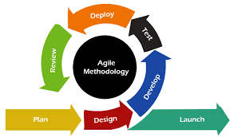
We have used Agile Model to implement Gaming Estate. We have implemented it using 3 levels of Game, the first one being Snake and Ladders, the second one mastermind and The Knights move is the last one.
We have done test driven development; we made this possible with the help of many small releases instead of less large releases.
The development of Gaming Estate was organized into multiple iterations or sprints, with each iteration resulting in a working product increment. The requirements and features of Gaming Estate were defined and refined continuously throughout the development process, based on feedback from users and stakeholders.
The team responsible for developing Gaming Estate was cross-functional, consisting of developers, testers, designers, and other necessary roles. Agile practices such as daily stand-up meetings, sprint retrospectives, and user feedback sessions were used to encourage communication and collaboration among the team members.
The development of Gaming Estate involved continuous integration and testing, with code changes frequently integrated and tested to ensure that the application was functioning correctly. The development of Gaming Estate was highly adaptive and flexible, with changes and adaptations made to the project as new requirements and feedback arose.
The development of Gaming Estate was highly customer-focused, with user needs and feedback used to guide the development process and prioritize features.

UML DIAGRAMS
USE CASE DIAGRAM
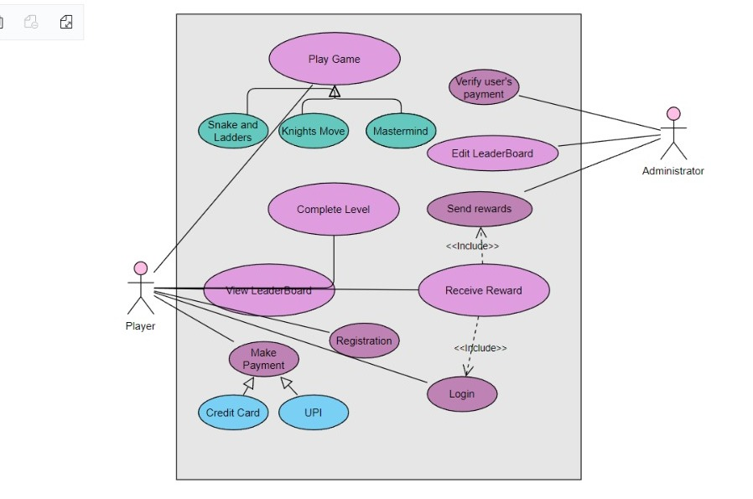

CLASS DIAGRAM
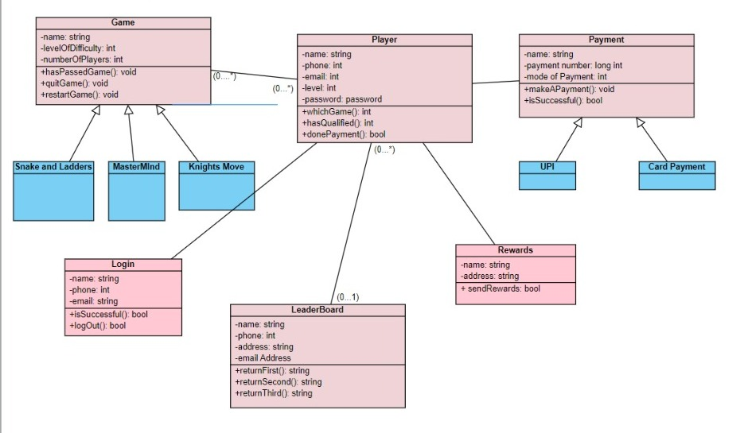
STATE DIAGRAM
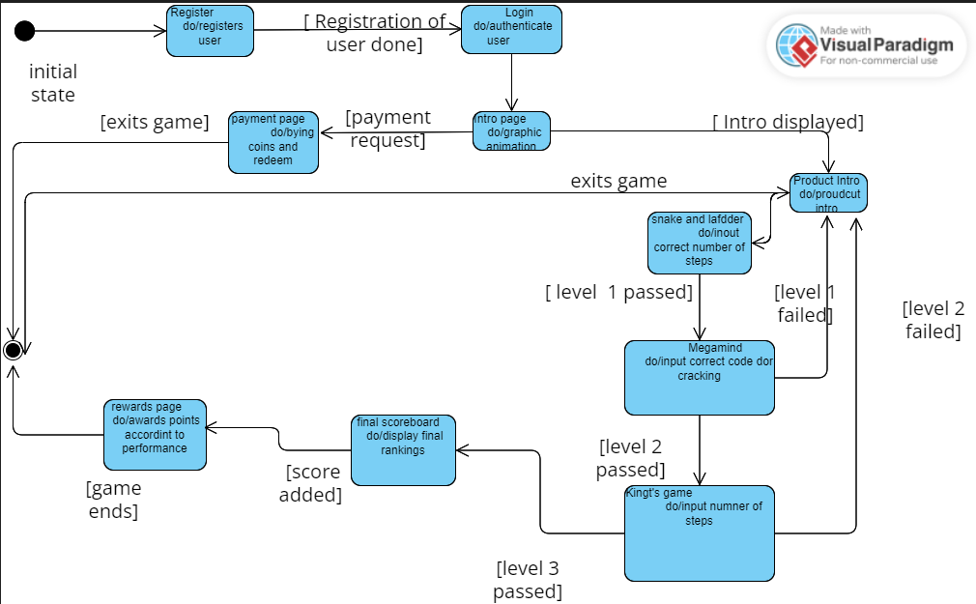
ACTIVITY DIAGRAM
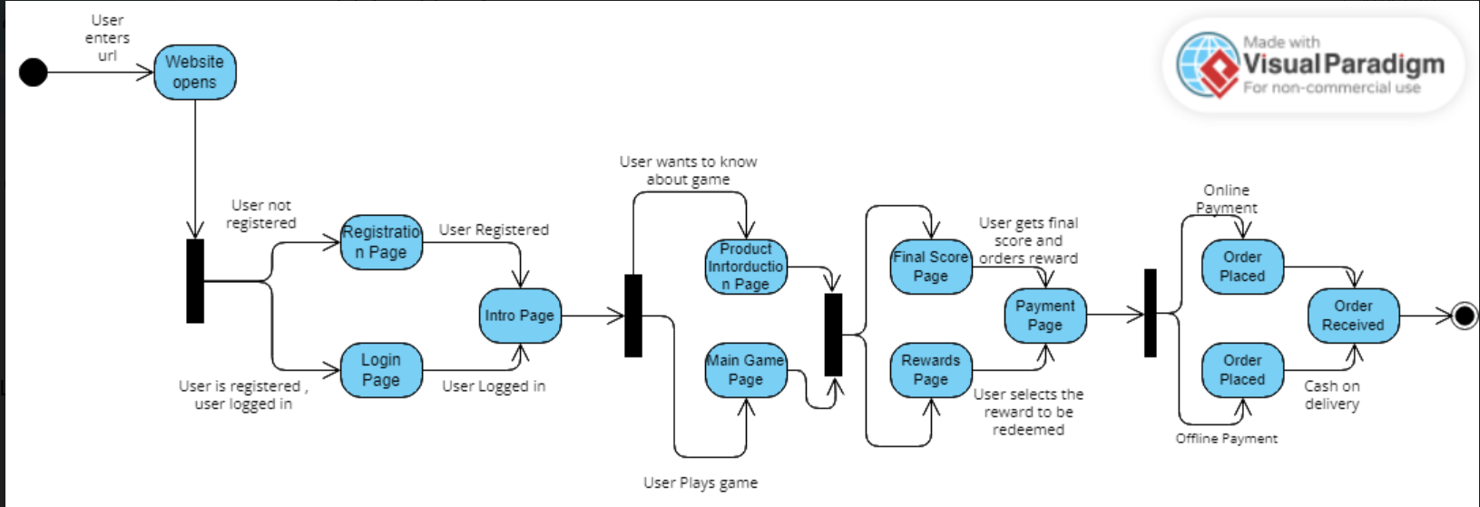
SEQUENCE DIAGRAM
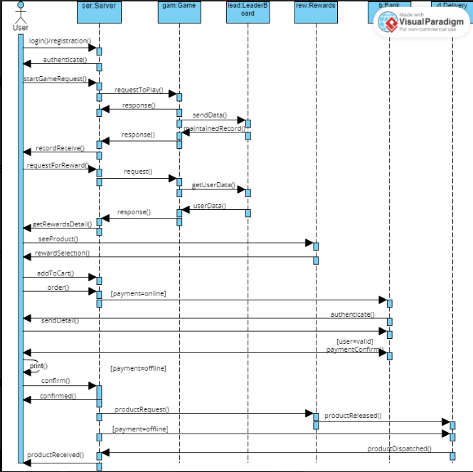
References:
[1] J. Sutherland and J. Altman, "The Agile Manifesto," in Agile Development Methodologies: An Overview, 2003, pp. 1-15.
[2]R. S. Pressman, Software Engineering: A Practitioner's Approach, 8th ed. New York, NY: McGraw-Hill, 2015.
[3]A. Cockburn, Agile Software Development: The Cooperative Game, 2nd ed. Upper Saddle River, NJ: Addison-Wesley Professional, 2006.

