On-Chain Audit Trails for AI Agent Delegation:
Implementing Delegation Capability Tokens on Ethereum
Ashwin Ganesan | Bineet Singh Chadha | NYU, Spring 2026

Abstract. As multi-agent AI systems grow in capability and autonomy, questions of accountability become critical: which agent acted, under whose authority, and with what permissions? This paper presents a practical implementation of Delegation Capability Tokens (DCTs) on the Ethereum blockchain, grounded in the theoretical framework proposed by Tomasev et al. (2026). We deploy a Solidity smart contract that records every delegation event and agent action as an immutable on-chain audit trail and connect it to a multi-agent Python pipeline where a Manager agent splits a software task between two parallel Coder agents and a Tester agent, each holding cryptographically-signed authority tokens. The result is a transparent, tamper-proof ledger of AI decision-making that any party can inspect — directly addressing the accountability gap in current agentic deployments.

1. Introduction
Modern AI deployments are increasingly agentic: a single user instruction may fan out into dozens of sub-tasks executed by specialized models, each calling tools, writing code, or issuing further instructions to other agents. This expansion of autonomous action raises a fundamental governance question — who is responsible when something goes wrong?
Current frameworks address this inadequately. API logs are mutable, agent frameworks offer no cryptographic binding between an action and the authority that sanctioned it, and there is no standard mechanism to reconstruct the chain of delegation from a human principal down to the agent that performed a specific action. This makes post-hoc auditing unreliable and renders meaningful accountability nearly impossible.
Blockchain offers a structural solution: a permissionless, append-only ledger where every write is signed by a private key, every record is immutable, and every state transition is publicly verifiable. This project implements that solution concretely by encoding agent delegation as on-chain tokens and recording every agent action as an on-chain event, drawing directly on the theoretical foundation laid by Tomasev et al. [1] in their framework for intelligent AI delegation.
The contribution of this work is threefold: (1) a production-grade Solidity smart contract implementing DCTs with scope enforcement, (2) a four-agent Python pipeline demonstrating parallel execution with full on-chain audit logging, and (3) a browser-based dashboard that reads the live delegation tree from any Ethereum-compatible network.

2. Background and Related Work

2.1 Delegation Capability Tokens
Tomasev et al. [1] introduce Delegation Capability Tokens as a mechanism for operationalizing the principle of least privilege in multi-agent AI systems. A DCT encodes: the delegating principal, the delegate agent, a scope of authority (e.g., MANAGE, CODE, TEST), a task description, validity bounds, and a parent token reference. Two invariants are enforced: (i) a delegate can never issue a child token with broader scope than their own, the no-privilege-escalation property, and (ii) revoking a token invalidates the authority of all descendant tokens in the chain.
The paper frames DCTs as a component of a broader governance architecture for AI systems, arguing that explicit, structured authority delegation is a prerequisite for deploying autonomous agents in high-stakes settings. Our work translates this theoretical construct into a deployed Solidity contract, making the invariants machine-enforceable rather than policy-dependent.

2.2 Blockchain as an Audit Mechanism
Using a blockchain as an audit log differs meaningfully from a traditional append-only database. Each transaction is signed by the sender's private key, providing cryptographic proof of identity. The ledger is replicated across thousands of nodes, making retroactive modification computationally infeasible. Smart contract logic is executed deterministically on-chain, so the scope-escalation check cannot be bypassed by a buggy or malicious client. These properties make the blockchain not just a log but a verifiable authority system.
Prior work on blockchain-based audit trails has focused on supply chains [2] and healthcare records [3]. Applying the same principles to AI agent delegation is a natural extension but requires a different data model — one that captures hierarchical authority relationships rather than linear event sequences.

3. System Design

3.1 Smart Contract: DelegationRegistry
The core artifact is DelegationRegistry.sol, a Solidity 0.8.20 contract deployed on the Ethereum Sepolia testnet. Each DCT is stored as a struct containing the fields described by Tomasev et al., with two additions motivated by practical auditing needs: an expiration timestamp and a completion flag. The scope hierarchy — MANAGE (0), CODE (1), TEST (2) — is encoded as an enum where a larger value denotes narrower authority. The no-privilege-escalation invariant is enforced in a single require statement:
require(uint8(scope) > uint8(parent.scope), "Scope escalation denied");
Action logging uses an indexed architecture: a global ActionLog array stores all actions append-only, while a per-token index mapping provides O(k) lookup (where k is actions for that token), avoiding the O(n) full-scan that a naive implementation would require.
The contract exposes five write functions (mintRoot, delegate, recordAction, complete, revoke) and five read functions (getChain, getChildTokens, getTokenActions, getAllActions, getAgentTokens). This separation cleanly distinguishes the write API used by agents from the read API used by auditors and dashboards.

Table 1. Token hierarchy for the four-agent pipeline.
Token | Issued By | Issued To | Scope & Permissions
#1 (root) | Human Principal | Manager Agent | Root principal — full authority, no token required
#2 | Manager Agent | Coder A | CODE — can delegate TEST only
#3 | Manager Agent | Coder B | CODE — can delegate TEST only
#4 | Manager Agent | Tester Agent | TEST — cannot sub-delegate

3.2 Agent Pipeline
The pipeline implements a manager-worker pattern across four agents, each running as a separate Python process and holding a unique Ethereum private key. Communication between agents happens only through the blockchain: there are no direct API calls between agents, and no agent has access to another's private key. This architecture mirrors the isolation that Tomasev et al. argue is necessary for meaningful accountability.
The Manager agent receives a task from the human principal (the deployer account), uses an LLM to decompose it into two independent subtasks, and issues CODE tokens to two Coder agents. The Coders run in parallel via Python's ThreadPoolExecutor, each writing a separate module and recording implementation steps on-chain. After both complete, the Manager issues a TEST token to the Tester agent, which writes and executes an integration test suite covering both modules. The Tester marks its token complete upon finishing, followed by the Manager completing its own root token.

4. Implementation

4.1 Technology Stack
The implementation uses exclusively open-source, zero-cost components, consistent with the project requirement of no paid APIs.
- Contract layer: Solidity 0.8.20 and Hardhat for smart contract development and local testing
- Blockchain client: Web3.py for Python-to-Ethereum communication; each agent signs transactions with its own private key
- LLM backend: LangChain + Ollama (llama3.2) for LLM inference, running entirely locally
- Concurrency: Python threading (ThreadPoolExecutor) for parallel agent execution
- Frontend: Ethers.js dashboard served via GitHub Pages for public inspection of the delegation tree
The contract is deployed on Sepolia testnet at address 0xf2b6428C961aDc4bAdBDA42d864B1147491d48bc, where all pipeline runs are publicly verifiable.

4.2 On-Chain Audit Trail
A complete pipeline run produces 12 on-chain transactions: one mintRoot, three delegate calls, seven recordAction calls, and four complete calls. Every action is immutably associated with the token ID (and thus the agent and scope) that authorized it. The getChain() view function reconstructs the full delegation ancestry of any token in O(d) time where d is the depth of the tree — typically 2–3 hops.
The parallel execution of Coder A and Coder B is visible in the action log: their STARTED_IMPLEMENTATION events are interleaved in block time, reflecting true concurrent execution. This is a meaningful demonstration of multi-party blockchain logging: two separate Ethereum accounts, controlled by separate private keys, racing to write transactions to the same contract.

4.3 Security Properties
Three security properties are enforced at the contract level rather than by application code, making them immune to bugs or malicious behavior in the agent layer. First, scope escalation is impossible — attempting to delegate a broader scope than your own token reverts at the EVM level. Second, only the token holder can record actions against it, enforced by checking msg.sender against the token's delegatee field. Third, once a token is revoked or completed, no further actions can be recorded against it. These properties hold regardless of what the agent software does — a compromised coder agent cannot impersonate the manager or extend its own authority.

5. Results and Discussion
The pipeline was run end-to-end on the Sepolia testnet. The Manager's LLM (llama3.2, 3.8B parameters) successfully decomposed the task — building an in-memory FIFO task queue — into two coherent subtasks: core queue operations (enqueue, dequeue, peek, is_empty, size) and utility extensions (clear, transfer). Both Coder agents produced syntactically valid Python modules. The Tester agent generated a pytest suite and executed it in a temporary directory, achieving 8 passing tests with 0 failures.
All four tokens were minted and completed on Sepolia, with 12 actions in the immutable log. The delegation tree is live and inspectable at the GitHub Pages dashboard by providing the contract address and any public Sepolia RPC endpoint. This fulfills the core accountability requirement: any observer can cryptographically verify which agent acted, under whose delegated authority, and in what sequence.
A practical limitation observed during testing was RPC rate-limiting from Alchemy under burst transaction loads — the parallel coders firing six transactions in quick succession occasionally caused dropped connections. This was mitigated by a brief sleep between parallel completion and the next delegation. Production deployments should use request queuing and exponential backoff for resilience.
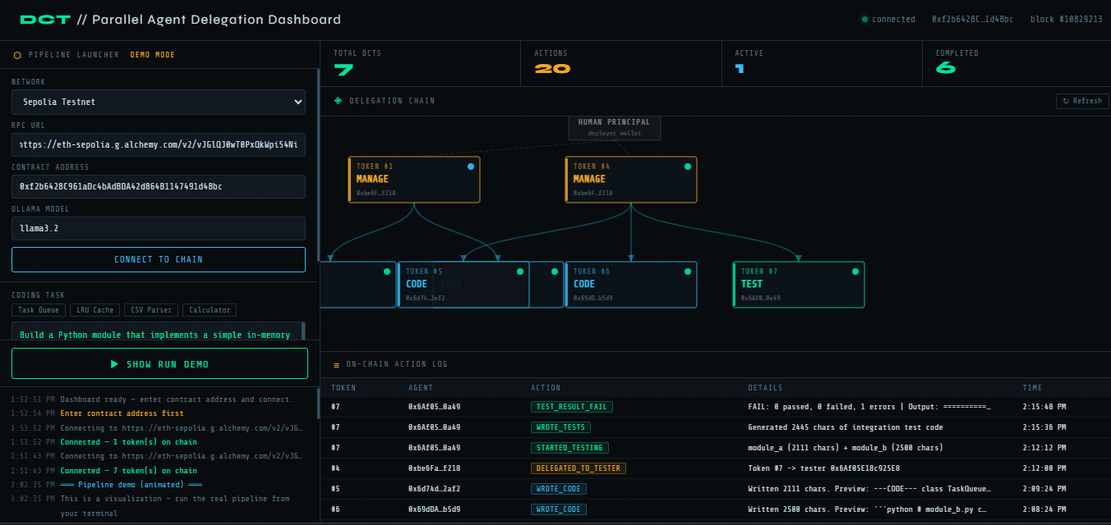
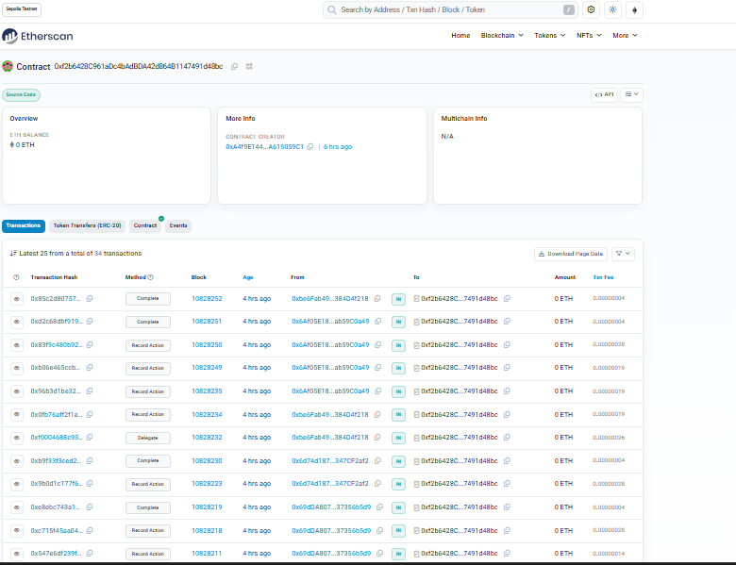
https://sepolia.etherscan.io/address/0xf2b6428C961aDc4bAdBDA42d864B1147491d48bc

6. Conclusion
This project demonstrates that blockchain-based delegation capability tokens are a viable and practical mechanism for auditing multi-agent AI systems. The combination of smart contract enforcement, per-agent Ethereum identities, and an append-only action log produces an accountability substrate that is transparent, tamper-proof, and independently verifiable — properties unachievable with conventional logging.
The implementation is fully open-source and uses no paid services, making it reproducible for further research. Future work could explore: automatic cascading revocation of child tokens, integration with W3C Decentralized Identifiers (DIDs) for agent identity, and on-chain verification of LLM output hashes to close the loop between the agent's stated actions and its actual outputs.
As AI systems take on more consequential tasks, the infrastructure for holding them accountable must keep pace. On-chain delegation trails are one concrete step toward AI deployments where trust is not assumed but verifiable.

References
[1] N. Tomasev et al., "Intelligent AI Delegation," arXiv preprint arXiv:2602.11865, 2026.
[2] M. Crosby et al., "Blockchain Technology: Beyond Bitcoin," Applied Innovation Review, vol. 2, pp. 6–19, 2016.
[3] A. Azaria et al., "MedRec: Using Blockchain for Medical Data Access and Permission Management," in Proc. 2nd Int. Conf. Open Big Data, 2016, pp. 25–30.
[4] N. Szabo, "Formalizing and Securing Relationships on Public Networks," First Monday, vol. 2, no. 9, 1997.
[5] S. Nakamoto, "Bitcoin: A Peer-to-Peer Electronic Cash System," bitcoin.org, 2008.

