JavaScript Practical 05
Objectives
1. Write function declarations, function expressions, and arrow functions for the same task.
2. Use parameters, arguments, return values, and default parameters correctly.
3. Distinguish global, local, and block scope in real code.
4. Trace the scope chain and explain variable shadowing.
5. Build one program that combines all three function styles with correct scope discipline.
6. Debug common mistakes that combine functions and scope together.

Part 1— Function Declaration Basics

Task 1.1: Write a function declaration isAdult(age) that returns true if age >= 18, otherwise false. Test it with 3 different ages.

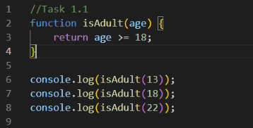

Output

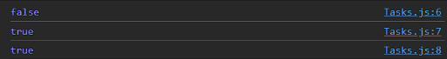

Task 1.2 (Fun Task) — "Member Discount": Write a function declaration calculateDiscount(price, isMember) that returns price * 0.9 if isMember is true, otherwise returns price unchanged. Test it once as a member and once as a non-member.

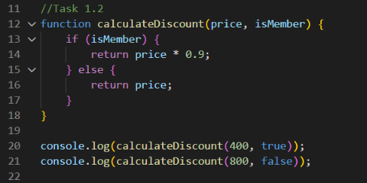

Output

Part 2— Function Expressions & Arrow Functions

Task 2.1: Rewrite your isAdult function from Task 1.1 as a function expression, stored in a const.

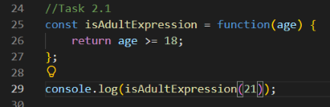

Output

Task 2.2 (Fun Task) — "Quick Square": Write an arrow function square(n) that returns n * n, using the shortest arrow form (no braces, no return keyword). Test it with 3 numbers.

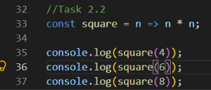

Output

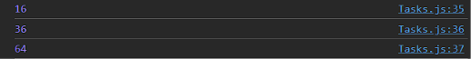

Task 2.3: Write an arrow function fullName(first, last) that returns the two names joined with a space. Test it with your own name.

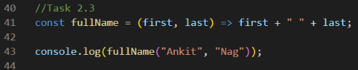

Output
Part 3 — Default Parameters & Argument Mismatch

Task 3.1: Write a function calculatePrice(price, tax = 0.18) that returns price + (price * tax). Test it once giving a custom tax rate, and once leaving tax out entirely.

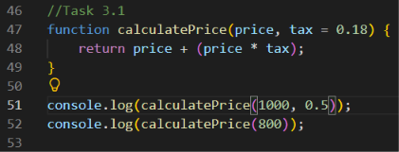

Output

Task 3.2 — Investigate: Call your calculateArea(length, width) function from Part 1 with only ONE argument, e.g. calculateArea(5). What do you get, and why? Write one sentence explaining it.

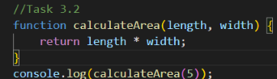

Output
Answer: The second argument width is undefined, so 5 * undefined produces NaN.

Part 4— Global vs Local Scope

Task 4.1: Create a global variable taxRate = 0.18. Write a function finalPrice(amount) that uses the global taxRate (not a parameter) to return amount + (amount * taxRate).

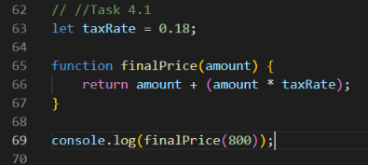

Output

Task 4.2 — Investigate: Inside a function, declare a local variable with the exact SAME NAME as a global variable you created. Print the value inside the function, then print the global one again afterward. Write 2 lines explaining what you observe — did the global change?
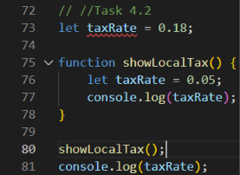

Output
Explanation
The local taxRate shadows the global taxRate inside the function. The global variable does not change and remains 0.18.

Part 5 — Block Scope: let vs var

Task 5.1: Write an if block that declares a variable with let inside it. Show (with console.log) that it works inside the block, and confirm it is not accessible outside.

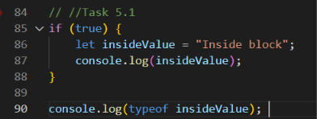

Output

Task 5.2 — Investigate: Repeat Task 5.1, but declare the variable with var instead of let. What is different about the result outside the block? Explain in 2+ sentences.

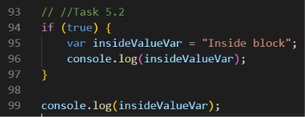

Output

Explanation
let is block-scoped, so it is not accessible outside the if block. var is function-scoped, so it remains accessible after the block when declared at the top level.

Part 6 — Scope Chain & Shadowing

Task 6.1: Write your own nested function (a function declared inside another function), where the inner function reads a variable declared in the outer function.

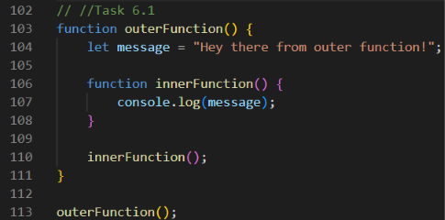

Output

Task 6.2 (Fun Task) — "Secret Admin Mode": Create a global variable role = "guest". Write a function loginAsAdmin() that declares a LOCAL role = "admin" and prints it. After calling the function, print the global role again to prove it never changed.

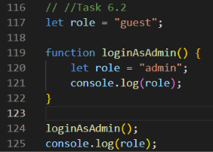

Output
Explanation
The local role shadows the global role inside loginAsAdmin(). The global role remains "guest" after the function finishes.

Part 7 — Mini Project: Student Grade & Fee

Manager

Requirements

1. Create a global variable totalFeeCollected = 0.
2. Write a FUNCTION DECLARATION calculateGrade(marks) that returns "A" (marks >= 90), "B" (>= 75), "C" (>= 60), or "F" — using if-else-if from an earlier unit.
3. Write a FUNCTION EXPRESSION calculateLateFee, stored in a const, that takes daysLate (default 0) and returns daysLate * 10.
4. Write an ARROW FUNCTION processStudent(name, marks, daysLate = 0) that calls calculateGrade and calculateLateFee (both LOCAL calls), adds the fee to the GLOBAL totalFeeCollected, and prints a one-line summary with the student's name, grade, and fee.
5. Call processStudent for at least 3 different students — use the default daysLate for at least one of them.
6. After all calls, print the final totalFeeCollected.

Implementation
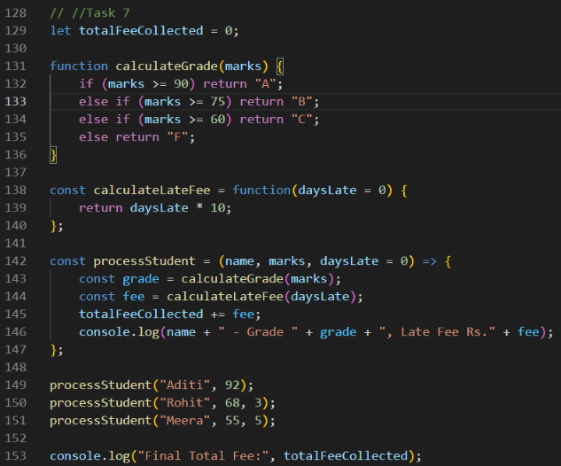

Output
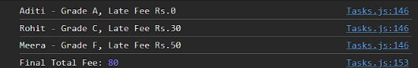
Sanity check for your own testing
processStudent("Aditi", 92, 0) → Grade A, Late Fee Rs.0. processStudent("Rohit", 68, 3) → Grade C, Late Fee Rs.30. processStudent("Meera", 55, 5) → Grade F, Late Fee Rs.50. Final totalFeeCollected → Rs.80.

Part 8 — Debugging Challenge

Each snippet below has ONE bug that combines today’s two topics. Find it, explain it, and fix it.

Snippet 1

function addNumbers(a, b) {
a + b;
}
console.log(addNumbers(5, 3));
Output
undefined
What Was Wrong?
The function calculates a + b but does not return the result, so the function call produces undefined.

Fixed Code
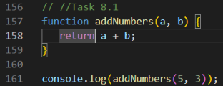

Output

Snippet 2

function setDiscount() {
discount = 20;
}
setDiscount();
console.log(discount);

What Was Wrong?
discount was assigned without being declared. In strict mode this causes a ReferenceError; it also breaks clear scope discipline.

Fixed Code
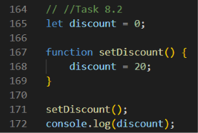

Output

Snippet 3

let balance = 1000;
function withdraw(balance, amount) {
balance = balance - amount;
return balance;
}

withdraw(balance, 200);
console.log(balance);

What Was Wrong?
The parameter balance is local to the function, so it shadows the global balance. The returned value is also ignored, so the global balance stays 1000.

Fixed Code
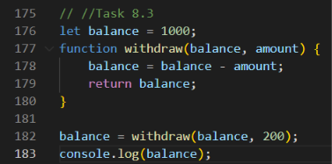

Output

Snippet 4

sayHello();

const sayHello = function() {
console.log("Hi!");
};

What Was Wrong?
A const function expression is not callable before its declaration is initialized. The function call must come after the const assignment.

Fixed Code
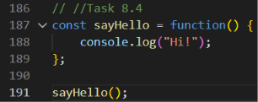
Output

