Practical Lab Assignment 6

Name: Ankit Nag
Course: B.SC IT 5th Sem

Part 1 — Hoisting with var
.
Task 1.1: Predict, then run. Write the output in your record:
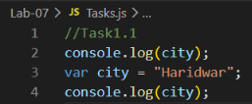

Prediction
Undefined
Haridwar

Output

Task 1.2: What does this print? Think about hoisting inside a function.
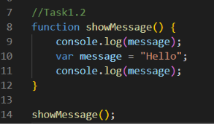

Output

Task 1.3 — Shadow Trap: Predict the output. Why is the first line NOT "global"?
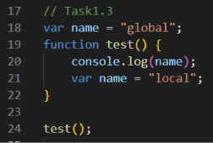

Output
Answer: The local var name is hoisted to the top of test(), so it hides the global name before the local variable receives the value "local".

Fun Task 1.4 — "Magic Trick": Write a 4-line program that prints undefined first and then your favourite food, using only var and two console.log lines.
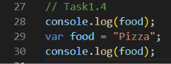

Output

Part 2 — Function Hoisting

Task 2.1: Run this. What error appears? Write the exact message.
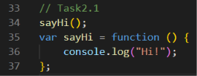

Expected error
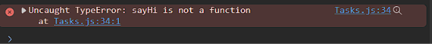

Task 2.2: Change var to const in Task 2.1. Does the error type change? Write both error types side by side.
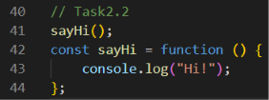

Output
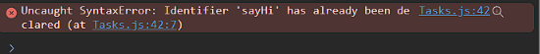

Task 2.3 — Sorting Table: Fill in the table. Run each one separately to check.
Code Works before its line? | Error type
function a() {} Yes None
var b = function() {} No TypeError
const c = () => {} No ReferenceError
let d = function() {} No ReferenceError

Task 2.4 — Two Functions, Same Name: Predict, then run:
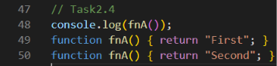

Output

Expected: Second. The later declaration wins.

Fun Task 2.5 — "Top-Down Story": Write a small program in which the main story lines are at the TOP of the file and the helper functions are at the BOTTOM.
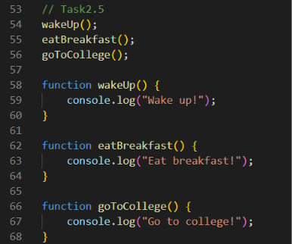

Output
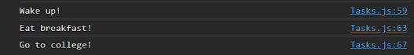

Answer: This works because function declarations are hoisted with their complete function body.

Part 3 — let, const and the Temporal Dead Zone

Task 3.1: Run the same for const PI = 3.14; placed after a console.log(PI);. Write the error message.
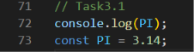

Expected: ReferenceError: Cannot access ‘age’ before initialization.

Output
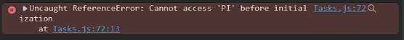

Task 3.2 — typeof Surprise: Predict and run both. They are NOT the same!
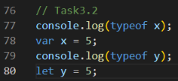

Expected: undefined for var x, but a ReferenceError for let y (TDZ).

Output

Task 3.3 — Investigate: Complete the sentence: "The three kinds of mistake when using a name too early are: undefined (when ___), ReferenceError (when ___), TypeError (when ___)."

Answer: undefined (when a var variable has been hoisted but not initialized), ReferenceError (when a let/const variable is accessed in the TDZ), TypeError (when a hoisted variable is undefined but is called as if it were a function).

Fun Task 3.4 — "Error Detective": Write four mini-programs, each one causing a different result.

(a) Prints undefined
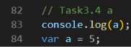

(b) ReferenceError
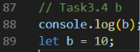

(c) TypeError
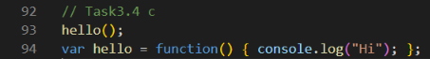

(d) Works because of hoisting
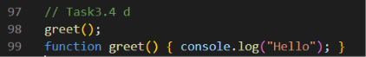

Part 4 — Your First Closure (25 min)

Task 4.1: Type the counter. Call counterA 5 times and counterB 2 times. Write the outputs. Why does counterB not continue from counterA?
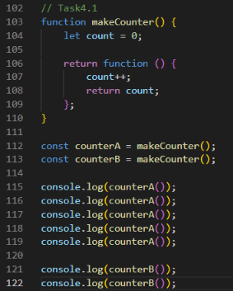

Output
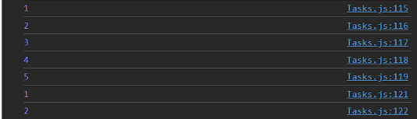

Answer: counterB does not continue from counterA because each call to makeCounter() creates a new closure with its own separate count variable.

Task 4.2: Try console.log(count); outside the function. What error? What does this prove about closure variables?
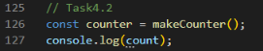
Output
Answer: This proves that count is private to the closure and is not directly accessible from outside.

Task 4.3 — Multiplier Factory: Complete and run:
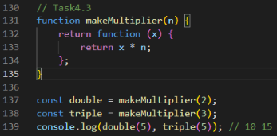

Output

Task 4.4: Write makeGreeter(greeting) so that makeGreeter("Namaste")("Aditi") prints Namaste, Aditi!.
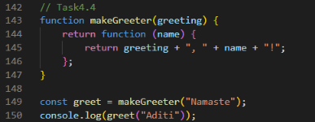

Output

Fun Task 4.5 — "Chai Counter": Make makeCupCounter() that returns a function. Each call adds one cup and returns the message "Cup number 3 of chai". Make two counters for two different friends and show they do not mix.
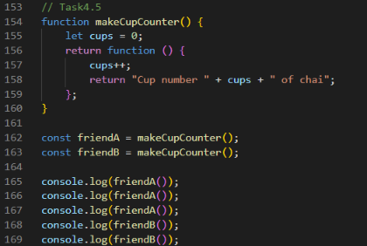

Output
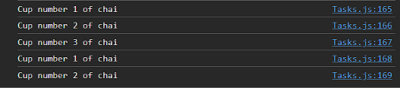

Part 5 — Private Data with Closures

Task 5.1: Type it. Try to cheat: wallet.balance = 99999; then wallet.show(). Did the money change? Why not?
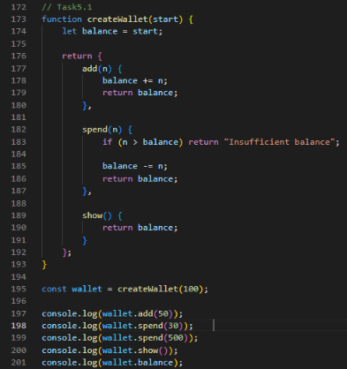

Output
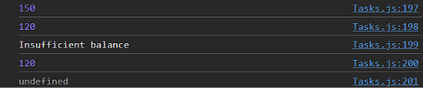

Cheat
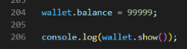

Output

Answer: The money does not change because balance is a private closure variable. wallet.balance creates a separate public property; it does not access the hidden balance.

Task 5.2: Add a reset() function that sets balance back to the starting amount.
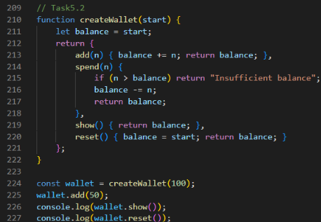

Output

Task 5.3 — Login Guard: Complete a closure limiter(max) that allows only max attempts.
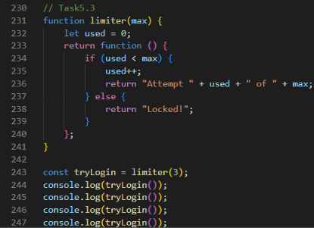

Output
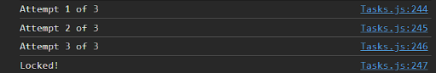

Fun Task 5.4 — "Secret Diary": Create createDiary() with write(text) and read(). The diary entries must be stored in a private array.
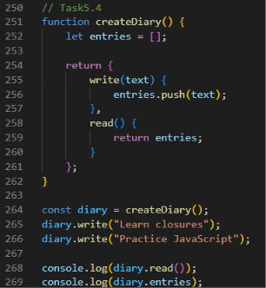

Output

Part 6 — Closures in Loops

Task 6.1: Write both outputs. Explain why var gives [3, 3, 3] while let gives [0, 1, 2].

var
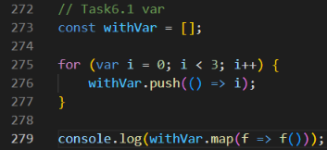

Output

let
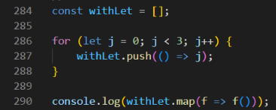

Output

Answer: var creates one shared function-scoped variable i, so all closures see its final value 3. let creates a new block-scoped binding for each loop iteration, so the closures remember 0, 1 and 2 separately.

Task 6.2: Predict first, then run this timer version. It prints after about 1 second:
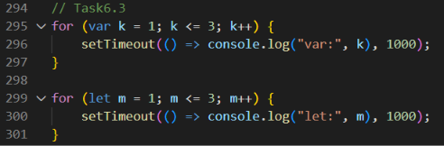

Output
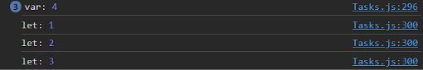

Fun Task 6.3 — "Fix the Bug": Change only ONE word in the var loop of Task 6.2 so it prints 1, 2, 3.
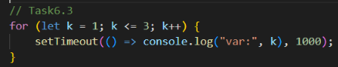

Output
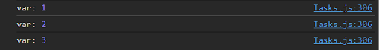
Part 7 — Mini Project: Smart Wallet with Login Guard
Combine hoisting and closures into one small program. Use index.html + script.js.
Requirements
1. Write createWallet(start) with add, spend, show and history. history() returns an array of text lines like "Added 200", "Spent 150".
2. Write a login guard limiter(3) as a second closure. A wallet action is allowed only if the guard says an attempt is available for the PIN check. Keep it simple: call the guard before each spend.
3. Put your main code at the TOP of the file and all functions below it as function declarations (hoisting makes this work).
4. Print a final summary using string concatenation or template literals.

Complete Program
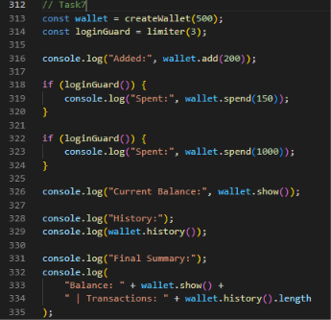
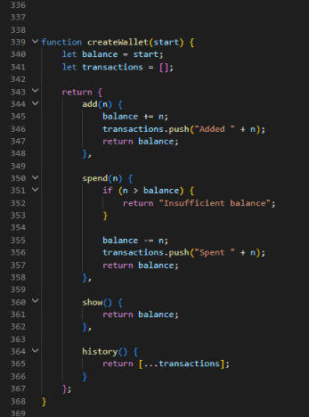
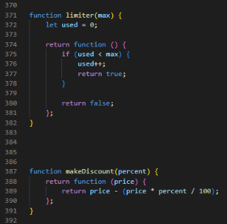

Output
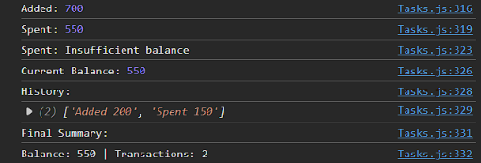

Part 8 — Debugging Challenge
Each snippet has a bug. Write the problem, the error or wrong output, and the fixed code.

Snippet 1
// Snippet 1 — runs, but prints "undefined" then 5. Make the "undefined" go away
console.log(total);
var total = 5;

What Was Wrong?
The console.log runs before total receives its value. var hoisting makes total exist, but its initial value is undefined.

Fixed Code
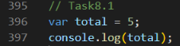

Output

Snippet 2
// Snippet 2 — TypeError. Fix it without changing "var" to "const"
greet();
var greet = function () { console.log("Hi"); };

What Was Wrong?
The variable greet is hoisted as undefined, so calling it before the assignment causes a TypeError.

Fixed Code
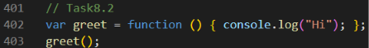

Output

Snippet 3
// Snippet 3 — counter always prints 0 0
function makeCounter() { let c = 0; return c++; }
const next = makeCounter();
console.log(next, next);

What Was Wrong?
makeCounter() returns a number, not a function. The counter state is not preserved between calls.

Fixed Code
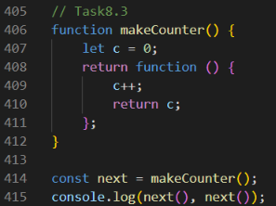

Output

Snippet 4
// Snippet 4 — counter always prints 1 1 1
function makeCounter2() {
return function () { let count = 0; count++; return count; };
}

const n = makeCounter2();
console.log(n(), n(), n());

What Was Wrong?
count is declared inside the returned function, so a fresh count is created every time n() is called. Nothing is remembered between calls.

Fixed Code
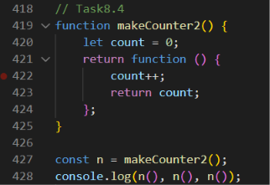

Output

