**MPMC Lab Assignment – 03**

PRAVALLIKA SALADI - 119EC0013

# Aim:

To find the sum of 5 numbers and store it to the variable ‘sum’.

# Program:

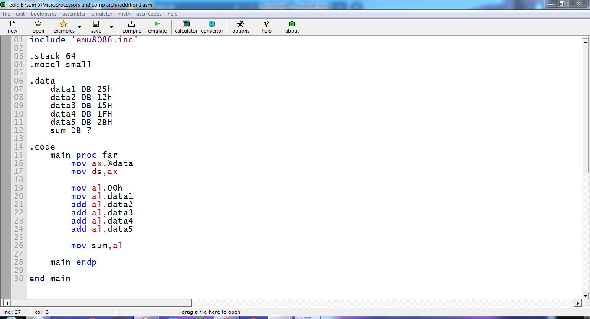

# Emulator:

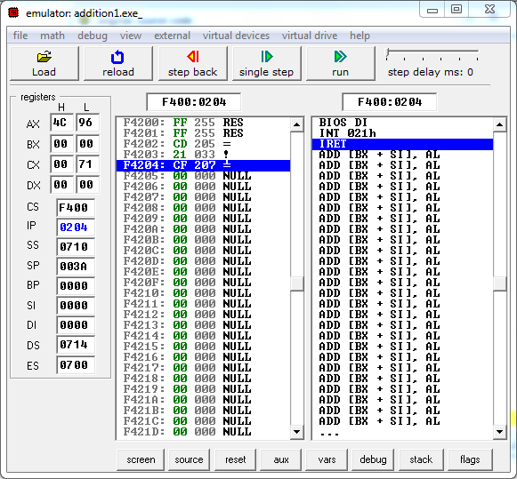

# Debug:

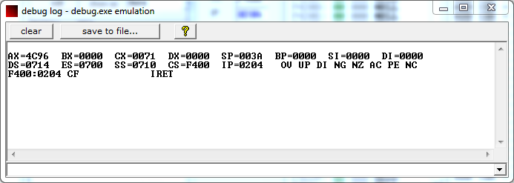

# Variables:

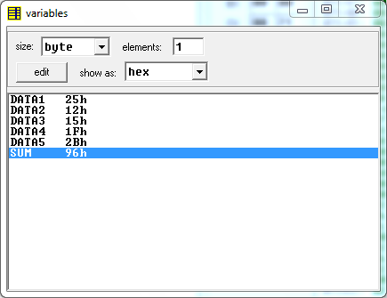

# Flags:

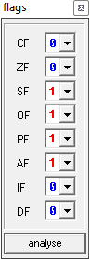

# Memory:

