**MPMC LAB ASSIGNMENT – 02**

PRAVALLIKA SALADI - 119EC0013

# Aim:

To add 5 digits (hexadecimal) using Data Segment with constant offset.

# Program:

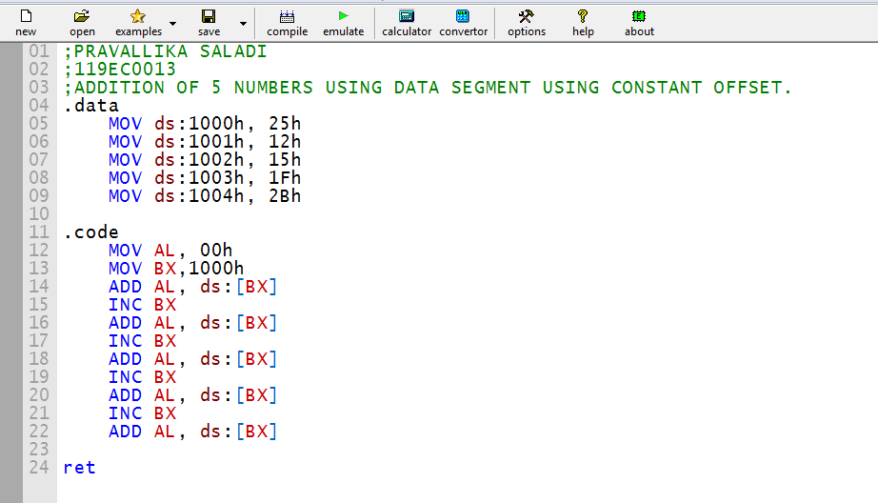

# Emulator:

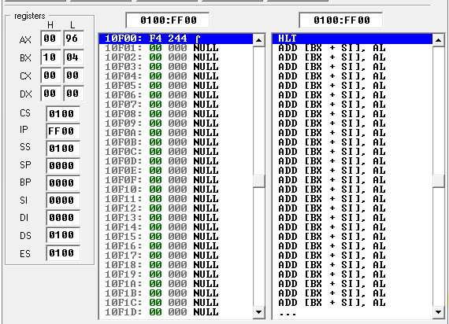

1. The sum of all the 5 digits is stored in AL.
2. The sum of 5 digits is 96
3. BX is used to point the address location. Since the 5th value address in 1004, BX register value is 10 04.

# Debug:

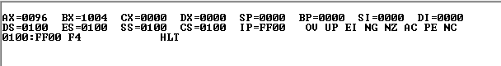

# Flags:

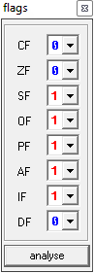

# Memory:

