MPMC Lab Assignment – 03

PRAVALLIKA - 119EC0013

# AIM:

To add 5 numbers using data segment and changing offset value and print the sum in int.

# Program:

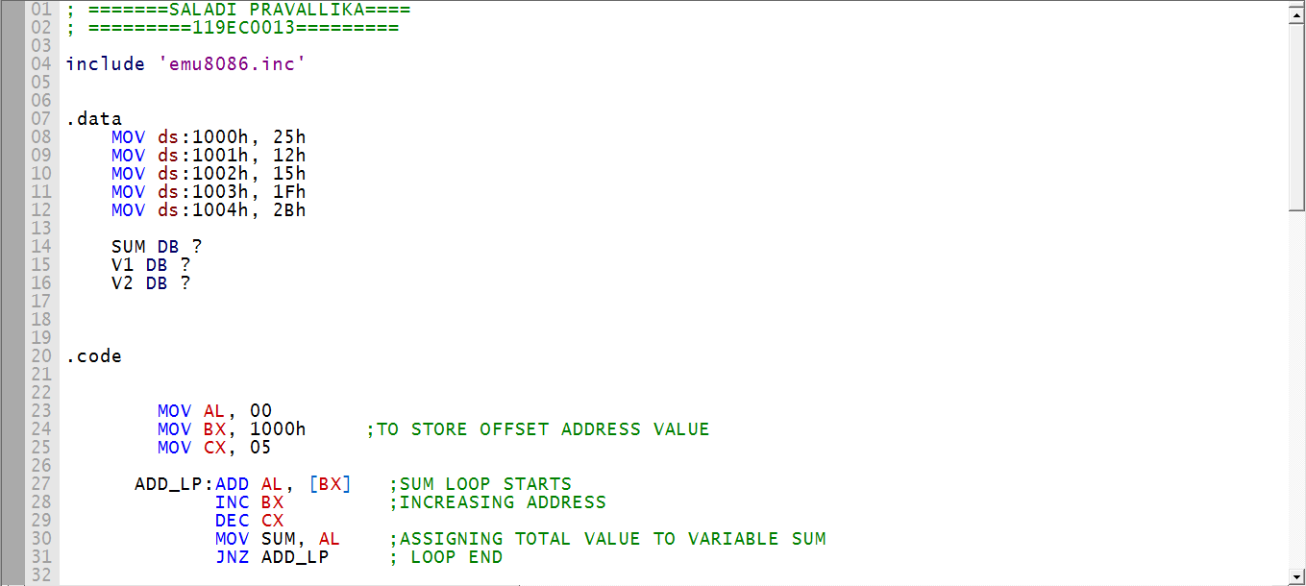

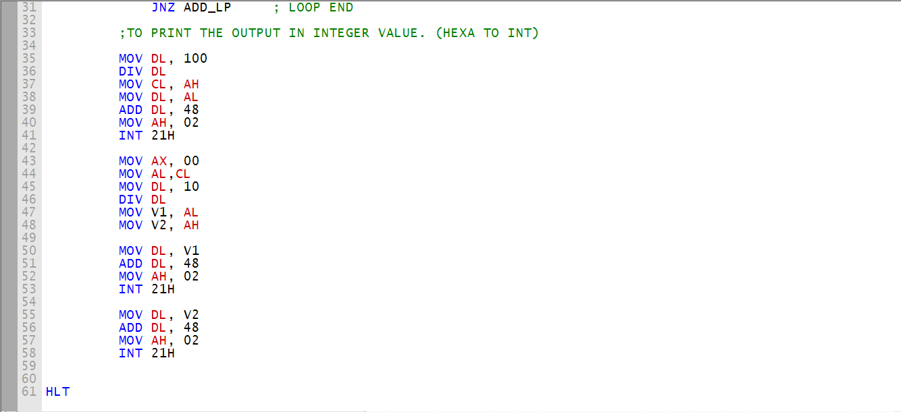

# Emulator:

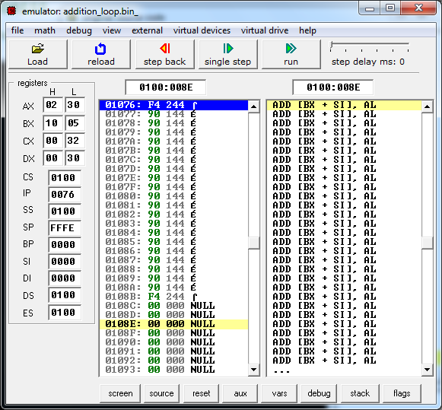

# Debug:

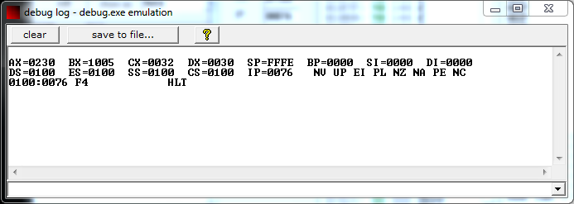

# Variables:

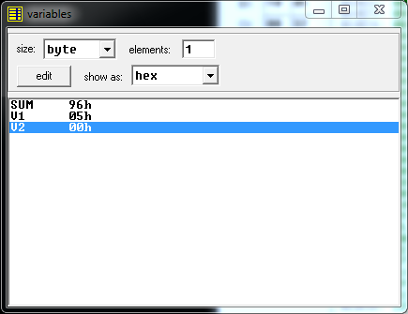

# Flags:

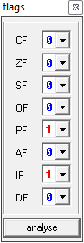

# Memory:

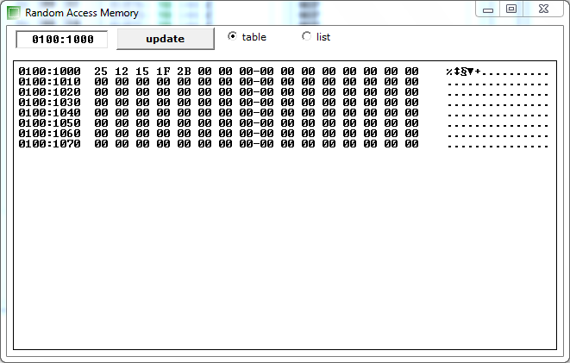

# Screen:

