**Overview:**

**Generation of invoice:**

* There may be any number of customers.
* Each customer selects a date.On this date,every month an invoice has to be generated for respective customer and should be sent through emails and also should be available on customer care websites.
* Each invoice contains particulars of purchases made in that one month duration(of that customer).
* All the items in the invoice,should be categorized according to the different sections present in the catalog and then finally summed up for the total bill.
* These services should use bank level security to protect the data of customers master card and more.
* User Profile: Any customer who uses places order in amazon site.

**Use Case Diagram:**

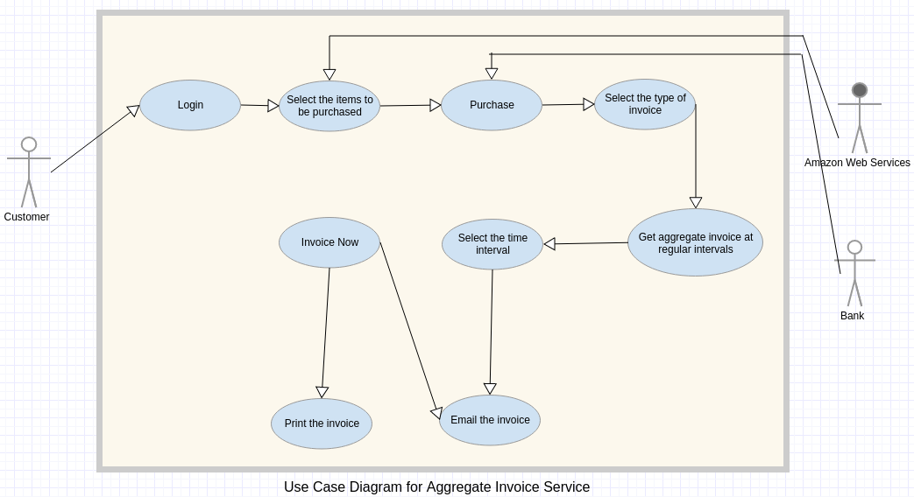

**High Level Data Flow:**

* The system takes the ‘Selected Items list’ input from Amazon Web services.
* Every time the customer purchases a set of items, this data is stored in the database. The database consists of the Customer ID, Categories of items, Number of items purchased in each category, total amount,DateTime.
* According to the time interval selected by the customer invoice is mailed to the customer at appropriate intervals of time using a mailing service.