

**MACAU UNIVERSITY OF SCIENCE AND TECHNOLOGY**

**School of Computer Science and Engineering**

**Faculty of Innovation Engineering**

**Final Report of Data Science**

**Recognition Face Fatigue Detection**

**Team member:**

CS

#NO.1 黎宇睿 ID: 19098533-I011-0044

#NO.10 李嘉赫 ID：19098535-I011-0096

#NO.18 林钢 ID:1909853F-I011-0042

#NO.25 邵乐天 ID: 1909853J-I011-0049

SE

#NO.1 李辰韬 ID: 1909853D-I011-0201

#NO.2庄哲楷 ID: 1909853F-I011-0030

**Team Contributions:**

1. 黎宇睿, 李嘉赫, 邵乐天 are responsible for the face recognition aspects of the code writing and review of the data.
2. 李辰韬, 庄哲楷, 林钢are responsible for code writing and data review for fatigue (blink) detection.
3. All team members make final code changes and optimizations.
4. 李辰韬, 林钢 Make reports and PPT.
5. All members of the group make a final Youtube video recording.

## Links

Video link: https://youtu.be/jGc\_jdMavbs

## Introduction

Fatigue driving is very likely to cause traffic accidents. It refers to the phenomenon that the driver's physiological and psychological functions become imbalanced after driving continuously for a long time, and the driving skills decline objectively. The driver's sleep quality is poor or insufficient, and he is prone to fatigue after driving for a long time. Driving fatigue can affect various aspects such as driver's attention, feeling, consciousness, thinking, judgment, will, decision and motion. If you continue to drive the vehicle after fatigue, you will feel drowsy, drowsy, weak in limbs, inattention, decreased judgment ability, and even appear in a trance or instant memory loss, delayed or premature action, operation pause or improper correction time and other unsafe factors, highly prone to road traffic accidents. In Pakistan, 34% of traffic accidents are caused by driver fatigue [1], in the United States, 20% of fatal car accidents are related to fatigue driving [2], in the European Union, 20% of commercial transportation accidents are also due to Fatigue driving [3]. All the stats and numbers are shocking.

Our team conducts an in-depth review of the scientific research and existing techniques for fatigue detection. Over the past decade, various driver drowsiness detection systems have been developed to reduce the number of drowsiness-related crashes. Most of these systems monitor steering patterns or the vehicle's position in the lane to assess drowsiness levels and warn the driver of his/her critical state. Drowsy drivers also exhibit certain observable behaviors, including eyelid and head movements that are significantly associated with drowsiness.

Focusing on the driver's eye movements, our algorithm estimates landmark locations and extracts a single scalar—the Eye Aspect Ratio (EAR)—that characterizes eye opening in each frame. Finally, the SVM classifier detects eye blinks as patterns of EAR values in short time windows.[4] According to the value of EAR, it is judged whether the driver is tired or not.

## Method

We first need to let the computer recognize the face, and then continue to find key points on the recognized face. We use 68 key point detection here.

图表, 散点图

Fig1 The 68 points mark-up used for annotations

For the eyes, each of his eyes has 6 key points. Here we can use a way to determine whether an eye blink is performed.

图示

Among the 6 key points of the eyes, we can find that when the eyes are open, the Euclidean distances between points 2 and 6 and between points 3 and 5 are larger. The distance between points 1 and 4 will increase a little bit, then we can use a formula.[4]

图形用户界面, 图表, 直方图

The figure above shows the degree of eye opening according to the aspect ratio of the eye, that is, the ratio of the width of the eye to the length of the eye. The principle is that when the eyes are open, the ratio of the width to the length of the human eye is a relatively fixed value. When the eyes are closed, the width of the human eye will become extremely smaller, and the aspect ratio of the eye will change at this time. This parameter is usually used in blink rate calculations. Corresponding to the figure is the subtraction of 2 points and 6 points, and the subtraction of 3 and 5 points. Then compare the difference between 1 and 4 points on 2 times. where are absolute values. In this way, the EAR value will be larger when the eyes are open, and the EAR value will be smaller when the eyes are closed. Then we set a threshold ourselves. If the value of EAR is lower than this threshold, it exceeds a few frames in the video frame. We then assume that the driver is closing his eyes. When the EAR value is less than 0.3, it is judged as a blink.

After the verification of the paper, it shows that the accuracy of the method is very impressive and has strong robustness. [4]

For whether you are in a state of fatigue, you need to test the number of frames with eyes closed within a period of time. According to the physical quantity PERCLOS proposed by the Carnegie Mellon Research Institute to measure fatigue/drowsiness, it is defined as a unit of time (generally 1 minute or 30 seconds) ) A certain proportion (5% or 15%) of the time when the eyes are closed, and when the following formula is met, it is considered to be in a state of fatigue:

According to a large number of experimental analyzes by domestic and foreign scholars, when f ≥ 0.12, the driver can be considered to be in a fatigued state; when f < 0.12, the driver can be considered to be in a awake state. So in the same way, if you blink more than 8 times in one minute, it will be regarded as a state of fatigue. [5]

## Results and Discussions

Firstly, the face will be positioned, and then the eyes can be accurately positioned, and then the EAR value can be calculated according to the marked points of the eyes.

We set that when the EAR value is less than 0.3, it is judged as a blink, and the EAR values of the left and right eyes are calculated separately.

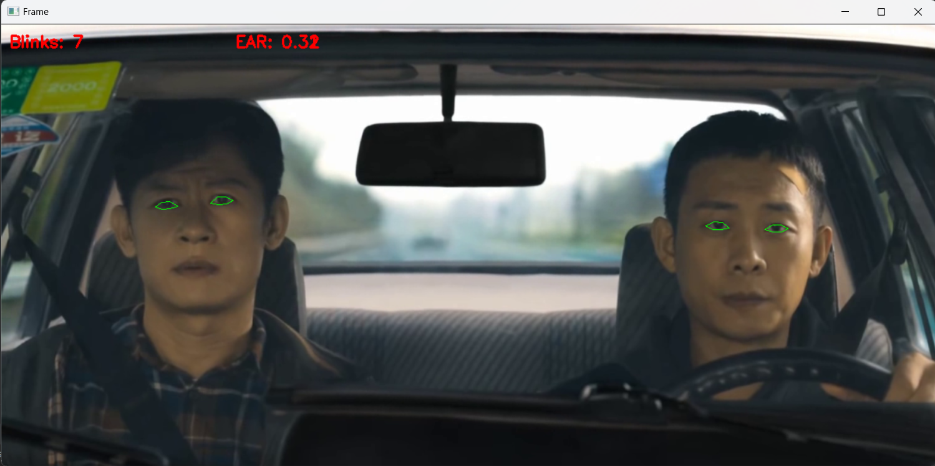

## Conclusion

Drowsy driving can be physically or psychologically damaging. The detection of fatigue is more important than the cure. We put the focus of fatigue detection on the eye movement. We use the eye blinking algorithm to do a fatigue detection, calculate an EAR value through the marked points of the eyes, and use the PERCLOS value to judge whether the driver is fatigued. Extracted Numbers are used for states of alertness and drowsiness.

The above are the facial behaviors that can be observed. We can judge whether the detected person is in a state of fatigue according to the facial behavior characteristics, but sometimes we may not be able to detect facial characteristics, such as raising the head, bowing the head, turning the head and other actions. This is an individual case, and the fatigue index cannot be detected.

References

1. K. Azam, A. Shakoor, R. A. Shah, A. Khan, S. A. Shah, and M. S. Khalil, “Comparison of fatigue related road traffic crashes on the national highways and motorways in Pakistan,” J. Eng. Appl. Sci., vol. 33, no. 2, pp. 47–54, 2014.
2. AAA Foundation for Traffic Safety. Accessed: Jan. 10, 2017. [Online]. Available: <https://www.aaafoundation.org>
3. Fatigue. Accessed: Jan. 21, 2017. [Online]. Available: https://ec.europa. eu/transport/road safety
4. T. Soukupova and J. Cech, “Real-time eye blink detection using facial ´landmarks,” in 21st Computer Vision Winter Workshop, 2016.

1. [Robert Chen-Hao Chang](https://sciprofiles.com/profile/2250883" \t "_blank), Chia-Yu Wang, “Drowsiness Detection System Based on PERCLOS and Facial Physiological Signal †” *Sensors* 2022, *22*(14), 5380