Hw1 part2 Xiaotian Zhu

1.First, I defined a function to compute the maximum likelihood given x, mu and Likelihood function.

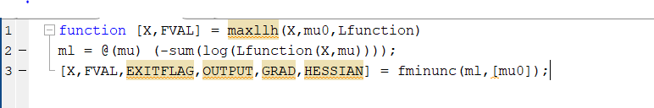

2.According to the Notes from the assignment, I set the parameters a and b to 1 and 0.6, the initial value to 0. I also simulate data to test my program. I choose the first 999 columns of X0 and the last 999 columns of it to create a new matrix of 2\*999 as the input.

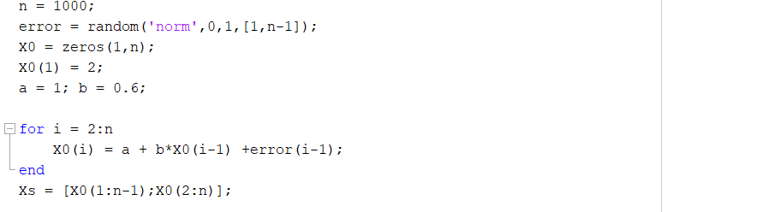

3.Then I use the mle function defined above to get the theta. And I set alpha to 0.05 to get the confidence interval

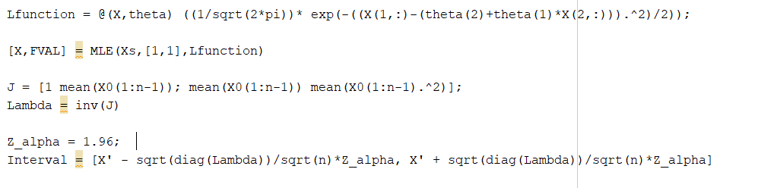

4. I choose to use Chi-Squared test

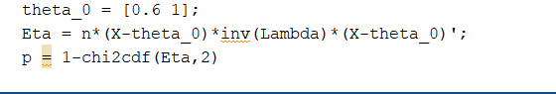

5.All the output is below:

