HW3 Xiaotian Zhu

1. >> plot(GSPC)

>> set(gca,'XTick',[1 314 630 945 1259])

set(gca,'XTickLabel',{'2/4/2015' '5/3/2016' '8/3/2017' '11/1/2018' '2/3/2020'})

>> ylabel('S&P 500 Index prices')

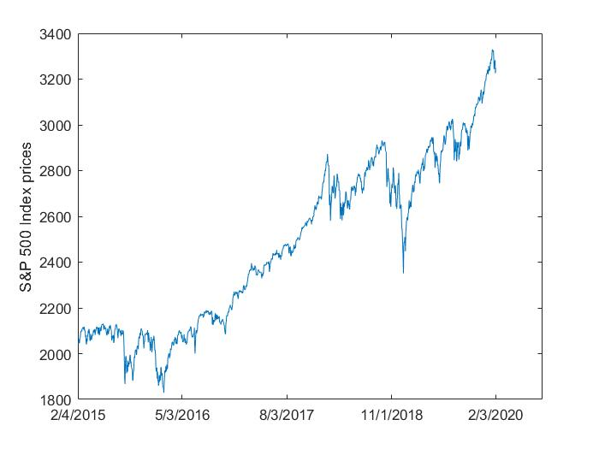

2. gspc=price2ret(GSPC)

plot(gspc)

>> set(gca,'XTick',[1 314 630 945 1259])

set(gca,'XTickLabel',{'2/4/2015' '5/3/2016' '8/3/2017' '11/1/2018' '2/3/2020'})

>> ylabel('S&P 500 Return')

33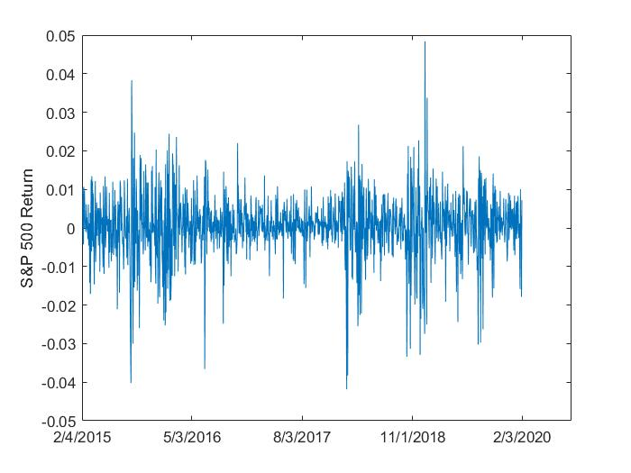

3. autocorr(gspc)

>> title('ACF With Bounds for Raw Return Series')

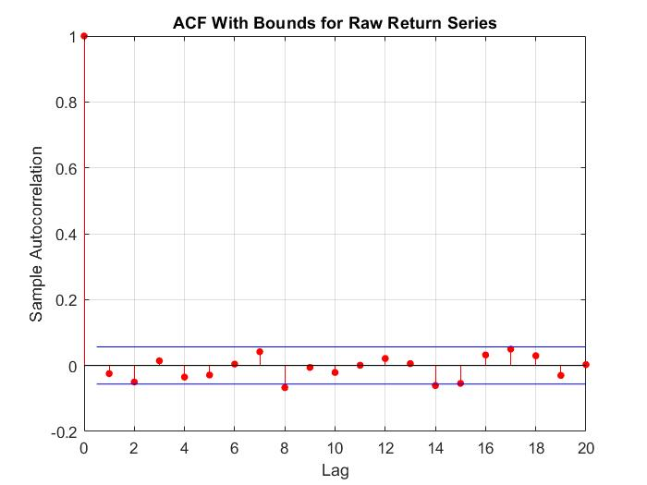Result: q= 1

parcorr(gspc)

>> title('PACF with Bounds for Raw Return Series')

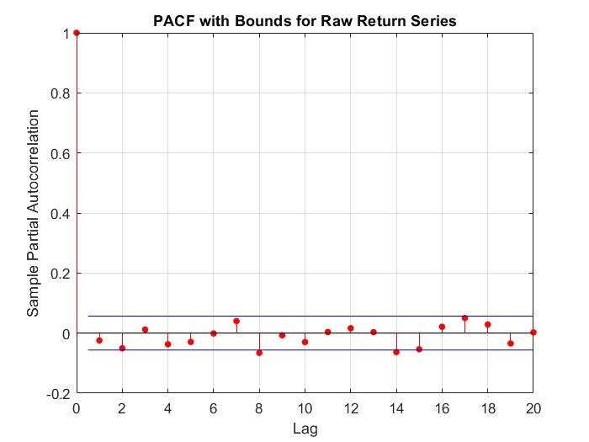

P=1

4. autocorr(gspc.^2)

>> title('ACF Of The Squared Returns')

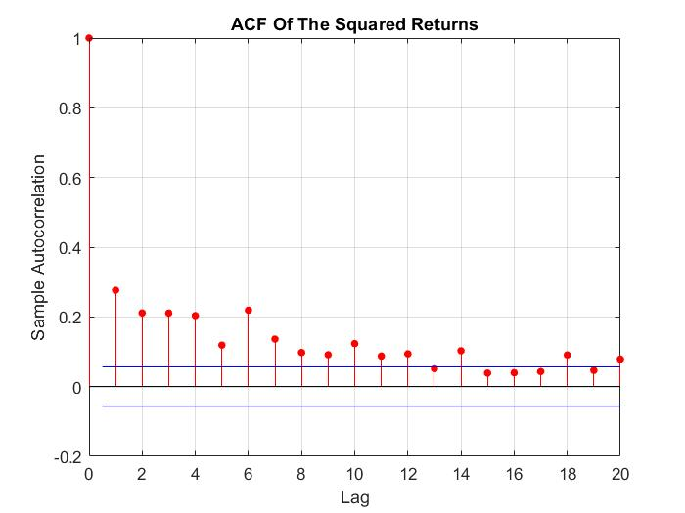

This figure shows that ,although the returns themselves are largely uncorrelated, the variance process exhibits some correlation.

5. 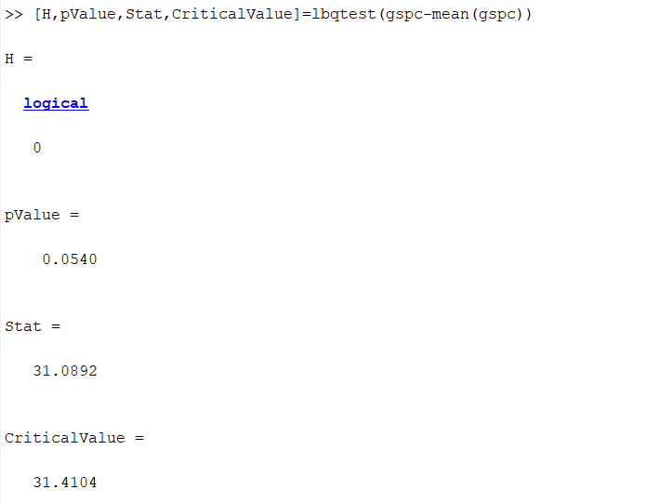

Result:No significant serial correlation .

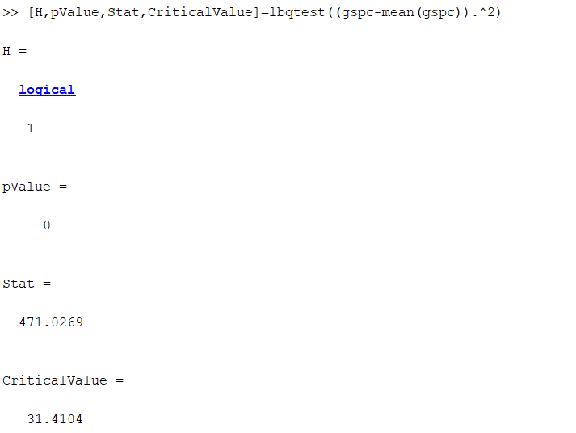

Result:There is significant serial correlation in square

5. Mdl=garch(1,1)

[EstMdl,EstParamCov]=estimate(Mdl,gspc(2:end),'E0',gspc(1))

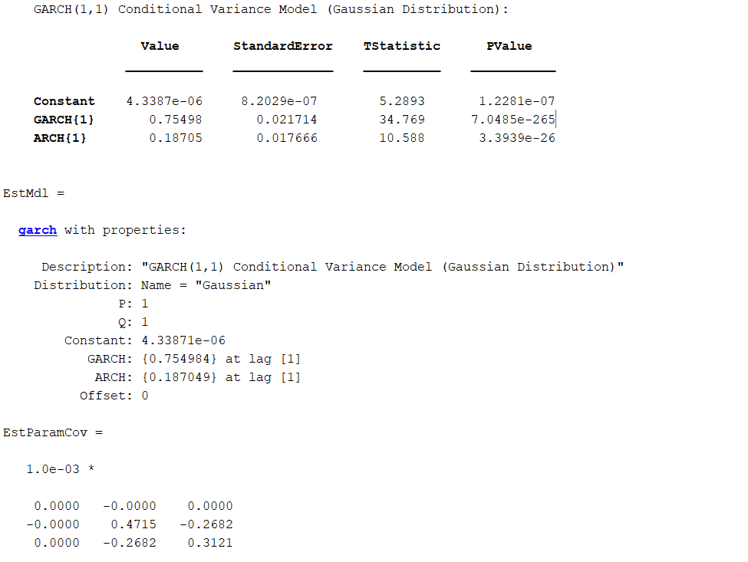

6.sub-sample-test( two parts)

Mdl=garch(1,1)

[EstMdl,EstParamCov]=estimate(Mdl,gspc(2:628),'E0',gspc(1))

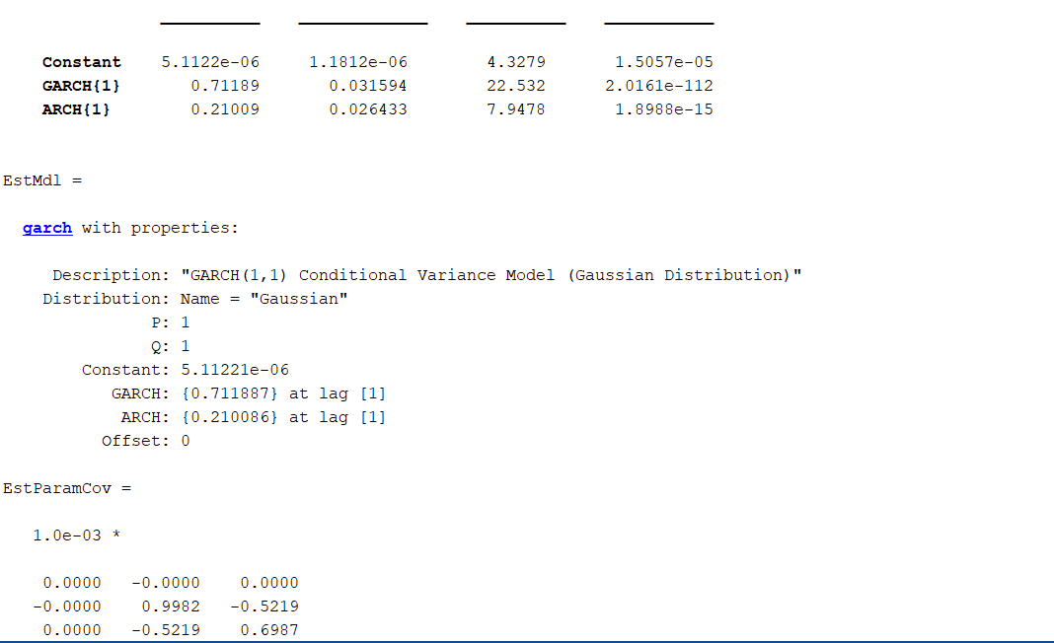

[EstMdl,EstParamCov]=estimate(Mdl,gspc(629:1257),'E0',gspc(629))

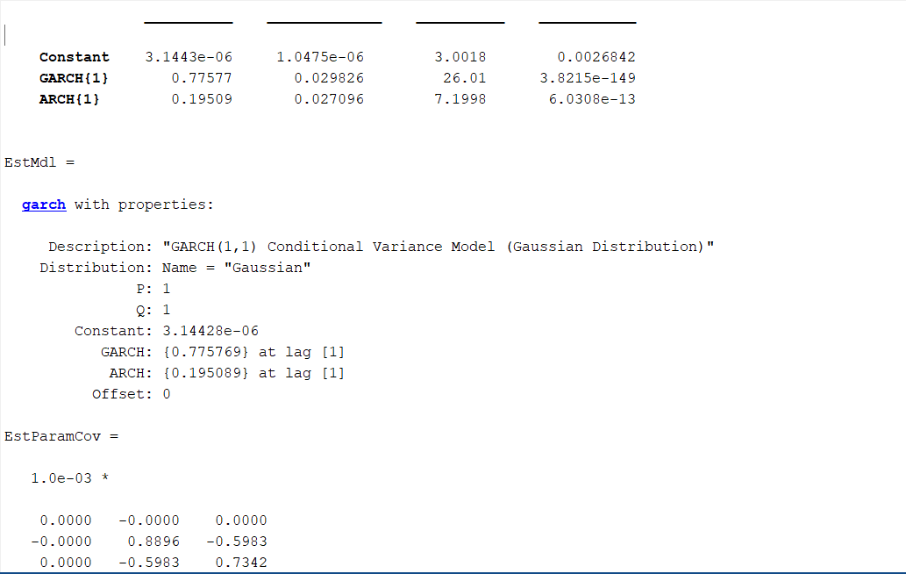

The subsamples parameters don’t change too much.