**Xiaotian Zhu**

1. Fix the random number generator

Number is the length of return

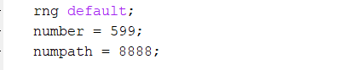

2.

theta = [alpha0, alpha1, beta1];

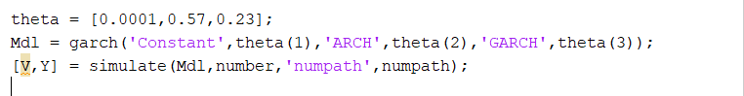

3.set the initial value of thetas, then use garch to create a model

Use simulate to simulate

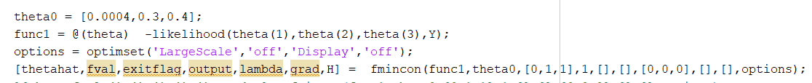

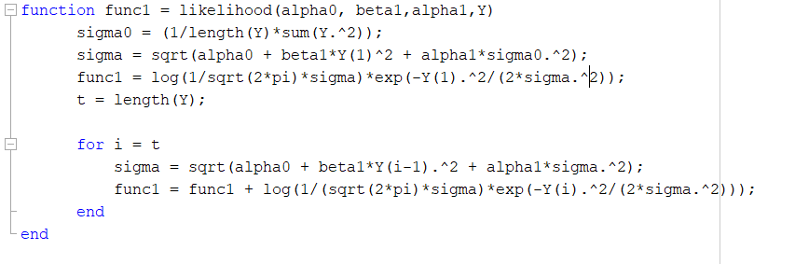

4. Covariance matrix of MLE

p-value, H0: theta_hat = theta

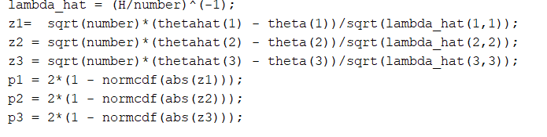

5. confidence interval

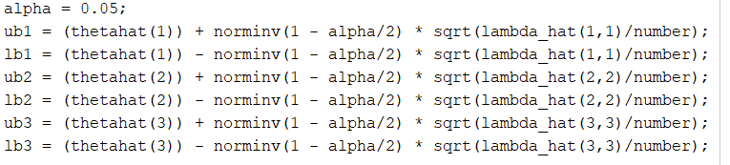

6.

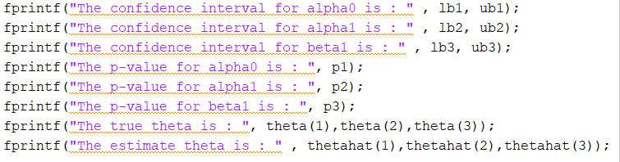

7.

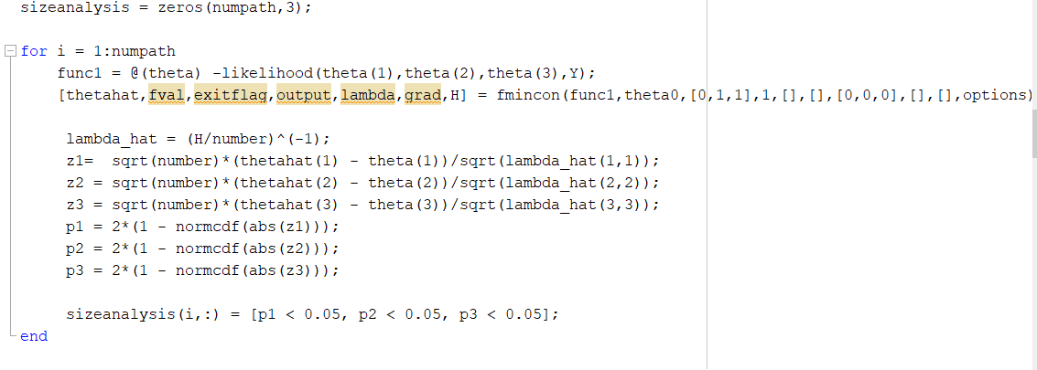

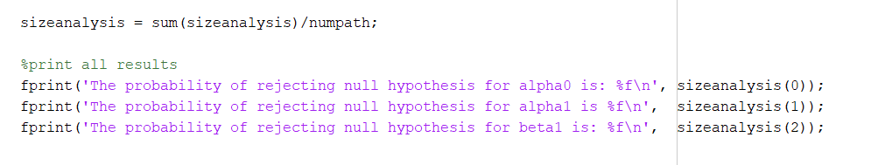

8. power analysis

