|  |
| --- |
| PSTAT 126 Project |
| How to Choose an Appropriate Model Selection Method |
|  |

|  |
| --- |
| Inwoong Bae, Sunnie Oh  2019-6-9 |

**Abstract**

We will figure out how to select the best model in our interest. This process could include transforming variables and selecting the sort of variables itself. In the first part, we will try to set up a fixed model and  transform variables in the fixed model and figure out if it is really meaningful. On the other hand, in the second part, we will construct the model by ourselves using two different methods and compare the results of each method from empty model or full model. We conclude that constructing the model by ourselves is more efficient to build the proper model.

**Problem and Motivation**

In data analysis process, model selection is one of the basic processes before we analyze data and conclude the results. Even though we select valid dataset and clean it up properly, the result could be totally different or even opposite from our expected result because of choosing wrong method and inappropriate transformations. So, we wonder how we are able to figure out which model would be the best to make a right conclusion. This question leads us to conduct two types of study about two different multiple linear model selection using several methods. The first study is to set up several abstract models, add or remove variables, and transform the variables. On the other hand, the second study is to run multiple model selecting method, which add or remove  and order variables from the empty model or full model. There are two types of our dataset that we are going to use for the model selection: The first dataset is the market historical dataset of real estate valuation that were collected from Sindian District, New Taipei City, Taiwan during the period of June 2012 to May 2013. The second dataset is the dataset from the paper, Modeling of strength of high performance concrete using artificial neural networks, written by Dr. I-Cheng Yeh.

**Data**

We use two types of datasets for this project. The first dataset is about real estate valuation dataset from Sindian District, New Taipei City, Taiwan during the period of June 2012 to May 2013. This dataset consists of 8 variables: TDate(the transaction date (e.g., 2013.250=2013 March, 2013.500=2013 June, etc.), Age(the house age (unit: year)), Metro(the distance to the nearest MRT station (unit: meter)), Stores(the number of convenience stores in the living circle on foot (integer)), Latitude(the geographic coordinate (unit: degree)), Longitude (the geographic coordinate (unit: degree)) and Price(the house price of unit area (10000 New Taiwan Dollar/Ping, where Ping is a local 7 unit, 1 Ping = 3.3 meter squared)). We are going to use this dataset to find the best model by selecting variables and transforming them in the first part. The second dataset was collected for the paper, Modeling of strength of high performance concrete using artificial neural networks, by Dr. I-Cheng Yeh. We will use this data set to model the relationship between the concrete compressive strength and the 8 concrete components: X1(Cement (component 1, unit kg=m3)), X2(Blast Furnace Slag (component 2, unit kg=m3)), X3(Fly Ash (component 3, unit kg=m3)), X4(Water (component 4, unit kg=m3)), X5(Superplasticizer (component 5, unit kg=m3)), X6(Coarse Aggregate (component 6, unit kg=m3)), X7(Fine Aggregate (component 7, unit kg=m3)),X8 Age (Day, 1  365) and Y(Concrete compressive strength (MPa)). We will use this dataset to find out the best model by multiple of variable selection methods.

**Questions of Interest**

In the first part, we think about which factors make price of real estate and select several factors. we set up a model with some variables that we think they are affecting the price of . After we build the model, we investigate the relationship between price and other factors such as location(latitude, longitude), distance from the nearest subway station, age of the house. Once we find the relationship, we figure out how much each variable affects the price by conducting some tests. Lastly, we transform the variables to get more clear relationship by using several methods.

In the second part, we select the most adequate model which identifies the relationship between concrete compressive strength and the 8 concrete components form X1 to X8. In this process, we will use two different methods. One is adding a variable continuously starting from the smallest model, and the other is deducting a variable continuously starting from the biggest model. After selecting which variables to contain in the model, we detect whether the selected model is really adequate model or not. In this process, we can remove some points. Next, we compare two different models and figure out if they are different from each other and the reason of the difference between each other.

**Regression Methods**

In the first part, we plot price and other predictors(TDate, Age, Stores, Latitude) and then see the relationship between price and the variables briefly.  After that, we set up the linear model between price and other predictors and conduct global f-test and plots such as Residual and Fitted value and Normal Q-Q plot to know how much each predictor would be significant for the model. We then build other possible model and compare it with the previous model by ANOVA table. Once we find the possibly best predictors for the response, price, then we try to transform the predictors to get more clear and ideal results using powerTransformation, Box-Cox method and polynomial regression.

In the second part, we will use two different variable selection methods, forward selection and backward elimination, to choose variables in the model. After fixing the model, we will check if it fulfills the linear regression assumptions by residuals vs. fitted values plot to check both non-linearity and non-constant variance, and also Normal Q-Q plot to check non-normality. And then, by using influential index plot, we will find any influential points to remove, particularly using leverages to detect data points with large influence. Finally, we will figure out if two models derived from two different selection methods are different from each other using ANOVA.

**Regression Analysis, Results and Interpretation**

part 1

MyData <- read.table("RealEstateValuation.txt", header = TRUE)  
head(MyData)

## TDate Age Metro Stores Latitude Longitude Price  
## 1 2012.917 32.0 84.87882 10 24.98298 121.5402 37.9  
## 2 2012.917 19.5 306.59470 9 24.98034 121.5395 42.2  
## 3 2013.583 13.3 561.98450 5 24.98746 121.5439 47.3  
## 4 2013.500 13.3 561.98450 5 24.98746 121.5439 54.8  
## 5 2012.833 5.0 390.56840 5 24.97937 121.5425 43.1  
## 6 2012.667 7.1 2175.03000 3 24.96305 121.5125 32.1

plot(MyData)

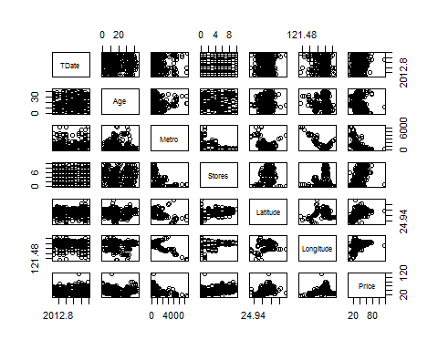

#According to the plot among variables in the dataset from Real Estate Valuation, there seems no significant relationship between price and each factor.  
mod <- lm(Price ~ TDate + Age + Stores + Latitude, data = MyData)  
summary(mod)

##   
## Call:  
## lm(formula = Price ~ TDate + Age + Stores + Latitude, data = MyData)  
##   
## Residuals:  
## Min 1Q Median 3Q Max   
## -32.620 -5.601 -0.714 4.207 80.465   
##   
## Coefficients:  
## Estimate Std. Error t value Pr(>|t|)   
## (Intercept) -1.742e+04 3.524e+03 -4.944 1.12e-06 ***  
## TDate 3.613e+00 1.686e+00 2.143 0.0327 *   
## Age -3.020e-01 4.178e-02 -7.227 2.44e-12 ***  
## Stores 1.929e+00 1.801e-01 10.712 < 2e-16 ***  
## Latitude 4.078e+02 4.278e+01 9.534 < 2e-16 ***  
## ---  
## Signif. codes: 0 '***' 0.001 '**' 0.01 '*' 0.05 '.' 0.1 ' ' 1  
##   
## Residual standard error: 9.654 on 409 degrees of freedom  
## Multiple R-squared: 0.5015, Adjusted R-squared: 0.4966   
## F-statistic: 102.8 on 4 and 409 DF, p-value: < 2.2e-16

let Y be price, x1 be TDate, x2 be Age, x3 be Stores, x4 be Latitude. then the equation for the fitted regression line is Y = -1.742e+04 + 3.613e+00*x1 - 3.020e-01*x2 + 1.929e+00*x3 + 4.078e+02 + error. By summary, the r-value of each variable except TDate is lower than 0.01. This means that the all variables except TDate are significant for this model. TDate is not significant for this model, so it can be removed to make the model become better model.

#Suppose we add Metro or longitude on the previous model.   
mod2 = lm(Price ~ TDate + Age + Stores + Latitude + Metro, data = MyData )  
mod3 = lm(Price ~ TDate + Age + Stores + Latitude + Longitude, data = MyData)  
  
#The null hypothesis for the original model and the the model that adds Metro is betha of Metro equals zero and the alternative hypothesis is the betha of Metro is nonzero.   
anova(mod,mod2) #anova table for the original model and the the model with Metro

## Analysis of Variance Table  
##   
## Model 1: Price ~ TDate + Age + Stores + Latitude  
## Model 2: Price ~ TDate + Age + Stores + Latitude + Metro  
## Res.Df RSS Df Sum of Sq F Pr(>F)   
## 1 409 38119   
## 2 408 31938 1 6181.8 78.972 < 2.2e-16 ***  
## ---  
## Signif. codes: 0 '***' 0.001 '**' 0.01 '*' 0.05 '.' 0.1 ' ' 1

#The null hypothesis for the original model and the the model that adds Longitude is betha of Longitude equals zero and the alternative hypothesis is the betha of Longitude is nonzero.   
anova(mod,mod3) #anova table for the original model and the the model with Longitude

## Analysis of Variance Table  
##   
## Model 1: Price ~ TDate + Age + Stores + Latitude  
## Model 2: Price ~ TDate + Age + Stores + Latitude + Longitude  
## Res.Df RSS Df Sum of Sq F Pr(>F)   
## 1 409 38119   
## 2 408 34997 1 3122.5 36.402 3.605e-09 ***  
## ---  
## Signif. codes: 0 '***' 0.001 '**' 0.01 '*' 0.05 '.' 0.1 ' ' 1

#by the anova tables, p-values of Metro and Longitude are much lower than significant level = 0.05. Therefore, both are available to be added on the original model.

#Suppose we have another possible model  
modSec <- lm(Price ~ TDate + Age + Metro + Latitude, data = MyData)  
summary(modSec)

##   
## Call:  
## lm(formula = Price ~ TDate + Age + Metro + Latitude, data = MyData)  
##   
## Residuals:  
## Min 1Q Median 3Q Max   
## -34.218 -5.269 -0.700 4.433 70.502   
##   
## Coefficients:  
## Estimate Std. Error t value Pr(>|t|)   
## (Intercept) -1.767e+04 3.359e+03 -5.262 2.30e-07 ***  
## TDate 5.570e+00 1.619e+00 3.440 0.000642 ***  
## Age -2.530e-01 4.001e-02 -6.323 6.71e-10 ***  
## Metro -5.764e-03 4.493e-04 -12.829 < 2e-16 ***  
## Latitude 2.607e+02 4.569e+01 5.705 2.23e-08 ***  
## ---  
## Signif. codes: 0 '***' 0.001 '**' 0.01 '*' 0.05 '.' 0.1 ' ' 1  
##   
## Residual standard error: 9.225 on 409 degrees of freedom  
## Multiple R-squared: 0.5448, Adjusted R-squared: 0.5403   
## F-statistic: 122.4 on 4 and 409 DF, p-value: < 2.2e-16

#The equation for the regression line is Price = -1.767e+4 + 5.570e+00 * TDate - 2.530e-01 * Age - 5.764e-03 * Metro + 2.607e+02 * Latitude.  
summary(mod)

##   
## Call:  
## lm(formula = Price ~ TDate + Age + Stores + Latitude, data = MyData)  
##   
## Residuals:  
## Min 1Q Median 3Q Max   
## -32.620 -5.601 -0.714 4.207 80.465   
##   
## Coefficients:  
## Estimate Std. Error t value Pr(>|t|)   
## (Intercept) -1.742e+04 3.524e+03 -4.944 1.12e-06 ***  
## TDate 3.613e+00 1.686e+00 2.143 0.0327 *   
## Age -3.020e-01 4.178e-02 -7.227 2.44e-12 ***  
## Stores 1.929e+00 1.801e-01 10.712 < 2e-16 ***  
## Latitude 4.078e+02 4.278e+01 9.534 < 2e-16 ***  
## ---  
## Signif. codes: 0 '***' 0.001 '**' 0.01 '*' 0.05 '.' 0.1 ' ' 1  
##   
## Residual standard error: 9.654 on 409 degrees of freedom  
## Multiple R-squared: 0.5015, Adjusted R-squared: 0.4966   
## F-statistic: 102.8 on 4 and 409 DF, p-value: < 2.2e-16

In both model, global p-values are same, but p-values for each individual variable are different. In the first model, p-value for TDate is relatively high and it results in being insignificant for the model by some significance levels. However, in the second model, all p-values are low enough to be significant for all significance levels. Therefore, we prefer the second model.

library(car)

## Warning: package 'car' was built under R version 3.5.3

## Loading required package: carData

## Warning: package 'carData' was built under R version 3.5.2

attach(MyData)  
outlierTest(modSec) #find outliers on original model

## rstudent unadjusted p-value Bonferonni p  
## 271 8.270876 1.8999e-15 7.8657e-13  
## 313 4.147533 4.0910e-05 1.6937e-02  
## 221 4.108887 4.8069e-05 1.9900e-02

newData <- MyData[c(1:220,222:270,272:312, 314:414),] #delete outliers  
newmodSec <- lm(Price ~ TDate + Age + Stores + Latitude, data = newData) #new dataset without outliers  
plot(newmodSec, which = 1)

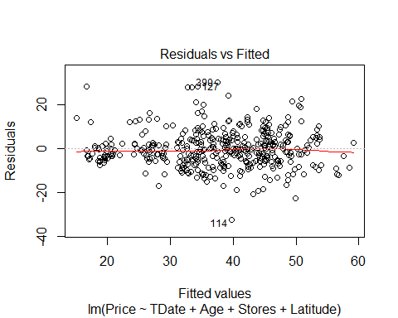

plot(newmodSec, which = 2)

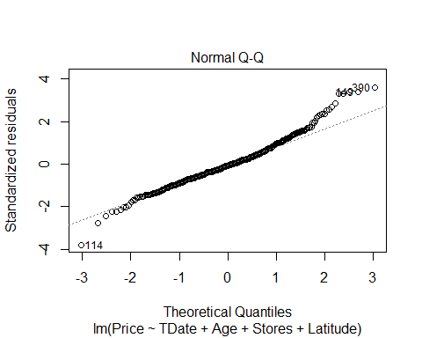

#When we see the Residuals vs Fitted, the line is not parallel at 0 and all points in Normal Q-Q plot are not in the line

Using the Box-Cox method, we see that λ = 0 is both in the interval, and extremely close to the maximum, which suggests a transformation of the form log(Price)

boxCox(newmodSec, lambda = seq(-0.2, 0.4, by = 0.05), plotit = TRUE)

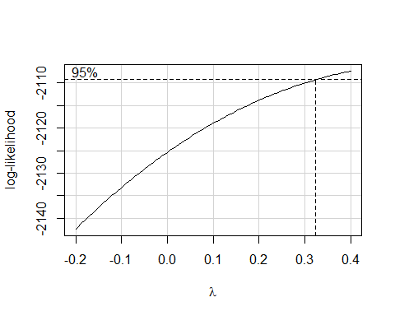

modSec_cox <- lm(log(Price) ~ TDate + Age + Stores + Latitude, data = newData)  
summary(modSec_cox)

##   
## Call:  
## lm(formula = log(Price) ~ TDate + Age + Stores + Latitude, data = newData)  
##   
## Residuals:  
## Min 1Q Median 3Q Max   
## -1.57120 -0.13585 0.00979 0.14493 0.94143   
##   
## Coefficients:  
## Estimate Std. Error t value Pr(>|t|)   
## (Intercept) -4.770e+02 9.104e+01 -5.240 2.59e-07 ***  
## TDate 6.565e-02 4.359e-02 1.506 0.133   
## Age -8.331e-03 1.083e-03 -7.693 1.10e-13 ***  
## Stores 5.465e-02 4.679e-03 11.678 < 2e-16 ***  
## Latitude 1.395e+01 1.104e+00 12.638 < 2e-16 ***  
## ---  
## Signif. codes: 0 '***' 0.001 '**' 0.01 '*' 0.05 '.' 0.1 ' ' 1  
##   
## Residual standard error: 0.2486 on 406 degrees of freedom  
## Multiple R-squared: 0.588, Adjusted R-squared: 0.5839   
## F-statistic: 144.8 on 4 and 406 DF, p-value: < 2.2e-16

#After modifying the model by Box-Cox method, we conclude that the model is not needed to be changed by Box-Cox method because the modified model has insignificant variable, TDate.

We now apply the powertransform method to the model.

summary(Price)

## Min. 1st Qu. Median Mean 3rd Qu. Max.   
## 7.60 27.70 38.45 37.98 46.60 117.50

summary(TDate)

## Min. 1st Qu. Median Mean 3rd Qu. Max.   
## 2013 2013 2013 2013 2013 2014

summary(Age)

## Min. 1st Qu. Median Mean 3rd Qu. Max.   
## 0.000 9.025 16.100 17.713 28.150 43.800

summary(Metro)

## Min. 1st Qu. Median Mean 3rd Qu. Max.   
## 23.38 289.32 492.23 1083.89 1454.28 6488.02

summary(Latitude)

## Min. 1st Qu. Median Mean 3rd Qu. Max.   
## 24.93 24.96 24.97 24.97 24.98 25.01

#Since Age has 0 value and it cannot be transformed by powerTransform. We therefore need to add a small constant to transform  
newData$Age1 <- with(newData, (Age*TDate + 1)/TDate)  
pt <- powerTransform(Price ~ cbind(TDate, Age1, Stores, Latitude), newData)  
summary(pt)

## bcPower Transformation to Normality   
## Est Power Rounded Pwr Wald Lwr Bnd Wald Upr Bnd  
## Y1 0.5854 0.5 0.3941 0.7768  
##   
## Likelihood ratio test that transformation parameter is equal to 0  
## (log transformation)  
## LRT df pval  
## LR test, lambda = (0) 39.79588 1 2.8194e-10  
##   
## Likelihood ratio test that no transformation is needed  
## LRT df pval  
## LR test, lambda = (1) 16.71345 1 4.3472e-05

pt$roundlam

## Y1   
## 0.5

summary(newMod2 <- lm(bcPower(Price, pt$roundlam) ~ TDate + Age1 + Stores + Latitude, data = newData))

##   
## Call:  
## lm(formula = bcPower(Price, pt$roundlam) ~ TDate + Age1 + Stores +   
## Latitude, data = newData)  
##   
## Residuals:  
## Min 1Q Median 3Q Max   
## -6.8564 -0.8779 -0.0252 0.7632 5.1160   
##   
## Coefficients:  
## Estimate Std. Error t value Pr(>|t|)   
## (Intercept) -2.626e+03 5.148e+02 -5.100 5.21e-07 ***  
## TDate 3.983e-01 2.465e-01 1.616 0.107   
## Age1 -5.040e-02 6.124e-03 -8.230 2.57e-15 ***  
## Stores 3.211e-01 2.646e-02 12.135 < 2e-16 ***  
## Latitude 7.343e+01 6.242e+00 11.763 < 2e-16 ***  
## ---  
## Signif. codes: 0 '***' 0.001 '**' 0.01 '*' 0.05 '.' 0.1 ' ' 1  
##   
## Residual standard error: 1.406 on 406 degrees of freedom  
## Multiple R-squared: 0.5836, Adjusted R-squared: 0.5795   
## F-statistic: 142.2 on 4 and 406 DF, p-value: < 2.2e-16

plot(newMod2, which = 1)

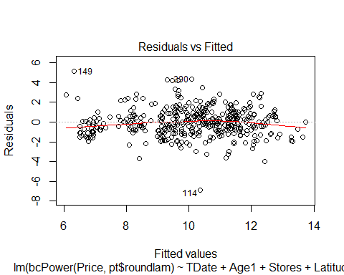

plot(newMod2, which = 2)

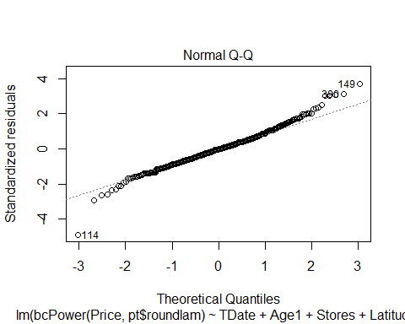 We apply polynomial fits

quadratic.lm1 <- lm(Price ~ TDate + Age + I(Age^2) + Stores + Latitude, data = newData)  
summary(quadratic.lm1)

##   
## Call:  
## lm(formula = Price ~ TDate + Age + I(Age^2) + Stores + Latitude,   
## data = newData)  
##   
## Residuals:  
## Min 1Q Median 3Q Max   
## -29.1291 -4.6118 -0.5942 4.7345 29.6598   
##   
## Coefficients:  
## Estimate Std. Error t value Pr(>|t|)   
## (Intercept) -1.629e+04 2.874e+03 -5.666 2.78e-08 ***  
## TDate 3.425e+00 1.378e+00 2.485 0.0133 *   
## Age -1.367e+00 1.284e-01 -10.646 < 2e-16 ***  
## I(Age^2) 2.663e-02 3.130e-03 8.506 3.51e-16 ***  
## Stores 1.688e+00 1.502e-01 11.234 < 2e-16 ***  
## Latitude 3.778e+02 3.488e+01 10.832 < 2e-16 ***  
## ---  
## Signif. codes: 0 '***' 0.001 '**' 0.01 '*' 0.05 '.' 0.1 ' ' 1  
##   
## Residual standard error: 7.838 on 405 degrees of freedom  
## Multiple R-squared: 0.6278, Adjusted R-squared: 0.6232   
## F-statistic: 136.6 on 5 and 405 DF, p-value: < 2.2e-16

quadratic.lm2 <- lm(Price ~ TDate + Age + I(Age^2) +I(Age^3)+ Stores + Latitude, data = newData)  
summary(quadratic.lm2)

##   
## Call:  
## lm(formula = Price ~ TDate + Age + I(Age^2) + I(Age^3) + Stores +   
## Latitude, data = newData)  
##   
## Residuals:  
## Min 1Q Median 3Q Max   
## -29.3748 -4.5603 -0.4862 4.5653 29.5234   
##   
## Coefficients:  
## Estimate Std. Error t value Pr(>|t|)   
## (Intercept) -1.607e+04 2.880e+03 -5.581 4.39e-08 ***  
## TDate 3.345e+00 1.380e+00 2.424 0.0158 *   
## Age -1.099e+00 2.754e-01 -3.990 7.86e-05 ***  
## I(Age^2) 8.544e-03 1.672e-02 0.511 0.6096   
## I(Age^3) 3.117e-04 2.831e-04 1.101 0.2715   
## Stores 1.695e+00 1.503e-01 11.275 < 2e-16 ***  
## Latitude 3.758e+02 3.492e+01 10.763 < 2e-16 ***  
## ---  
## Signif. codes: 0 '***' 0.001 '**' 0.01 '*' 0.05 '.' 0.1 ' ' 1  
##   
## Residual standard error: 7.836 on 404 degrees of freedom  
## Multiple R-squared: 0.6289, Adjusted R-squared: 0.6234   
## F-statistic: 114.1 on 6 and 404 DF, p-value: < 2.2e-16

quadratic.lm3 <- lm(Price ~ TDate + Age + Stores + Latitude + I(Latitude^2), data = newData)  
summary(quadratic.lm3)

##   
## Call:  
## lm(formula = Price ~ TDate + Age + Stores + Latitude + I(Latitude^2),   
## data = newData)  
##   
## Residuals:  
## Min 1Q Median 3Q Max   
## -32.557 -5.488 -0.608 4.170 32.646   
##   
## Coefficients:  
## Estimate Std. Error t value Pr(>|t|)   
## (Intercept) -2.878e+06 1.237e+06 -2.327 0.0205 *   
## TDate 2.824e+00 1.487e+00 1.898 0.0584 .   
## Age -3.120e-01 3.684e-02 -8.469 4.63e-16 ***  
## Stores 1.813e+00 1.668e-01 10.870 < 2e-16 ***  
## Latitude 2.297e+05 9.907e+04 2.319 0.0209 *   
## I(Latitude^2) -4.592e+03 1.984e+03 -2.315 0.0211 *   
## ---  
## Signif. codes: 0 '***' 0.001 '**' 0.01 '*' 0.05 '.' 0.1 ' ' 1  
##   
## Residual standard error: 8.454 on 405 degrees of freedom  
## Multiple R-squared: 0.567, Adjusted R-squared: 0.5617   
## F-statistic: 106.1 on 5 and 405 DF, p-value: < 2.2e-16

#All polynomial fits does not get better than original one.

After modifying the model by transform methods, we cannot see any significantly positive changes and improvements.There are some influencial points such as outliers in this models and the influencial points distract us when we find the appropriate model. We conclude that transformation is unnecessary to apply because none of method affects to make it clear.

Part 2

concrete<-read.table('Concrete.txt')  
summary(concrete)

## X1 X2 X3 X4   
## Min. :102.0 Min. : 0.0 Min. : 0.00 Min. :121.8   
## 1st Qu.:192.4 1st Qu.: 0.0 1st Qu.: 0.00 1st Qu.:164.9   
## Median :272.9 Median : 22.0 Median : 0.00 Median :185.0   
## Mean :281.2 Mean : 73.9 Mean : 54.19 Mean :181.6   
## 3rd Qu.:350.0 3rd Qu.:142.9 3rd Qu.:118.27 3rd Qu.:192.0   
## Max. :540.0 Max. :359.4 Max. :200.10 Max. :247.0   
## X5 X6 X7 X8   
## Min. : 0.000 Min. : 801.0 Min. :594.0 Min. : 1.00   
## 1st Qu.: 0.000 1st Qu.: 932.0 1st Qu.:731.0 1st Qu.: 7.00   
## Median : 6.350 Median : 968.0 Median :779.5 Median : 28.00   
## Mean : 6.203 Mean : 972.9 Mean :773.6 Mean : 45.66   
## 3rd Qu.:10.160 3rd Qu.:1029.4 3rd Qu.:824.0 3rd Qu.: 56.00   
## Max. :32.200 Max. :1145.0 Max. :992.6 Max. :365.00   
## Y   
## Min. : 2.332   
## 1st Qu.:23.707   
## Median :34.443   
## Mean :35.818   
## 3rd Qu.:46.136   
## Max. :82.599

names(concrete)

## [1] "X1" "X2" "X3" "X4" "X5" "X6" "X7" "X8" "Y"

head(concrete)

## X1 X2 X3 X4 X5 X6 X7 X8 Y  
## 1 540.0 0.0 0 162 2.5 1040.0 676.0 28 79.98611  
## 2 540.0 0.0 0 162 2.5 1055.0 676.0 28 61.88737  
## 3 332.5 142.5 0 228 0.0 932.0 594.0 270 40.26954  
## 4 332.5 142.5 0 228 0.0 932.0 594.0 365 41.05278  
## 5 198.6 132.4 0 192 0.0 978.4 825.5 360 44.29608  
## 6 266.0 114.0 0 228 0.0 932.0 670.0 90 47.02985

mod.full<-lm(Y~.,data=concrete)  
anova(mod.full)

## Analysis of Variance Table  
##   
## Response: Y  
## Df Sum Sq Mean Sq F value Pr(>F)   
## X1 1 71172 71172 658.0463 < 2.2e-16 ***  
## X2 1 22957 22957 212.2606 < 2.2e-16 ***  
## X3 1 21636 21636 200.0464 < 2.2e-16 ***  
## X4 1 11459 11459 105.9488 < 2.2e-16 ***  
## X5 1 1360 1360 12.5785 0.0004079 ***  
## X6 1 253 253 2.3435 0.1261178   
## X7 1 1 1 0.0058 0.9393393   
## X8 1 47905 47905 442.9232 < 2.2e-16 ***  
## Residuals 1021 110428 108   
## ---  
## Signif. codes: 0 '***' 0.001 '**' 0.01 '*' 0.05 '.' 0.1 ' ' 1

According to the anova table above, 1021=n-8-1. So n=1030

1. forward selection with BIC

mod.0<-lm(Y~1, data=concrete) #linear model with only intercepts  
mod.full<-lm(Y~.,data=concrete) #full model  
step(mod.0, scope = list(lower = mod.0, upper = mod.full), direction = 'forward', k = log(1030))

## Start: AIC=5806.38  
## Y ~ 1  
##   
## Df Sum of Sq RSS AIC  
## + X1 1 71172 216001 5520.0  
## + X5 1 38490 248683 5665.1  
## + X8 1 31061 256112 5695.4  
## + X4 1 24087 263086 5723.1  
## + X7 1 8033 279140 5784.1  
## + X6 1 7811 279362 5784.9  
## + X2 1 5220 281953 5794.4  
## + X3 1 3212 283961 5801.7  
## <none> 287173 5806.4  
##   
## Step: AIC=5519.97  
## Y ~ X1  
##   
## Df Sum of Sq RSS AIC  
## + X5 1 29646.5 186354 5374.8  
## + X8 1 23993.8 192007 5405.6  
## + X2 1 22957.4 193043 5411.2  
## + X4 1 17926.8 198074 5437.7  
## + X6 1 3548.0 212453 5509.8  
## + X3 1 2894.4 213106 5513.0  
## <none> 216001 5520.0  
## + X7 1 960.2 215041 5522.3  
##   
## Step: AIC=5374.85  
## Y ~ X1 + X5  
##   
## Df Sum of Sq RSS AIC  
## + X8 1 37498 148857 5150.4  
## + X2 1 19456 166898 5268.2  
## + X7 1 5862 180493 5348.9  
## <none> 186354 5374.8  
## + X4 1 782 185572 5377.5  
## + X3 1 741 185613 5377.7  
## + X6 1 241 186113 5380.4  
##   
## Step: AIC=5150.38  
## Y ~ X1 + X5 + X8  
##   
## Df Sum of Sq RSS AIC  
## + X2 1 19908.5 128948 5009.4  
## + X4 1 4868.8 143988 5123.1  
## + X7 1 3385.5 145471 5133.6  
## <none> 148857 5150.4  
## + X3 1 323.9 148533 5155.1  
## + X6 1 36.9 148820 5157.1  
##   
## Step: AIC=5009.43  
## Y ~ X1 + X5 + X8 + X2  
##   
## Df Sum of Sq RSS AIC  
## + X4 1 9544.7 119403 4937.2  
## + X3 1 6524.7 122423 4962.9  
## + X6 1 1737.0 127211 5002.4  
## <none> 128948 5009.4  
## + X7 1 3.5 128945 5016.3  
##   
## Step: AIC=4937.16  
## Y ~ X1 + X5 + X8 + X2 + X4  
##   
## Df Sum of Sq RSS AIC  
## + X3 1 8547.4 110856 4867.6  
## + X7 1 1895.7 117508 4927.6  
## <none> 119403 4937.2  
## + X6 1 24.1 119379 4943.9  
##   
## Step: AIC=4867.59  
## Y ~ X1 + X5 + X8 + X2 + X4 + X3  
##   
## Df Sum of Sq RSS AIC  
## <none> 110856 4867.6  
## + X6 1 44.271 110812 4874.1  
## + X7 1 29.398 110827 4874.3

##   
## Call:  
## lm(formula = Y ~ X1 + X5 + X8 + X2 + X4 + X3, data = concrete)  
##   
## Coefficients:  
## (Intercept) X1 X5 X8 X2   
## 29.03022 0.10543 0.23900 0.11349 0.08649   
## X4 X3   
## -0.21829 0.06871

Do diagnostic checks

mod.for<-lm(Y ~ X1 + X5 + X8 + X2 + X4 + X3, data = concrete)  
plot(mod.for)

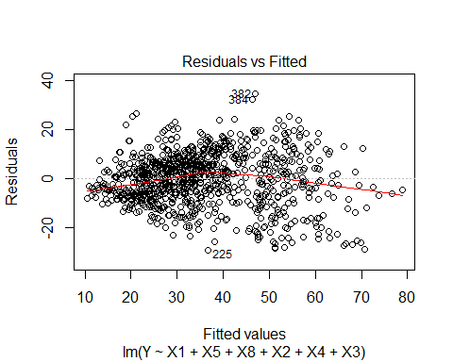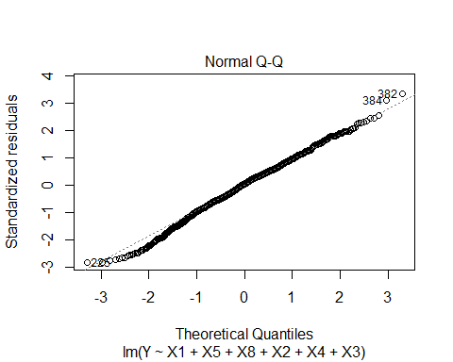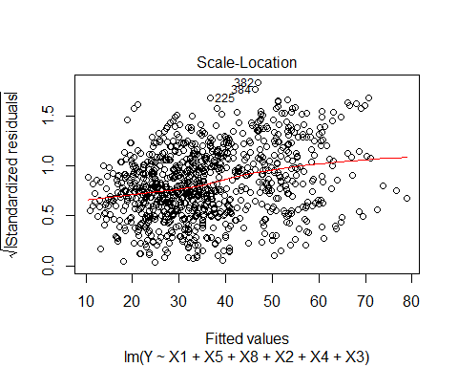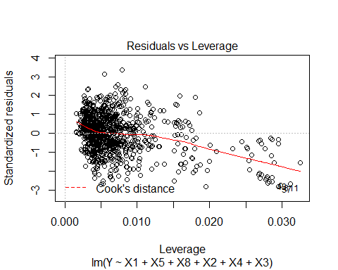

According to the plots, model by forward selection pretty fufills noramlity, linearity, and constant variance.

Use influenceIndexPlot to find influential points

library(car)  
infIndexPlot(mod.for)

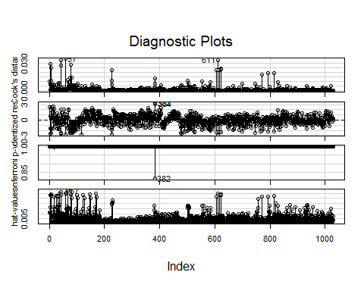

predict(mod.for, data.frame(X1= 200, X5=10, X8=100, X2=150, X4=180, X3=85),  
interval = 'confidence', level = 0.95)

## fit lwr upr  
## 1 43.37686 42.12569 44.62803

We are 95% confident that true mean response is between 42.126 and 44.628

predict(mod.for, data.frame(X1= 200, X5=10, X8=100, X2=150, X4=180, X3=85),  
interval = 'prediction', level = 0.95)

## fit lwr upr  
## 1 43.37686 22.91161 63.84211

We are 95% confident that concrete compressive strength for and individual value of each predictor values is between 22.912 and 63.842

1. Backward elimination with BIC

step(mod.full, scope = list(lower = mod.0, upper = mod.full), direction = 'backward', k = log(1030))

## Start: AIC=4877.49  
## Y ~ X1 + X2 + X3 + X4 + X5 + X6 + X7 + X8  
##   
## Df Sum of Sq RSS AIC  
## - X7 1 384 110812 4874.1  
## - X6 1 398 110827 4874.3  
## <none> 110428 4877.5  
## - X5 1 1046 111474 4880.3  
## - X4 1 1513 111942 4884.6  
## - X3 1 5281 115709 4918.7  
## - X2 1 11353 121781 4971.3  
## - X1 1 21533 131961 5054.0  
## - X8 1 47905 158333 5241.7  
##   
## Step: AIC=4874.12  
## Y ~ X1 + X2 + X3 + X4 + X5 + X6 + X8  
##   
## Df Sum of Sq RSS AIC  
## - X6 1 44 110856 4867.6  
## <none> 110812 4874.1  
## - X5 1 877 111688 4875.3  
## - X4 1 8526 119338 4943.5  
## - X3 1 8568 119379 4943.9  
## - X2 1 30693 141505 5119.0  
## - X8 1 47522 158334 5234.8  
## - X1 1 64008 174819 5336.8  
##   
## Step: AIC=4867.59  
## Y ~ X1 + X2 + X3 + X4 + X5 + X8  
##   
## Df Sum of Sq RSS AIC  
## <none> 110856 4867.6  
## - X5 1 865 111721 4868.7  
## - X3 1 8547 119403 4937.2  
## - X4 1 11567 122423 4962.9  
## - X2 1 32757 143613 5127.3  
## - X8 1 47731 158587 5229.5  
## - X1 1 66760 177616 5346.2

##   
## Call:  
## lm(formula = Y ~ X1 + X2 + X3 + X4 + X5 + X8, data = concrete)  
##   
## Coefficients:  
## (Intercept) X1 X2 X3 X4   
## 29.03022 0.10543 0.08649 0.06871 -0.21829   
## X5 X8   
## 0.23900 0.11349

Do diagnostic checks

mod.back<-lm(Y ~ X1 + X2 + X3 + X4 + X5 + X8, data=concrete)  
plot(mod.back)

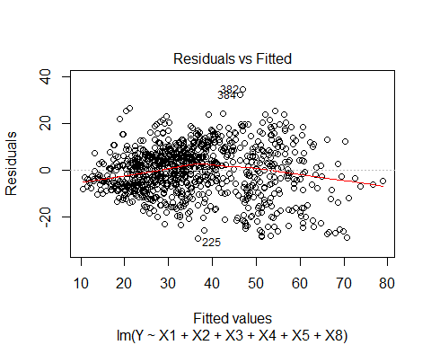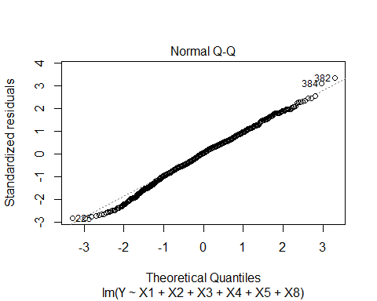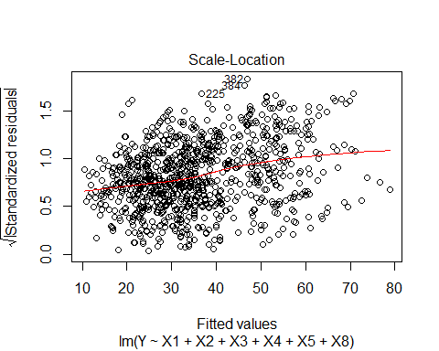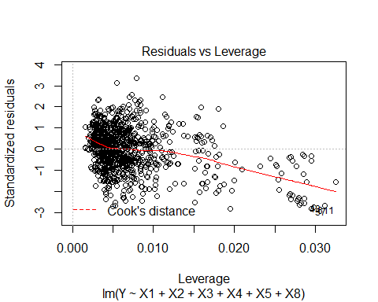

According to the plots, model by forward selection pretty fufills noramlity, linearity, and constant variance.

Use influenceIndexPlot to find influential points to remove

library(car)  
infIndexPlot(mod.back)



anova(mod.for, mod.back)

## Analysis of Variance Table  
##   
## Model 1: Y ~ X1 + X5 + X8 + X2 + X4 + X3  
## Model 2: Y ~ X1 + X2 + X3 + X4 + X5 + X8  
## Res.Df RSS Df Sum of Sq F Pr(>F)  
## 1 1023 110856   
## 2 1023 110856 0 5.8208e-11

The models derived by two differnt methods are same except for the order of predictors. And the result of ANOVA also same.

**Conclusions**

We conduct two types of study to find the best way of model selection and both part 1 and part 2 are sort of choosing models, but the way they approach how to select the model is different. In the case of part 1, we set an abstract model first and then we try to find an adequate model by adding and deducting some variables. Lastly, we transform some relatively insignificant variables to get more precise model. On the other hand, in part 2, we used two different model selecting methods: forward selection and backward elimination. When we use these methods, we do not have to go through all the processes of adding and deducting variables as we tried in part 1. Therefore, we conclude that even though we intend to choose the most adequate model in both Part1 and Part2, the method we use in the Part 2 is more efficient to choose the model. However, we believe that this method does not guarantee that the model we have as a result of the method in part 2 is absolutely right to make a conclusion because there is a possible way to get better model such as transformation and applying to nonlinear model.