ReviewRoll
A Movie Review, Watchlist & Discussion Platform

DBMS Project Report — Tasks 1 & 2
Tutorial Group 7 · Group 95
Anmol Saluja (2024085) · Ishank Choudhary (2024268) · Rishit Sansanwal (2024468)

Introduction
ReviewRoll is a database-centric web application that brings movie enthusiasts together on a single structured platform. Users can discover films, submit ratings and reviews, manage watchlists, and participate in discussion threads. The project demonstrates core relational database principles — schema design, normalisation, constraints, triggers, and transactions — applied to a real-world problem.

Task 1: Project Scope & Business Requirements

1.1 The Real-World Problem
Movie lovers today juggle multiple disconnected platforms — one for ratings, another for reviews, another for discussions. ReviewRoll consolidates these into a single system offering peer-sourced ratings, written reviews, personal watchlists, and moderated discussion boards, all backed by a robust relational database.

1.2 Target Users
- General Users — Browse, rate, review, and discuss films; maintain personal watchlists; request new movies.
- Administrators — Approve movie requests, moderate discussions, and manage movie metadata.

1.3 Major Features
- User Management — Registration, authentication, and role-based access (User / Admin).
- Movie Catalogue — Rich metadata: title, year, language, duration, description, budget, revenue, average rating, trailers, and trivia.
- Ratings & Reviews — Numeric ratings (1–10) and written reviews per user per movie; aggregate average maintained via trigger.
- Watchlists — Users create named watchlists and add movies via the Watchlist_Item junction table.
- Cast & Crew — Movie_Cast (character name, billing order) and Movie_Crew (job, department) link movies to persons.
- Genre Tagging — Many-to-many tagging via Movie_Genre.
- Discussion Boards — Threaded posts with nested replies (self-referencing FK) and soft-delete support.
- Movie Requests — Users submit new-movie requests; admins approve or reject them.

1.4 Key Assumptions
- One rating and one review per user per movie (unique constraint on User_ID + Movie_ID).
- Avg_rating is a derived field, auto-updated by a trigger on the Rating table.
- Discussion threads may reference a movie, a genre, or both (nullable FKs).
- Admins are identified by Role = 'admin' in the User table — no separate admin table needed.
- Soft deletion (Is_deleted) preserves thread continuity for removed posts.

1.5 Why a Database is Necessary
- Referential Integrity — FK constraints prevent orphaned reviews or ratings.
- Concurrent Access — ACID transactions handle simultaneous writes safely.
- Complex Queries — Multi-table joins power features like "top-rated films by genre".
- Triggers & Automation — Avg_rating recalculates automatically on every rating change.
- Scalability — 3NF normalisation eliminates redundancy and update anomalies.

Task 2: Conceptual Model — ER Diagram & Relational Schema

2.1 ER Diagram
The ER diagram below maps every business requirement to a formal entity or relationship. Each major feature — ratings, reviews, watchlists, cast/crew, genres, discussions, and requests — is represented by a dedicated entity.
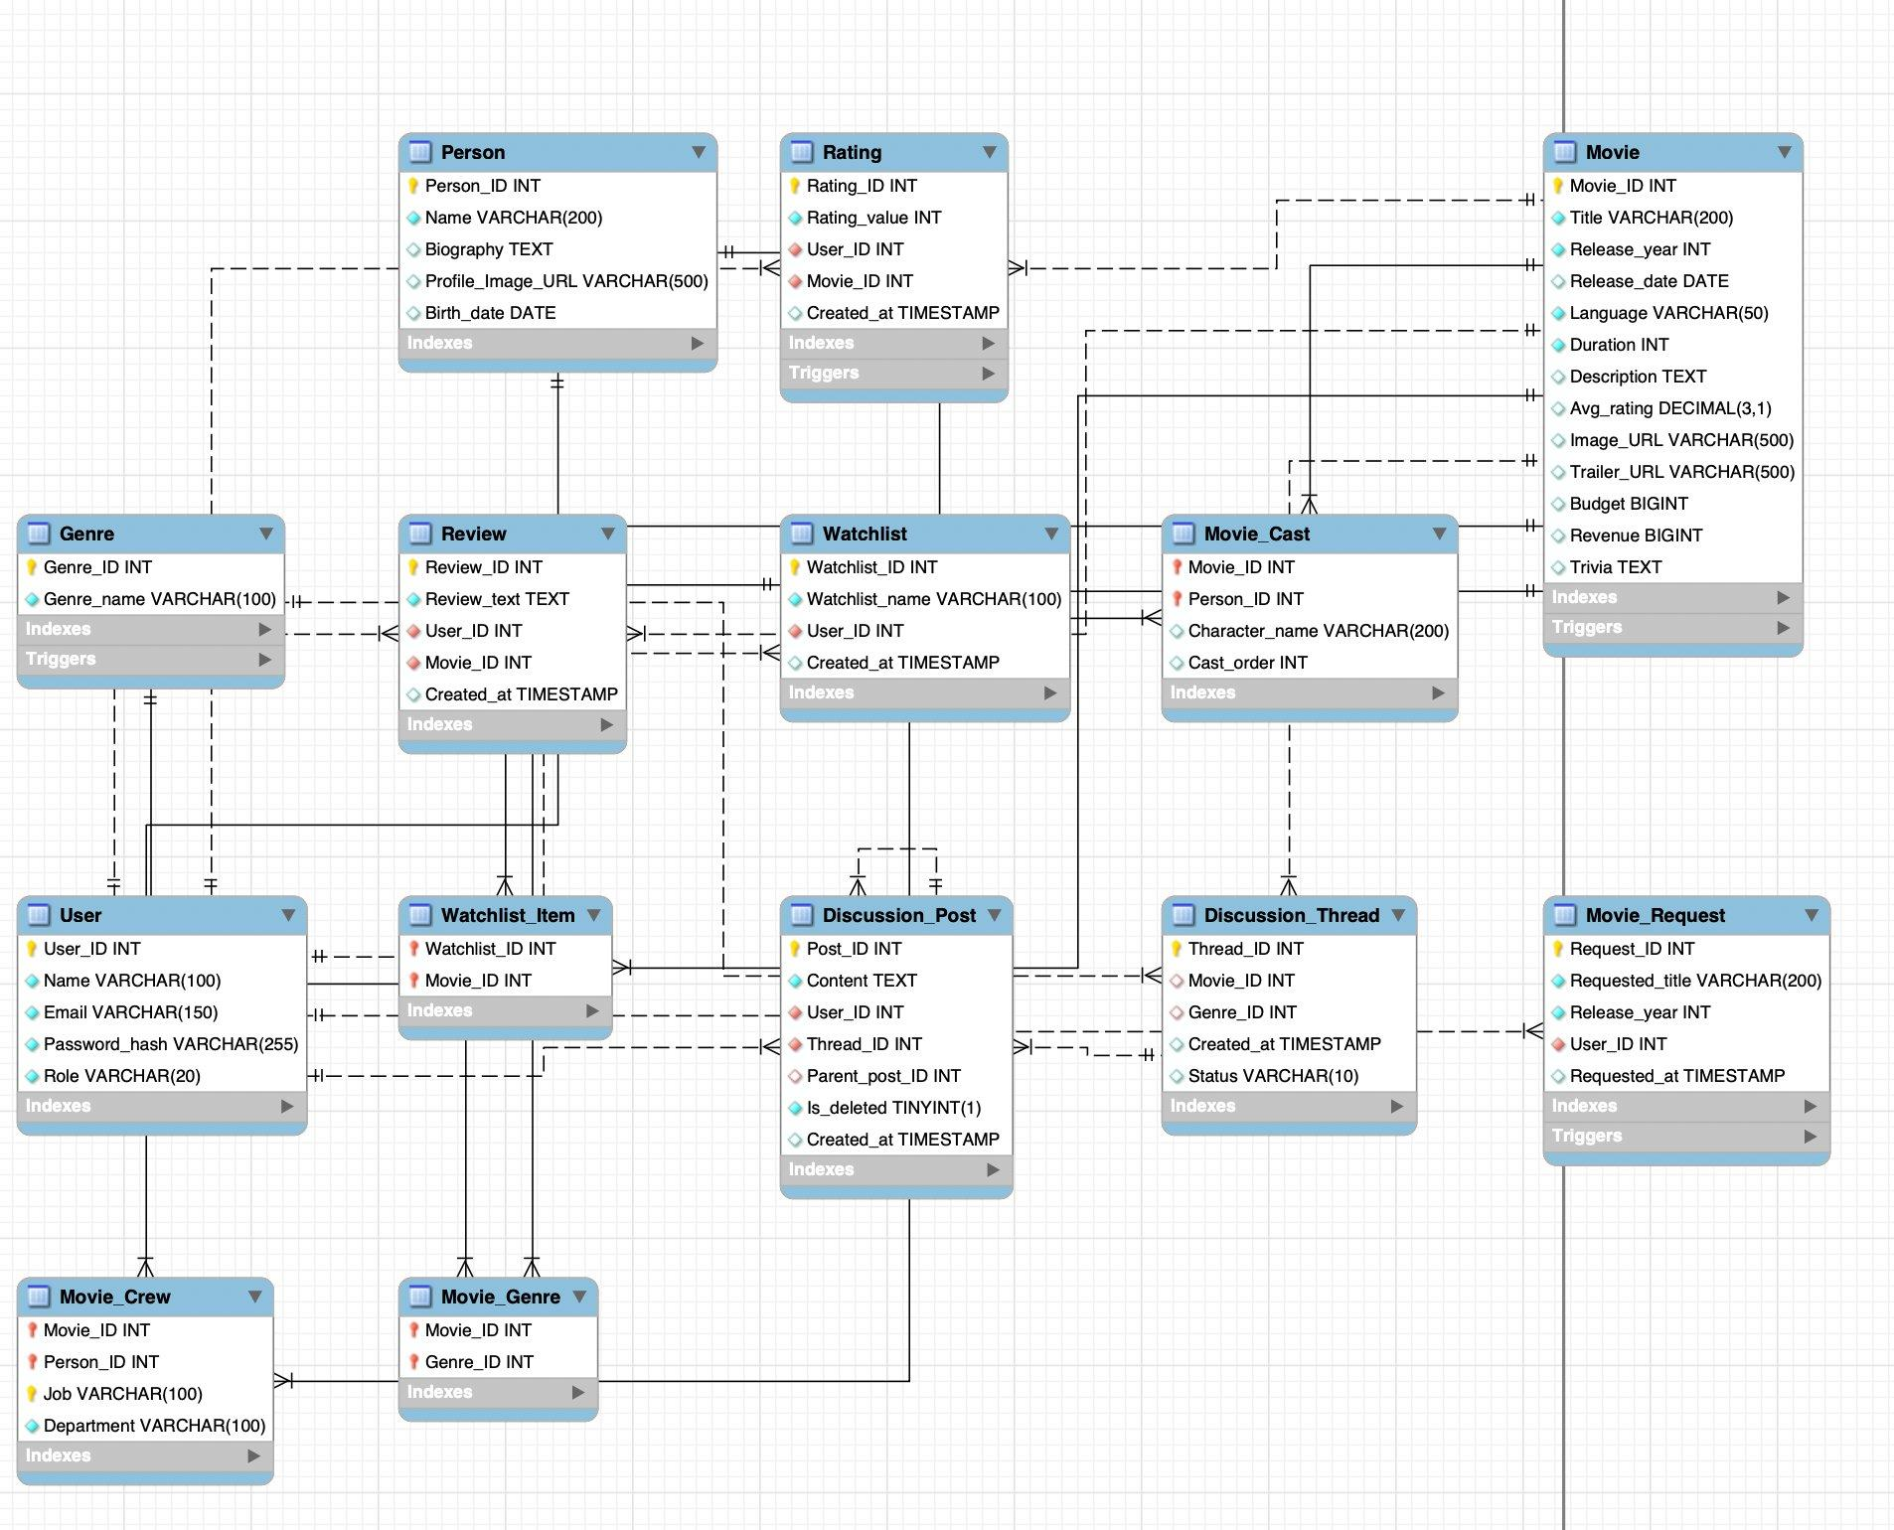
Figure 1: ER Diagram — ReviewRoll

2.2 Key Entities & Relationships
The schema comprises 13 tables. Key entities and their roles:
- User — Central actor. Participates in Rating, Review, Watchlist, Discussion_Post, and Movie_Request.
- Movie — Core content entity with full metadata including budget, revenue, avg rating, and media URLs.
- Person — Represents cast and crew members, linked to movies via Movie_Cast and Movie_Crew.
- Genre — Lookup table; linked to movies via Movie_Genre (M:N).
- Rating / Review — Each tied to one User and one Movie (1:N from both sides); unique per user-movie pair.
- Watchlist + Watchlist_Item — User owns many watchlists (1:N); each watchlist contains many movies via Watchlist_Item (M:N).
- Movie_Cast / Movie_Crew — Junction tables resolving M:N between Movie and Person, with extra attributes (character name, job, department).
- Discussion_Thread + Discussion_Post — Thread is the parent container; posts support nested replies via self-referencing Parent_post_ID.
- Movie_Request — Users submit requests; admins action them.

2.3 Relational Model
The relational schema below is the direct conversion of the ER diagram into tables. Each entity becomes a table; M:N relationships become junction tables; 1:N relationships are represented by foreign keys.
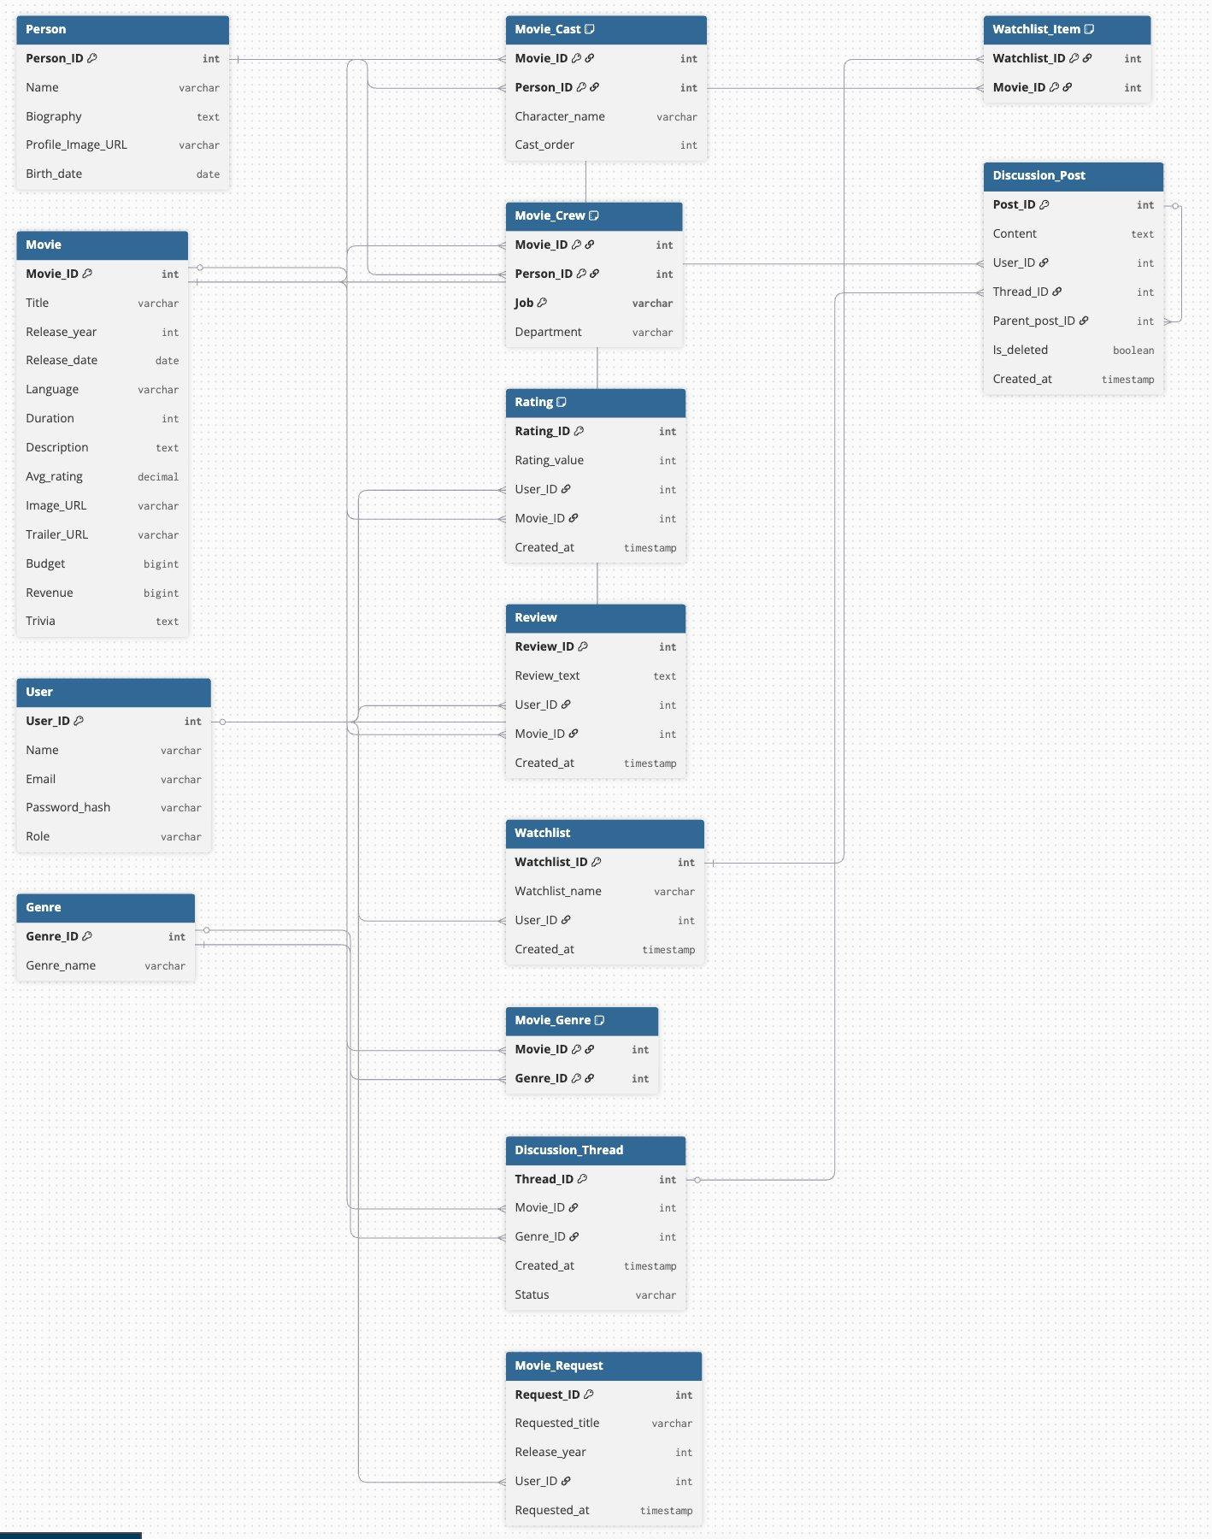
Figure 2: Relational Schema — ReviewRoll

2.4 ER-to-Relational Conversion
Conversion follows standard mapping rules:
- Strong Entities → Tables — Each entity maps to a table; its identifier becomes the Primary Key. All attributes become columns with appropriate data types.
- M:N Relationships → Junction Tables — Movie_Genre, Movie_Cast, Movie_Crew, and Watchlist_Item are junction tables with composite PKs. Relationship attributes (e.g., Character_name, Job) are included as non-key columns.
- 1:N Relationships → Foreign Keys — The PK of the 'one' side appears as a FK on the 'many' side — e.g., User_ID in Rating, Review, Watchlist, Discussion_Post, and Movie_Request.
- Self-Referencing FK — Discussion_Post.Parent_post_ID is a nullable FK referencing Post_ID in the same table, enabling threaded nested replies.

2.5 Constraints & Normalisation
- Primary Keys — Simple auto-increment PKs for independent entities; composite PKs for junction tables.
- Foreign Keys — All inter-table references enforced, preventing orphaned records.
- UNIQUE — Email in User; (User_ID, Movie_ID) in Rating and Review.
- CHECK — Rating_value constrained to 1–10.
- Trigger — Avg_rating in Movie recalculated automatically after any Rating insert/update/delete.
- 3NF — Multi-valued attributes (genres, cast, crew) factored into junction tables; no redundancy or update anomalies.

Conclusion
ReviewRoll demonstrates a complete relational database design for a real-world entertainment platform. The ER model faithfully captures all business requirements across 13 entities, which are systematically converted to a normalised relational schema enforced with keys, constraints, and triggers. Junction tables, self-referencing FKs, and trigger-maintained averages collectively ensure consistency, query efficiency, and maintainability at scale.

