Project Documentation:

Online police Record Management System

Submitted By:

* + **Inzamam Ul Haq 107**
  + **Faisal Rahseed 170\***
  + **Muhammad Muneeb 124**
  + **Moin Ahmad 132**
  + **Hafiz Muhammad Zaid Amjad 128**
  + **Muhammad Shahzad 140**

Class:

**BSCS Evening 5th**

Session:

**2014-2018**

The Islamia University of Bahawalpur

# Contents:

* + Summary ………………………………………………………………………………………………………3
  + Advantages ………………………………………………………………………………………………………4
  + Objectives ………………………………………………………………………………………………………4
  + Functional Requirements …………………………………………………………………………………5-6
  + Use Case Diagram ………………………………………………………………………………………………7
  + Use Case Scenario ………………………………………………………………………………………………8
    - Login ……………………………………………………………………………………………………..8
    - Add ……………………………………………………………………………………………………..9
    - Edit ……………………………………………………………………………………………………..10
    - View ……………………………………………………………………………………………………..11
    - Status ……………………………………………………………………………………………………..12
    - Search ……………………………………………………………………………………………………..13
    - Delete ……………………………………………………………………………………………………..14
    - FIR ……………………………………………………………………………………………………..15
  + Logical Database Design ……………………………………………………………………………………..16
  + User Interface ….………………………………………………………………………………………………..17-20

# Summary:

Installing the online system to police management system reduces much more deficiencies. People just go to police station, meet with front desk officers, tell their problems and appropriate response. Front desk officers are not uniformed. So people just feel comfortable in telling their issues to the officers.

The front desk officer listens to the complainant and register their pre-FIR report. And that report is forwarded to the Officer of the respective Police Station. The officer will visit the complainant and have some necessary info about the case. If the issue is serious, the FIR will be submitted. If the officer doesn’t respond within 24 hours, the pre-FIR report will be automatically forwarded to IG-Cell /DPO-Cell.

# Advantages:

* 1. Time Saving
  2. No fear of Uniform
  3. Quick Response
  4. Corruption less

# Objective:

As in our traditional police culture, it is known that people should have some fear of uniform. And as they have to go to police station for their complaints or issues. And there they have some fear from the officers and also from the uniform. The second major fault of our police system is corruption.

## External Interface Requirements

### 3.1.1 System Interfaces

### 3.1.2 Interfaces

### User Interface

### For the front end of the database the software provides good graphical interface. That the users can use the software with ease.

### 3.1.3 Hardware Interfaces

### The hardware requirement should be in the system.

### • Processor should have Dual Core,

### • The RAM should be greater than 1GB

### • Processor should be 2GHz

### • The Hard disk should be 160 GB.

## Non-Functional Requirements

### The additional requirements specification applies to Police Record Management System. This condition defines the non-functional requirement of the scheme

### 3.5.1 Performance

The performance depends on hardware specification.

### 3.5.2 Reliability

Reliability The system is required during working time.

### 3.5.3 Availability

It stands not for one application; many users may use it at a time.

### 3.5.5 Maintainability

It means the developed project should be maintained in future.

### 3.5.6 Portability

The developed project should run on all types of pc

## 3.6Design Constraints

Require project boundaries that can be essential by other standards, hardware limitations, etc.

Functional REQUIREMENTS.

|  |  |  |  |
| --- | --- | --- | --- |
| **Id** | **Requirement** | **Priority** | **Source** |
| **REQ 1.** | There should a mechanism to operate the complaint automatically | High | Front desk |
| **REQ 2.** | The User should be able to enter his username and password to login | High | Front desk |
| **REQ 3.** | The User should be able to add a new complain of complainant | High | Front desk |
| **REQ 4.** | The User should be able to enter the basic information of the complainant including cell number | Low | Front desk |
| **REQ 5.** | The User should be able to enter all the relative information regarding the complaint | Medium | Front Desk |
| **REQ 6.** | The User should be able to edit any complaint that has already been registered | Low | Front Desk |
| **REQ 7.** | The user should be able to remove any complain | Low | Front Desk |
| **REQ 8.** | The user should be able to view to status of any complain | Medium | Front Desk |
| **REQ 9.** | The complainant should be able to view the status of his complain by searching with cell number or complain number | Medium | Complainant |
| **REQ 10.** | The user should be able to register the FIR of any complain by providing the complaint number | High | Front Desk |
| **REQ 11.** | the user should be able to view the total number of complaints ,FIR and those with pending cases | High | Front Desk |
| **REQ 12.** | System should provide the facility of text messaging on the complainant cell number | High | Operations Department |
| **REQ 13.** | System should forward the complaint to the investigation officer | Medium | IG Office complain Cell |
| **REQ 14.** | The system should forward the complaint to the head office if it is not reported by the investigation officer | High | Operations Department |

Use Case Diagram

Log In

Add Complaint

Edit Complaint

View Complaint

View Status

Search Complaint

Del. Complaint

Front Desk

Officer

Complainant

IG/DPO Cell

Request for Complaint

Use Case Scenarios

|  |  |  |
| --- | --- | --- |
| **Use Case Title** | **LOGIN** | |
| **Abbreviated Title** |  | |
| **Use Case Id** | UC001 | |
| **Requirement Id** | REQ 2 | |
| **Desecration:** In this ,the user will login to the system | | |
| **Pre Conditions:** Login portal should be open | | |
| **Task Sequence** | | **Exceptions** |
| 1. The user will enter the | | Server is down/Invalid Login. |
| **Post Conditions:** System will indicate successful submission | | |
| **Unresolved issues: None** | | |
| **Authority:** Front Desk Officer and DPO/IG Cell. | | |
| **Modification history: None**  **Author:** SYED SALMAN QADRI  **Description:** Initial version | | |

|  |  |  |
| --- | --- | --- |
| **Use Case Title** | **ADD COMPLAINT** | |
| **Abbreviated Title** |  | |
| **Use Case Id** | UC002 | |
| **Requirement Id** | REQ 3 | |
| **Desecration:** In this ,the user will add a new complaint to the system. | | |
| **Pre Conditions:** Add Complaint portal should be open | | |
| **Task Sequence** | | **Exceptions** |
| 1. The user will enter the complaint. | | Server is down. |
| **Post Conditions:** System will indicate successful submission | | |
| **Unresolved issues: None** | | |
| **Authority:** Front Desk Officer | | |
| **Modification history: None**  **Author:** SYED SALMAN QADRI  **Description:** Initial version | | |

|  |  |  |
| --- | --- | --- |
| **Use Case Title** | **EDIT COMPLAINT** | |
| **Abbreviated Title** |  | |
| **Use Case Id** | UC003 | |
| **Requirement Id** | REQ 6 | |
| **Desecration:** In this ,the user will edit an existing complaint. | | |
| **Pre Conditions:** Edit Complaint portal should be open | | |
| **Task Sequence** | | **Exceptions** |
| 1. The user will edit the complaint if it already exists in system. | | Complaint ID doesn’t exist. |
| **Post Conditions:** System will indicate successful Updation. | | |
| **Unresolved issues: None** | | |
| **Authority:** Front Desk Officer | | |
| **Modification history: None**  **Author:** SYED SALMAN QADRI  **Description:** Initial version | | |

|  |  |  |
| --- | --- | --- |
| **Use Case Title** | **VIEW COMPLAINT** | |
| **Abbreviated Title** |  | |
| **Use Case Id** | UC004 | |
| **Requirement Id** | REQ 8 | |
| **Desecration:** In this ,the user will view an existing complaint. | | |
| **Pre Conditions:** View Complaint portal should be open | | |
| **Task Sequence** | | **Exceptions** |
| 1. The user will be able to view the complaint if it already exists in system. | | Complaint ID doesn’t exist. |
| **Post Conditions:** System will display the complaint. | | |
| **Unresolved issues: None** | | |
| **Authority:** Front Desk Officer ,IG/DPO cell | | |
| **Modification history: None**  **Author:** SYED SALMAN QADRI  **Description:** Initial version | | |

|  |  |  |
| --- | --- | --- |
| **Use Case Title** | **VIEW STATUS** | |
| **Abbreviated Title** |  | |
| **Use Case Id** | UC005 | |
| **Requirement Id** | REQ 9 | |
| **Desecration:** In this ,the user will be able to view status of complaint. | | |
| **Pre Conditions:** Search Complaint portal should be open | | |
| **Task Sequence** | | **Exceptions** |
| 1. The user will view status of the complaint if it already exists in system. | | Complaint ID doesn’t exist. |
| **Post Conditions:** System will display the status (Yes or No). | | |
| **Unresolved issues: None** | | |
| **Authority:** Complainant and Front Desk Officer | | |
| **Modification history: None**  **Author:** SYED SALMAN QADRI  **Description:** Initial version | | |

|  |  |  |
| --- | --- | --- |
| **Use Case Title** | **SEARCH COMPLAINT** | |
| **Abbreviated Title** |  | |
| **Use Case Id** | UC006 | |
| **Requirement Id** | REQ 11 | |
| **Desecration:** In this ,the user will search an existing complaint. | | |
| **Pre Conditions:** Search Complaint portal should be open | | |
| **Task Sequence** | | **Exceptions** |
| 1. The user will search the complaint if it already exists in system. | | Complaint ID doesn’t exist/ Invalid Complaint ID. |
| **Post Conditions:** System will display the requested complaint. | | |
| **Unresolved issues: None** | | |
| **Authority:** Front Desk Officer | | |
| **Modification history: None**  **Author:** SYED SALMAN QADRI  **Description:** Initial version | | |

|  |  |  |
| --- | --- | --- |
| **Use Case Title** | **DELETE COMPLAINT** | |
| **Abbreviated Title** |  | |
| **Use Case Id** | UC007 | |
| **Requirement Id** | REQ 7 | |
| **Desecration:** In this ,the user will delete an existing complaint. | | |
| **Pre Conditions:** Delete Complaint portal should be open | | |
| **Task Sequence** | | **Exceptions** |
| 1. The user will edit the complaint if it already exists in system. | | Complaint ID doesn’t exist. |
| **Post Conditions:** System will indicate successful Deletion. | | |
| **Unresolved issues: None** | | |
| **Authority:** Front Desk Officer | | |
| **Modification history: None**  **Author:** SYED SALMAN QADRI  **Description:** Initial version | | |

|  |  |  |
| --- | --- | --- |
| **Use Case Title** | **REGISTER FIR** | |
| **Abbreviated Title** |  | |
| **Use Case Id** | UC008 | |
| **Requirement Id** | REQ 11 | |
| **Desecration:** In this ,the user will Register an FIR. | | |
| **Pre Conditions:** Add FIR portal should be open. | | |
| **Task Sequence** | | **Exceptions** |
| 1. The user will add a new FIR regarding to the complaint ID in system. | | Complaint ID doesn’t exist. |
| **Post Conditions:** System will indicate successful FIR Submission. | | |
| **Unresolved issues: None** | | |
| **Authority:** Front Desk Officer | | |
| **Modification history: None**  **Author:** SYED SALMAN QADRI  **Description:** Initial version | | |

Logical Database Design:

Name

CNIC

1

1

M

1

Complainant Basic Info.

M

1

1

1

M

Gender

Contact

1

Address

1

1

1

Password

Username

Front Desk/DPO/IG Cell

1

## User Interface:

## Log In and Search Form.

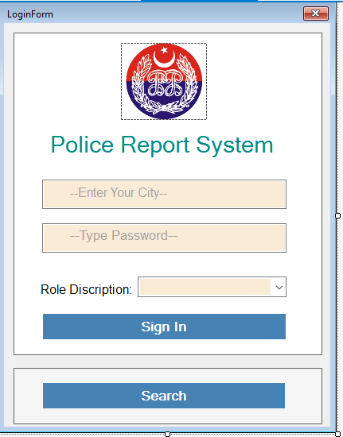

Station Complaint Listing:

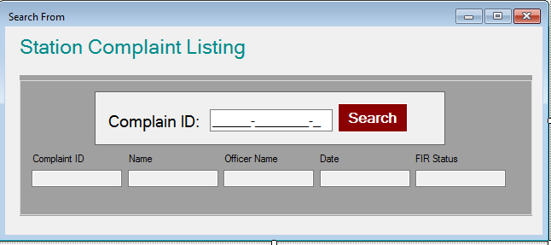

## Register Complaint Form.

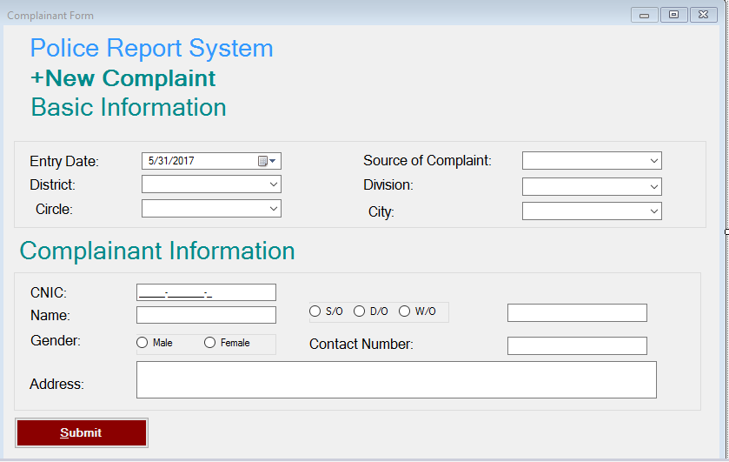

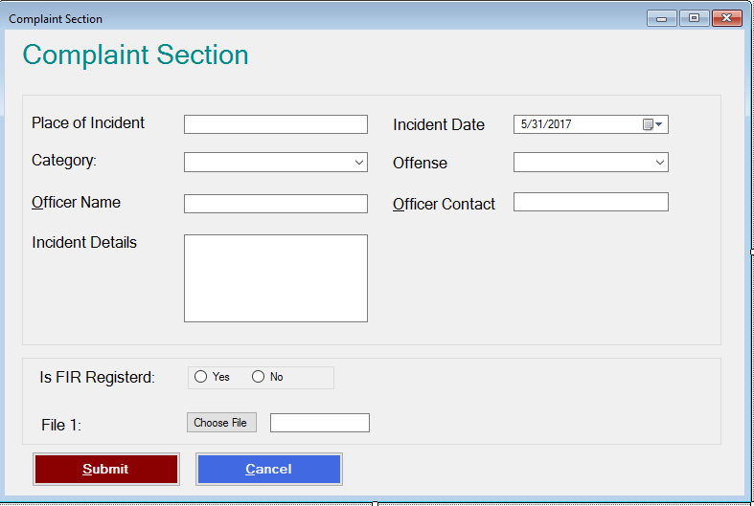

## Dtabase Information.

Sql Server 2014 is used; command Type is Store Procedure.

## Dtabase Design For Complaint Information.

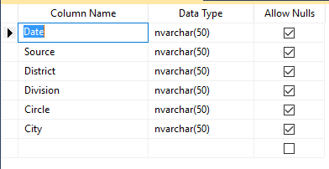

## Dtabase Design For Complaint Information.

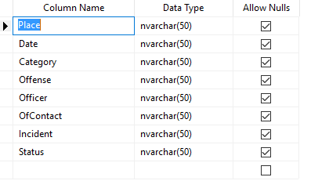

## Dtabase Design For Complainant Information:

