**The Nominal Dataset is shown as this:**

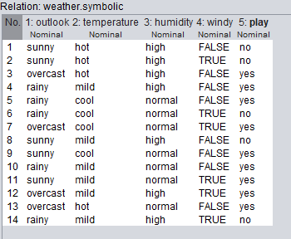

**Plot Matrix (correlation Matrix):**

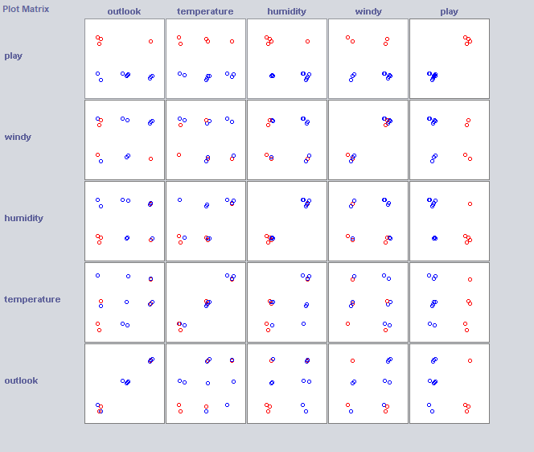

**Removing Outlook and Temperature:**

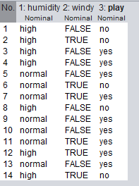

Removing Outlook because as when we visualize the pair plots for all these attributes while looking into that we can see that it holds a less correlation with the play attribute which in turn will not be useful in providing a good decision.

Also removing Temperature Attribute because it seems to be similar to the humidity attribute so either way we can drop one or the other and in my case I am dropping Temperature.

**The Numeric Dataset is shown as:**

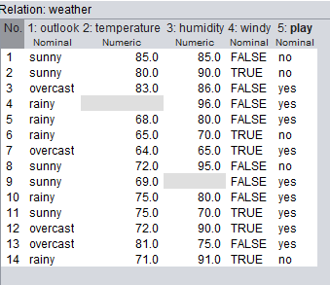

**Filling Missing Values:**

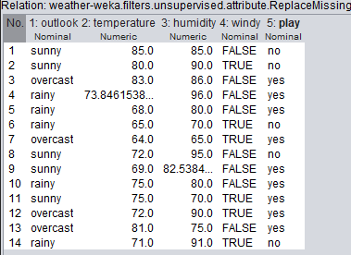

**The small_telco_labOne Dataset is shown as:**

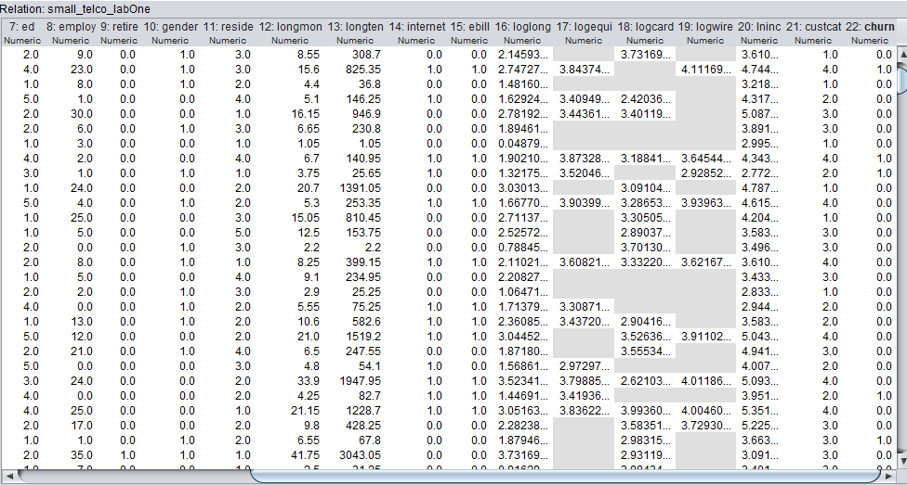

**After Replacing Filling Missing Values :**

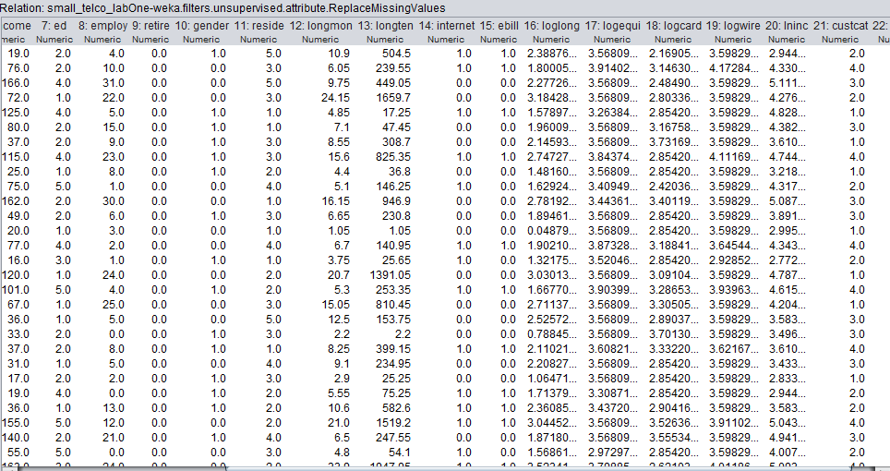

**Detecting Outliers using Interquartile Range:**

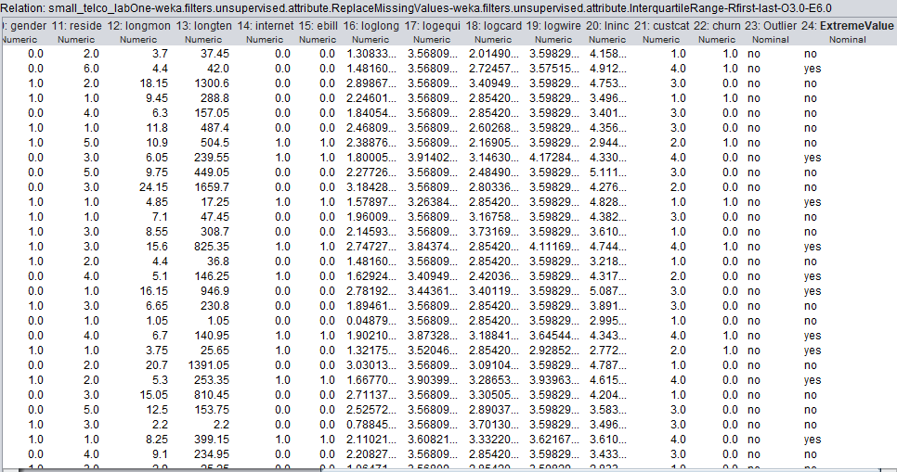

**Extreme Values Column created that shows ‘no’ values show no outliers while ‘yes’ values shows that outliers are detected.**

**Applying outlier-extreme indicator pair on the dataset:**

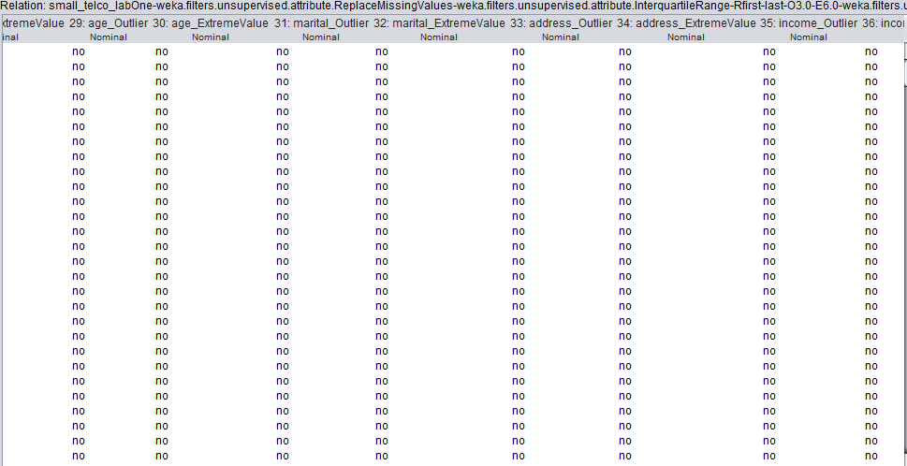

**After applying Remove with Values on the dataset:**

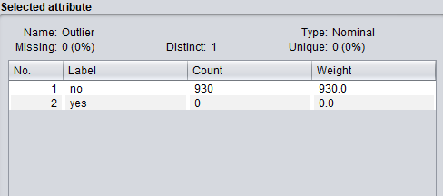

**After Applying Normalization (scaling from 0 to 1) on the dataset:**

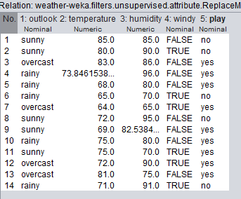

**Changing scaling and translation factor from 0 to 2 on the dataset:**

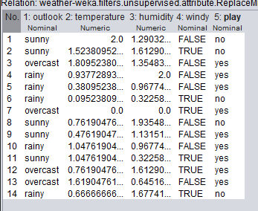

**Changing scaling and translation factor from -1 to 2 on the dataset:**

