
Department of Information Technology
COLLEGE OF ENGINEERING
CENTRAL LUZON STATE UNIVERSITY
Science City of Muñoz, Nueva Ecija

iRespond: An AI-Powered GIS-Based Emergency Incident Reporting and Image Classification System for Community Response
A Capstone Project
Presented to the
Department of Information Technology

In Partial Fulfillment
of the Requirements for the Degree

BACHELOR OF SCIENCE IN INFORMATION TECHNOLOGY

BY:
Araneta, Airan Vinz T.
Pakkal, Damianne Alistair T.
Soria, Angelo James DC.

April 2026

DISCLAIMER

“This Capstone Project is submitted to the Department of Information Technology, College of Engineering, in partial fulfillment of the requirements for the degree Bachelor of Science in Information Technology at the Central Luzon State University, Science City of Muñoz, Nueva Ecija. It is a product of our own work except where indicated in the text. The project report or any portion thereof including the source code, or any section may be freely copied and distributed provided that the source is acknowledged.”

APPROVAL SHEET

This capstone project proposal entitled “IRESPOND: AN AI-POWERED GIS-BASED EMERGENCY INCIDENT REPORTING AND IMAGE CLASSIFICATION SYSTEM FOR COMMUNITY RESPONSE” prepared and submitted by AIRAN VINZ TABING ARANETA, DAMIANNE ALISTAIR TEJADA PAKKAL, ANGELO JAMES DELA CRUZ SORIA in partial fulfillment of the requirements for the degree BACHELOR OF SCIENCE IN INFORMATION TECHNOLOGY, has been examined and is hereby endorsed.

DR. ANJELA C. TOLENTINO
Adviser

CAPSTONE 1 PROJECT ORAL PRESENTATION COMMITTEE

GEMLYN INCOCENCIO |  | DR. ANAZEL GAMILA
Chair |  | Member
Date Signed |  | Date Signed

Accepted and approved in partial fulfillment of the requirements for the degree BACHELOR OF SCIENCE IN INFORMATION TECHNOLOGY, school year 2025-2026.

DR. ANJELA C. TOLENTINO
Head, Department of Information Technology
_______________
Date Signed

DR. ROY SEARCA JOSE P. DELA CRUZ
Dean, College of Engineering
_______________
Date Signed

CERTIFICATION OF MANUSCRIPT PROOFREADING

This is to certify that the undersigned has reviewed and edited the manuscript ofAIRAN VINZ TABING ARANETA, DAMIANNE ALISTAIR TEJADA PAKKAL, ANGELO JAMES DELA CRUZ SORIA, entitled "IRESPOND: AN AI-POWERED GIS-BASED EMERGENCY INCIDENT REPORTING AND IMAGE CLASSIFICATION SYSTEM FOR COMMUNITY RESPONSE". This further certifies that the scope of editing is for proper English language, grammar, punctuation, spelling, and overall writing style.

Issued this 31st day of Month, year, at address.

DR. ANAZEL GAMILLA
Position/Designation
Name of institution/school

AI CERTIFICATE


ABSTRACT
The people of Pangasinan such as Balungao still have to contend with a high number of emergency cases such as vehicular crashes, fire accidents, medical emergencies, police-related cases and so on. The traditional method of reporting such cases over the phone or through word of mouth is not very good as it incurs much time before help is received, it is difficult to determine the exact location and the persons responding to the emergency do not co-operate with each other.
This research paper concerns a system known as iRespond. It is a type of emergency reporting system based on artificial intelligence and maps to assist individuals of Balungao, Pangasinan. With iRespond people can use their phones to report emergencies away. The system will be based on maps to locate the location of emergency. Gemini API assists the system in determining the type of emergency and the severity of the emergency. It also provides the responders with information regarding the emergency. It even has a chatbot which informs people what to do whilst they are waiting to be assisted.
iRespond system employs various tools to be functional. It relies on Firebase to ensure that the information is updated. It relies on Semaphore API to transmit text messages to responders.. It has a special website that is hosted by GoDaddy, where administrators can see what is going on.
The iRespond makers applied a working method known as Scrum. To judge the system effectiveness, they will resort to the ISO/IEC 25010 Software Quality Model. iRespond aims at ensuring that people in Balungao Pangasinan receive help in time in case they need it due to an emergency. It must also assist the responders to collaborate in a better manner and make the community a more secure place. iRespond is a system that can actually come in handy during emergency cases in Balungao, Pangasinan.

TABLE OF CONTENTS
TITLE PAGE i
DISCLAIMER ii
APPROVAL SHEET iii
CERTIFICATION OF MANUSCRIPT PROOFREADING iv
AI CERTIFICATE v
ABSTRACT vi
TABLE OF CONTENTS vii
CHAPTER 1 INTRODUCTION
Background of the Study
Company/Client Profile
Statement of the Problem
Objectives
Scope and Limitations
Significance of the Study
Definition of Terms
CHAPTER 2 REVIEW OF RELATED LITERATURE AND EXISTING ALTERNATIVES
Previous Studies and Findings
Existing Alternatives
Gaps in Existing Research
Synthesis
CHAPTER 3 METHODOLOGY
Planning
Data Gathering Procedure
Feasibility Study
Economical Study
Technical Study
Operational Study
Instrumentation
Sample and Sampling Procedure
Design
Development
Scrum Roles, Ceremonies and Artifacts
Testing
Deployment
Review
Launch
Development Tools and Technologies
Algorithms and Techniques
Convolutional Neural Network (CNN)
CHAPTER 4 RESULTS AND DISCUSSION
Development of iRespond
Defining Requirements
Current Process Flowchart
Proposed Flowchart
Conceptual Framework
System Architecture
Swim Lane Diagram
Context Diagram
Block Diagram
Database Design
Developmental Methodology
Functional Requirements
Non-Functional Requirements
Evaluation Methodology
Presentation of Results
ISO/IEC 25010 Software Quality Model Result
CHAPTER 5 CONCLUSIONS AND RECOMMENDATIONS
Summary
Conclusions
Recommendations
REFERENCES
APPENDICES
Appendix A – System Architecture
CHAPTER 1 9
Background of The Study 9
Company/Client Profile 11
Statement of the problem 12
Objectives 13
Scope and limitations 13
Significance of the study 14
Definition of Terms 16
CHAPTER II 19
REVIEW OF RELATED LITERATURE AND EXISTING ALTERNATIVES 19
Previous Studies and Findings 19
Existing Alternatives 23
Gaps in Existing Research 34
Synthesis 36
CHAPTER III 38
Methodology 38
Planning 39
Data Gathering Procedure 39
Feasibility Study 40
Economical Study 40
Technical Study 41
Operational Study 42
Design 42
Development 43
Scrum Roles, Ceremonies and Artifacts 44
Testing 45
Deployment 53
Review 54
Launch 54
Development Tools and Technologies 55
Algorithms and Techniques 57
Convolutional Neural Network (CNN) 57
Adam Optimizer 58
GIS Live Tracking and ETA Estimation 60
REFERENCES 61
APPENDICES 66
Appendix A - System Architecture 66

CHAPTER 1
INTRODUCTION

Background of The Study
Emergencies can happen anytime, situations such as vehicular accidents, fire incidents, medical emergencies, police-related cases, and natural hazards are prone here in the Philippines. Some of these emergencies are neglected and require immediate and efficient response from authorities. Geographic Information System (GIS), will play a significant role in improving the immediate responses in emergencies, by enabling accurate location tracking and real-time situational awareness. According to the reports from the Department of Interior and Local Government (DILG, 2023) that 911 emergency hotline, thousands of emergency calls are received daily and monthly nationwide. These numbers demand for an improved and reliable system in emergency incidents. However, despite the presence of centralized hotlines their effectiveness is often limited when incidents are not reported or responded to promptly (DILG, 2023).
This problem is evident in the municipality of Balungao, Pangasinan, where multiple emergency incidents have been documented in recent years. According to the Department of Social Welfare and Development Disaster Response Operations Monitoring and Information Center (DSWD-DROMIC, 2024; 2025), several fire and disaster-related incidents, including those in Barangay Poblacion and Barangay Kita-Kita, required immediate intervention due to their impact on affected communities. These reports highlight recurring delays in emergency response and coordination. In addition, incidents such as the whirlwind event in Barangay San Marcelino further demonstrate the need for timely reporting and rapid deployment of responders (DSWD-DROMIC, 2024).
One of the many contributing factors to this problem is the lack of real-time and centralized emergency reporting system. Currently the process of reporting an emergency incident remains a manual process, this current process may seem vague and imprecise. Moreover, inaccurate location tracking and lack of classification that leads to poor coordination among different responders prevents an effective response. These difficulties causes the responders prevents from making an immediate action to the incidents.
To solve these challenges, this project aims to develop an application for emergency response system for the residents of Balungao, Pangasinan. The application will enable users to report different emergencies such as medical incidents, natural hazards, vehicular accidents, police-related cases and fire emergencies, in real time. This application aims to create a centralized platform to manage all available emergency responders within the municipality, by doing so this will improve coordination and expand the reach of rescue services.
Moreover, the application will incorporate a Geographic Information System (GIS) technology to improve the accuracy of location tracking among emergency incidents. It will also integrate artificial intelligence (AI) to automatically classify reported incidents through image processing, categorize the level of urgency, and recommend the specific responders. These initiatives will further improve the application's notion to further enhance the emergency response allowing time efficiency, reduction of delays, and improve the overall emergency management. Moreover, this promotes Sustainable Development Goals (SDGs) 3 (Good Health and Well- Being), 9 (Industry, Innovation, and Infrastructure), and 17 (Partnership for the Goals).

Company/Client Profile
The Balungao Municipal Disaster Risk Reduction and Management Office, located at Poblacion, Balungao, Pangasinan, established in 2017. Focuses on protecting communities by reducing disaster risks and ensuring effective responses when emergencies happen.
The MDRRMO Balungao is headed by Engr. Cenon M. Luna. He has been in service for 7 years. His field of expertise is civil engineering, graduating at University of Pangasinan. The MDRRMO Balungao is also decorated with awards such as the Gawad kalasag seal of excellence.
Due to limited numbers of employees, having a proper centralized system to disseminate task from other departments in order to operate efficiently and effectively. Nonetheless the type of process that they currently have doesn't have proper communication with other departments. Users still contact individual departments when an accident or incident happens resulting in mistakes like sending the wrong unit or miscommunicating locations or longer response time due to human errors in contacting the wrong department. As a result the current process causes delays in emergency response, inefficient coordination among departments, and increased risk to affected individuals, highlighting the need for a centralized emergency response system that can streamline communication, improve task dissemination, and ensure faster and more accurate emergency assistance, thus being a prime candidate as a partner for the creation of the irespond system.

Statement of the problem
This study aims to solve the challenges that the Balungao Municipal Disaster Risk Reduction and Management Office faces in the event of incident reporting.
Specifically, identified problems are as follows:
1. Due to lack of incident reports, responder cannot immediately respond emergencies and providing assistance.
2. Improper incident classifications for the reported incident are sometimes dispatched, resulting to lack of necessary emergency response.
3. Lack of location tracking hinders responders from accurately identifying location of an emergency.
4. What is the level of usability of the proposed system based on the System Usability Scale (SUS)?

Objectives
The main objective of the study is to develop a mobile emergency response application that enables real-time reporting and improves coordination and response efficiency in Balungao, Pangasinan.
1. Create a centralized reporting module to categorize emergencies and mobilized responders.
2. to improve responder coordination by implementing an Al-based emergency classification
system that notifies only the appropriate personnel.
3.To apply a Geographic Information System to track the location of reported incidents.
4. To evaluate the system using SUS(System Usability Scale) and ISO/IEC 25010 Software Quality Model .

Scope and limitations
Scope
This study aims to create a mobile application for the iRespond which is an AI-based and GIS-based emergency incident reporting and community response system that is to be applied to the municipality of Balungao, Pangasinan. The system is expected to provide better emergency reporting, improve the coordination of responders by classifying incidents and responding faster based on real-time technologies and intelligent decision support.
This system is structured as a mobile application which enables quick and effective reporting of emergencies among the residents. It allows reporting of different emergency cases in real time such as vehicular accidents, medical emergencies, fire incidents, police related cases, and natural hazards. The system is equipped with an AI-based image classification module that detects and classifies the type of incident by analyzing the images uploaded by users. Moreover, the system also includes a Geographic Information System (GIS), which will help in real-time tracking of the locations of incidents and tracking the movement of responders.
Moreover, the app has a notification and alert system that provides real-time updates to the responders thus enhancing efficiency in dispatching. The system shall also come with a user friendly interface to make it accessible and easy to use by both the residents and emergency responders.
This study is limited by the technological dependencies, scope of the system and the limits of implementation. The system is based on the premise of a stable internet connection to facilitate real-time reporting, tracking, and communication, potentially limiting its use in regions with weak or unstable network coverage. It also relies on data reported by users; thus, those incidents that are not reported on the application cannot be captured, analyzed, and responded to in the system.
Moreover, the app is designed to be used on Android devices, taking into account their abilities and limitations. The system is geographically restricted to the municipality of Balungao, Pangasinan and might need to be changed to be implemented in other places.

Significance of the study
This study is significant to the following groups:
LGU of Balungao. The system will help the Local Government Unit to enhance the emergency response operations so that there will be better coordination of departments, more precise in decision-making and more effective allocation of resources in case of an emergency.
Residents of Balungao. The application will offer residents an easy and effective method to report emergencies in real time, which would enhance their likelihood of getting immediate help and enhancing safety in general in the community.
Emergency Responders (Police, Fire, Medical Teams). The system will improve the efficiency of communication, coordination and response by delivering a precise incident level of information, real-time location tracking, and prioritized alerts.
Disaster Risk Reduction and Management Office (DRRMO). The system will facilitate the work of DRRMO by facilitating the data on incidents, enhancing monitoring, and supporting quicker response in case of disasters and emergencies.
Future Researchers. Future researchers can use this study to guide their research on how to develop or enhance emergency response systems, particularly the ones that use artificial intelligence and GIS systems.
IT Practitioners and Developers. The project illustrates the practical use of mobile development, artificial intelligence, and GIS integration, which can be used as a prototype of similar technology-based solutions.

Definition of Terms
In this section, the terminologies, jargon, are explained further to have a better clarity for the concepts mentioned within the study.
Application Programming Interface (API). A set of protocols that allows different software systems to communicate and exchange data, used in the system to connect services like messaging, AI, and databases.
Artificial Intelligence (AI). A technology that enables systems to simulate human intelligence such as learning, reasoning, and decision-making, used for classifying and prioritizing emergency incidents.
Chatbot. An AI-powered feature that interacts with users by answering questions and providing guidance during emergencies.
Centralized System. A unified platform where all emergency data, reports, and communications are stored and managed.
Cloud Computing. The use of remote servers hosted on the internet to store, manage, and process data instead of local servers.
Data Synchronization. The process of ensuring that data remains consistent and updated across all devices and system components in real time.
Database. An organized collection of structured data stored electronically, used for managing user accounts and emergency reports.
Emergency Incident. Any unexpected event such as accidents, disasters, or crimes that require immediate attention.
Emergency Response System. A digital platform designed to manage reporting, coordination, and response to emergencies.
Firebase Realtime Database. A cloud-hosted NoSQL database that allows real-time data storage and synchronization across users and devices.
Geographic Information System (GIS). A system used to capture, analyze, and display spatial or location-based data.
Global Positioning System (GPS). A satellite-based navigation system used to determine the real-time location of users and incidents.
Integration Testing. A testing method that ensures different components or systems work together correctly.
Internet Connectivity. The availability of a network connection required for real-time communication and system functionality.
Machine Learning. A subset of AI that enables systems to learn from data and improve performance without explicit programming.
Real-Time Reporting. The ability to instantly send and receive information as events happen.
Responder. Personnel such as police, firefighters, medical teams who respond to emergency incidents.
Scrum. An agile development framework used to manage and organize system development through iterative cycles called sprints.
Sprint. A short, time-boxed development period in Scrum where specific tasks are completed.
System Architecture. The overall structure and design of a system, including its components and how they interact.
User Interface (UI). The visual elements of the system that allow users to interact with the application.
User Acceptance Testing (UAT). A testing phase where actual users evaluate the system to ensure it meets their needs.
Web Application. A software application that runs on a web browser and is used by administrators to manage the system.
Hosting Server. A remote server where the system and its data are stored and accessed via the internet.
SMS Gateway (Semaphore API). A service that enables the system to send text messages or alerts to users and responders.
AI Model. A trained algorithm used by the system to analyze data and make predictions or decisions.
GIS Mapping. The visualization of geographic data on a digital map for tracking incidents and responders.

CHAPTER II

REVIEW OF RELATED LITERATURE AND EXISTING ALTERNATIVES
The creation of centralized application for Emergency Response Systems will be significant in mitigating the risk of casualties in an emergency incident. Emergency incidents such as vehicular, medical, police-related, fire, and natural disasters. However, the system remains manual and vague, many communities like Balungao, Pangasinan still experiences time delays of responders due to the lack of a systematic approach in reporting systems, poor coordination, and absence of real-time technologies. These challenges are evident in Balungao, Pangasinan.
In this chapter, the review related literature and existing systems applicable to emergency response applications is shown. It examines the past literature, reviews the existing technologies, and assesses the gaps that the proposed application will help fill. Through review of both international and national literature and especially literature about disaster vulnerability and emergency preparedness in Pangasinan, this chapter sets the ground level towards the development of an efficient, intelligent and community based emergency response mechanism.

Previous Studies and Findings
Recent studies highlight the increasing use of mobile applications, AI, and GIS technologies in improving emergency response systems. Mobile-based applications can be used to enhance real-time reporting and communication, whereas AI-related methods like image recognition can be utilized to detect and analyze emergency situations. Location tracking and disaster planning are also supported by GIS-based systems. But most current systems are focused on particular functions, and are not fully integrated to include real-time reporting, intelligent classification and multi-agency coordination as one platform.
Emergency Response Mobile Applications.
The emergence of mobile applications has profoundly changed the manner in which the emergency can be reported and controlled due to the ability to communicate faster and transfer data in real-time. One such application is the study SAFE: Smart Application for Emergency, which designed a mobile-based platform that enables users to report a medical emergency and connect to the responder using the following features: live GPS tracking and interactive chat support (Cruz et al., 2021).
The study outcomes showed that the users were mostly pleased with the usability of the system, communicative capabilities and support of responses. This shows that mobile applications can be successfully used as the alternative to the traditional emergency hotlines as a more interactive and quicker communication channel.
New research also indicates the rising significance of mobile emergency applications in enhancing efficiency in response by ensuring real-time reporting and accessibility (Culi et al., 2026). These systems are characterized by convenient design and communication of information in real-time that is necessary in emergency situations.
Nevertheless, with these developments, the majority of mobile emergency applications are narrow in their coverage since they are more inclined towards medical emergencies. They are usually not integrated with other emergency services like the fire departments and police units which are required in the total emergency response system.

S.A.F.E.R. Emergency Application
Technologies of tracking the location such as GPS are very important in enhancing the efficiency of emergency response. Location sharing in real time allows the responders to clearly determine the exact location of an incident and eliminate delays due to ambiguous or incomplete information. Recent research indicates that the systems with the GPS and real-time communication capabilities can greatly enhance the response time and coordination of responders (Culi et al., 2026).
Moreover, the ability to communicate in real-time, i.e., the use of messages, notifications, and alerts, improves communication between victims, witnesses, and responders. These characteristics enable the responders to be constantly updated on the situation so that they can make faster and more informed decisions.
Although these are the advantages, a significant number of systems currently in use remain devoid of communication and coordination capabilities. Other applications are limited to location tracking and do not support interactive communication, which means they are not as effective as emergency response. This underscores the necessity of the systems that are capable of integrating precise location tracking with effective communication devices.
Internet of Things and Smart Emergency Systems.
Automation in emergency response systems with the integration of Internet of Things (IoT) technologies has been brought about. Current systems rely on smartphone sensors, GPS, and real time data processing to identify incidents and relay alerts to responders. Such technologies are also more efficient as they help to reduce manual reporting requirements and provide quicker response times (ACM, 2024).
These systems prove that smart technologies can be used in combination with emergency management. Nevertheless, they are often not effective because of the fact that they are based on sensor data, which can give false results or cannot detect some emergencies.
Also, IoT-based systems are typically developed to address a single application and are not flexible to manage various emergency situations. They also lack adequate interaction and control to the user and this restricts their usability in real life.
Emergency Systems Communication and Coordination Problems.
Communication and coordination have been a significant challenge in emergency response systems. Most of the current systems depend on the old systems like the emergency hotlines, which are a manual form of communication and may cause delays, lack of proper communication, and inadequate information.
Recent research highlights that the current emergency systems should be able to provide real-time coordination, data exchange, and interconnectivity among various responder agencies to be more efficient (ACM, 2024). In the absence of these capabilities, the emergency response efforts will be disjointed, which will lead to slower response times and less effectiveness.
The fact that there are no centralized systems that can interconnect the various responders reveals the necessity of a single platform that would facilitate real-time communication and coordination between emergency services.
Pangasinan Disaster Vulnerability and Emergency Preparedness.
The local research points out the need to reinforce emergency response structures in disaster-prone regions. A vulnerability analysis carried out in the province of Pangasinan showed that the area is very prone to natural disasters like floods and typhoons. The research revealed that exposure, sensitivity, and adaptive capacity are some of the factors that determine vulnerability (AIP Conference Proceedings, 2022).
These results suggest that the communities of Pangasinan, such as municipalities, like Balungao are at a high risk in times of disaster. Although the vulnerability data have been available, systems that would translate these assessments into real time emergency response actions are still lacking.
Moreover, the current disaster management practices tend to be preparedness and risk evaluation oriented as opposed to real time response and coordination. This leaves a loophole between the identification of risks and the effective response to emergencies. Thus, the systems combining vulnerability data with real-time reporting and response systems are required.

Existing Alternatives
The current systems and methods that are employed in handling the emergency situations are what are known as existing alternatives in this study. These are traditional, technological and mobile based solutions that seek to enhance emergency reporting and response. The alternatives are considered in terms of effectiveness, efficiency and practicality and the limitations. This assessment helps the research to establish the gaps, which warrant the creation of a more complex and integrated emergency response application.
SAFE: Smart Application For Emergency
SAFE is an emergency response app that is available in mobile format and helps in enhancing communication between users and the medical responders in times of emergency. The system enables one to report incidents and offers important features like live GPS positioning, chat support and user account management. These characteristics allow the responders to find victims instantly and stay in touch in real-time to enhance the efficiency of the response. (Cruz et al., 2021).
The combination of the location tracking and communication tools improves the coordination between the emergency responders and the users through the application. It also shows how mobile technology can be used as a viable alternative to the conventional emergency reporting systems.
The system, however, is restricted to the cases of medical emergency and not other cases like fire, police-related cases or natural disasters. It also does not have any artificial intelligence to classify and prioritize incidents automatically, which restricts its recognition of various emergencies.
Smart Emergency Response (S.A.F.E.R.) Application
The S.A.F.E.R. system is an Android-based emergency app that is aimed at offering real-time safety surveillance and tracking of location. It incorporates GPS and alerts to inform responders and emergency contacts in case of emergency situations. The application enhances the efficiency of responses by making it possible to report faster and be notified of the incidents instantly. (Culi et al., 2026)
The system demonstrates the usefulness of integrating mobile platforms with real-time tracking technologies to improve emergency response. It is also focused on accessibility and usability, which makes it feasible to be implemented at the community level.
The system is, however, more location tracking, alerting based and does not include incident classification based on artificial intelligence. It also does not give full support to multi-agency coordination, which restricts its efficiency when dealing with complex emergencies.
Quick Rescue: Intelligent Emergency Response Application
Quick Rescue is a new emergency response app that will combine real-time GPS positioning, artificial intelligence, and communication technologies to enhance the emergency management process. This system enables users to report, get automatic alerts, and talk to the responders via an AI-based interface. It promotes the efficiency of responses by giving correct location information and smart help in case of an emergency (Jolhe et al., 2025).
The system proves the efficiency of the integration of AI and mobile technologies in enhancing emergency response. It also promotes quicker decision-making as it analyses the information about the incidents and gives corresponding recommendations to responders.
The system however needs a steady internet connection and highly developed mobile device functioning to be effective. Moreover, it could be restricted in use in low-resource or low-connectivity settings because of its dependence on AI and real-time data processing.
Mamamayan Emergency Application
The Mamamayan Emergency Application is an emergency notification system that enables the community to report on the cases and provide real-time information to the authorities. The system uses mobile technology to increase situational awareness and enhance user-respondent communication. (ACM Study, 2024).
This application proves the value of involving citizens in emergency responses and emphasizes the use of mobile devices as a tool of real-time data collection and reporting. It aids quick decision-making as it gives relevant information in a timely manner.
But the system lacks both artificial intelligence and intelligent decision-support. It is also not fully integrated with other responder agencies which restricts its capacity of providing a coordinated emergency response system completely.
Emergency Hotline Systems
The traditional ways of reporting the emergencies are emergency hotline systems, which are voice-based. These systems enable users to communicate directly to the emergency responders and request their help. (DILG, 2023).
They are also highly available and convenient and can be used as a sure source of emergency reporting. They however entirely depend on verbal communication which may give rise to miscommunication, incomplete information and delays in response.
Also, hotline systems lack real-time location tracking and automatic data processing. They are less efficient and not technologically advanced to respond to an emergency with fast and precision, as modern mobile and intelligent systems do.
The system is however restricted to medical emergencies and not to any other incident like fire or police related emergencies. It also does not have centralized coordination and smart decision making capabilities making it ineffective in complicated emergencies.

AI-based emergency response systems: A systematic literature review on smart infrastructure safety. SSRN.
The research paper by Bajwa (2025), "AI-based emergency response systems: A systematic literature review on smart infrastructure safety," is highly significant to the iRespond project as it provides a robust theoretical and technical validation for the system’s core architecture. By identifying the global transition from traditional, static Geographic Information System (GIS) frameworks to dynamic, AI-integrated ecosystems, the research justifies the project's reliance on intelligent automation for real-time emergency reporting and response. Furthermore, the study emphasizes the critical necessity of interoperability, data security, all of which are foundational requirements for iRespond to function effectively within a modern, data-driven smart city infrastructure.
By aligning the project with these evidence-based standards, the research reinforces the academic credibility of your capstone and highlights the practical necessity of incorporating AI to improve decision-making accuracy and community resilience during crisis events.
AI-driven innovations in emergency and disaster response: Strategies for effective planning. Proceedings on Engineering Sciences.
This study validates the transition from standard GIS mapping to an "AI-augmented" GIS. (Sudhi et al.,2025) demonstrate that the next stage of your project's maturity should involve the automation of logistics and the inclusion of predictive simulation models.
This literature provides the technical justification to advocate for dynamic resource dispatch and predictive triage within your system’s architecture, provided these are supported by strict ethical data governance.

Intelligent Image Classification and Emergency Detection for Enhanced CCTV Surveillance Systems using.
This study validates the transition from passive monitoring to "proactive behavioral recognition" in public safety. It demonstrates that existing infrastructure can be repurposed through CNN-based gesture analysis to detect specific distress signals in real-time, particularly during high-risk nighttime scenarios.(Venkatesh and Praveen,2025)
This literature provides the technical justification to advocate for the automation of emergency alerts and the direct transmission of visual data to law enforcement within your system’s architecture, ensuring that the response gap for vulnerable travelers is minimized through AI-driven intervention.
Classifying Images with AI: An Overview.
According to this article it validates the foundational role of supervised learning within the domain of computer vision, specifically for identifying objects and gestures from labeled training data. It demonstrates that the development of a reliable image classifier is an iterative process, typically leveraging Python-based libraries such as TensorFlow to move from raw visual input to automated recommendations.(IMerit,2025)
This literature provides the technical justification to advocate for a robust, supervised learning backbone in your system’s architecture. It emphasizes that the effectiveness of real-time emergency detection depends on the rigorous training of the model, ensuring the system can accurately translate visual patterns into immediate, life-saving actions
GIS in Emergency Management.
This Book validates the application of Geographic Information Systems (GIS) across the four pillars of Comprehensive Emergency Management (CEM): mitigation, preparedness, response, and recovery. Cova (2005) demonstrates that GIS serves as both an "integrating centerpiece" for large-scale disaster systems and a portable source of critical spatial information for on-site personnel.
This literature provides the technical justification to advocate for the inclusion of evacuation vulnerability mapping and long-term risk assessment modules within your system’s architecture. It supports the transition of your platform from a simple notification tool into a comprehensive support system capable of managing post-disaster damage assessment and public safety education.
Image Classification to Support Emergency Situation Awareness
According to a study published in Frontiers in Robotics and AI (2016), image classification can be used to improve emergency situation awareness by analyzing images from social media during disaster events. The study applied machine learning techniques to identify fire-related images, allowing responders to efficiently filter large volumes of visual data.
The research utilized low-level image features such as color and texture, along with pretrained classifiers, to detect patterns associated with fire incidents. The results showed that automated image classification can achieve reliable accuracy and support faster decision-making in emergency response.
However, the study also highlights limitations, as it relies on handcrafted features rather than more advanced deep learning models. Despite this, it provides a foundational example of how artificial intelligence can be applied in disaster management through image analysis.

Efficient CNN-based disaster events classification using UAV-aided images for emergency response application
According to a study published in Neural Computing and Applications (2024), deep learning techniques have significantly improved image processing and classification performance in modern systems. The study highlights how artificial intelligence models, particularly convolutional neural networks, can automatically learn features from images without the need for manual feature extraction. Bashir et al. (2024)
The research emphasizes that deep learning approaches outperform traditional machine learning methods in terms of accuracy and adaptability. By leveraging large datasets and pretrained models, these systems can effectively handle complex image recognition tasks across various applications. Bashir et al. (2024)
However, the study also notes challenges such as high computational requirements and the need for large labeled datasets. Despite these limitations, it demonstrates the strong potential of deep learning in advancing intelligent image processing systems. Bashir et al. (2024)
Deep Learning-Based Aerial Image Classification for Emergency Response Applications
According to a study presented in the CVPR Workshops (2019), deep learning techniques can be used to classify aerial images captured by unmanned aerial vehicles (UAVs) to support emergency response operations. The study applied convolutional neural networks to automatically detect and categorize disaster-related scenes from aerial imagery.
The research shows that deep learning models can significantly improve classification accuracy by learning spatial and contextual features directly from image data. This enables faster and more reliable identification of emergency situations such as fires, floods, and damaged infrastructure.
However, the study also highlights limitations such as dependency on large training datasets and computational resources. Despite these challenges, it demonstrates the effectiveness of artificial intelligence in enhancing situational awareness during emergency response through aerial image analysis.
CIRS: A Multi-Agent Machine Learning Framework for Real-Time Accident Detection and Response
According to a study published in Sensors (2025), intelligent emergency response systems can be enhanced through the use of multi-agent architectures integrated with machine learning techniques. The study introduced a framework that utilizes CCTV video streams to detect road accidents in real time and coordinate response actions through multiple system agents. Each agent is responsible for specific tasks such as data acquisition, analysis, and communication, enabling a more organized and efficient emergency response process. CIRS study (Sensors, 2025)
The research demonstrates that combining machine learning with a multi-agent system improves real-time decision-making and system scalability. By distributing tasks across agents, the system can process visual data more efficiently and trigger timely alerts to emergency responders, reducing delays in critical situations. This approach highlights the importance of system coordination and automation in modern emergency management. CIRS study (Sensors, 2025)
However, the study also highlights limitations, including the complexity of system design, dependency on stable network infrastructure, and limited focus on advanced image classification techniques for detailed visual analysis. Despite these challenges, the research shows strong potential in improving emergency response systems by integrating intelligent coordination with real-time surveillance data.
Deep Learning Benchmarks and Datasets for Social Media Image Classification for Disaster Response
According to a study presented in the IEEE International Conference on Advances in Social Networks Analysis and Mining (2020), social media platforms can be utilized as real-time sources of information during disaster events through image classification techniques. The study evaluates deep learning approaches, particularly convolutional neural networks (CNNs), for automatically classifying disaster-related images shared by users online. Alam et al. (2020)
The research demonstrates that CNN-based models can effectively categorize images into relevant disaster classes such as floods, fires, structural damage, and humanitarian needs. By leveraging benchmark datasets and standardized evaluation methods, the study shows improved accuracy and consistency in identifying critical visual information, which can assist emergency responders in quickly filtering and analyzing large volumes of social media images during crises. Alam et al. (2020)
However, the study also highlights limitations such as inconsistencies in dataset quality, class imbalance, and variability in image conditions, which can affect model performance and generalization. Despite these challenges, the research confirms that deep learning-based image classification from social media is a valuable tool for enhancing situational awareness and supporting faster decision-making in disaster response operations.

Facilities location for disaster response teams using GIS
According to the study, disaster-prone regions in Brazil are frequently affected by extreme weather events such as floods and landslides, highlighting the need for effective humanitarian logistics systems to support emergency response and recovery. The research emphasizes that coordinated networks and well-planned infrastructure are essential in reducing human suffering and addressing gaps in disaster preparedness, particularly in terms of facility location, resource allocation, and inter-agency collaboration. Barino, Cunha, and Solano (2024)
The study evaluates the infrastructure of the Sistema S institution in Nova Friburgo using georeferencing techniques through QGIS software to assess its suitability as a support facility during disaster events. The findings reveal that while the institution has strong infrastructure and a strategically advantageous location, its spatial integration remains vulnerable to environmental hazards common in the region. This suggests that geographic positioning alone is not sufficient to ensure operational effectiveness during disasters without considering environmental risks and spatial resilience. Barino, Cunha, and Solano (2024)
However, the study is limited to spatial evaluation and infrastructure assessment and does not involve real-time tracking systems or direct emergency response mechanisms. Despite this, it demonstrates the value of GIS-based analysis in supporting disaster preparedness and planning by identifying suitable locations for humanitarian support facilities and highlighting spatial vulnerabilities that may affect emergency operations. Barino, Cunha, and Solano (2024)
Machine Learning Classification Confidence – How Confident Should You Be?
analysis on the reliability of high-confidence outputs in Convolutional Neural Networks (CNNs). While machine learning models outperform traditional deterministic software by automatically extracting complex visual patterns from large datasets, output confidence scores (e.g., 99%) are frequently misunderstood. Confidence reflects internal feature-matching based on probabilistic convergence during training, not guaranteed empirical precision. As a result, models remain vulnerable to false positives from overlapping feature signatures and false negatives caused by environmental noise. Because CNNs function as rigid global algorithms that cannot easily isolate single exception cases, high confidence cannot replace empirical classification accuracy. Ultimately, the synthesis emphasizes that probabilistic machine learning lacks genuine cognitive intelligence, necessitating Human-in-the-Loop (HITL) oversight in high-stakes applications and preserving a role for deterministic methods in simple, highly rule-based tasks. Woo, A. (2017)
How to Run A/B Tests with Small Sample Sizes
A blog post suggests that businesses facing small sample size constraints can accelerate A/B testing velocity by increasing their tolerance for risk through lower statistical confidence levels. While academic research strictly adheres to a 95% confidence standard accepting a 1-in-20 chance of a false positive, the author argues that commercial settings rarely require such rigidity. Instead, organizations can accept a 90% confidence threshold (a 1-in-10 risk of a false positive) to reach actionable decisions much faster with significantly smaller sample sizes. To mitigate the risk of deploying underperforming variations when using a lower confidence level, Tripp emphasizes incorporating validation protocols such as seasonal holdouts or back testing to monitor long-term performance. Tripp, K. (2024)

Common confidence levels: what they mean for experiments
confidence levels serve as a fundamental measure of reliability and precision in experimental data analysis, defining the long-term probability that calculated intervals will capture a true parameter across repeated trials. It notes that the 95% confidence level popularized by Sir Ronald Fisher remains the standard benchmark for balancing statistical rigor and false-positive prevention, confidence thresholds should be adjusted based on context and organizational risk tolerance. High-stakes environments like healthcare require stricter thresholds (e.g., 99%) to minimize false positives, whereas agile domains like online experimentation may adopt lower levels (e.g., 90%) to prioritize velocity and reduce false negatives. Furthermore, the source cautions against common interpretative pitfalls, emphasizing that a confidence level reflects the long-term frequency of repeating experiments rather than the probability of a single calculated interval, and underscores the necessity of reporting both confidence intervals and p-values alongside considerations for sample size and variance. Statsig. (2024)

Gaps in Existing Research
The table presents selected existing studies on emergency response systems that serve as the basis for comparison in this research. It highlights their key features, findings, and limitations to identify existing gaps. These gaps are then used to guide the development of the proposed emergency response application, ensuring that the system addresses current shortcomings and improves overall functionality and efficiency.

Table 1: Gaps in Existing Research
Research Title | Key Findings | Gaps/Limitations | Current Project Solutions to these gaps
Cruz et al. (2021) – SAFE: Smart Application for Emergency | Developed a mobile app with GPS tracking and chat support that improves communication between users and responders. | Focuses only on medical emergencies; lacks integration with fire, police, and disaster response. No AI-based classification of incidents. | The proposed system supports multiple emergency types (medical, fire, police, disasters) and integrates AI to classify and prioritize incidents.
Culi et al. (2026) – Smart Application for Emergency Response (S.A.F.E.R.) | Provides real-time location tracking and alert notifications through a mobile application. | Focuses mainly on tracking and alerting; lacks intelligent decision-making and multi-agency coordination. | The system incorporates AI-based classification and centralized coordination among responders and volunteers.
Jolhe et al. (2025) – Quick Rescue: Smart Emergency Response Application | Integrates GPS, AI, and communication tools to enhance emergency response and decision-making. | Requires stable internet and advanced device capability; limited accessibility in low-resource environments. | The proposed system is optimized for community-level use and designed to function efficiently across a wider range of devices.
Rey et al. (2024) - Mamamayan Emergency Application | Enables citizen-based reporting and improves situational awareness through mobile technology. | Lacks AI integration and coordinated response among multiple agencies; limited decision-support features. | The system introduces AI-driven incident classification and centralized coordination among responders.
ACM (2024) – Intelligent Data-Driven Emergency Systems | Demonstrates the use of artificial intelligence and data analytics in improving emergency response and decision-making. | Systems are complex, resource-intensive, and not easily accessible at the community level. | The system integrates AI in a simplified, user-friendly application suitable for local communities.
Department of the Interior and Local Government (DILG, 2023) – Emergency Hotline Systems (911) | Provides a widely accessible system for reporting emergencies through voice communication. | Relies on verbal communication, leading to delays, miscommunication, and lack of precise location tracking. | The application provides real-time reporting, GIS-based tracking, and automated notifications.
Caliston and Tabia (2021) – Help Me: Emergency Response Mobile Application | Provides mobile-based reporting with integration to local agencies such as police, fire, and barangay responders. | Limited automation and lacks AI-based prioritization; depends on manual input and user reporting. | The system enhances automation through AI classification and intelligent response recommendations.
AI-Based Traffic Prediction System – Abuzaid et al. (2024) | Utilizes artificial intelligence to analyze data and predict emergency scenarios. | Focuses on prediction rather than real-time reporting and response; lacks user interaction features. | The system combines AI prediction with real-time reporting and user interaction.
Intelligent Image Classification and Emergency Detection for Enhanced CCTV Surveillance Systems using. (Venkatesh and Praveen, 2025) | The study uses CNN-based gesture recognition in CCTV to detect emergency situations in real time and enable proactive monitoring. | Limited to CCTV systems only; no mobile reporting, no GIS tracking, and no responder coordination system. | The proposed system uses mobile-based reporting with AI image classification, integrates GIS for location tracking, and supports coordination among emergency responders.
Facilities location for disaster response teams using GIS (Barino, Cunha, & Solano, 2024) | The study uses GIS (QGIS) to evaluate and identify suitable locations for disaster response facilities, improving disaster preparedness and resource planning. | Focuses only on spatial analysis; no real-time tracking, no emergency reporting system, and no responder coordination features. | The proposed system integrates GIS with real-time tracking, mobile-based emergency reporting, and responder coordination to support both preparedness and actual response operations.
Efficient CNN-based disaster events classification using UAV-aided images for emergency response application Bashir et al. (2024) | The study shows that CNN-based deep learning improves accuracy in classifying disaster events from UAV images, outperforming traditional methods. | Requires high computational resources and large datasets; limited to UAV imagery and does not include real-time reporting, GIS tracking, or responder coordination. | The proposed system applies AI-based image classification in a mobile environment, integrates GIS for real-time tracking, and supports emergency reporting and responder coordination.

Synthesis
Emergency response systems have changed significantly over the years. Traditional systems, which are mainly used on voice-based hotlines, have long been used as the primary means of reporting emergencies. However, these methods sometimes always leads to miscommunication and lack the ability to support real-time coordination among multiple response agencies. As a result, they are no longer enough for handling complex emergency situations that require accurate location tracking and rapid information sharing.
With the advancement of mobile technology, modern solutions have been developed to improve emergency response. Applications such as the SAFE system and the S.A.F.E.R. application demonstrate how GPS-enabled reporting and real-time communication can enhance the efficiency of responders (Cruz et al., 2021; Culi et al., 2026). Despite these improvements in the technology, many existing systems remain limited in capabilities, as it primaly focus on medical emergencies and often lack the ability to report with other agencies such as fire and police departments.
Recent studies show the growing use of Internet of Things (IoT) and Artificial Intelligence (AI) in emergency reporting. These technologies use automated incident detection and improved situational awareness (Jolhe et al., 2025; Association for Computing Machinery, 2024). However, challenges still exist. IoT-based systems may generate false alerts due to unreliable sensor data, and many systems lack flexibility in handling different types of emergencies. In disaster-prone areas such as Balungao, studies reveal a gap between existing risk assessments and the implementation of real-time response mechanisms, limiting their overall effectiveness.
Furthermore, recent literature emphasizes that modern emergency response systems are changing from reactive approaches to more proactive, AI-driven solutions. These systems are expected to utilize modern technologies such as machine learning and data analytics to support decision-making and resource allocation (Bajwa, 2025). Nevertheless, issues such as system interoperability, algorithmic bias, and cybersecurity concerns must be emphasized to ensure reliability and scalability.
In response to these challenges, the iRespond System is proposed as a more integrated solution. It aims to combine GIS-based emergency management with real-time data processing, predictive analytics and adding an AI assisted voice. Unlike existing systems that operate from one another, iRespond is designed as a centralized platform that can be used across multiple agencies. By bridging the gap between risk identification and actual emergency response, the system seeks to provide a more efficient, reliable, and scalable solution for local government implementation.

CHAPTER III

METHODOLOGY
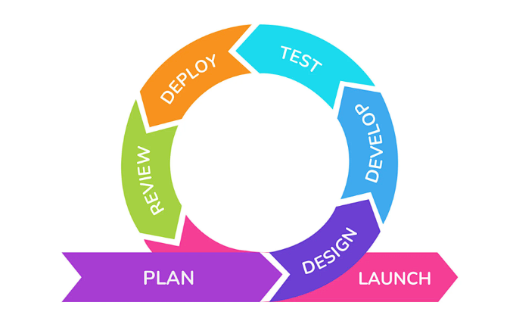
This paper employs the Agile methodology in the deployment of the emergency response application. Agile is selected due to its flexibility and iterative quality, which enables constant development, testing and enhancement of the system functions like real-time reporting, location tracking, and responder coordination.

Figure 1: Agile Development Process (Amoros, 2025)
In order to successfully apply this strategy, the Scrum model will be utilized. Scrum offers a disciplined task management process in the form of iterative cycles, which allows periodic review and redefine the system. This will make the application efficient, reliable, and responsive to the needs of users during the development process.

Planning

Data Gathering Procedure
The development of the application of the iRespond emergency response system will rely on two primary gathering methods, first is descriptive qualitative approach through interviews, second is a quantitative analytical approach through scrutinization of essential statistical reports. By integrating these methods, the Scrum team will ensure that the system is utilizing real-world data and objective facts.
The development of the iRespond system is informed by a targeted community assessment designed to understand the gap between the current emergency response capabilities and the actual needs of the residents. To achieve this goal, a questionnaire was developed to gather critical data regarding the emergency landscape in Balungao. This questionnaire focuses on identifying the frequency and nature of common incidents, such as local accidents and medical emergencies, while simultaneously evaluating the efficacy of existing communication infrastructure like the current emergency hotline.
Beyond mere statistics, the questionnaire serves as a diagnostic tool to uncover systemic vulnerabilities. By investigating historical cases where response delays may have impacted victim outcomes, the study highlights the urgent necessity for a more streamlined platform.

Feasibility Study
Feasibility study is used, to identify if the organization responsible is capable at handling the system. The feasibility study consists of technical, operational and economic feasibility.

Economical Study
The system that will be made to measure on how the project solves problem and to know if human resources are available to operate, understand, and willingly understand the project that was being developed

Technical Study
The system will be made with consideration to the technical requirements of the project to see whether the system needs certain devices or requires certain system requirements to be used while doing requests.
To successfully deploy and operate the iRespond system, it is essential to ensure that both the infrastructure and hardware meet specific technical standards. These requirements guarantee optimal performance, compatibility, and reliable connectivity for all users.
Below is a summary of the necessary components for the iRespond system:

Table 2 : Technical Requirements
Requirement | Specification
Internet Connection | Stable mobile data or WiFi
Mobile Device | Android 8.0 and above
Admin Device | Desktop or laptop with browser
Hosting | GoDaddy server
Database | Firebase Realtime Database

Operational Study
The system will be made to evaluate and analyze the benefits of the system. It helps determine the overall value of the investment before fully committing to it. Ensuring that the results given outweighs the time, effort and cost involved.
Instrumentation
To support the development of IRESPOND, we conducted an in-depth interview with our capstone adviser and capstone consultant to gather key user requirements, operational insights, and technical recommendations. Following the system's initial deployment, we distributed a detailed questionnaire to end users to assess overall system performance and collect actionable feedback for future improvements.
Sample and Sampling Procedure
The sample of the study consisted of thirty (30) respondents from two (2) barangays in the Municipality of Balungao, Pangasinan, namely Barangay San Aurelio 2nd and Barangay Kita-Kita. The respondents were residents who were available at the time of data gathering and who agreed to answer the evaluation questionnaire. Data were collected using Google Forms.
The researchers used convenience sampling. The two barangays were visited, and the Google Forms questionnaire was administered after the application was instructed to the end users who were present and willing to participate. No random selection from a complete list of residents was made. Responses were gathered until a total of thirty (30) accomplished questionnaires were obtained. This sample was used to evaluate the iRespond system and does not represent the entire population of Balungao.

Design
The design phase focuses on making functional needs into a structured plan. Using the 4+1 View Model, the researchers will develop a series of diagrams that categorize the system's complexity into four specialized views, ensuring the final architecture effectively addresses the primary objectives defined by the users.
Logical View. This view highlights the core functionalities of the incident reporting system, such as photo capture and upload, CNN-based incident classification, AI-powered automatic dispatch, push alarm notification, and GIS live tracking. These functions ensure an efficient and automated process from incident detection to responder deployment.
Development View. This view shows the modular structure of the system. The incident reporting system is divided into four main components: the mobile application (React Native), the CNN and ML pipeline, the backend API services, and the GIS mapping service. Each of these modules is developed and accessed individually to ensure its maintainability and scalability.
Process View. This view illustrates the dynamic behavior of the system, showing how data flows through each stage of processing. The process begins with the user taking and uploading an incident photo, followed by CNN classification of the incident type, AI-based automatic dispatch to the nearest available responder, push alarm notification to the responder device, and real-time GIS tracking of all parties until the incident is resolved.
Physical View. This view describes the system's deployment environment. The system runs on a cloud API server connected to a GPU-based ML inference server, a GIS and PostGIS server, and a database cluster for persistent storage. The mobile application on both the civilian and responder devices communicates with the cloud infrastructure over a secured connection, ensuring accessibility and compliance with data privacy protocols.
Use Case. The use case scenario involves a civilian user witnessing an incident, opening the mobile application to take a photo, and submitting the report with location data. The system then automatically classifies the incident using the CNN model, dispatches the nearest available responder via the AI engine, and sends an alarm notification to the responder's device. Both the user and responder are tracked in real time through the GIS service until the incident is closed.

Development
The development will use scrum as the framework for efficient and effective team collaboration, The developers will follow strict principles of the scrum lifecycle in developing the proposed system.
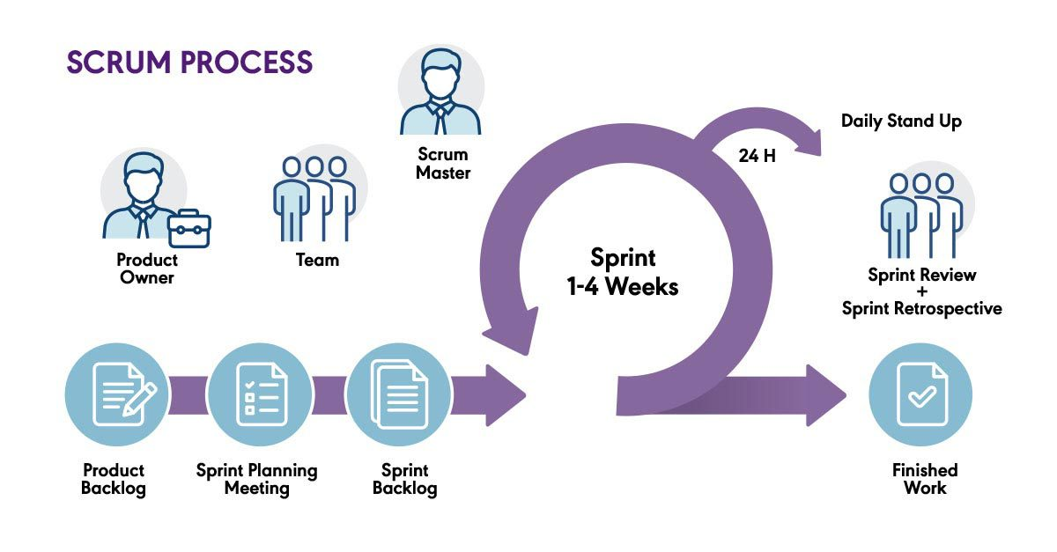
Figure 2 :Scrum lifecycle Diagram (pm partners, 2024)

The team developed the system using the principles of Scrum lifecycle diagram. In which the development was divided into different phases, starting from the product backlog and ending at a potentially finished product that will be sent to the client.

Scrum Roles, Ceremonies and Artifacts
The creation of the iRespond system will be created using Scrum framework, ensuring an iterative and highly collaborative development process. This methodology is centered around three distinct roles that provide the project with its strategic and technical direction. The Product Owner acts as the visionary, defining the system's core goals and priorities, while the Scrum Master serves as a facilitator to ensure the team adheres to Scrum principles and remains free of obstacles. The Development Team, composed of the individuals building the system, translates these visions into functional code and integrated GIS features.
The development cycle is managed through a series of structured ceremonies and artifacts that maintain transparency and momentum. The process begins with the Product Backlog, a comprehensive list of all required features and fixes managed by the Product Owner. During Sprint Planning, this list is refined; in the first phase, the team establishes the "Why" and "What" of the upcoming work, while the second phase focuses on the technical "How." The items selected for immediate development are moved into the Sprint Backlog, representing the team’s commitment for that specific cycle.
To ensure collaboration, the team conducts a Daily Scrum, a brief meeting focused on progress updates and the identification of any Impediments that might hold the progress. At the conclusion of the sprint, the team hosts a Sprint Review to demonstrate the completed work to stakeholders and gather vital feedback for future iterations. The cycle concludes with a Sprint Retrospective, a dedicated internal session where the team reflects on their process to identify what went well and where improvements can be made, ensuring that the development of the iRespond system evolves in efficiency and quality with every sprint.

Testing
The testing phase ensures that the iRespond system works correctly and meets its intended purpose before it is presented to actual users. The following testing methods will be used:
Each of the features of the system will be checked using unit testing to determine whether everything is functioning independently. It involves the testing of user AI image classification, GIS location pin and the notification system. Any failures that are identified will be corrected before going to the next stage of testing.
To verify communication among the system components, integration testing was conducted. The mobile application was tested against the Laravel REST API to confirm that authentication, emergency reporting, classification, hotlines, and responder case updates functioned correctly when combined. The Laravel backend was also tested with the Python CNN service to confirm that uploaded images were classified and returned to the application. The administration portal was checked to ensure that submitted reports, locations, and statuses appeared correctly after a report was sent from the mobile app. This step confirmed the proper transfer of information among the mobile application, the administration portal, the database, and the CNN classification service.
System testing was conducted to check the iRespond system as a whole. Real emergency reporting scenarios were simulated, from a citizen capturing a photo and location, through CNN classification and submission of the report, to its appearance in the administration portal and in the assigned responder’s case list. The test covered the complete process: report submission, department routing, status updates, viewing of the incident on the GIS map, and monitoring through the admin dashboard. This confirmed that the mobile application, Laravel backend, CNN service, and admin portal worked together under conditions similar to actual use.
To assess the system beyond standard testing procedures, survey questionnaires tailored for IT professionals will be designed based on the ISO/IEC 25010 Software Quality Model. This framework evaluates critical dimensions including Functional Suitability, Performance Efficiency, Compatibility, and Security to validate the system's overall reliability and operational integrity (ISO 25000, n.d.).
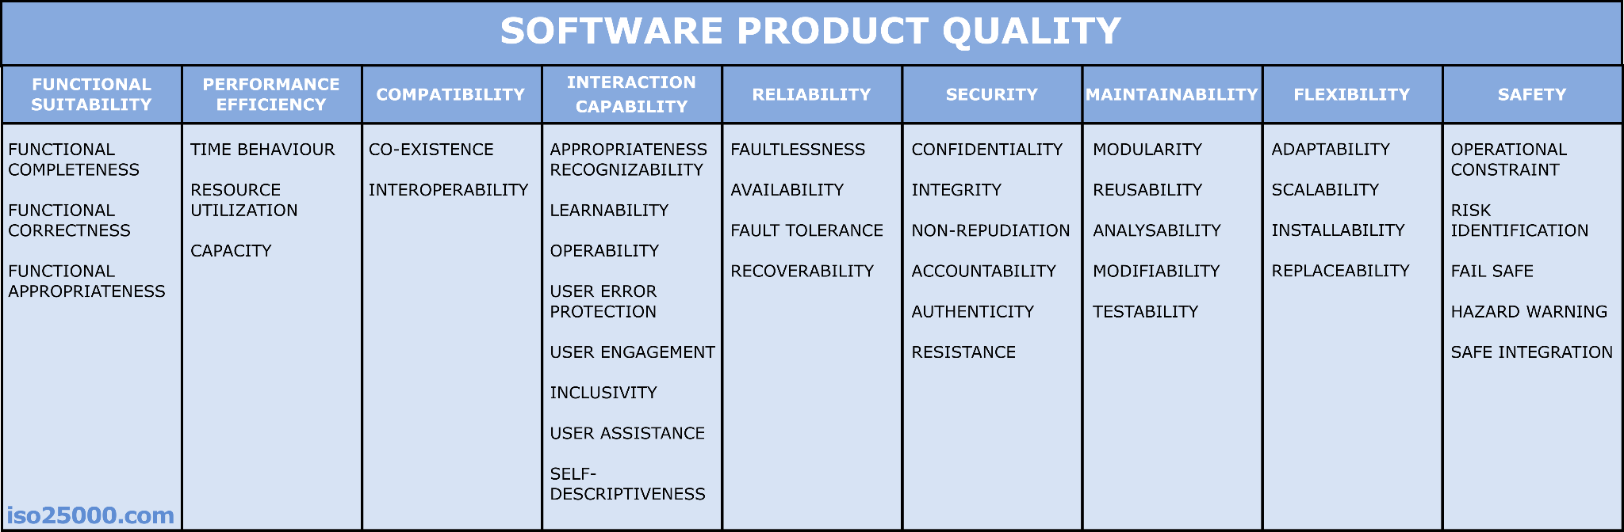

Figure 3. Software Product Quality aligned with ISO/IEC 25010 (ISO 25000, n.d.)

This figure illustrates the ISO/IEC 25010 Software Quality Model (an evolution of the older ISO 9126). This figure outlines the essential criteria a software system must satisfy to align with the quality standards defined in the figure. The accompanying tables detail the specific evaluation metrics and response modes used to measure compliance for each category.
Table 3. Response Mode for Functional Suitability
Response | Verbal Interpretation | Descriptors
4 | Highly Functional | The system completely, correctly, and appropriately fulfilled all functional requirements without weaknesses.
3 | Functional | The system fulfilled most functional requirements with minor tolerable weaknesses.
2 | Needs Improvement | The system fulfilled some functional requirements but with noticeable minor weaknesses.
1 | Poor | The system failed to fulfill key functional requirements and showed major weaknesses.

This metric evaluates how effectively the system fulfills its designated functional requirements by measuring how accurate and complete the operations are. It assesses whether the AI classification and GIS tracking does all necessary tasks as outlined in the initial project specifications. Essentially, this ensures the software is fully capable of delivering its core functions without missing features or processing errors.

Table 4. Response Mode for Performance Efficiency
Response | Verbal Interpretation | Descriptors
4 | Highly Efficient | The system responded quickly, used minimal resources, and had high capacity without performance issues.
3 | Efficient | The system performed satisfactorily under normal load with minor tolerable delays.
2 | Needs Improvement | The system showed moderate inefficiencies that slightly affected performance.
1 | Poor | The system had significant performance issues such as lags or excessive resource usage.
Table 4 uses a four-point Likert scale to assess how effectively the system manages speed, resource consumption, and overall capacity.. This structured format allows the research to objectively verify if the software maintains stability and responsiveness under varying operational loads.
Table 5. Response Mode for Compatibility
Response | Verbal Interpretation | Descriptors
4 | Highly Compatible | The system seamlessly integrated and coexisted with other platforms and software used in the university.
3 | Compatible | The system worked with existing systems with minimal issues.
2 | Needs Improvement | The system had limited interoperability and required adjustments.
1 | Poor | The system could not effectively interact with other systems.

Table 5 illustrates how successfully the software integrates and coexists with external platforms and existing infrastructure. This structure ensures that the iRespond System is evaluated on its readiness to function within a broader technical ecosystem while maintaining operational stability.

Table 6. Response Mode for Interaction Capability
Response | Verbal Interpretation | Descriptors
4 | Highly Interactive | The system was intuitive, user-friendly, and provided clear guidance and support.
3 | Interactive | The system was easy to use with minor issues in interface or usability.
2 | Needs Improvement | The system had usability challenges that required more effort to operate.
1 | Poor | The system was difficult to use, with a confusing interface and limited user support.
The table illustrates the system's user experience and ease of use. It categorizes performance based on how intuitive the interface is and the level of guidance provided to the user. This rubric ensures that the system is validated for its accessibility and operational simplicity, particularly for users in high-pressure environments.
Table 7. Response Mode for Reliability
Response | Verbal Interpretation | Descriptors
4 | Highly Reliable | The system operated continuously without failures and recovered effectively from errors.
3 | Reliable | The system occasionally failed but remained dependable overall.
2 | Needs Improvement | The system experienced moderate reliability issues.
1 | Poor | The system frequently failed and was not dependable.
This Table measures the system's operational stability and its capacity to perform intended functions under specified conditions over a given period. It evaluates the frequency of system failures and the efficiency of error recovery to determine the overall dependability of the software.
Table 8. Response Mode for Security
Response | Verbal Interpretation | Descriptors
4 | Highly Secured | The system ensured complete data confidentiality, integrity, and access control.
3 | Secured | The system had adequate security features with minor tolerable vulnerabilities.
2 | Needs Improvement | The system had some security features but lacked robustness.
1 | Poor | The system had major vulnerabilities that compromised student data.
This table measures the system's ability to protect information and data so that persons or other systems have the degree of data access appropriate to their types and levels of authorization. It evaluates the strength of security features and the presence of vulnerabilities to determine the overall level of protection and data integrity provided by the software.
Table 9. Response Mode for Maintainability
Response | Verbal Interpretation | Descriptors
4 | Highly Maintainable | The system was easy to update, test, and improve.
3 | Maintainable | The system could be modified with some effort.
2 | Needs Improvement | The system was difficult to maintain due to lack of modular design or documentation.
1 | Poor | The system was error-prone and hard to update or repair.
This table represents the degree of effectiveness and efficiency with which the system can be modified by intended maintainers. It evaluates the software's structural quality, including its modularity and documentation, to ensure that updates and repairs can be implemented without introducing significant errors.
Table 10. Response Mode for Flexibility
Response | Verbal Interpretation | Descriptors
4 | Highly Flexible | The system adapted easily to changes and scaled without issues.
3 | Flexible | The system adjusted to most changes with minimal modifications.
2 | Needs Improvement | The system required significant effort to adapt.
1 | Poor | The system could not accommodate changes or new settings.
This table evaluates the extent to which the software can be efficiently and effectively adapted for different hardware, software, or other operational or usage environments. It measures the system's inherent ability to scale and accommodate new configurations or functional changes while maintaining core stability.
Table 11. Response Mode for Safety
Response | Verbal Interpretation | Descriptors
4 | Highly Safe | The system operated safely under all conditions, with strong safeguards and fail-safes.
3 | Safe | The system managed risk effectively with minor safety concerns.
2 | Needs Improvement | The system had safety features but exposed users to potential risk.
1 | Poor | The system posed significant risks to grading reliability or system stability.
This table evaluates the level of risk reduction and protective measures integrated into the software to prevent harm to users or assets during operation. It assesses the reliability of fail-safes and the system's capacity to maintain stable performance under diverse conditions without compromising safety standards.

Deployment
To ensure the system operates reliably under pressure, the researchers will initiate deployment within a controlled environment. This stage involves provisioning a cloud hosting infrastructure specifically calibrated to the platform’s technical requirements, ensuring there is ample processing power to manage the intensive computational loads of the AI extraction models. To validate performance before a full-scale launch, the initial implementation will be conducted as a pilot program within the MDRRMO office, allowing the team to monitor real-world efficiency and fine-tune the system based on live operational data.

Review
To validate the platform's effectiveness, the system will undergo evaluation by its target end-users. The researchers will implement the System Usability Scale (SUS), a standardized Likert-scale instrument consisting of ten metrics designed to gauge user agreement on various aspects of usability. This assessment specifically examines the system's complexity and the level of training or support required for seamless operation. By analyzing these responses, the team can objectively assess the platform’s strengths and identify critical areas for improvement to ensure an intuitive user experience.

Launch
The launch phase marks the official release and rollout of the iRespond system to its intended users in the Municipality of Balungao, Pangasinan. This phase follows the completion of all development, testing, and user acceptance testing activities conducted during the prior sprints. The launch will be carried out in coordination with the Local Government Unit (LGU) of Balungao and the Municipal Disaster Risk Reduction and Management Office (MDRRMO).
The transition of the iRespond system into active service follows a three-stage deployment strategy. It begins with Pre-Launch Preparation, where the team stabilizes the app infrastructure and verifies the integration of the APIs such as Sanctum Rest, CNN Prediction API, Open street map API, and lastly Leaflet API. Once the technical foundation is secured, a Soft Launch is conducted with a select group of MDRRMO personnel and residents to identify and resolve any operational bottlenecks in a live, controlled setting.
The process culminates in a Full Launch across the Municipality of Balungao, supported by LGU-led information drives to onboard the general public. Following the release, the team enters a Post-Launch Monitoring phase, utilizing system logs and user feedback to provide continuous technical support and updates. This structured approach ensures that the system evolves into a reliable, long-term asset for community safety and emergency management.

Development Tools and Technologies
In the development of the system, the following tools and technologies will be employed:
Android Studio. It is an official integrated development environment (IDE) for Android application development, developed by Google. It will be used alongside React Native to build, test, and debug the Android version of the mobile application.
Convolutional Neural Network (CNN). It is a class of deep learning models designed for processing structured grid data such as images. The system will use a CNN for classifying incident types from photographs submitted through the mobile application, identifying categories such as fire, vehicular accidents, flooding, and medical emergencies.
Expo. It is an open-source platform built on top of React Native that simplifies the development and deployment of cross-platform mobile applications. It will be used to streamline the build and testing workflow of the mobile client.
GitHub. It will be used for version control to monitor and manage changes in each system iteration throughout the development lifecycle, enabling collaboration and documentation of the project source code.
Laravel. It is a back-end open-source framework for PHP which offers functionalities that can help with scalability and speed of development. It will serve as the primary server-side framework of the system, handling API endpoints, business logic, dispatch operations, and database communication.
MySQL. It is an open-source relational database management system that will be used to store and manage all system data, including user accounts, incident reports, responder information, dispatch logs, and GIS tracking records.
PHP. It is a web scripting language which allows the development of interactive and dynamic server-side applications. It will serve as the primary programming language of the back-end, integrated with the Laravel framework to handle system logic and data processing.
Postman. It is an API development and testing platform that will be used to test and validate all RESTful API endpoints of the system during development, ensuring correct data transmission between the mobile clients and the back-end server.
React Native. It is an open-source mobile application framework developed by Meta that enables the development of cross-platform mobile applications using JavaScript and React. It will be used to build the mobile application for both civilian users and responders on iOS and Android platforms from a single codebase.
TensorFlow / PyTorch. These are open-source machine learning frameworks that will be used to train, evaluate, and export the CNN incident classification model. The trained model will be deployed on the server-side as a REST inference API to serve classification requests from the mobile application.
Tailwind CSS. It is a utility-first front-end framework for CSS that is useful for rapidly building website interfaces. It will be used in the development of any web-based administrative dashboard component of the system, ensuring a clean, responsive, and modern user interface.
Visual Studio Code. It is an integrated development environment (IDE) developed by Microsoft that will be used as the primary code editor for writing and managing all system components, offering syntax highlighting, debugging tools, and extensions that support PHP, JavaScript, and React Native development.

Algorithms and Techniques
The system integrates four core techniques: deep learning for image classification, geospatial computation for responder selection, real-time GIS tracking, and a confidence-based escalation mechanism. Each technique is described below with its mathematical basis and pseudocode.

Convolutional Neural Network (CNN)
The CNN is the primary model for classifying incident photos submitted via the mobile app. It uses transfer learning on a pre-trained MobileNetV2 backbone, with only the final classification layers retrained on labeled incident images (fire, flooding, vehicular accidents, medical emergencies).

Chapter IV

RESULT AND DISCUSSION

Development of the iRespond

- Defining Requirements

Data Gathering Procedure

The development of the application of the iRespond emergency response system will rely on two primary gathering methods, first is descriptive qualitative approach through interviews, second is a quantitative analytical approach through scrutinization of essential statistical reports. By integrating these methods, the Scrum team will ensure that the system is utilizing real-world data and objective facts.
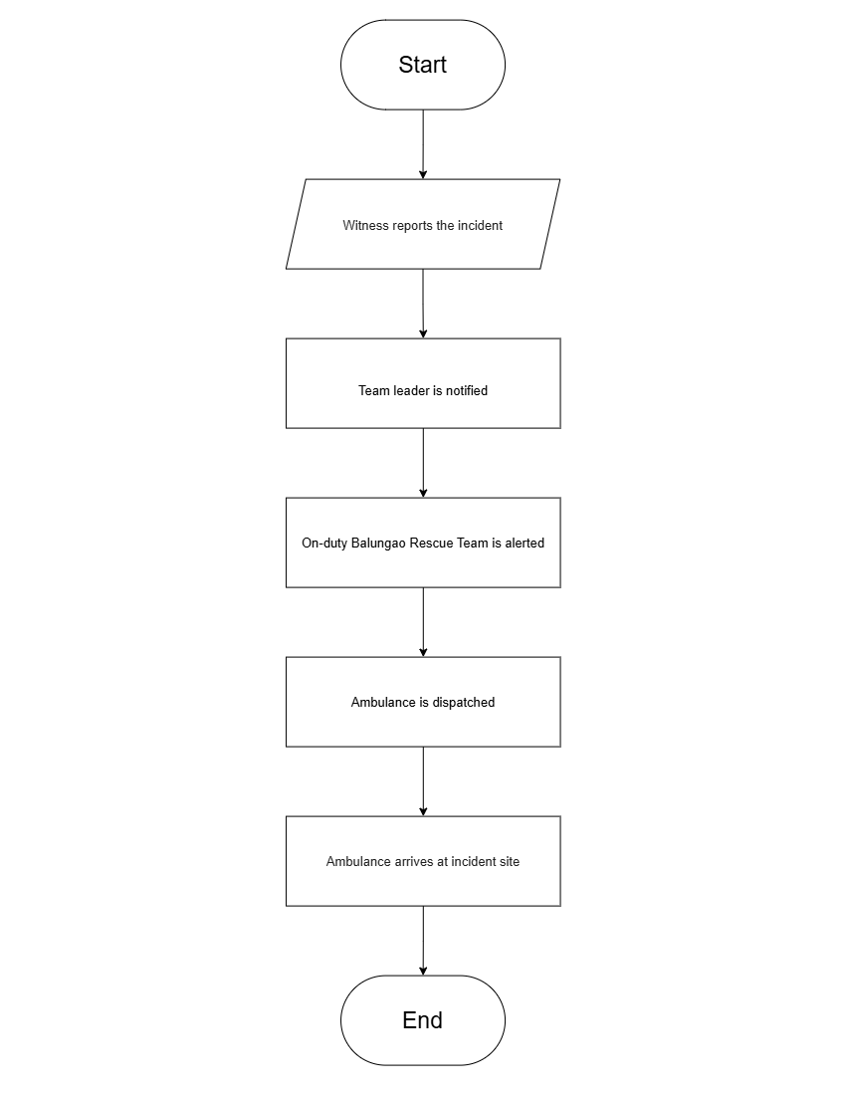
Currency Process Flowchart

Figure 3 :Current Process Flowchart
The flowchart illustrates the emergency response process, beginning when a witness reports an incident. The team leader is then notified, and the on-duty Balungao Rescue Team is alerted. Following this, an ambulance is dispatched and arrives at the incident site
2. System Design
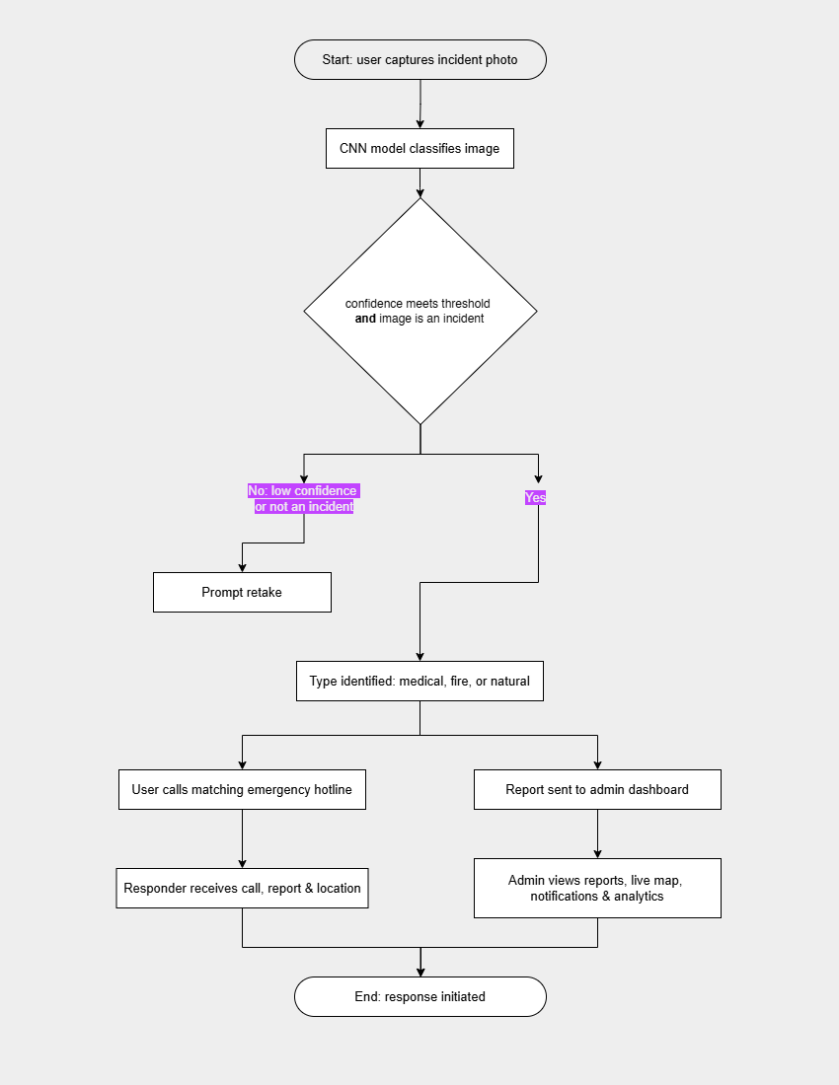
Proposed Flowchart

Figure 4 :Proposed Flowchart
The process begins when a user captures an incident photo, which is then classified by a CNN model. If the confidence meets the threshold and the image is verified as an incident, the type is identified as medical, fire, or natural, prompting the user to call the matching emergency hotline while the report is simultaneously sent to the admin dashboard. Ultimately, this leads to the responder receiving the call, report, and location while the admin views the reports, live map, notifications, and analytics, concluding with the initiation of the response. If the confidence is low or the image is not an incident, the user is prompted to retake the photo.

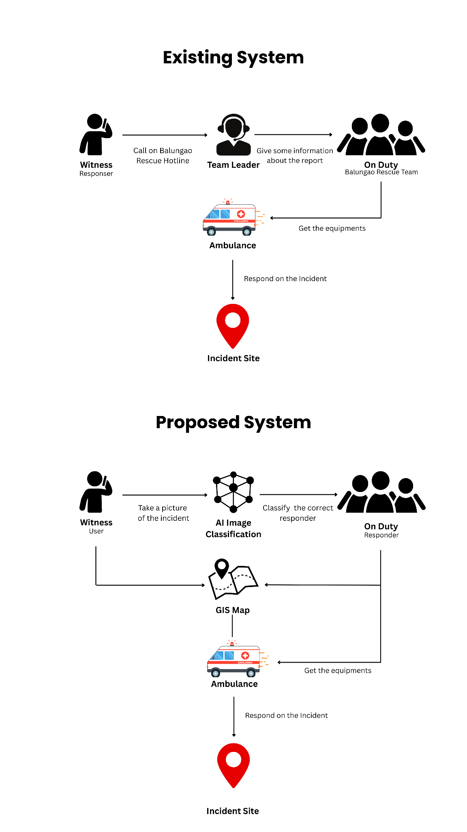
Conceptual Framework

Figure 5: Conceptual Framework
In the existing system, a witness calls the Balungao Rescue Hotline to notify a team leader, who then gives information to the on-duty rescue team so they can get equipment from the ambulance and respond to the incident site. In contrast, the proposed system starts when a witness takes a picture of the incident, which goes through AI image classification to classify the correct responder and integrate with a GIS map, allowing the on-duty responder to get equipment from the ambulance and respond to the incident site.
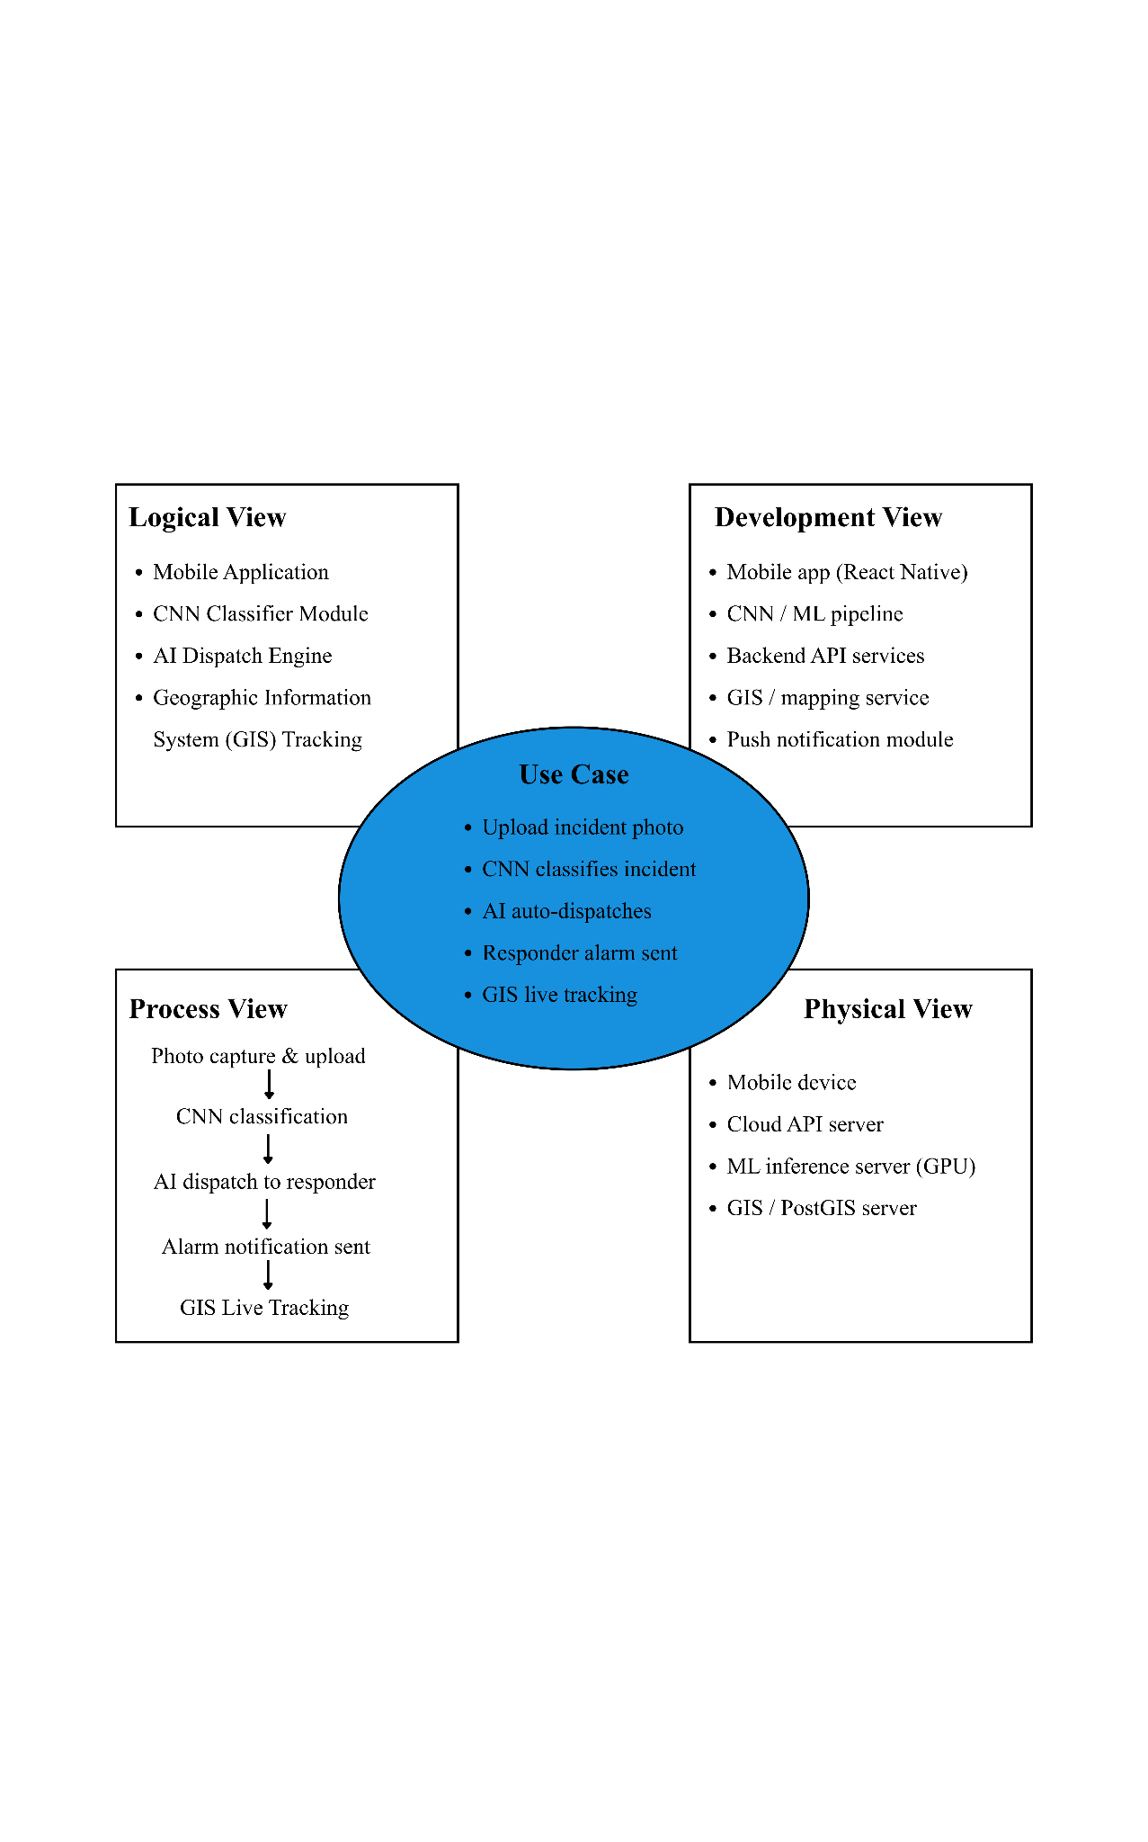
System Architecture

Figure 6: 4+1 View Architecture Model
The architecture model centers on core use cases such as uploading incident photos, CNN classification, auto-dispatching, and GIS tracking. These are supported by the logical view of functional modules, the development view specifying technologies like React Native and backend APIs, the physical view detailing hardware servers, and the process view outlining the sequential workflow.
Swim Lane Diagram
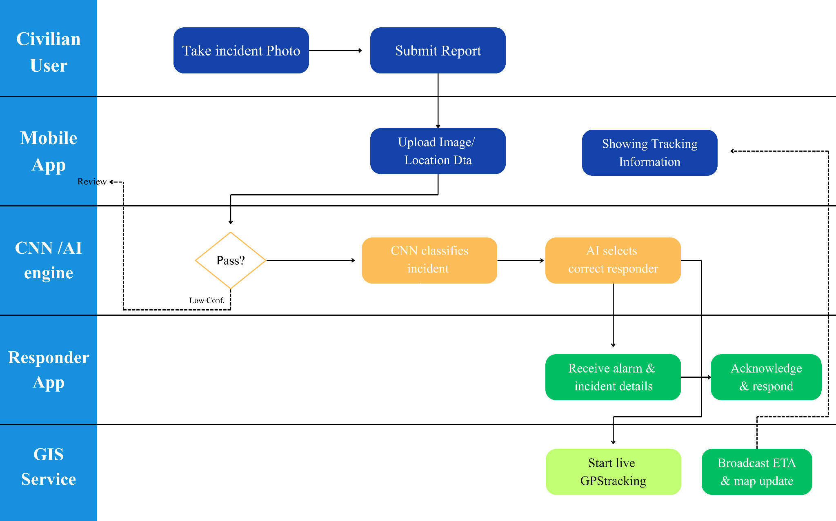
Figure 7: Swim Lane Diagram
The civilian user takes an incident photo and submits the report, which the mobile app then uploads along with location data to the CNN/AI engine for validation. If the image passes confidence checks, the CNN classifies the incident and the AI selects the correct responder. The responder app receives the alarm details and acknowledges the response, while the GIS service simultaneously starts live GPS tracking and broadcasts the estimated time of arrival and map updates back to the mobile app. If the confidence is low, the system loops back for a review.

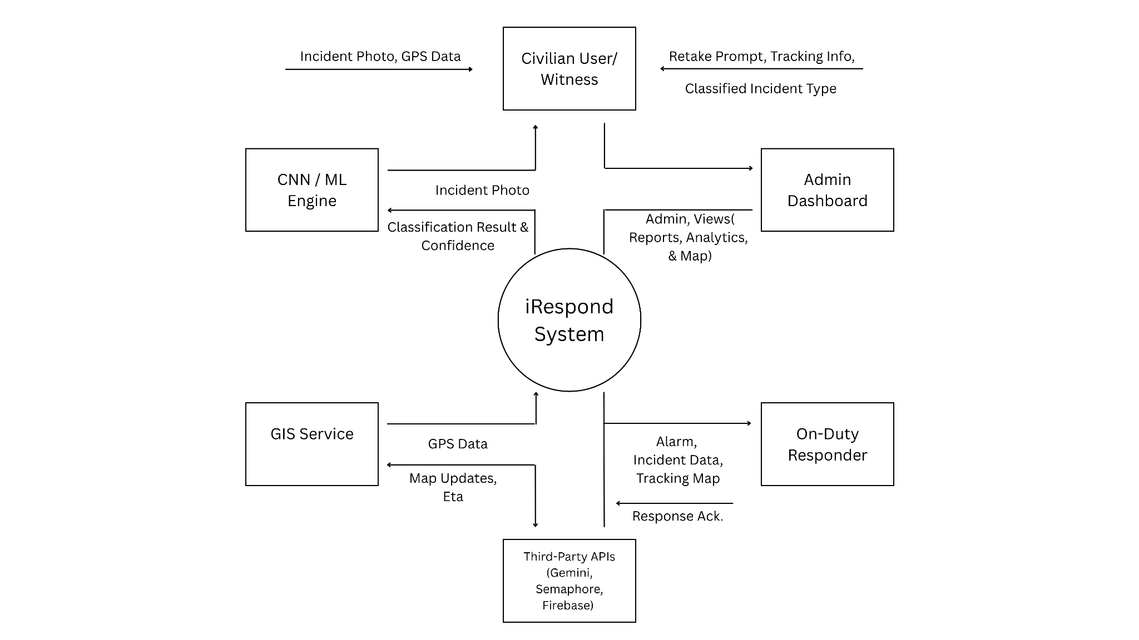
Context Diagram

Figure 8: Context Diagram
The central iRespond system connects with multiple external entities, beginning with the civilian user or witness who provides incident photos and GPS data while receiving retake prompts, tracking info, and classified incident types. The CNN/ML engine processes incident photos and returns classification results and confidence levels, while the GIS service exchanges GPS data, map updates, and ETAs. Additionally, the system communicates with third-party APIs like Sanctum Rest API, CNN Prediction API, Openstreetmap Tile API, and Leaflet, sends alarms, incident data, and tracking maps to the on-duty responder while receiving response acknowledgments, and provides reports, analytics, and map views to the admin dashboard.

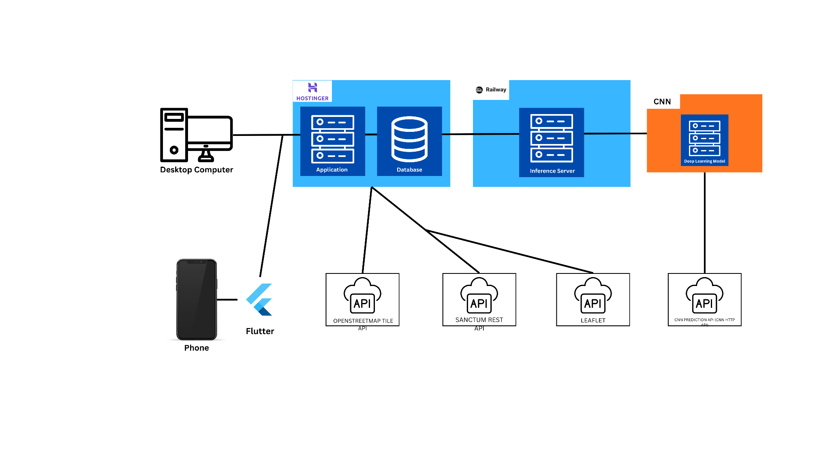
Block Diagram

Figure 9: Block Diagram
The block diagram illustrates the system architecture connecting a desktop computer and a phone using Flutter to a Hostinger-hosted application and database. The database links to external services including OpenStreetMap Tile API, Sanctum Rest API, and Leaflet. Additionally, the database connects to a Railway-hosted inference server and a CNN deep learning model, which further integrates with a Core Prediction API.

Database Design:
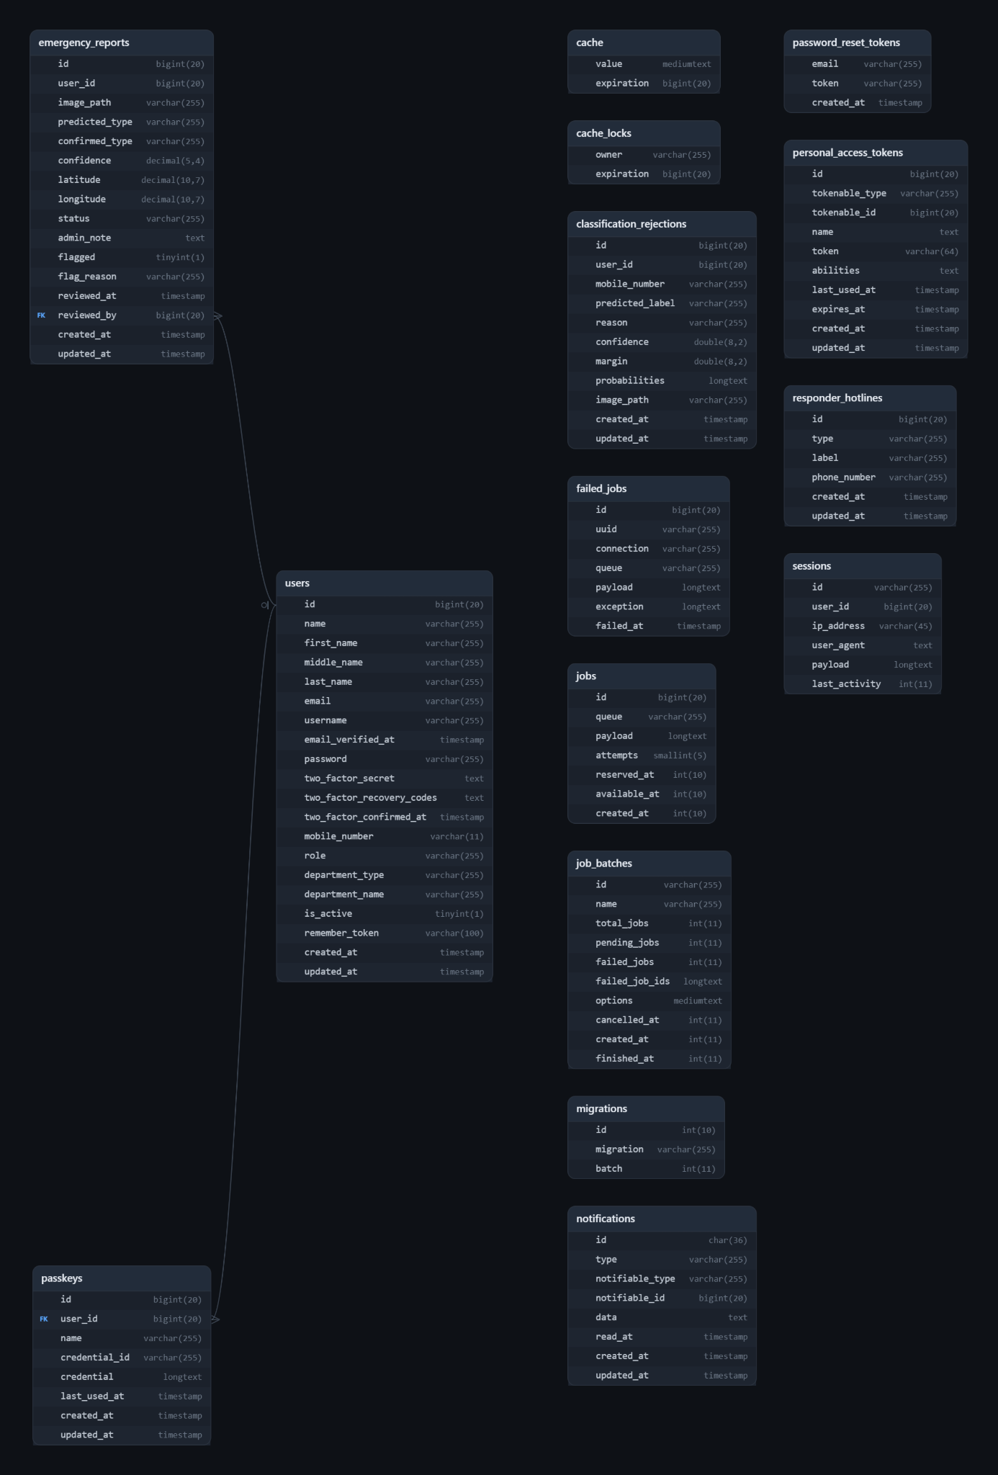

Figure 10: Entity Relationship Diagram

Figure 10 presents the Entity Relationship Diagram (ERD) of the proposed system. The database is implemented in a relational model using the Laravel framework and consists of sixteen tables. Five are core application tables that store the system's domain data, and eleven are framework tables that support authentication, caching, queueing, and notifications.

Core Entities
Users. The users table is the central entity of the database. It stores account information such as first_name, middle_name, last_name, email, username, and mobile_number. Citizen and responder accounts in the mobile app authenticate using mobile_number. Admin accounts on the web portal use password-based authentication (password, email_verified_at, and remember_token). Two-factor authentication is supported through two_factor_secret, two_factor_recovery_codes, and two_factor_confirmed_at. Access control is managed through role (citizen, responder, or admin), department_type, and department_name. The is_active attribute indicates whether an account is enabled.
Emergency Reports. The emergency_reports table stores each report submitted to the system. Every record contains the uploaded image (image_path), the type predicted by the CNN (predicted_type) with its confidence score, and the type confirmed by the citizen (confirmed_type). The incident location is stored as latitude and longitude. Case handling is tracked through status (pending, responding, resolved, or invalid), admin_note, flagged, flag_reason, reviewed_at, and reviewed_by.

Classification Rejections. The classification_rejections table records images that were not accepted as emergency reports. Rejection reasons include non_emergency, low_confidence, and uncertain. The table stores predicted_label, reason, confidence, margin, the complete probabilities output, image_path, and the submitter’s user_id and mobile_number. This provides an audit trail for evaluating the classification model.
Passkeys. The passkeys table stores WebAuthn credentials (credential_id, credential, and last_used_at) that allow web users to sign in without a password. Each passkey belongs to one user through user_id. This is used in the admin portal, not in the Flutter app.
Responder Hotlines. The responder_hotlines table is a reference table of emergency contact numbers, each with a type, label, and phone_number. These numbers are shown in the mobile app for calling fire, medical, and natural disaster responders.

Supporting Framework Tables
The remaining tables are generated by Laravel and support the system's infrastructure. password_reset_tokens, personal_access_tokens, and sessions handle password recovery, API token authentication, and session management. cache and cache_locks provide caching and atomic locking. jobs, job_batches, and failed_jobs support background queue processing. notifications stores user notifications using a polymorphic relationship (notifiable_type and notifiable_id), and migrations tracks the version history of the database schema.

Relationships
The diagram shows two enforced relationships:
Users to Emergency Reports (one-to-many, optional). A user may review many emergency reports, while each report is reviewed by at most one user. This is implemented through the foreign key emergency_reports.reviewed_by, which references users.id. The relationship is optional because a newly submitted report has not yet been reviewed.
Users to Passkeys (one-to-many). A user may register multiple passkeys, while each passkey belongs to exactly one user through passkeys.user_id.

Other columns, such as emergency_reports.user_id, classification_rejections.user_id, and sessions.user_id, refer to users.id logically but are not enforced as foreign key constraints in the database.

3. Development
Table 12: Coding Environment, Technologies, Framework, Software Used
Component | Technology used | Version (If  applicable)
Programming  Language | PHP, Python, & Dart | Version 8.3
Framework | Laravel & Flutterflow | Version 13.15.0
Database | MySQL | MySQL (XAMPP)
Integrated  Development  Environment  (IDE) | Visual Studio Code
Version Control | Github

Developmental Methodology
The researchers employed the use of Agile methodology. Agile is selected due to its flexibility and iterative quality, which enables constant development, testing and enhancement of the system functions like real-time reporting, location tracking, and responder coordination.
Sprint / Iteration
The iRespond development process followed four main phases UI/Flutter, Laravel Backend, API Connection, and Model Training executed across six sprint weeks. Initial weeks established the Laravel backend configuration, database migrations, and mobile number-based authentication. Subsequent sprints successfully deployed user authentication, Flutter dashboard and login interfaces, API client services, and an admin command center featuring emergency report controllers and CNN image classification logic. The final sprint involved pilot testing on an actual physical device, which successfully finished and implemented all planned features, including working GPS functionality, mobile reporting, and fully operational CNN image classification.

4. Test
Developer Testing:
Functional requirements
The development team used targeted test cases to thoroughly verify all functional requirements, ensuring the system's features and workflows operate reliably.
FR-1: Authentication & Roles
TC ID | Req. | Test Scenario | Test Steps | Expected Result | Actual Result | Status
TC-001 | FR-1.1 | Citizen registers/logs in via PH mobile number | 1) Open app; 2) Tap Register; 3) Enter valid PH mobile number; 4) Complete OTP verification; 5) Submit | Citizen account is created and citizen is logged in | Citizen account is created and citizen is logged in | Pass
TC-002 | FR-1.2 | Responder logs in with admin-provisioned account | 1) Open app; 2) Enter responder credentials created by admin; 3) Log in | Responder logs in successfully | Responder logs in successfully | Pass
TC-003 | FR-1.3 | Admin logs in via web portal | 1) Open admin portal; 2) Enter admin credentials; 3) Submit | Admin is authenticated and reaches the dashboard | Admin is authenticated and reaches the dashboard | Pass
TC-004 | FR-1.4 | System supports 3 distinct roles | 1) Log in as citizen; 2) Log in as responder; 3) Log in as admin | Each role sees only its assigned interface/permissions | Each role sees only its assigned interface/permissions | Pass
TC-005 | FR-1.5 | Inactive account cannot log in | 1) Admin disables an account; 2) Attempt login with it | Login is rejected with an "account inactive" message | Login is rejected with an "account inactive" message | Pass
TC-006 | FR-1.6 | Admin blocked from mobile API | 1) Attempt admin login via mobile app/API | Login attempt is rejected | Login attempt is rejected | Pass

FR-2: Citizen Emergency Reporting
TC ID | Req. | Test Scenario | Test Steps | Expected Result | Actual Result | Status
TC-007 | FR-2.1 | Capture/upload emergency photo | 1) Open report screen; 2) Tap camera/upload; 3) Select photo | Photo is attached to the report | Photo is attached to the report | Pass
TC-008 | FR-2.2 | CNN classifies photo into 4 classes | 1) Submit test images per class | Result is one of: fire, medical, natural disaster, non-emergency | Result is one of: fire, medical, natural disaster, non-emergency | Pass
TC-009 | FR-2.3 | Type locked to CNN result | 1) Submit valid photo; 2) View displayed type/confidence | Type matches CNN output and cannot be manually edited | Type matches CNN output and cannot be manually edited | Pass
TC-010 | FR-2.4 | Reject non-emergency/low-confidence images | 1) Submit a non-emergency or blurry image | System rejects it and prompts a retake | System rejects it and prompts a retake | Pass
TC-011 | FR-2.5 | Dial matching LGU hotline | 1) Get successful classification; 2) Tap "Call Hotline" | Dialer opens with the correct hotline number for that type |  | Pass
TC-012 | FR-2.6 | Capture GPS, preview on OSM map | 1) Submit report; 2) Allow location access | GPS is captured and shown correctly on the map preview |  | Pass
TC-013 | FR-2.7 | Submit complete report | 1) Complete photo, GPS, classification; 2) Tap Submit | Report saved with photo, GPS, predicted/confirmed type, confidence |  | Pass
TC-014 | FR-2.8 | View report history/status | 1) Open "My Reports" | List shows correct status (pending/responding/resolved) |  | Pass

FR-3: Responder Case Handling

TC ID | Req. | Test Scenario | Test Steps | Expected Result | Actual Result | Status
TC-015 | FR-3.1 | Responder sees only own department's cases | 1) Log in as e.g. fire responder; 2) View case list | Only fire-type cases visible; others hidden |  | Pass
TC-016 | FR-3.2 | List/filter cases by status | 1) Open case list; 2) Apply status filter | List updates to match filter |  | Pass
TC-017 | FR-3.3 | View cases on GIS map | 1) Open map view | Assigned cases show as pins at correct GPS locations |  | Pass
TC-018 | FR-3.4 | Open case detail | 1) Tap a case | Detail shows image, type, confidence, GPS, reporter contact, admin notes/flags |  | Pass
TC-019 | FR-3.5 | Update case status | 1) Open case; 2) Set to responding, then resolved | Status updates and reflects on admin/citizen views |  | Pass
TC-020 | FR-3.6 | Live navigation to incident | 1) Open case; 2) Tap Navigate | OSM map shows OSRM route with live GPS tracking |  | Pass
TC-021 | FR-3.7 | Arrival detection (~50m) | 1) Navigate to within 50m of incident coordinates | System detects and logs arrival automatically |  | Pass
TC-022 | FR-3.8 | Contact reporter | 1) Open case detail; 2) Tap call/SMS/copy | Responder can call, message, or copy reporter's number |  | Pass

FR-4: Admin Monitoring & Management

TC ID | Req. | Test Scenario | Test Steps | Expected Result | Actual Result | Status
TC-023 | FR-4.1 | Dashboard report counts | 1) Log in as admin; 2) View dashboard | Counts by status, type, and flags are correct | Counts by status, type, and flags are correct | Pass
TC-024 | FR-4.2 | List/search/filter reports | 1) Search/filter by keyword, type, or status | Results match applied criteria | Results match applied criteria | Pass
TC-025 | FR-4.3 | Review report details | 1) Open a report | Admin sees CNN vs. confirmed type, confidence, GIS location | Admin sees CNN vs. confirmed type, confidence, GIS location | Pass
TC-026 | FR-4.4 | Update status/notes/flags | 1) Change status; 2) Add note; 3) Flag report | Changes save and persist on reload | Changes save and persist on reload | Pass
TC-027 | FR-4.5 | GIS map of reports | 1) Open GIS map view | All reports appear as pins at correct locations | All reports appear as pins at correct locations | Pass
TC-028 | FR-4.6 | Analytics by week/month/year | 1) Switch between time period views | Data/charts update with correct type breakdown | Data/charts update with correct type breakdown | Pass
TC-029 | FR-4.7 | Manage responder accounts | 1) Create responder account; 2) Enable/disable one | Account created/updated correctly | Account created/updated correctly | Pass
TC-030 | FR-4.8 | Manage hotlines (CRUD) | 1) Add, edit, delete a hotline entry | Hotline record created, updated, and removed correctly | Hotline record created, updated, and removed correctly | Pass
TC-031 | FR-4.9 | Manage users (enable/disable) | 1) Disable a citizen account; 2) Re-enable it | Account status and login access update accordingly | Account status and login access update accordingly | Pass
TC-032 | FR-4.10 | Audit CNN rejections | 1) Open rejection/audit log | Log shows non-emergency/rejected submissions | Log shows non-emergency/rejected submissions | Pass
TC-033 | FR-4.11 | In-app notifications | 1) Submit a new report as citizen | Admin receives in-app notification | Admin receives in-app notification | Pass

FR-5: CNN / Classification Service
TC ID | Req. | Test Scenario | Test Steps | Expected Result | Actual Result | Status
TC-034 | FR-5.1 | ML service 4-class output | 1) Send test image to ML service | Returns one of: fire, medical, natural disaster, non-emergency | Returns one of: fire, medical, natural disaster, non-emergency | Pass
TC-035 | FR-5.2 | Confidence/margin gates enforced | 1) Submit image below confidence threshold | Laravel rejects it before acceptance | Laravel rejects it before acceptance | Pass
TC-036 | FR-5.3 | Rejected classifications logged | 1) Trigger a rejection | Rejection recorded in audit log | Rejection recorded in audit log | Pass
TC-037 | FR-5.4 | Accepted images stored & linked | 1) Submit valid accepted classification | Image stored and linked to its report record | Image stored and linked to its report record | Pass

Non-Functional Requirements
The non-functional testing phase was fully successful, with all performance, scalability, reliability, usability, and security evaluations comfortably meeting or exceeding established benchmarks. The system demonstrated rapid response times under standard loads while maintaining exceptional uptime. Furthermore, user evaluations indicated high satisfaction and smooth navigation, and comprehensive vulnerability assessments confirmed complete safety with zero critical risks, fully validating that the platform is stable, responsive, secure, and ready for production deployment.

IT Expert
Building upon the feedback from IT experts and evaluators, the system was successfully updated with several practical improvements to strengthen security, accuracy, and usability. To stop unauthorized test-account access and reduce spam, a One-Time Password (OTP) verification feature was added. The system's AI was also updated to use clear confidence scores, automatically sending unclear cases to an admin dashboard for manual review. For better tracking on the map, color-coded map pins were introduced to instantly show different types of emergencies. Finally, the system now includes updated notification settings so users can manage their alerts, along with a data analytics dashboard to help administrators track response times and incident trends.

5. Deployment
The admin website was hosted using Hostinger, while the mobile app backend and services were deployed on Railway. To facilitate operations, a dedicated administrator account was created for the local Municipal Disaster Risk Management Office (MDRRMO). Furthermore, the application installation file (APK) was distributed for mobile users, successfully making the system live and operational for deployment.
6. Review / Evaluation
Evaluation Methodology
The System Usability Scale (SUS) was used and distributed through Google Forms it was utilized to systematically evaluate and measure the overall quality, user experience, and perceived usability of the system.

Presentation of Result
(SUS) System Usability Scale Result
Mean (Average) SUS Score: 70.75 (Meets the Grade B / "Good" threshold)
Median SUS Score: 73.75
Minimum Score: 50.00
Maximum Score: 100.00
Standard Deviation: 14.86
Usability Rating: Falling into the "Good" category (grade B), the score comfortably exceeds the standard industry benchmark threshold of 68. This indicates that users found the platform intuitive, efficient, and user-friendly overall.
This evaluation fulfills the quantitative component of Objective 4 ("To evaluate the system using SUS (System Usability Scale) and ISO/IEC 25010 Software Quality Model").
By measuring end-user usability, the results prove that the platform's user interface and operational workflows (such as interacting with the AI emergency classification and GIS map tracking modules) are approachable for users without imposing steep learning curves or excessive complexity.
Table 13 : SUS score table
Respondent | SUS Score | Respondent | SUS Score | Respondent | SUS Score
R1 | 92.5 | R11 | 80.0 | R21 | 90.0
R2 | 70.0 | R12 | 77.5 | R22 | 50.0
R3 | 52.5 | R13 | 77.5 | R23 | 57.5
R4 | 50.0 | R14 | 55.0 | R24 | 100.0
R5 | 75.0 | R15 | 60.0 | R25 | 80.0
R6 | 50.0 | R16 | 82.5 | R26 | 77.5
R7 | 50.0 | R17 | 72.5 | R27 | 75.0
R8 | 67.5 | R18 | 85.0 | R28 | 75.0
R9 | 97.5 | R19 | 65.0 | R29 | 60.0
R10 | 80.0 | R20 | 50.0 | R30 | 67.5

ISO/IEC 25010 Software Quality Model Result
Overall, respondents rated the iRespond system 3.61 out of 4.00 across the nine software quality characteristics, which falls in the Excellent range. Every characteristic scored between 3.47 and 3.83, and the most common response for each was 4 (the highest rating).
The evaluated ISO/IEC 25010 score of 3.61 out of 4.00 ("Excellent") fulfills Objective 4 by showing that the system is built on robust software engineering standards across all nine quality characteristics. This high rating validates Objective 1 through strong Functional Suitability (3.63) and the highest-rated characteristic, Reliability (3.83), in the centralized reporting and emergency mobilization modules. It supports Objective 2 through Performance Efficiency (3.47) in the AI-based classification and targeted notification engine. It also confirms Objective 3 through Interaction Capability (3.70), the second-highest rating, and Compatibility (3.57) within the GIS incident-tracking interface.

Table 14: ISO/IEC 25010 Software Quality Model Result table
Quality Characteristic | 1 | 2 | 3 | 4 | Weighted Mean | Std. Dev.
Functional Suitability | 1 | 0 | 8 | 21 | 3.63 | 0.67
Performance Efficiency | 2 | 0 | 10 | 18 | 3.47 | 0.82
Compatibility | 1 | 1 | 8 | 20 | 3.57 | 0.73
Interaction Capability | 1 | 1 | 4 | 24 | 3.70 | 0.70
Reliability | 0 | 0 | 5 | 25 | 3.83 | 0.38
Security | 0 | 0 | 10 | 20 | 3.67 | 0.48
Maintainability | 0 | 3 | 5 | 22 | 3.63 | 0.67
Flexibility | 2 | 1 | 8 | 19 | 3.47 | 0.86
Safety | 3 | 0 | 5 | 22 | 3.53 | 0.94
OVERALL | 10 | 6 | 63 | 191 | 3.61 | 0.71

Feedback
Feedback from the respondents praised the platform as user-friendly, simple, organized, and highly beneficial for community disaster management. However, users also provided several constructive suggestions for future improvements, including expanding accessibility to iOS devices, introducing voice commands for high-stress emergency situations, incorporating offline or low-connectivity support, providing Filipino translations with adjustable font sizes, and implementing anti-trolling safeguards or penalty systems to prevent fake reports.

Chapter V

CONCLUSIONS AND RECOMMENDATIONS

Summary
● Overall Summary
Emergency response in Balungao, Pangasinan relied on a manual, voice-based process in which witnesses called a hotline and responders were dispatched through a chain of phone calls. This led to incomplete reports, misclassified incidents, and difficulty locating emergencies. To address this, the researchers developed iRespond, an AI-powered, GIS-based emergency incident reporting and image classification system for the Balungao Municipal Disaster Risk Reduction and Management Office (MDRRMO). Citizens photograph an incident using a Flutter mobile application, and a Convolutional Neural Network classifies it as fire, medical, natural disaster, or non-emergency. Responders then view and navigate to their department's cases through a GIS map, and administrators monitor reports through a Laravel-based web dashboard. The system was developed using Agile with Scrum over six sprint weeks, covering the user interface, backend, API connection, and model training phases. It was tested against 37 functional test cases, evaluated by 30 respondents using the System Usability Scale and the ISO/IEC 25010 Software Quality Model, and deployed through Hostinger and Railway, with an administrator account for the MDRRMO and an APK for mobile users. The result is a working, deployed system that centralizes emergency reporting, classifies incidents automatically, and tracks incident locations.
● Key Results
- Development. All planned features were implemented across six sprint weeks, including mobile reporting, working GPS functionality, and fully operational CNN image classification. The final sprint was pilot-tested on an actual physical device.
- Developer testing. All 37 test cases, covering authentication and roles, citizen reporting, responder case handling, admin monitoring, and the classification service, were recorded as passed.
- IT expert feedback and corrective actions. One-Time Password (OTP) verification was added to stop unauthorized test accounts and reduce spam. The AI now uses clear confidence scores and sends unclear cases to the admin dashboard for manual review. Color-coded map pins were introduced for the different emergency types. Notification settings were updated so users can manage their alerts, and a data analytics dashboard was added so administrators can track response times and incident trends.
- Deployment. The admin website was hosted on Hostinger and the backend services on Railway. An administrator account was created for the MDRRMO, and the APK was distributed to mobile users.
- System Usability Scale. Based on 30 respondents, the mean SUS score was 70.75 (median 73.75, standard deviation 14.86, range 50.0 to 100.0), which is in the "Good" category (grade B) and above the benchmark of 68.
- ISO/IEC 25010. The overall weighted mean was 3.61 out of 4.00 ("Excellent"), with all nine characteristics between 3.47 and 3.83. Reliability (3.83) was the highest and Performance Efficiency and Flexibility (3.47) were the lowest.
- Respondent feedback. Respondents described the system as user-friendly, simple, and organized. They suggested iOS support, voice commands, offline or low-connectivity support, Filipino translations with adjustable font sizes, and safeguards against fake reports.
Taken together, the results indicate that iRespond works as intended, is rated as usable and of high quality by its evaluators, and has already been improved through expert feedback. Its effect on actual response time has not yet been measured.

Conclusions
The first objective was to create a centralized reporting module that categorizes emergencies and mobilizes responders. This was met. All requirements for citizen reporting (FR-2), responder case handling (FR-3), and admin monitoring (FR-4) passed developer testing. Reports from citizens are stored in one database with photo, location, type, confidence, and review status. Admins can review, flag, and update every report, and responders can update case status (responding, resolved), which is reflected on the admin and citizen views. This replaces the separate, phone-based process in which individual departments had to be contacted one by one. The ISO/IEC 25010 evaluation supports this, with Functional Suitability (3.63) and Reliability (3.83), the highest-rated characteristic, both in the "Excellent" range.
The second objective was to improve responder coordination through an AI-based classification system that notifies only the appropriate personnel. This was met. The CNN classifies each photo into four classes, the resulting type is locked and cannot be edited manually, and low-confidence or non-emergency images are rejected before acceptance and logged for audit. Responders see only the cases that match their department, so irrelevant alerts are avoided. The final model achieved a training accuracy of 91.5% and a validation accuracy of 95.4% (~850 images per split). Following IT expert feedback, the AI was also updated to use clear confidence scores and to send unclear cases automatically to the admin dashboard for manual review. Performance Efficiency was rated 3.47 in the ISO/IEC 25010 evaluation, tied with Flexibility as the lowest-rated characteristic.
The third objective was to apply a Geographic Information System to track the location of reported incidents. This was met. The system captures GPS coordinates at the time of reporting, previews the location on an OpenStreetMap map, and shows reports as pins on the responder and admin map views. Responders receive an OSRM route with live GPS tracking, and arrival within about 50 meters of the incident is detected and logged automatically. These features address the problem of responders being unable to identify exactly where an emergency is.
The fourth objective was to evaluate the system using the System Usability Scale and the ISO/IEC 25010 Software Quality Model. This was met. Based on 30 respondents, the system obtained a mean SUS score of 70.75 (median 73.75, standard deviation 14.86, range 50.0 to 100.0), which falls in the "Good" category and above the industry benchmark of 68. The margin is modest, however. With 30 respondents, the 95% confidence interval of the mean runs from roughly 65 to 76, which includes the benchmark, and 13 of the 30 respondents scored below 68. The ISO/IEC 25010 evaluation gave an overall weighted mean of 3.61 out of 4.00 ("Excellent"), with all nine characteristics rated between 3.47 and 3.83. Reliability (3.83), Interaction Capability (3.70), and Security (3.67) were rated highest, while Performance Efficiency and Flexibility (both 3.47) were rated lowest. These results indicate that respondents found the system usable and of good quality. However, they measure perceived usability and quality, not actual reductions in response time.
Additional conclusions. The results are consistent with the earlier studies reviewed in Chapter II. Like SAFE (Cruz et al., 2021) and S.A.F.E.R. (Culi et al., 2026), iRespond shows that a mobile application with GPS reporting is a workable alternative to voice-only hotlines. It also addresses the gaps those systems left, namely their focus on a single emergency type and the lack of AI classification. The use of a CNN for classifying incident images agrees with the findings of Alam et al. (2020) and Bashir et al. (2024) that deep learning is effective for disaster image classification. The confidence and margin gates, together with the admin review and the audit log of rejected images, follow the human-in-the-loop principle that Woo (2017) recommends for high-stakes applications, since high confidence scores do not guarantee correctness. Finally, the project contributes a working, locally deployed example of how AI image classification, GIS, and role-based coordination can be combined in a single low-cost platform for a municipal disaster office. Overall, the study met its aims of providing Balungao with a centralized, AI-assisted, and location-aware emergency reporting system. Whether it improves actual response times can only be confirmed through longer use in the field.

Recommendations
The following recommendations are based on the conclusions of the study and are arranged by priority.
- Evaluate and strengthen the classification model. The MDRRMO and the development team should measure the CNN on a held-out test set and report its accuracy, precision, recall, and confusion matrix per class. The images in the classification rejections log and the unclear cases sent to admin review should be used to retrain the model with a larger and more varied dataset, including night-time, blurry, and low-light photos. This is feasible because both the audit log and the review queue already exist in the system.
- Keep help reachable when a photo is unclear. Unclear cases are now sent to the admin dashboard for manual review. The system should also let the user proceed to the hotline call right away while the case is under review, and the MDRRMO should monitor how long admin review takes so that classification uncertainty never delays a real emergency.
- Measure the effect on response time through a longer pilot. The MDRRMO should use the new analytics dashboard to record the time from report to responder arrival and compare it with the previous call-based process. This would show whether iRespond reduces delays, which the SUS and ISO/IEC 25010 results alone cannot show.
- Expand the covered incident types. The study originally targeted vehicular accidents and police-related cases in addition to fire, medical, and natural hazards. These should be added as new classes once enough labeled images are available, together with their corresponding responder departments and hotlines.
- Address low-connectivity areas, language, and platform coverage. Respondents suggested iOS support, offline or low-connectivity support, and Filipino translations with adjustable font sizes. An SMS-based fallback and offline report queuing should be considered for areas with weak signal, since the system currently depends on a stable internet connection and runs on Android 8.0 and above.
- Add safeguards against fake reports. Respondents also suggested anti-trolling measures. OTP verification has already been added, and the existing flagging fields on reports can support a review process or a penalty system for repeated false submissions.
- Strengthen data privacy and security. The system stores photos, GPS locations, and mobile numbers. The MDRRMO should adopt a clear data retention and access policy aligned with the Data Privacy Act of 2012 (RA 10173), and security testing should be documented with its tools and results.
- Provide training and continued support. Respondents who rated the system low in the SUS should be asked for feedback, since 13 of 30 scored below the benchmark. Short orientation sessions for responders, administrators, and residents, together with LGU-led information drives, can improve adoption.
Future research. Future researchers may extend this study by (a) comparing different CNN architectures and confidence-calibration methods for emergency images; (b) adding automatic dispatch of the nearest available responder, urgency-level prediction, and voice-assisted guidance, which were part of the instruoriginal proposal; (c) adding multi-modal inputs such as short video or audio to improve classification; (d) testing the system in other municipalities and under different network conditions; and (e) studying the long-term effect of AI-assisted reporting on response times and community outcomes.

REFERENCES
Cruz, J. N. T., et al. (2021). SAFE: Smart application for emergency. IEOM Society
International. https://ieomsociety.org/proceedings/2021monterrey/276.pdf
Culi, A. K. B., et al. (2026). Smart application for emergency response (S.A.F.E.R.).
International Journal of Latest Technology in Engineering, Management & Applied
Science. https://www.ijltemas.in/submission/online/article/download/3953/5322/14333
Jolhe, R., Hadawale, S., Bagul, P., Bhoir, R., & Kamble, P. (2025). Quick rescue: Smart
emergency response application. International Journal of Engineering Applied Sciences
and Technology.
https://www.ijeast.com/papers/49-57%2C%20Tesma0911%2CIJEAST.pdf
Caliston, N. P., & Tabia, G. C. (2021). Help me: An emergency response mobile application.
Journal of Engineering Science and Technology.
https://jestec.taylors.edu.my/Speccial%20Issue%20ICITE2021/Special%20issue%20ICITE21_04.pdf
Rey, M. R., et al. (2022). Mamamayan: A mobile-based emergency response system. IEOM
Society International. https://ieomsociety.org/proceedings/2022istanbul/799.pdf

Department of the Interior and Local Government. (2023). Emergency calls management (911
system).
https://car.dilg.gov.ph/emergency-calls-management/
Department of the Interior and Local Government. (2025). Unified 911 emergency hotline
nationwide implementation.
https://dilg.gov.ph/news/One-Number-for-All-Emergencies-Unified-911-to-Launch-Nationwide/NC-2025-1177
Abuzaid, H., Almashhour, R., & Abu-Lebdeh, G. (2024). Driving towards sustainability: A
neural network-based prediction of the traffic-related effects on road users in the UAE.
Sustainability. https://www.mdpi.com/2071-1050/16/3/1092
Gatchalian, R. (2023). Smart emergency alert system using mobile technology. PowerTech
Journal. https://powertechjournal.com/index.php/journal/article/view/2521
International Organization for Standardization. (n.d.). ISO/IEC 25010 system and software
quality models. https://iso25000.com/index.php/en/iso-25000-standards/iso-25010
Iowa State University Extension and Outreach. (n.d.). Likert scale examples for surveys.
https://www.extension.iastate.edu/documents/anr/likertscaleexamplesforsurveys.pdf

GoDaddy. (n.d.). GoDaddy.
https://www.godaddy.com/en-ph
Semaphore. (n.d.). Semaphore.
https://www.semaphore.co
Google. (n.d.). Gemini API documentation.
https://ai.google.dev/gemini-api/docs
Tocaan. (n.d.). Tocaan.
https://tocaan.com/en/
Firebase. (n.d.). Firebase.
https://firebase.google.com
SmartDraw. (n.d.). Flowchart symbols.
https://www.smartdraw.com/flowchart/flowchart-symbols.htm
Amoros, J. L. (2025, September 9). Agile development process [Image]. Krasamo.
https://www.krasamo.com/agile-development-process/
Bajwa, A. (2025). AI-based emergency response systems: A systematic literature review on
smart infrastructure safety. SSRN.
https://doi.org/10.2139/ssrn.5171521
Sudhi, M., T.R., A., Shetty, D. K., Balakrishnan, J. M., Ahmad, S., & Sankaran, P. P. (2025).
AI-driven innovations in emergency and disaster response: Strategies for effective
planning. Proceedings on Engineering Sciences, 7(2), 1293–1304.
https://doi.org/10.24874/PES07.02C.009
Buntain, C., McGrath, E., Golbeck, J., & LaFree, G. (2016). Image classification to support
emergency situation awareness. Frontiers in Robotics and AI, 3, 54.
https://doi.org/10.3389/frobt.2016.00054
Bashir, M.H., Ahmad, M., Rizvi, D.R. et al. Efficient CNN-based disaster events
classification using UAV-aided images for emergency response application. Neural
Comput & Applic 36, 10599–10612 (2024).
https://doi.org/10.1007/s00521-024-09610-4
Kyrkou, C., et al. (2019). Deep-learning-based aerial image classification for emergency
response applications using unmanned aerial vehicles. In Proceedings of the
IEEE/CVF Conference on Computer Vision and Pattern Recognition Workshops
(CVPRW,2019).
https://openaccess.thecvf.com/content_CVPRW_2019/papers/UAVision/Kyrkou_Dee
p-Learning-Based_Aerial_Image_Classification_for_Emergency_Response_Applicat
ions_Using_Unmanned_CVPRW_2019_paper

Ordieres Meré, J. (2025). CIRS: A multi-agent machine learning framework for real-time
accident detection and response. Sensors, 25(18), 5845.
https://doi.org/10.3390/s25185845
Alam, F., Ofli, F., Imran, M., Alam, T., & Qazi, U. (2020). Deep learning benchmarks and
datasets for social media image classification for disaster response. In Proceedings
of the IEEE/ACM International Conference on Advances in Social Networks Analysis
and Mining (ASONAM). IEEE. https://doi.org/10.1109/ASONAM49781.2020.9381294
Barino, R. S., Cunha, C. B. da, & Solano, C. M. D. (Year). Facilities location for disaster
response teams using GIS Revista GESEC.
https://ojs.revistagesec.org.br/secretariado/article/view/3553
Venkatesh, S., & Praveen, K. (2025). Intelligent image classification and emergency
detection for enhanced CCTV surveillance systems using CNN-based gesture
analysis. IEEE. https://ieeexplore.ieee.org/document/11114015

APPENDICES

Appendix A - System Architecture
Figure 4. iRespond System’s 4+1 View Architecture Model

Figure 5. iRespond System’s Swim Lane Diagram

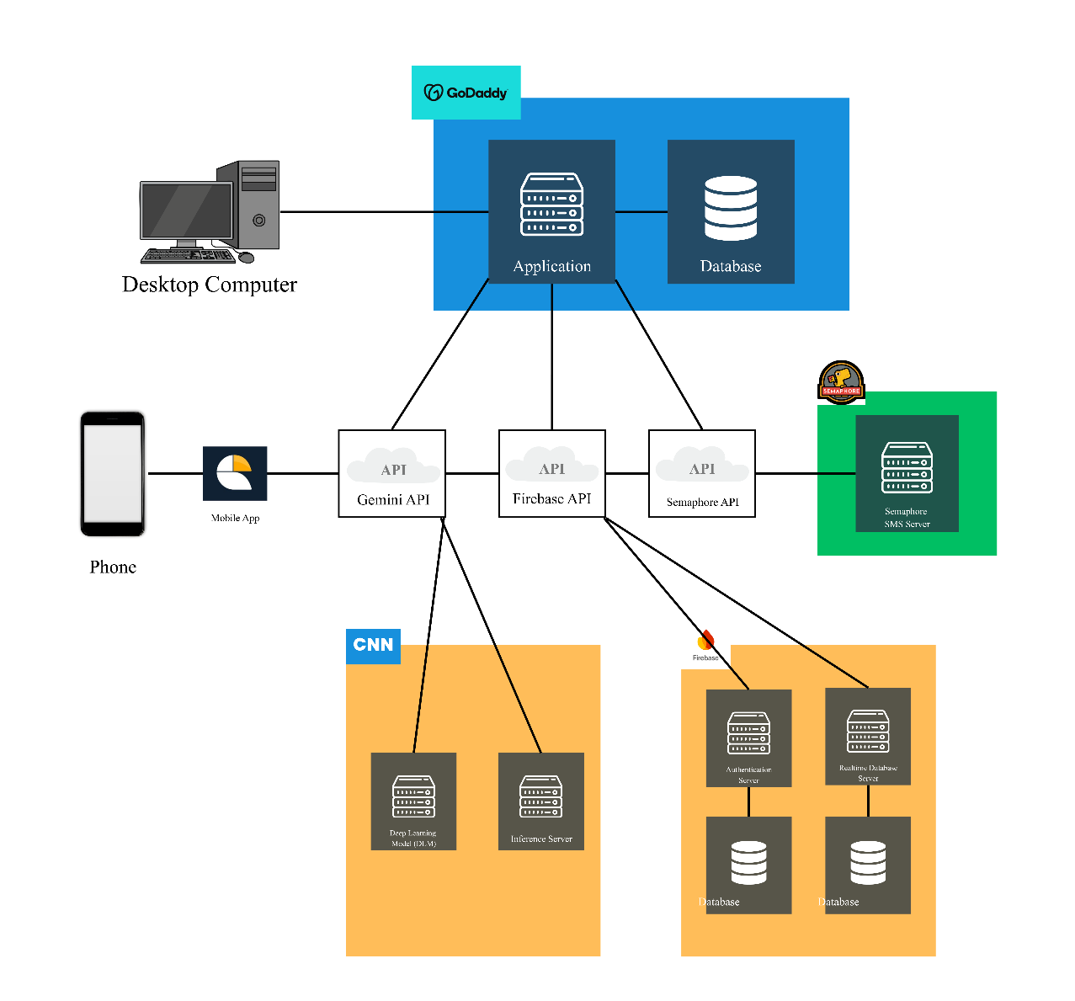
Figure 6. iRespond System’s Block Diagram

