

***Thank you for buy Ekume Engine 2D***

Before to starting with this package, please register your invoice number in our web page <http://www.ekume.com/web/cuenta/> (First you should to create an account and log in)

***Register the invoices is necessary to enable the support area for buyers.***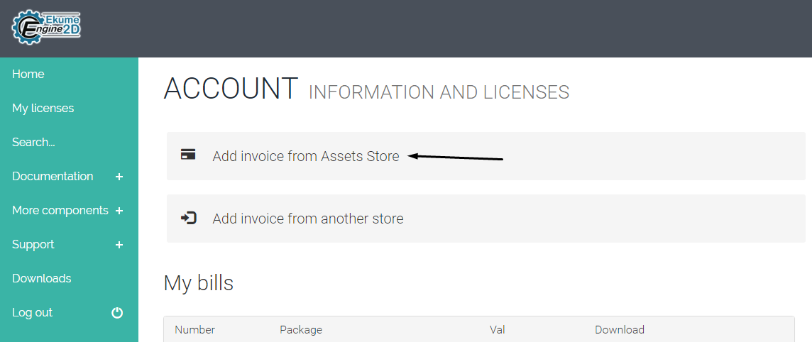

You can find the documentation for everything in: <http://www.ekume.com/web/docu/> and <http://www.ekume.com/web/tuto/>

For report bugs and support: <http://www.ekume.com/web/soporte/ask>

***NOTE:*** *The folder that contains the Platformer Game is in Assets/EkumeEngine2D/Platformer Game.* ***You can to delete this folder if you want to start a new project from scratch with EE2D.***

**REMEMBER ADD ALL THE SCENES OF *Assets/EkumeEngine2D/Platformer Game/Scenes* (EVEN THE SCENES IN THE FOLDERS OF *Levels* and *Maps*) TO THE BUILD SETTINGS (File -> Build Settings).**

**To disable the icon of the components, go to Gizmos and disable every icon of all components.**

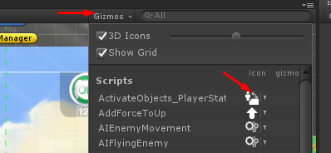

## What is Ekume Engine 2D (EE2D)?

EE2D is a complete bundle of components, systems and plugins, focused to ease the creation of 2D Games in Unity Engine, mainly this was made to work in different types of platformer games, but can be used in many other kind of 2D games. Ekume Engine 2D works for all platforms of Unity Engine, like Mobile Devices, PC, Web or even Consoles. The main version of Ekume Engine contains a complete platformer Game made 100% with this, all the Game Art and all the components used in the demo game of Ekume Engine 2D are available to use freely for your games.

***One of the best things of Ekume Engine 2D is that you do not need knowledge about programming to do an amazing game, you just need the basic knowledge about the functioning of Unity Engine.***

# HOW TO START AND BASIC INFORMATION

# Where can i find all the plugins, components and tools?

From the scene window you can find in the lower right part a little window with name Tools, here you can opent the main tools of EE2D.

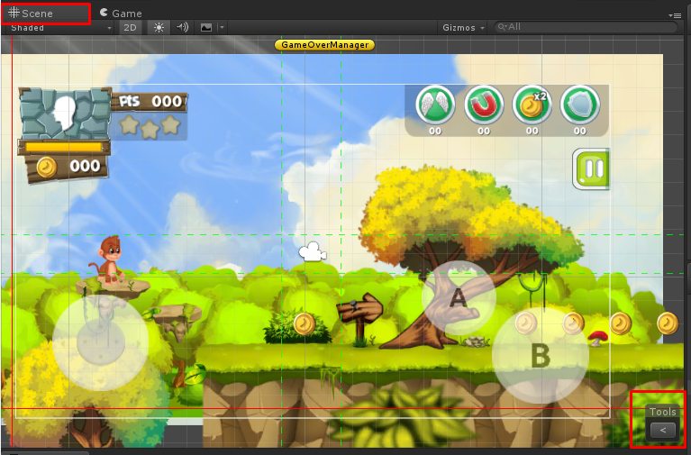

In the left of the window you can find all the main plugins of EE2D, and in the right appear 2 buttons very important for the scenes.

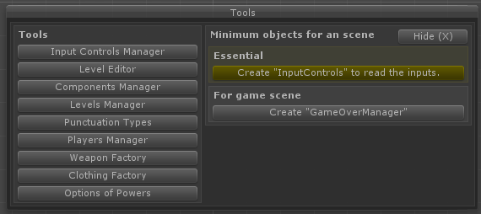

The component InputControls should be added to every scene. This component controls the inputs added in the Input Controls Manager, without this component you cannot use the inputs added in the plugin.

The component GameOverManager is very important for the levels of the game, this manages when the player lose, when win or when want to continue. This component manages the save points and manage when save the punctuations when the level finish.

## What components and plugins have Ekume Engine 2D?

Ekume Engine 2D currently have more than 150 plugins and components that can help you to make amazing games 2D. Here are some of the most important components.

### Input Controls Manager

This plugin allows you to create the inputs for your game easily and faster for all platforms only adding the name of the input and selecting the corresponding control for each platform; Ekume Engine 2D will activate the corresponding control depending of the platform that is running the game. This plugin is accompanied of many other components for the game, to use the corresponding inputs added in this plugin.

[*To read all about this plugin and his components visit the corresponding documentation*](http://www.ekume.com/web/docu/24)

### Level Editor

With the level editor you can edit more easily your levels, you can add your own objects to the level editor, separate by categories, subcategories and create your levels most easy just clicking in the object and later clicking in the scene to create the object.

[*To read all about this plugin and his components visit the corresponding documentation*](http://www.ekume.com/web/docu/26)

### Components Manager

The Components Manager allows you to find between the components availables of Ekume Engine 2D, that helps you to make the things you want in your game, like for example you can find the components to manage the player, the AI o the enemies, the score managers, sounds managers, animator managers, scripts for the camera movement, scripts to make mounts, buttons to buy weapons, characters, clothing... and more than 130+ scripts. You will be able to separate the scripts by categories, add new categories and add your own scripts with your own descriptions. Here you can find a little description of the functioning of every script that you can use in the game, and you can edit it too if you want.

[*To read all about this plugin and his components visit the corresponding documentation*](http://www.ekume.com/web/docu/25)

### Levels Manager

This plugin manages the levels, you can add new levels and worlds to use it with the components corresponding to the levels, for example to make a level selection and show the won or locked levels, or even it is essential for the score system, to show the points, stars, or any score type corresponding to the levels. This plugin includes testing tools to test the levels, for example to set some level like won, or locked.

[*To read all about this plugin and his components visit the corresponding documentation*](http://www.ekume.com/web/docu/%3C/em%3E%3Cem%3Ehttp:/www.ekume.com/web/docu/27%3C/em%3E%3Cem%3E)

### Score Types Manager

With this plugin you can add the types of the score that you will use in your game, for example the Points, Coins or the Stars. You can define if the score is accumulative (like the coins), if will save the best score of the level, and many other options related with the scores. With the values added in the plugin you can use many componnent of Ekume Engine 2D, for example the components (Buttons) to buy weapons, clothing, characters, bullets for weapons, and more; or the components to show the total of some score (like the coins), show the current score, the best scores of the levels, etc... This plugin includes testing tools to test the scores and add values to the score types.

[To read all about this plugin and his components visit the corresponding documentation](http://www.ekume.com/web/docu/28)

### Players Manager

A little plugin, but with a big importance in the game. With this plugin you can name the characters that you will use in the game, and define the default character, this if you will have more than one character to select. If you will want a character selection, a character shop or some like this, you can use the components related to this plugin, for example the component (Button) to buy a character or the button to select an specific character etc...

[*To read all about this plugin and his components visit the corresponding documentation*](http://www.ekume.com/web/docu/%3C/em%3E%3Cem%3Ehttp:/www.ekume.com/web/docu/31%3C/em%3E%3Cem%3E)

### Weapon Factory

With this plugin you can create melee attacks, powers to use like "spells", you can create any type of gun, bullet for the guns, melee weapons like swords or hammers, or anything to attack or shoot. The weapons can be used by the Player, any Enemy or the mounts for the player. With this plugin you can use different components, for example the component to use a wepon, to buy weapons and buy bullets, the component to select weapons, to show the unlocked weapons, etc...

[*To read all about this plugin and his components visit the corresponding documentation*](http://www.ekume.com/web/docu/%3C/em%3E%3Cem%3Ehttp:/www.ekume.com/web/docu/34%3C/em%3E%3Cem%3E)

### Clothing Factory

This plugin allows you to add items of clothing, to put in the player or in another site of the game. With this plugin you can create categories for the items, add the corresponding objects, his names, and you will be ready to use the components to put the corresponding clothing in the player or any object in some part of the game. You will be able to use components to make an item shop of any type, like a clothing shop for player or even you can use this plugin and components to make a shop of furniture to decore the house of the player. The main name of this plugin is Clothing Factory, but you are not limited to use it only for clothing, this plugin and his components have a high quantity of uses.

[*To read all about this plugin and his components visit the corresponding documentation*](http://www.ekume.com/web/docu/%3C/em%3E%3Cem%3Ehttp:/www.ekume.com/web/docu/39%3C/em%3E%3Cem%3E)

### Powers

EE2D has 7 powers ready to be added to the player, this powers are the most comun or popular in different types of games, like Coins x2, Jetpack, Coins Magnet, Shield, Power to fly, and more. With this plugin you can use different components to make many things, for example you will be able to make a power upgrades scene and you can take the control about the number of uses of the powers, and even you can make a shop where the player can buy uses for the powers.

[*To read all about this plugin and his components visit the corresponding documentation*](http://www.ekume.com/web/docu/%3C/em%3E%3Cem%3Ehttp:/www.ekume.com/web/docu/37%3C/em%3E%3Cem%3E)

### Mounts

This is one of the exclusive plugins of EE2D that you will not find in other asset for Unity, this is a plugin and a bundle of components that allows you to make mounts for the player and add different options to the mount, for example, you can add an exclusive weapon for the mount, you can manage the life of the mount, the method to mount and the method to dismount, you can make that the player fly on the mount and a lot of options more. This is very popular in some games, for example Metal Slug, where you can mount robots, tanks or animals, or the best example is Super Mario World, where you can mount a dinosaur (Yoshi).

[*To read all about this plugin and his components visit the corresponding documentation*](http://www.ekume.com/web/docu/%3C/em%3E%3Cem%3Ehttp:/www.ekume.com/web/docu/40%3C/em%3E%3Cem%3E)

### Enemies

With EE2D you will be able to create enemiges with different types of AI, usually used for platformer games but you can create different types of enemies for other type of games. The component of AI have all you need to make the enemy like you want, you can create from simple enemies that go side-to-side, until enemies that can follows you by the level with his own AI.

[*To read all about this plugin and his components visit the corresponding documentation*](http://www.ekume.com/web/docu/%3C/em%3E%3Cem%3Ehttp:/www.ekume.com/web/docu/41%3C/em%3E%3Cem%3E)

### 100+ components

Apart of the mentioned before, EE2D has 100+ components to make your game like you want, for example PathFollower is an amazing tool used to make an object move between ways defined by you, from simple lines to complex curve ways, allowing you for example make movable platforms or movable traps. Like the PathFollower you can find many components very usefull for different types of games that you can make with Ekume Engine 2D.

***Find more on the***[***Documentation***](http://www.ekume.com/web/docu/)***and***[***More Components***](http://www.ekume.com/web/tuto/)***page.***