How to add new language

1. Launch LanguageEditor. You need to set parameters of your language. To add it click right arrow until it gets like this: 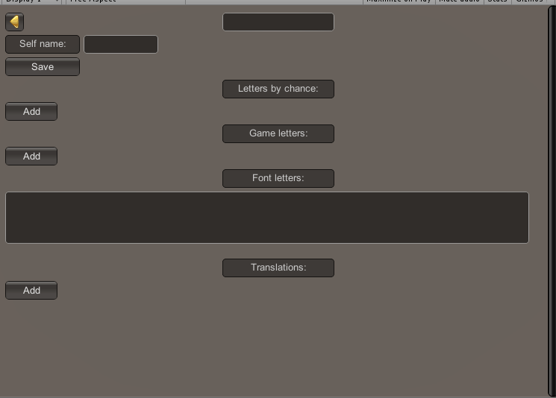

1.1 First field is language name by english (Don't use spaces in name). Self name is the name of the language by this language. If it is Japanese, self name should be日本語.

1. 2 Letters by chance

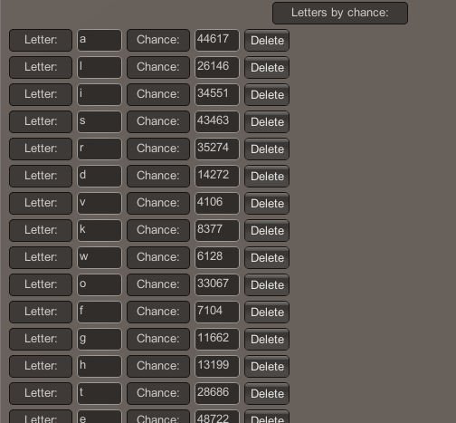

You need to add all letters to this list and set their chances. Chance - is how much does this letter appears in the word. This must be integer. If letter x has chance 10 and letter y has chance 20 that means, that y appears 2 times more than x. The best way is to add letters in order by descending chances.

1.3 Game letters

You should ignore this field.

1.4 Font letters

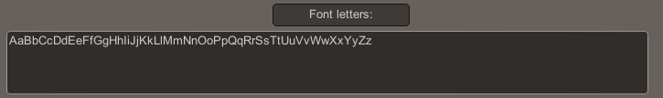

Here you need to write all of your letters in some order to use it after in (3).

1.5 Translations

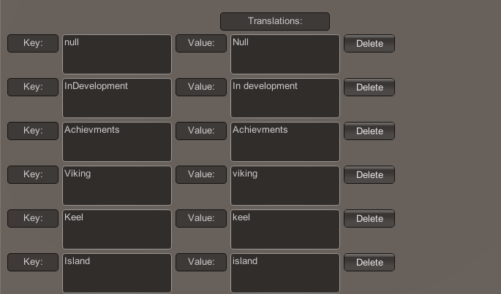

To translate your game for all languages you need, there is a system of translations. This is a list of Key-Value pairs. Key is a name of a word\phrase program wants to use. Value is the translation of to selected language. So code don't need to have inside of it any translations.

1.6 After you have set all the values, save it and go to the root folder of LanguageEditor and copy Languages.txt with Translations.txt to game folder.

2. After all settings are set, you should add new fonts images for this language like below (Fonts\Textures\TextFont* files). You can leave some places empty it's not bad.

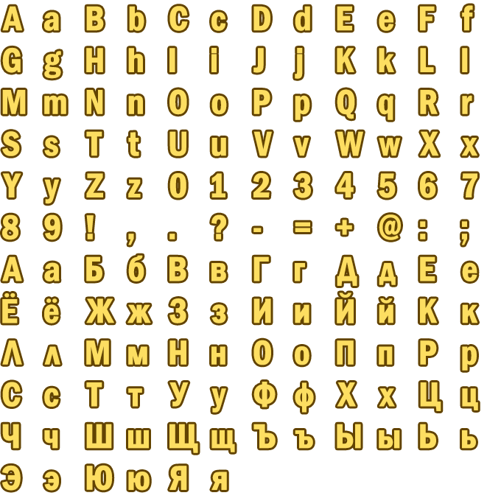

3. After that you need to set pairs (symbol-code, position in font-image like in TextFontEn (image below)) (create new file TextFontFr or other). This is pairs between ASCII symbol codes and (x,y) coordinates where x and y are from (0,0) (BottomLeft point of image) and (1, 1) (UpperLeft). Unity has short ASCII table, so there are only english letters. To remove that problem, all symbols from non-english languages are translated to english symbols (Font letters from 1.4).

AaBbCcDdEeFfGgHhIiJjKkLlMmNnOoPpQqRrSsTtUuVvWwXxYyZz[{\\|]}^~_#&</>

If your symbol from FontLetters has number in that list 5 - it will be translated to 5th letter in list before (C). It has some ASCII code. It will be found in TextFont%YourLanguage% and image will be set for 5th letter from the upper image.

