IoT Development Team - Car Automation Internship
Accelerator Actuation: One Method We Plan to Use
Date: 31 July 2026
Test vehicle: Maruti Suzuki Fronx

1. Aim
This document explains one method by which the car can be accelerated automatically, following the request to set out how this can be done. As reported earlier, sending an acceleration command electronically through the OBD port is not workable, because that port is read only and the engine control unit rejects external pedal commands for safety. The practical route is to press the accelerator pedal physically, under electronic control. The method described here uses a small, low cost rig to do exactly that. It covers the parts involved, how it would be fitted in the car, how it would be powered and wired, and how it would be tested safely.
This is one of the methods we plan to take forward. The aim would be to achieve controlled, repeatable throttle actuation on the vehicle, meaning a pedal position can be commanded from a laptop and the engine responds smoothly and predictably, verified using the live OBD data pipeline we have already built and demonstrated.

2. Approach in Brief
In this method a high torque servo motor is mounted on a small frame that sits on the footwell floor. An arm on the servo rests on the accelerator pedal. When the servo rotates, the arm presses the pedal down by a controlled amount. When the servo returns, the pedal’s own return spring brings it back to idle. An ESP32 microcontroller, connected to a laptop, tells the servo what position to hold.
The design is kept deliberately simple, and three choices make it so. The servo only pushes and is never attached to the pedal, so no clamps or linkages are needed and nothing is fixed to the pedal itself. The rig rests in the footwell and braces against the seat base, so nothing is drilled, bolted or cut anywhere on the vehicle and the whole assembly lifts out in under a minute. The servo also holds its own position internally, so no complex control software is required at this stage.
An important point in favour of this approach is that it works with the car’s own safety systems rather than against them. The engine control unit sees a normal pedal press and behaves exactly as it was designed to. A person in the driver’s seat can also override the rig at any time simply by using the pedals normally.

3. Fitting in the Vehicle
The photograph below shows the footwell of the test vehicle. The accelerator is on the right and is hinged at the floor, which suits this design well. The arm would contact the upper part of the pedal face, where there is the most leverage and the most movement.
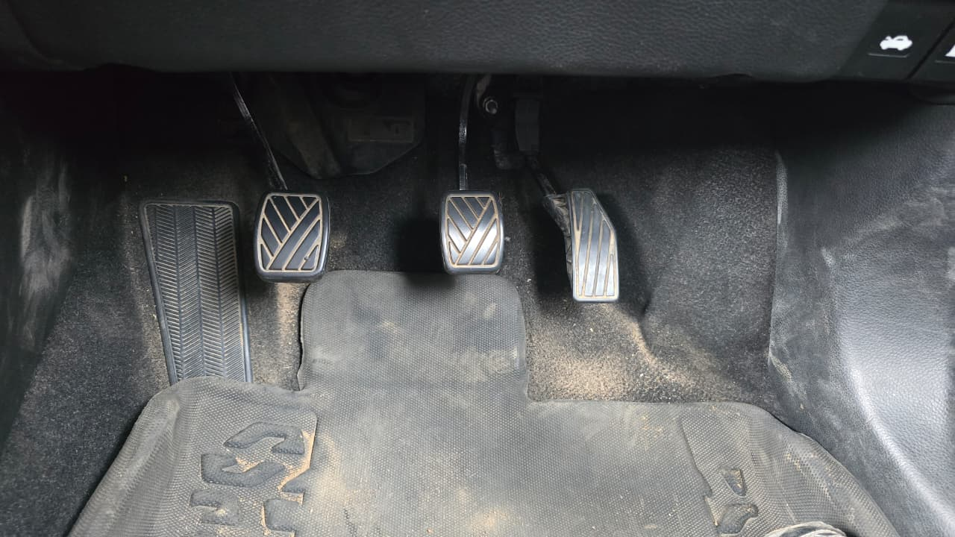
Footwell of the test vehicle, showing the floor hinged accelerator pedal on the right.
The drawing below shows how the rig would sit in the footwell, viewed from the side.
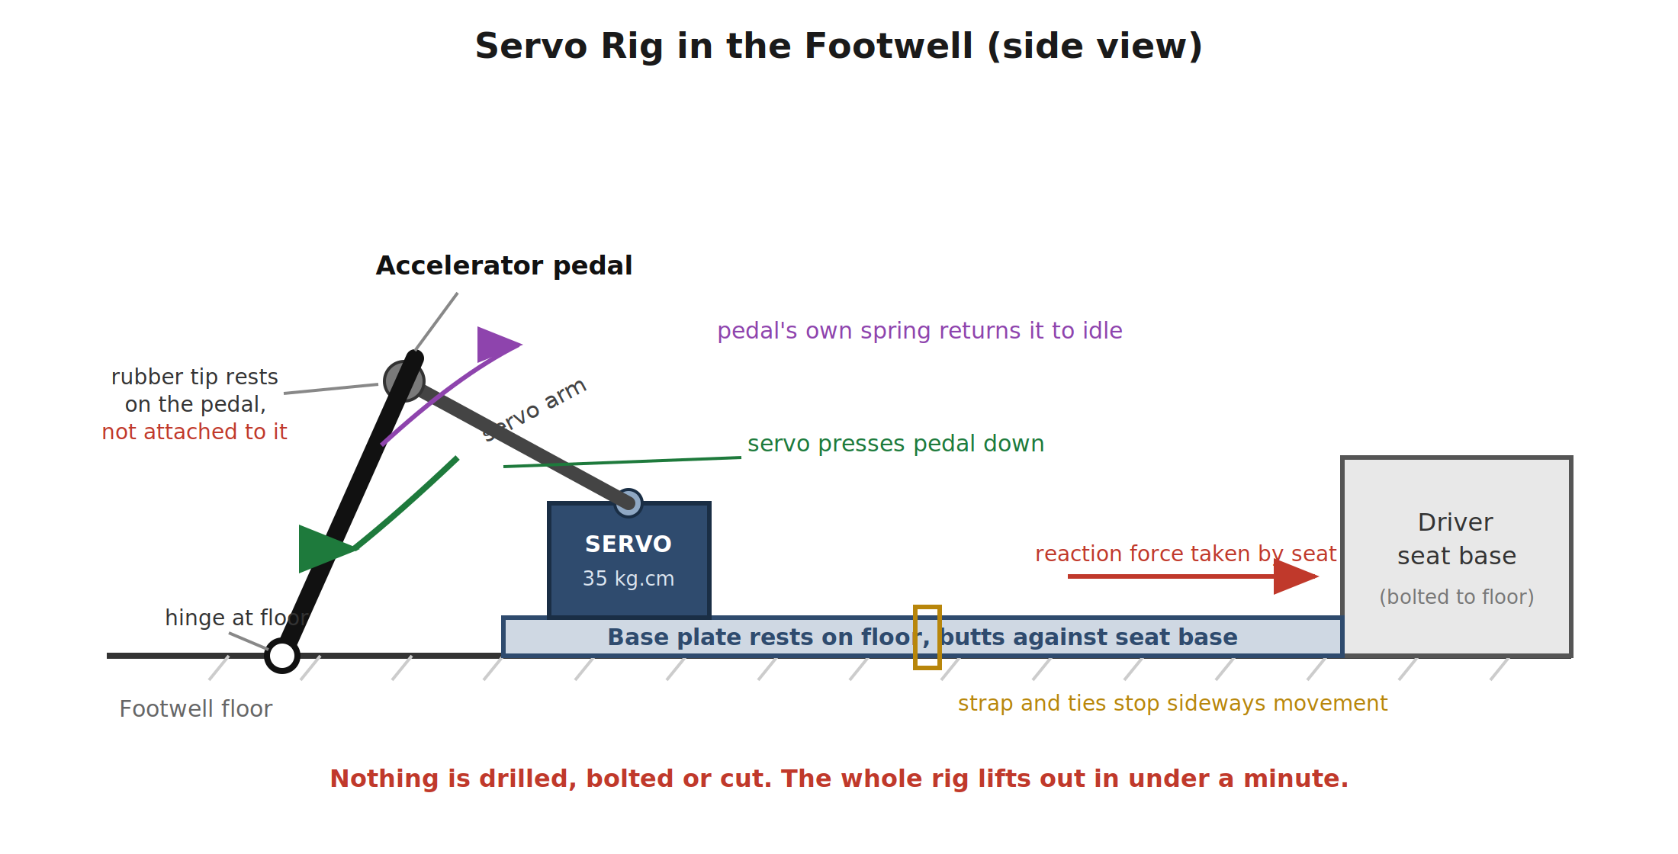
How the servo rig would be arranged in the footwell.
Anchoring is important because the force used to press the pedal pushes back equally on the rig. The base plate would therefore be made long enough to rest against the driver’s seat base, so this reaction force is taken by the seat, which is already bolted to the floor. Straps and ties stop the rig from shifting sideways. No part of the vehicle is modified in any way.
Two conditions would be treated as absolute requirements. First, the rig must never obstruct the driver, who must be able to press any pedal fully and immediately. Second, the arm must be removable from the pedal within seconds, so normal use of the car is restored at once.

4. Power Supply
Power is taken from the car’s 12V accessory socket using a standard plug. This socket is already fused by the vehicle and requires no cutting or modification of any wiring. In most vehicles it is also switched by the ignition, which gives an additional way of cutting power to the rig.
A buck converter steps the 12V down to the servo’s rated voltage, and is chosen with a 5A or higher rating so there is comfortable headroom. A capacitor across the supply absorbs the current surges the servo draws when it moves, which prevents the voltage from dipping. The controller itself is powered separately from the laptop over USB, so if the vehicle supply dips the controller stays running and in command.
One operating rule applies here: the rig is switched on only after the engine has been started, and never during cranking, because the vehicle voltage drops sharply while the starter is turning.

5. Connections
The complete set of connections is listed below. There are no connections to any existing vehicle wiring.
From | To | Purpose
Car 12V accessory socket | Buck converter input | Takes power from the vehicle, already fused by the car
Buck converter output (set to servo voltage) | Toggle kill switch | Steps 12V down to the servo’s rated voltage
Toggle kill switch | Servo power (red) and ground (brown/black) | Lets us cut servo power instantly by hand
1000uF capacitor | Across servo power and ground | Absorbs current surges so the supply does not dip
ESP32 signal pin | Servo signal wire (orange/yellow) | Carries the position command to the servo
ESP32 ground | Servo supply ground | Shared ground so the signal has a reference
Laptop USB | ESP32 | Powers the controller and carries commands

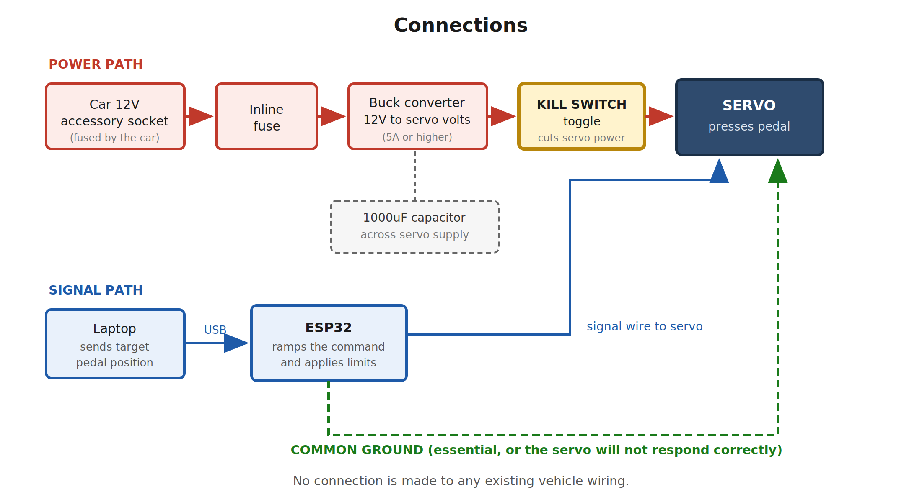
Connections in block form. Power path in red, signal path in blue, common ground in green.
Cables are routed along the transmission tunnel and secured with ties, kept well clear of all three pedals so nothing can catch a foot or interfere with pedal movement.

6. Control
The ESP32 receives a target pedal position from the laptop and passes it to the servo. Rather than jumping straight to the target, the software moves towards it gradually over a short period, so the pedal is pressed smoothly instead of suddenly. Limits are set in software for the maximum pedal position and the maximum rate of change, so no command can apply full throttle instantly.
Verification comes from the data pipeline already completed in the previous phase. When a position is commanded, the throttle position and engine RPM read from the car over OBD are logged, which shows directly whether the command produced the intended result. No additional sensors are needed.

7. Safety Measures
- A hardware toggle switch in the servo supply line. Switching it off removes power and the pedal spring returns the pedal to idle, with no software involved.
- Unplugging the accessory socket plug, and switching off the ignition, both of which also remove power.
- Software limits on maximum pedal position and maximum rate of change.
- The driver can override the rig at any time using the pedals normally, and the clutch can be pressed to disconnect drive.
- All testing is done with the vehicle stationary, in neutral, with the handbrake applied, in an open area and under company supervision.
Testing begins with the engine switched off, so that the rig can be checked mechanically with no possibility of engine response. Only when that is satisfactory is the engine started for the next stage.

8. Parts Involved and Indicative Cost
The parts this method uses are listed below, with indicative costs for reference only. The total is small, at roughly 3,000 rupees.
Item | Purpose | Approx. cost (INR)
Hook type luggage scale | To measure actual pedal force before buying | 200
High torque metal gear servo (35 kg.cm class) | Presses the accelerator pedal | 1,200 to 1,800
Aluminium servo horn and rubber tip | Arm that contacts the pedal face | 150
12V accessory socket plug with lead | Takes power from the car | 150
Buck converter, 12V input, 5A or higher | Steps voltage down for the servo | 250 to 400
Heavy duty toggle switch | Hardware kill switch | 100
Inline fuse holder and fuses | Protection | 80
1000uF capacitor | Stabilises the servo supply | 20
Base plate and angle section | Rig frame that sits in the footwell | 300
Straps, zip ties, fasteners | Securing the rig and cable routing | 150
ESP32 and jumper wires | Controller, already in stock | In stock
Estimated total |  | about 2,600 to 3,350

The first item on the list is deliberate. The actual force needed to press the accelerator can be measured with a simple hook scale before anything else is decided. That single measurement confirms whether a servo of this size is suitable or whether a stronger motor would be needed, so the choice is based on a measured figure rather than an assumption.

9. Test Sequence
- Measure the pedal force with a hook scale and confirm the chosen servo is adequate.
- Assemble and test the rig on a desk, away from the vehicle, checking smooth movement and confirming that the kill switch works.
- Fit the rig in the vehicle with the engine switched off. Confirm the arm presses the pedal through its full range, the rig stays firmly in place, and it does not obstruct the driver.
- Start the engine, keep the vehicle in neutral with the handbrake applied, and command a range of pedal positions while logging throttle position and RPM.
- Review the logged data to confirm the response is smooth, repeatable and within limits.

10. Note on Vehicle Type
One point is worth raising for planning. The test vehicle we are working on has a manual gearbox. Controlling the accelerator alone is enough to prove throttle actuation, which is the aim of this phase, but it is not enough to make a manual car move on its own. Moving a manual vehicle also requires coordinated control of the clutch and the gear lever, which is a considerably larger and more complex task.
With an automatic vehicle, the same rig described here would be sufficient to produce controlled forward movement, since only the accelerator needs to be operated. It would therefore be significantly easier and quicker to reach a moving demonstration on an automatic car.
With the vehicle we have been working on, the method described above is what we have found to be practical, and it is the direction we plan to take. If an automatic vehicle happens to be available at the later stage, moving from controlled throttle actuation to controlled movement would be much quicker.

