IoT Development Team - Car Automation Internship
Day 4 - Planning & System Architecture
DATE: 2/07/2026

1. Aim of Today's Work
Today was different from the previous three days - it was a planning and team-restructure day, not a hardware day. No new components were wired up or tested. Instead, the whole team stepped back, went through every original project objective one by one, honestly checked what is actually done versus what is only planned, and reorganised the team and the plan around what is realistically buildable in the time we have.
This was needed because a few of the original goals (in particular, controlling a real car over CAN) turned out to not be possible the way they were first imagined. Section 3 below explains the reasoning behind the changes we made.

2. Review of Project Objectives and Current Status
The original project objectives, and where each one honestly stands as of today:
# | Objective | Status | Notes
- | Backend server + API that all module data flows to | Not started (planned) | This is Track C, assigned to Person C starting now
I | GPS live location | Hardware done | NEO-6M working, real fix obtained in Chennai with 6-7 satellites. Not yet sent to a backend
II | Camera + speaker/mic for lane-discipline and driver-drowsiness detection with announcements | Not started | Parked for a later phase - see Section 3
III | Real-time OBD vehicle data (RPM, load, clutch, speed, fuel mileage, AC, brake) | Partial | MCP2515 CAN proven by loopback test. ELM327 hands-on with a real car still pending. 32-byte payload designed but not yet validated on a real car
IV | Tyre parameters (pressure, temperature) sent as exactly 16 bytes | Designed only | 16-byte packet layout is defined. No TPMS sensor has actually been tested yet

3. Key Decisions and Reframing Made Today

3.1 The autonomous-control goal moves to our own built vehicle
The biggest decision today: the "drive and control a vehicle over CAN" goal will now be demonstrated on a small platform that we build ourselves, not on a real car.
Reason: an ELM327/OBD-II adapter can only read a real car's ECU. It cannot send throttle or brake commands - car manufacturers block writing control commands over OBD-II for safety reasons. So "control a vehicle via CAN" was not achievable on a real car with the hardware we have. Instead, we will build our own small platform where the ESP32 sends commands over CAN (through the MCP2515) to a motor controller. This is safe to test and actually demonstrates a deeper understanding of CAN than just reading data would.

3.2 The project is now split into three parallel tracks
- Track A - Sensing on a real car: ELM327 + TPMS, packed into the 32-byte and 16-byte payloads.
- Track B - Autonomous platform we build: drive forward about 100 m, controlled deceleration/braking, and collision avoidance.
- Track C - Backend + API: receives all data, stores it, and serves both dashboards.

3.3 Objective II (camera / lane / drowsiness) is parked
This objective needs proper computer-vision hardware - a Raspberry Pi or a phone, not just an ESP32. It is being noted honestly as a later-phase item rather than something we pretend is in progress.

3.4 Two separate dashboards
- Dashboard 1 - Telemetry Monitor: real-car data, read-only, already about 80% built by a teammate and deployed at lus.nalusa.space.
- Dashboard 2 - Vehicle Control Console: commands and live feedback for the platform we build.
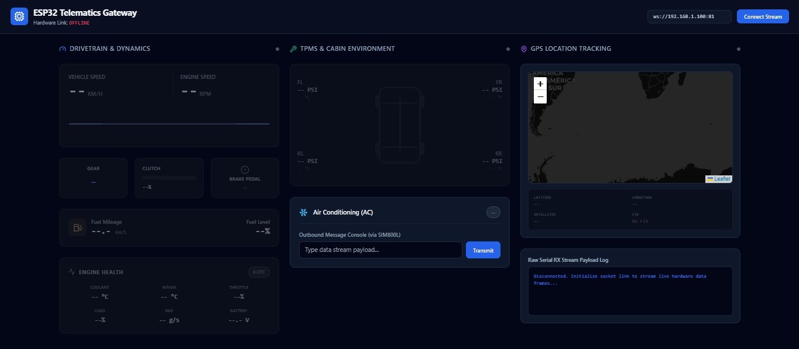
Figure: Dashboard 1 (Telemetry Monitor) as currently deployed at lus.nalusa.space

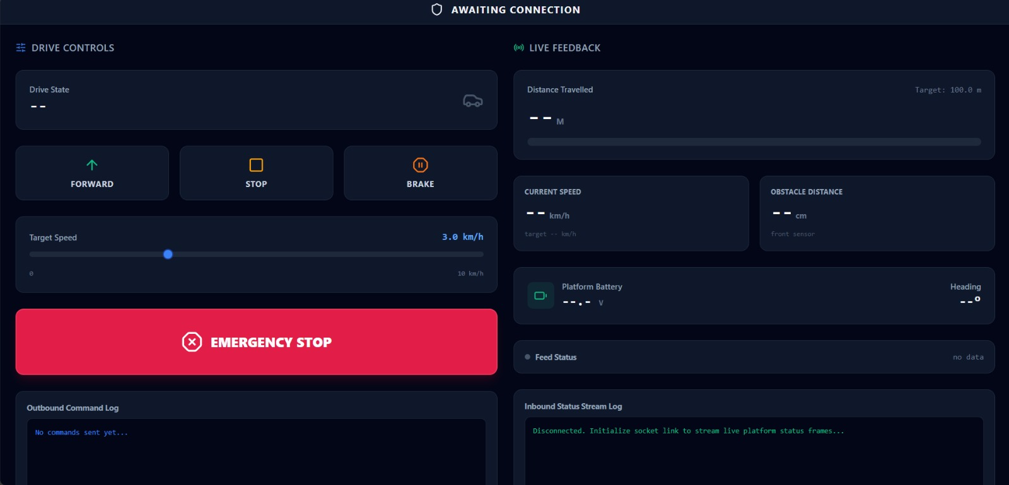

3.5 A shared message schema
Both dashboards and the backend now use one identical JSON format, defined in MESSAGE_SCHEMA.md. Data travels as compact binary on the hardware link (the 32-byte vehicle packet and the 16-byte tyre packet) and as JSON over WebSocket to the browsers. The binary is only unpacked into JSON once, at the ESP32 firmware / backend boundary - nobody working on the UI has to touch raw bytes.

3.6 WebSocket chosen over MQTT (for now)
Both dashboards are browsers, which speak WebSocket natively, and we only have a handful of devices right now, so WebSocket is less to deploy. We can revisit MQTT later if we scale up to many vehicles or bring back a cellular link - the message format itself is transport-agnostic, so this is not a one-way decision.

3.7 New requirement from the project lead
The project lead has asked us to implement collision-avoidance algorithms for when the vehicle is moving over a distance. This sits on top of the Track B platform and has been added to Person E's research work (see Section 4).

4. Team Roles (6 People)
Person | Responsibility
Team Lead (me) | Overall planning, sequencing, decisions, and getting sign-off from the project lead.
Person A | Dashboard 1 (Telemetry Monitor) - extend the existing dashboard, add a GPS breadcrumb trail and stale-data indicators, bind it to the shared schema.
Person B | Dashboard 2 (Vehicle Control Console) - new build, same visual style as Dashboard 1, with drive/brake/e-stop controls and live platform feedback.
Person C | Backend + API - WebSocket relay, storage, and REST history endpoints.
Person D | Platform hardware / procurement - research and list all parts for the car we build. No buying until budget sign-off from the project lead.
Person E | Real-car sensing (ELM327 + TPMS hands-on) and researching the collision-avoidance algorithms the project lead asked for.

5. System Architecture
At a high level, the system has three layers: the hardware (ESP32 boards with GPS, CAN, and sensors, plus the platform we build), a backend (WebSocket relay, storage, and API), and two browser dashboards on top.
- Hardware - ESP32 + NEO-6M GPS + MCP2515 CAN + sensors on the real-car sensing side (Track A), and the ESP32 + motor driver + IMU + obstacle sensor on the platform side (Track B). These pack their readings into the 32-byte and 16-byte binary payloads described in MESSAGE_SCHEMA.md.
- Backend - unpacks the binary payloads once, relays live data to both dashboards over WebSocket as JSON, and stores history for the REST endpoints (Track C).
- Dashboards - Dashboard 1 shows real-car telemetry (read-only). Dashboard 2 sends commands to the built platform and shows its live status. Both speak only JSON - never raw bytes.
This is the two-layer data flow: compact binary on the hardware link (bandwidth-efficient, this is the "wire format"), and JSON over WebSocket from the backend to the browsers (easy for the UI people to work with).
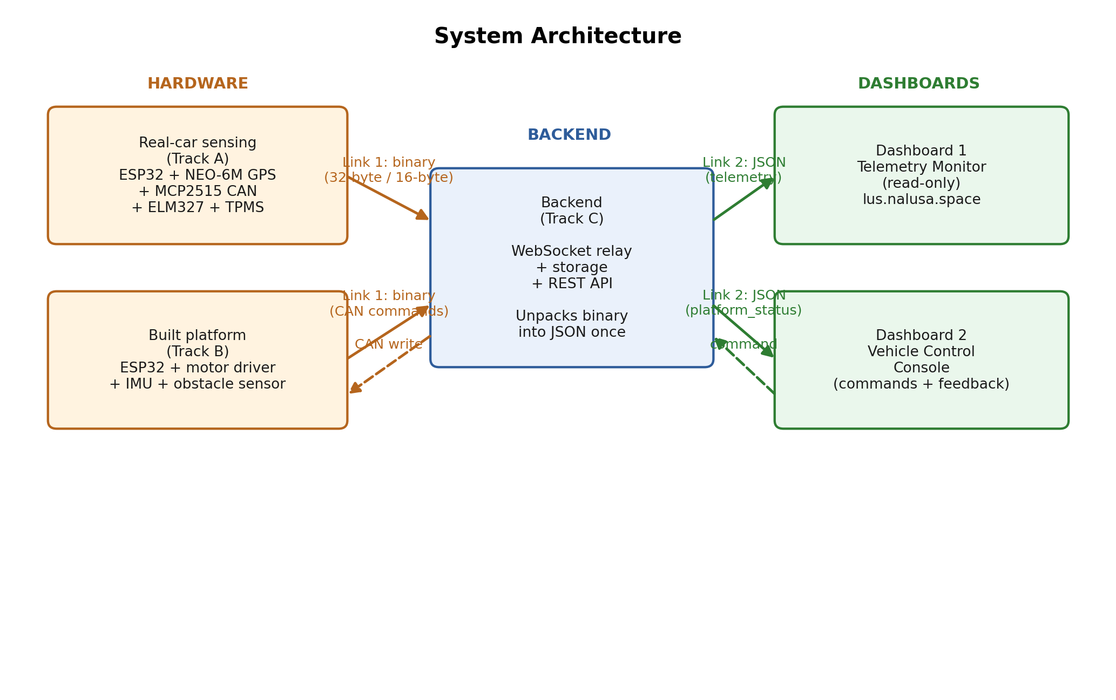
Figure: System architecture - hardware -> backend -> two dashboards

6. Next Steps
- Get the project lead's sign-off on the reframe (own platform for control) and on the parts budget before ordering anything.
- In parallel while parts ship: build the backend with a fake data sender, build both dashboards against the shared schema, do the ELM327/TPMS hands-on work, and research the collision-avoidance algorithms.

