Elixir

Smart Irrigation and Agriculture System

Admin Manuel

*This manual can be used for Elixir Portal version 1.0.0 and newer.

Table of Contents

1. General features 3

1.1. Access to Interface 3

1.2. Login 3

1.3. Navigation Bar 4

1.4. Logout 4

1.5. User Profile 4

2. Admin Panel 6

2.1. Create User and Farm 7

2.1.1. Create Farm 8

2.1.2. Create User 9

2.2. Edit or Delete User 11

2.3. Edit or Delete Farm 13

3. Admin Home Page 16

List of Figures

Figure 1: Login Page 3

Figure 2: Sign in Panel 3

Figure 3: Admin Navigation Bar 4

Figure 4: Logout Button 4

Figure 5: Access to Account Details 4

Figure 6: Options in Account Details 5

Figure 7: Admin Options – Dropdown Menu 6

Figure 8: Create User and Farm Page 7

Figure 9: Create Farm Form 8

Figure 10: Create User Panel 10

Figure 11: User Selection Panel 11

Figure 12: Edit User Panel 12

Figure 13: Change Password Panel 13

Figure 14: Select Edit Farm Panel 14

Figure 15: Edit Farm Panel 15

Figure 16 Weather Forecast Panel 17

Figure 17: User Home Page 17

# General features

## Access to Interface

Elixir is a web-based application. It can be accessed from <http://elixirapp.live/>

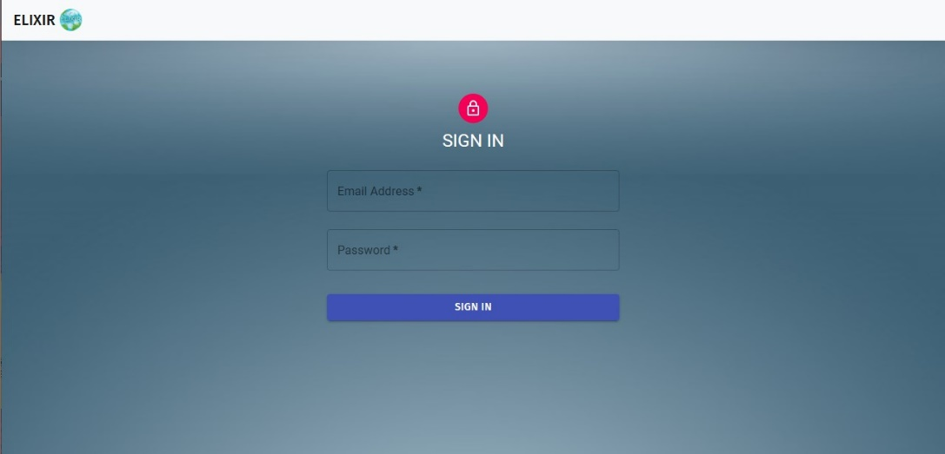***Note****: The browser recommended for Elixir is Chrome and Firefox, and the screen resolution is 1920 * 1080.*

Figure 1: Login Page

## Login

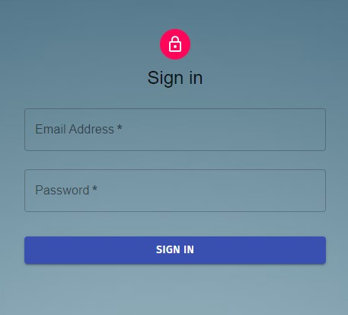The user must enter their **Email** and **Password** and click the **SIGN IN** button to access Elixir.

Figure 2: Sign in Panel

When you Sign in Elixir will got to the **Home Page** to show your general information. For more information about the home page check Section 3.

***Note****: If the wrong* ***Email*** *or* ***Password*** *information are entered an error message will be given.*

***Note****: If these are correct than a simple message will prompt the user that the login is successful and the suer will Signed In*.

## Navigation Bar

After logging into the application, navigation bar can be displayed on the top side of the page. When a user wants to access a page through the navigation bar, they can click on the name of the module they want to access, then they will be directed to the relevant page.

Figure 3: Admin Navigation Bar

***Note:*** *The Elixir Logo will take you to the home page.*

## Logout

To Logout from Elixir, use the **Logout** button option located in the upper most left part of the navigation bar.

Figure 4: Logout Button

## User Profile

To access the user profile page, use the **Change Account Details** option located in the upper right part of the navigation bar. Then click to access it.

Figure 5: Access to Account Details

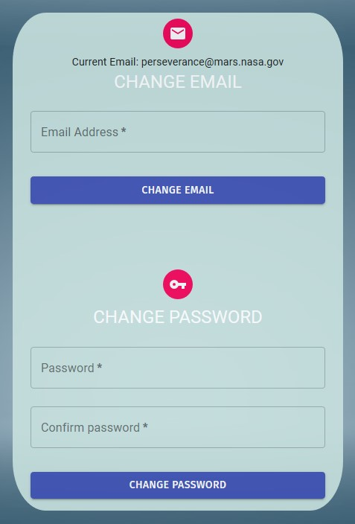

Figure 6: Options in Account Details

This section has two options **Change Email** and **Change Password.**

**Change Password:**

The user can change his/her password within this panel. To do this, enter the new password in the **Password** fields. In order to change the password, the following criteria must be met:

* Password must contain at least 8 characters.
* Password must contain at most 256 characters.

If these conditions are met the user will be able to change their passwords by clicking the **Change Password** button.

The password is not updated in the following situations and the user is warned:

* The new password does not meet the requirements.

***Important Note: Password and Confirm Password must not be empty and they must match to change the password.***

***Note****: Your initial password will be sent to your* ***Email******address,*** *that was given to the Admins of Elixir.*

***Note:*** *For security purposes the Admins do not know your password and the initial password that was set will be sent automatically.*

**Change Email:**

The user can change his/her **Email** within this panel. To do this, enter the new Email in the **Email** fields. In order to change the password, the following criteria must be met:

* Email must be a valid email address.

If these conditions are met the user will be able to change their mail by clicking the **Change Email** button.

The email is not updated in the following situations and the user is warned:

* Entered email is not valid email address.

# Admin Panel

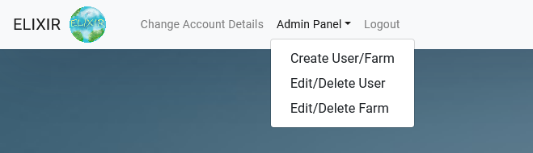To access the Admin Panel, use the **Admin Panel** option located in the upper left corner of the application. Then click on the **Admin Panel** option to access a dropdown list of Admin options.

Figure 7: Admin Options – Dropdown Menu

## Create User and Farm

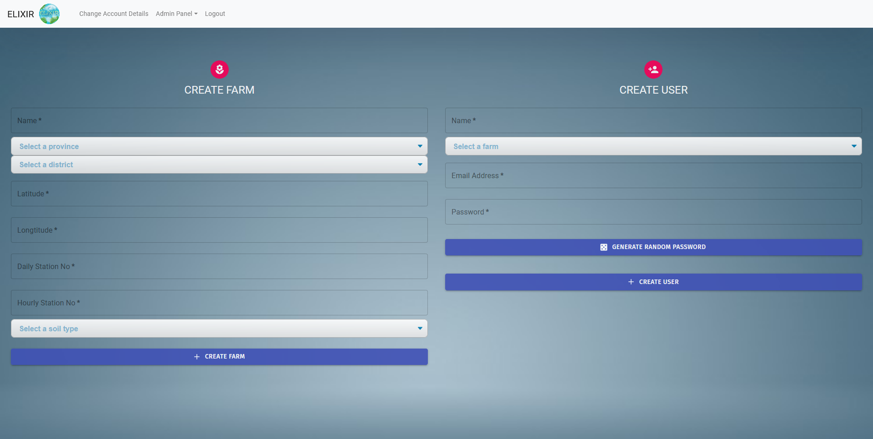From the **Create User/Farm** option, the admin can create a normal user and their farm.

Figure 8: Create User and Farm Page

### Create Farm

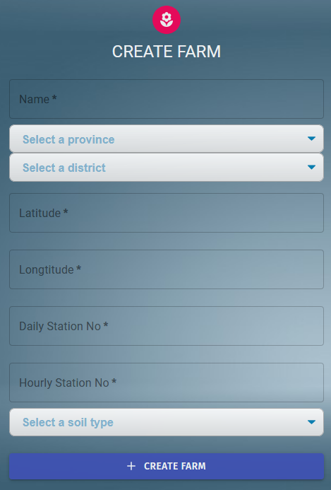The admin can **Create** a farm in Elixir, on behalf the user. To do this, Enter/Select the **Name**, **Province**, **District**, **Latitude**, **Longitude**, **Daily Station No**, **Hourly** **Station No** and lastly **Soil Type**.

Figure 9: Create Farm Form

In order to successfully create a farm, the following criteria must be met:

* All fields must be filled or selected,
* Coordinates must be numerical and valid,
  + Latitude: Between -90.00 and +90.00 including both numbers.
  + Longitude: Between -180.00 and +180.00 including both numbers.
* Hourly Station must be valid,
  + Use the sites stated below.
* Daily Stations must be valid.
  + Use the sites stated below.

To enter a **Station,** admin **MUST** use the following sites:

* <http://www1.mgm.gov.tr/kurumsal/istasyonlarimiz.aspx>
* <https://mgm.gov.tr/kurumsal/istasyonlarimiz.aspx>

To set farm **Coordinates**, admin **MAY** use following sites:

* <https://www.gps-coordinates.net/>

If these conditions are met the admin will be able to create a farm by clicking the **Create Farm** button. And when the farm is created the new farm can be found in the User Farm dropdown menu.

The Farm is **NOT created** in the following situations and the admin is **warned**:

* The coordinate inputs are **not valid**,
* If there are any **empty** inputs,
* If the Hourly Station are **not valid,**
* If the Daily Stations are **not valid.**
* If the Daily Stations are **not valid.**
* If City is **not** selected.
* If District is **not** selected.
* If Soil Type is **not** selected.

### Create User

The admin can **Add** a new user to Elixir. To do this, Enter the **Name**, **E-Mail**, click the **Generate Password** button, and select a farm. In order to successfully create a User, the following criteria must be met:

* All fields must be filled,
* A farm is selected,
* E-Mail address is valid,
* The password input is filed.

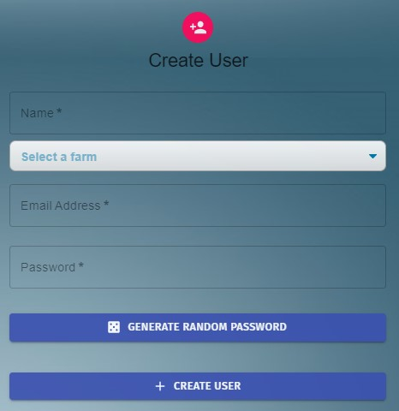If these conditions are met the admin will be able to create a new User by clicking the **Create User** button.

Figure 10: Create User Panel

The User is **not created** in the following situations and the admin is **warned**:

* If there are any **empty** inputs,
* E-Mail address is **not valid**,
* Password input is **empty.**
* Farm is **selected**

***Note:*** *The after the current user credentials are entered and a random password is generated, an email is sent to the user which contains their password.*

***Note****: The admin may set the user’s password them self but the user will have the option to change their password after they are logged in.*

## Edit or Delete User

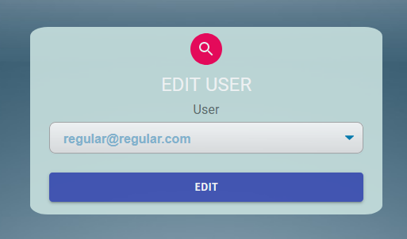The admin can **Edit** or **Delete** an existing **User** in Elixir. To do this, Admin must select an existing user, by using their Emails, from the dropdown menu.

Figure 11: User Selection Panel

After a user has been selected to be edited. Admin clicks the **EDIT** button to start editing.

This panel has **two** main sections, **Edit User Section** where the admin can edit the **User Type, Name, Farm** and **E-Mail**. The other section is **Change Password** **Section** this panel is here so that Elixir admins can reset user passwords.

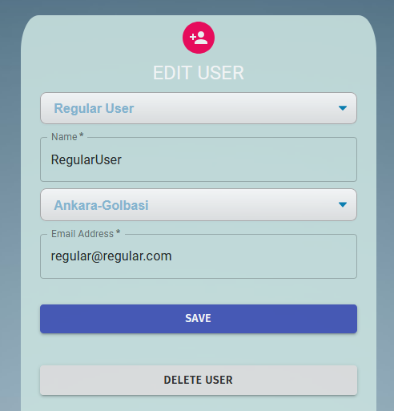

Figure 12: Edit User Panel

User type can be change between **Admin User** and **Normal User**

***Note:*** *Caution! Do* ***NOT*** *change a real Normal user to an Admin User.*

The **Name** can be changed to anything without restrictions. This name is used in the **User Home Page.** The name must meet the following criteria;

* Name must be longer than 3 characters.
* Name must be shorter than 256 characters.

If the criteria are not met, then an error prompt is displayed.

The admin can change the users **Email** within this panel. To do this, enter the new Email in the **Email** fields. In order to change the password, the following criteria must be met:

* Email must be a valid email address.

If these conditions are met the user will be able to change their mail by clicking the **Change Email** button.

The email is not updated in the following situations and the user is warned:

* Entered email is not valid email address.

***Important Note:*** *As of version v.1.0.0 email change does* ***NOT*** *send a confirmation mail.*

***Important Note:*** *The* ***Delete User*** *button deletes the selected user.*

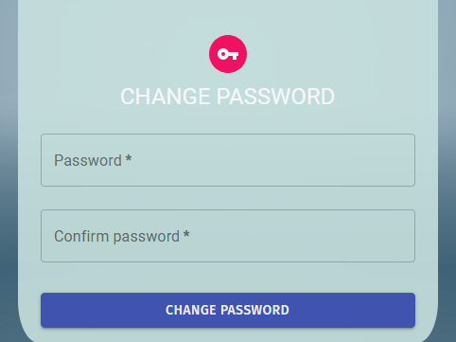

Figure 13: Change Password Panel

The admin can change the user’s **Password** within this panel. To do this, enter the new password in the **Password** fields. In order to change the password, the following criteria must be met:

* Password must contain at least 8 characters.
* Password must contain at most 256 characters.

## Edit or Delete Farm

The admin can **Edit** or **Delete** an existing **Farm** in Elixir. To do this, Admin must select an existing Farm, from the dropdown menu.

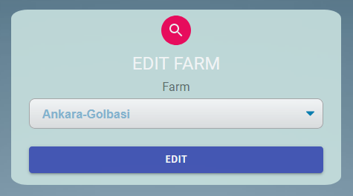

Figure 14: Select Edit Farm Panel

After a farm has been selected to be edited. Admin clicks the **EDIT** button to start editing.

In this panel admin can edit the **Farm Name, Soil Type, Farm Location (City and Province), Farm Coordinate, Daily Station No and Hourly Station No.**

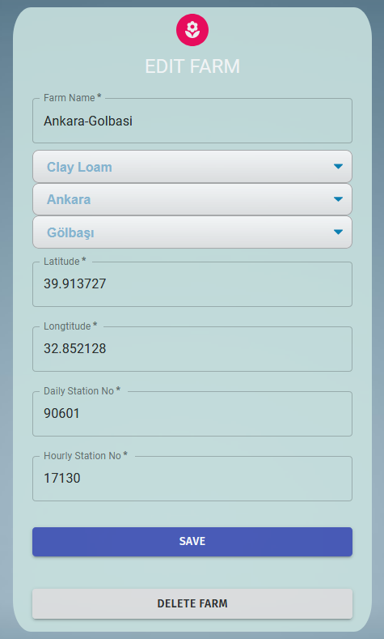

Figure 15: Edit Farm Panel

The same criteria are used from Section Create Farm.

The admin can **Edit** a farm in Elixir, on behalf the user. To do this, Enter/Select the **Name**, **Province**, **District**, **Latitude**, **Longitude**, **Daily Station No**, **Hourly** **Station No** and lastly **Soil Type.**

In order to successfully change a farm, the following criteria must be met:

* All fields must be filled or selected,
* Coordinates must be numerical and valid,
  + Latitude: Between -90.00 and +90.00 including both numbers.
  + Longitude: Between -180.00 and +180.00 including both numbers.
* Hourly Station must be valid,
  + Use the sites stated below.
* Daily Stations must be valid.
  + Use the sites stated below.

To enter a **Station,** admin **MUST** use the following sites:

* <http://www1.mgm.gov.tr/kurumsal/istasyonlarimiz.aspx>
* <https://mgm.gov.tr/kurumsal/istasyonlarimiz.aspx>

To set farm **Coordinates**, admin **MAY** use following sites:

* <https://www.gps-coordinates.net/>

If these conditions are met the admin will be able to create a farm by clicking the **Save Farm** button.

The Farm is **NOT updated** in the following situations and the admin is **warned**:

* The coordinate inputs are **not valid**,
* If there are any **empty** inputs,
* If the Hourly Station are **not valid,**
* If the Daily Stations are **not valid.**
* If the Daily Stations are **not valid.**
* If City is **not** selected.
* If District is **not** selected.
* If Soil Type is **not** selected.

# Admin Home Page

This page opens automatically as you **Sign in** to Elixir.

To access the Home Page, use the **Elixir Logo** located in the upper most right part of the navigation bar. Then click to access it

Here the user can see a **Searchable Weather Forecast Panel**.

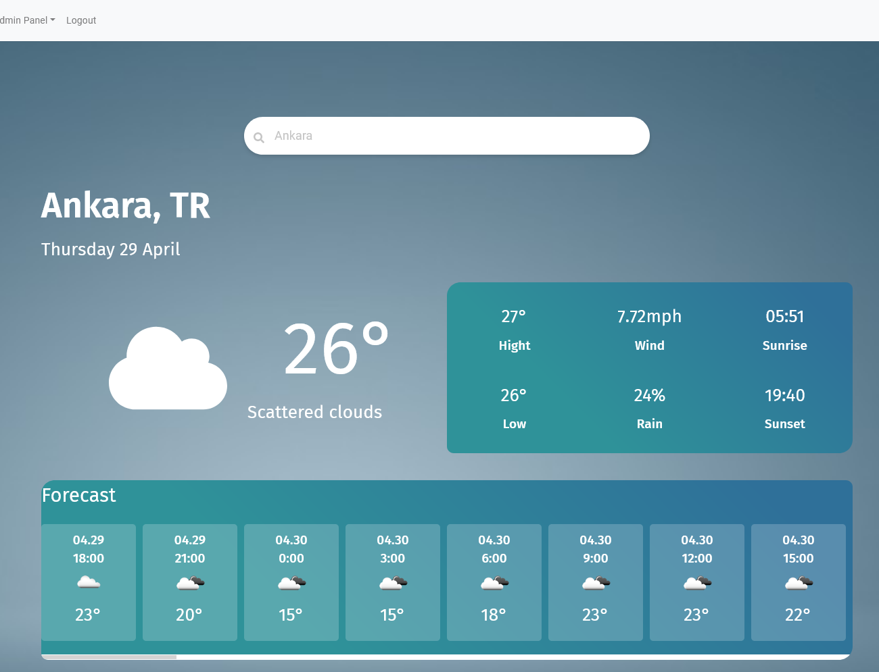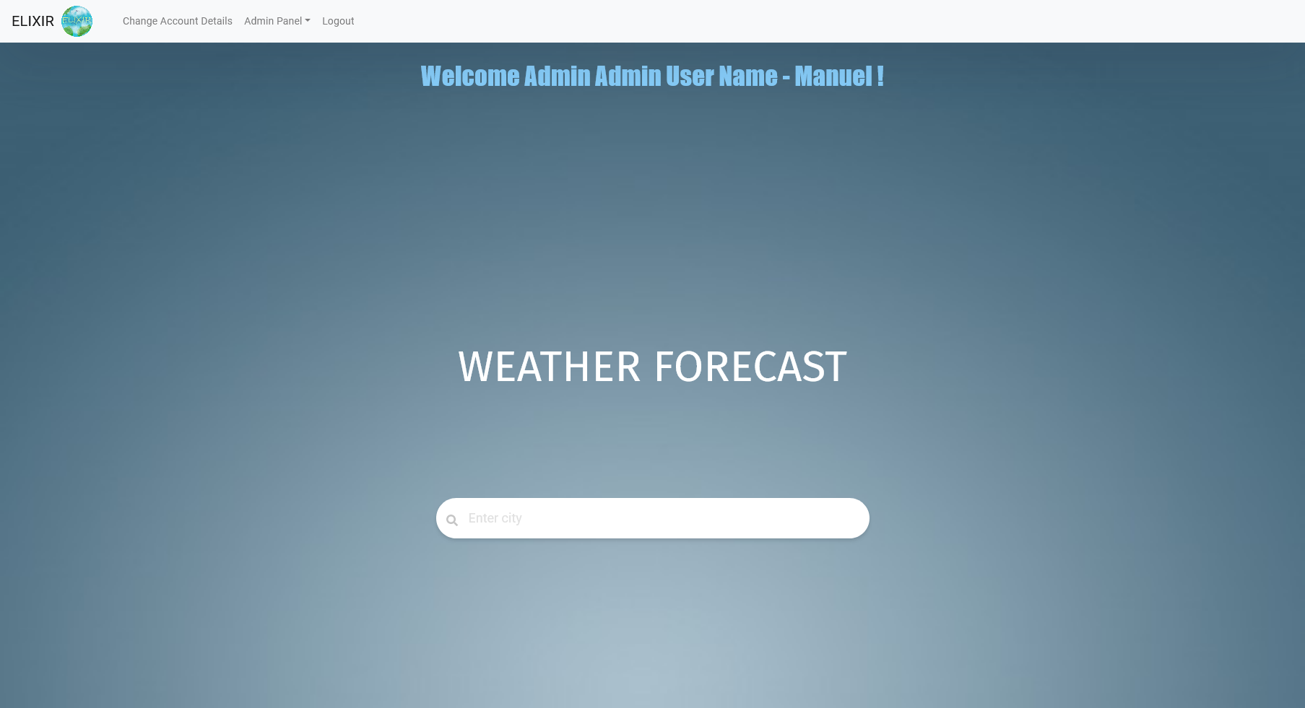

Figure 16 Weather Forecast Panel

Figure 17: User Home Page

If the City name is valid and found, the panel will show Hourly Forecast for the next 30 Hours, additionally the user will be able to see the current date, chance of rain, wind speed and lastly Sunset and Sunrise times for the day.

If the City is name is wrong or not found than the user is prompted with a message stating “**Sorry, the specified city was not found.** “

***Note:*** *This Searchable Weather Forecast only work with city names.*