Elixir

Smart Irrigation and Agriculture System

User Manual

*This manual can be used for Elixir Portal version 1.0.0 and newer.

Contents

1. General features 4

1.1. Access to Interface 4

1.2. Login 4

1.3. Navigation Bar 5

1.4. Logout 5

1.5. User Profile 5

2. Dashboard 7

3. Home Page 11

4. Irrigation 15

1.6. Smart Irrigation 15

1.7. Schedule Manual Irrigation 17

5. Upload Farm Info 22

6. Crop Panel 24

List of Figures

Figure 1: Login Page 4

Figure 2: Sign in Panel 4

Figure 3: Navigation Bar 5

Figure 4: Logout Button 5

Figure 5: Access to Account Details 5

Figure 6: Options in Account Details 6

Figure 7: Dashboard 7

Figure 8: Sun Exposure 8

Figure 9: Table for Pesticide Suitability and Frost Risk 8

Figure 10: Information Charts 9

Figure 11: Chart Hover 9

Figure 12: Dark Mode for Status Page 10

Figure 13: Stress Table 10

Figure 14: User Home Page 11

Figure 15: User Information Panel 12

Figure 16: Weather Forecast Panel 13

Figure 17: Search Weather Forecast Panel 13

Figure 18: Manage Irrigation Panel 15

Figure 19: After Crop Info is Uploaded 16

Figure 20: Smart Irrigation Prompt 16

Figure 21: Schedule Manual Irrigation Panel 17

Figure 22: Select Hour Panel 18

Figure 23: Select Minute Panel 18

Figure 24: Schedule Manual Irrigation Panel - Hour 19

Figure 25: Schedule Manual Irrigation Panel - Days 20

Figure 26: Schedule Manual Irrigation Successful Prompt 21

Figure 27: Upload Crop Signature Panel 22

Figure 28: Crop Signature File Example 24

Figure 29: Main Crop Page 25

Figure 30: Crop Signature 25

Figure 31: Temperature Compatibility 26

Figure 32: Soil Moisture Compatibility 26

Figure 33: Ideal Temperature Compatibility 27

Figure 34: Colour Information 27

# General features

## Access to Interface

Elixir is a web-based application. It can be accessed from <http://elixirapp.live/>

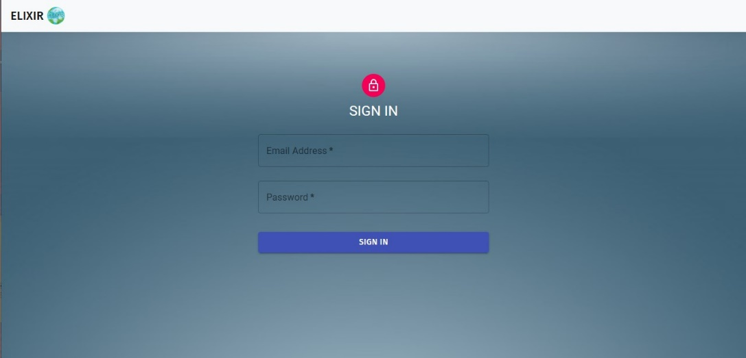***Note****: The browser recommended for Elixir is Chrome and Firefox, and the screen resolution is 1920 * 1080.*

Figure 1: Login Page

## Login

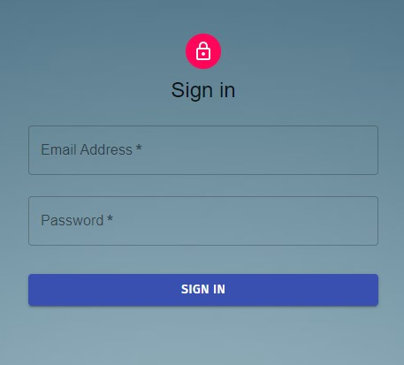The user must enter their **Email** and **Password** and click the **SIGN IN** button to access Elixir.

Figure 2: Sign in Panel

When you Sign in Elixir will got to the **Home Page** to show your general information. For more information about the home page check Section Home Page.

***Note****: If the wrong* ***Email*** *or* ***Password*** *information are entered an error message will be given.*

***Note****: If these are correct than a simple message will prompt the user that the login is successful and the suer will Signed In*.

## Navigation Bar

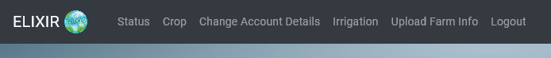After logging into the application, navigation bar can be displayed on the top side of the page. When a user wants to access a page through the navigation bar, they can click on the name of the module they want to access, then they will be directed to the relevant page.

Figure 3: Navigation Bar

***Note:*** *The Elixir Logo will take you to the home page.*

## Logout

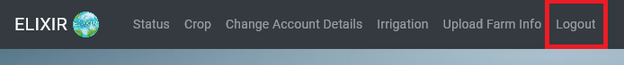To Logout from Elixir, use the **Logout** button option located in the upper most left part of the navigation bar.

Figure 4: Logout Button

## User Profile

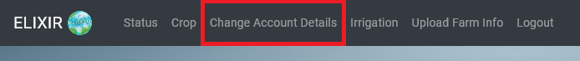To access the user profile page, use the **Change Account Details** option located in the upper right part of the navigation bar. Then click to access it.

Figure 5: Access to Account Details

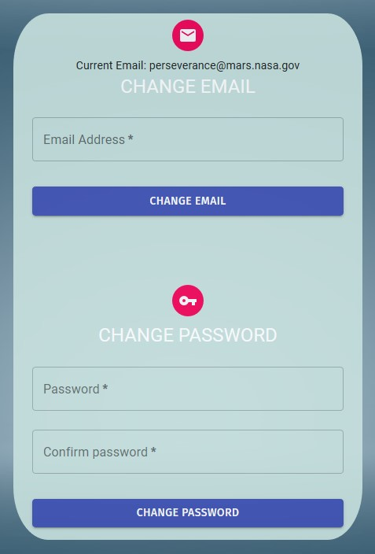

Figure 6: Options in Account Details

This section has two options **Change Email** and **Change Password.**

**Change Password:**

The user can change his/her password within this panel. To do this, enter the new password in the **Password** fields. In order to change the password, the following criteria must be met:

* Password must contain at least 8 characters.
* Password must contain at most 256 characters.

If these conditions are met the user will be able to change their passwords by clicking the **Change Password** button.

The password is not updated in the following situations and the user is warned:

* The new password does not meet the requirements.

***Important Note: Password and Confirm Password must not be empty and they must match to change the password.***

***Note****: Your initial password will be sent to your* ***Email******address,*** *that was given to the Admins of Elixir.*

***Note:*** *For security purposes the Admins do not know your password and the initial password that was set will be sent automatically.*

**Change Email:**

The user can change his/her **Email** within this panel. To do this, enter the new Email in the **Email** fields. In order to change the Email. In order to change the password, the following criteria must be met:

* Email must be a valid email address.

If these conditions are met the user will be able to change their mail by clicking the **Change Email** button.

The email is not updated in the following situations and the user is warned:

* Entered email is not valid email address.

# Dashboard

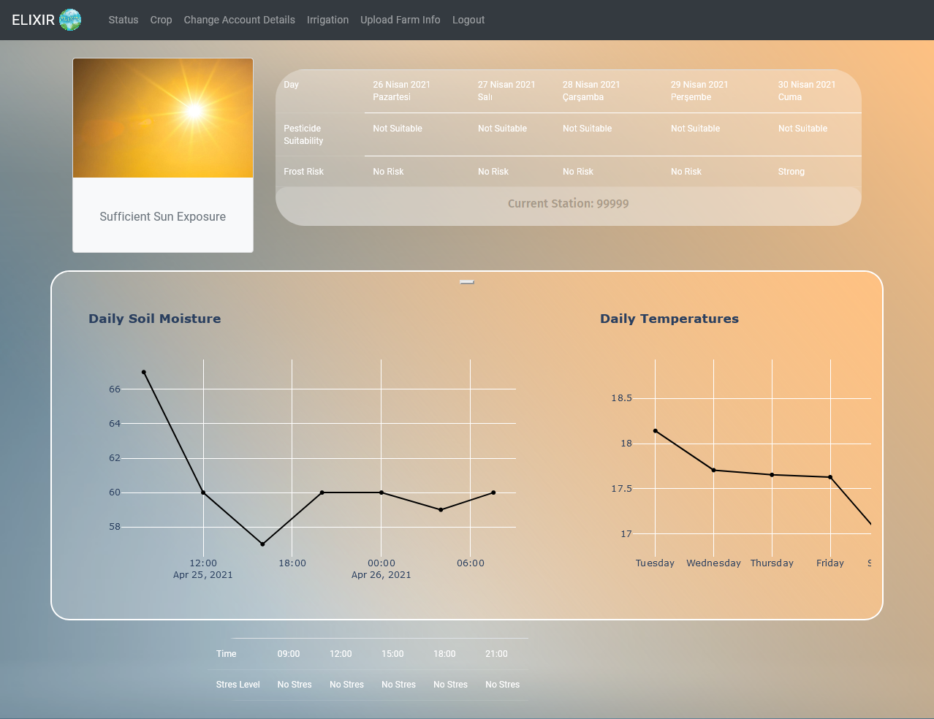Dashboard is an interface created to give general information to the user after logging to the system.

Figure 7: Dashboard

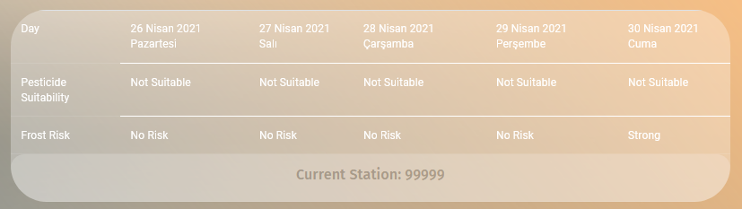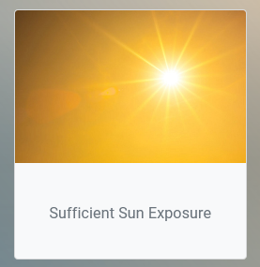This page shows the last **Current Temperature, Soil Moisture**, **Daily Temperature**, **Heat Stress Level**, **Frost Risk**, **Pesticide Suitability**, **Sun Exposure** and **Weather Forecast**. The user can click on the charts to see more detailed information about the shown values.

Figure 8: Sun Exposure

Figure 9: Table for Pesticide Suitability and Frost Risk

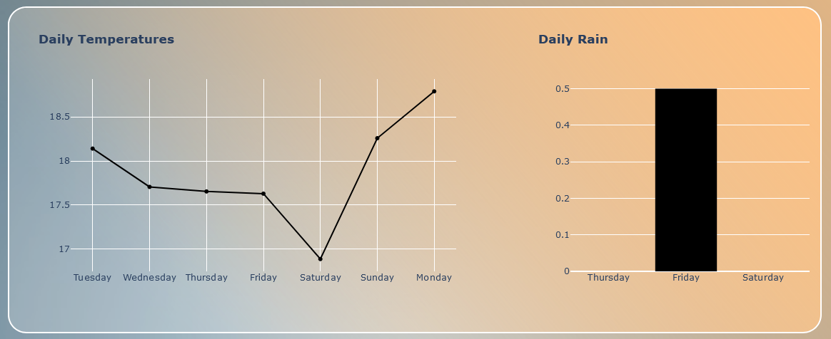

Figure 10: Information Charts

There are more than one Charts here. So, to move between them you can drag or click the buttons to change the chart.

*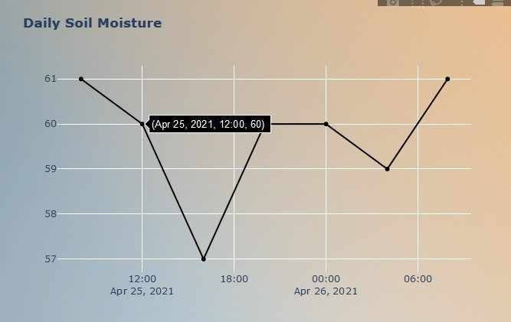****Note****: The charts visualize the respected data for the last 5 days.*

Figure 11: Chart Hover

***Note****: The user can hover above them for more info.*

Figure 12: Dark Mode for Status Page

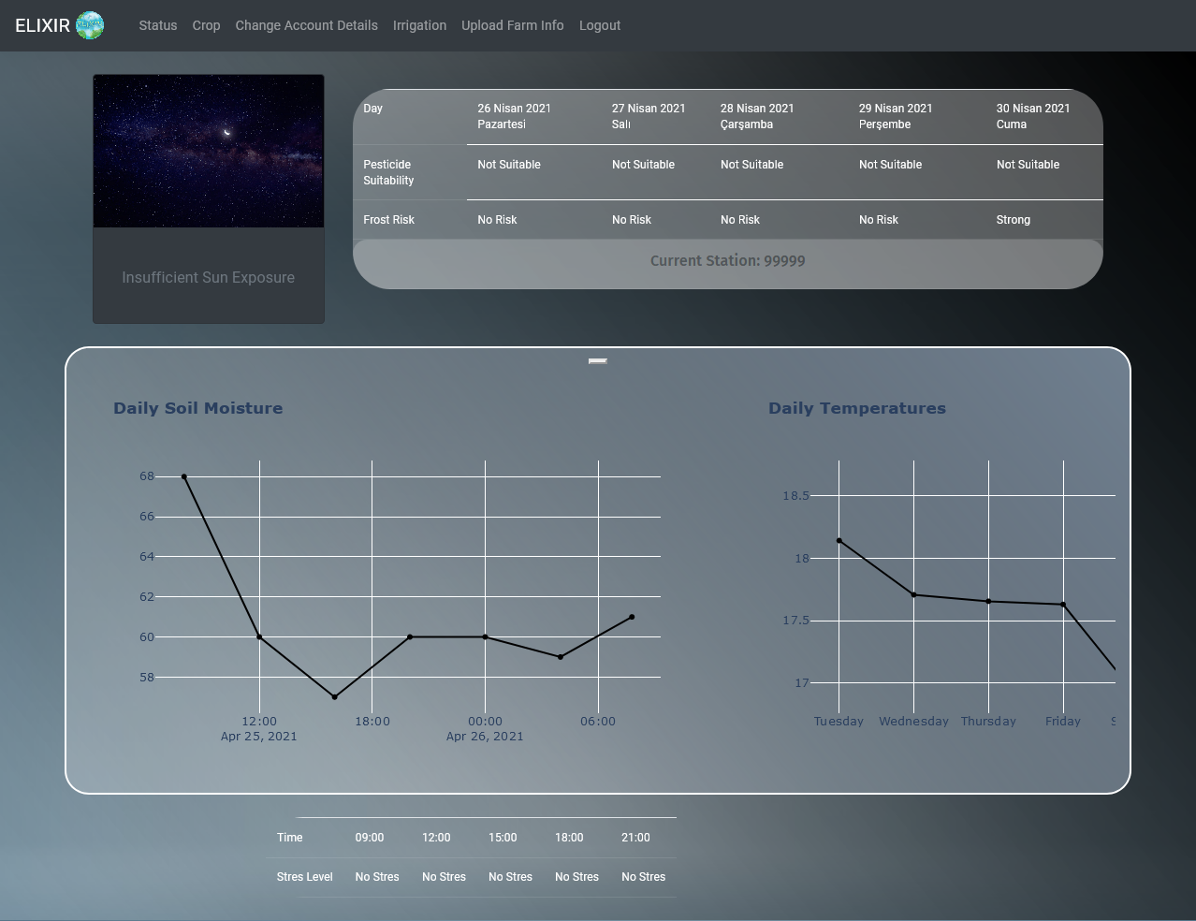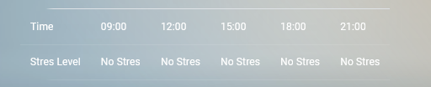This page also changes to dark mode, indicating that the Sun Exposure level is lower than expected.

Figure 13: Stress Table

# Home Page

This page opens automatically as you **Sign in** to Elixir.

To access the Home Page, use the **Elixir Logo** located in the upper most right part of the navigation bar. Then click to access it

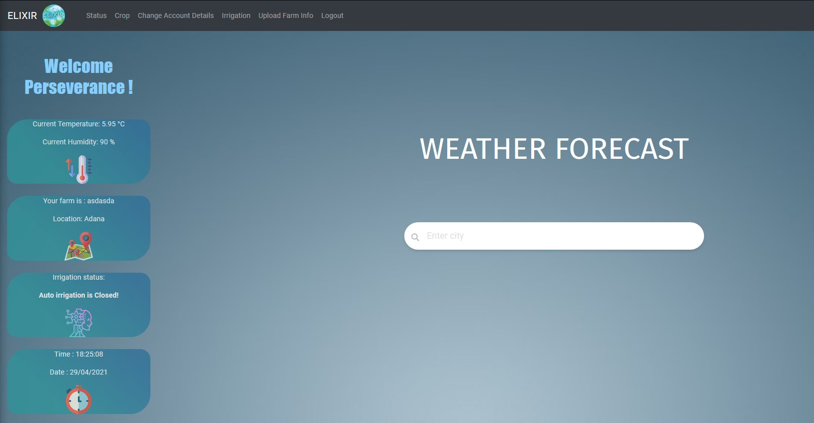Here the user can see their **Farm Name**, **Irrigation Status** of your farm, **Current Temperature and Humidity** of your farm, A **Searchable Weather Forecast Panel** and lastly the date and time.

Figure 14: User Home Page

On the left side of the screen, the user sees their **Farm Name**, **Irrigation Status** of your farm, **Current Temperature and Humidity** of your farm.

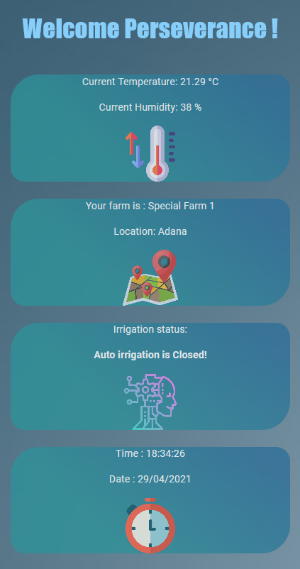To use the **Weather Forecast Panel**, start by typing the name of the city you want to check.

Figure 15: User Information Panel

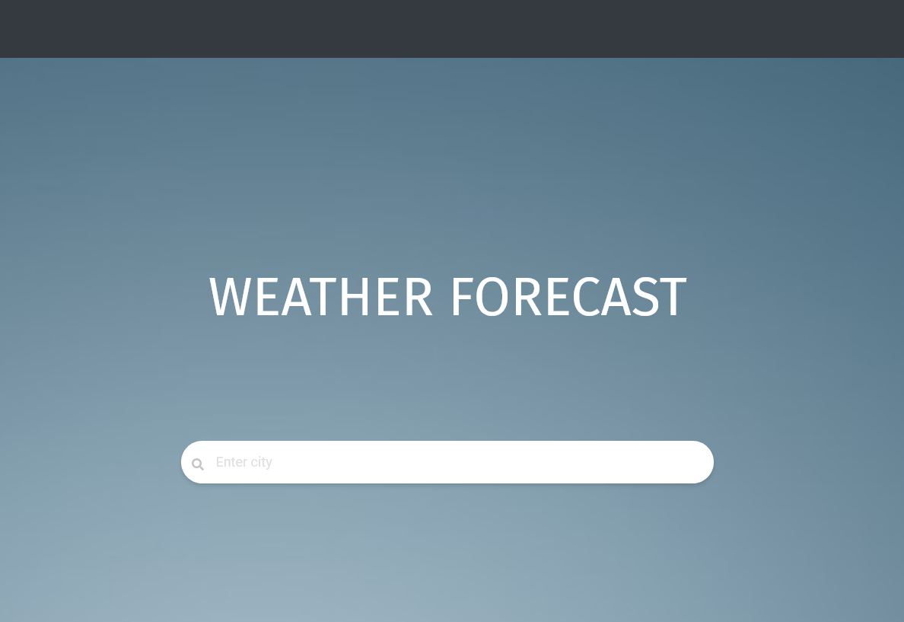

Figure 16: Weather Forecast Panel

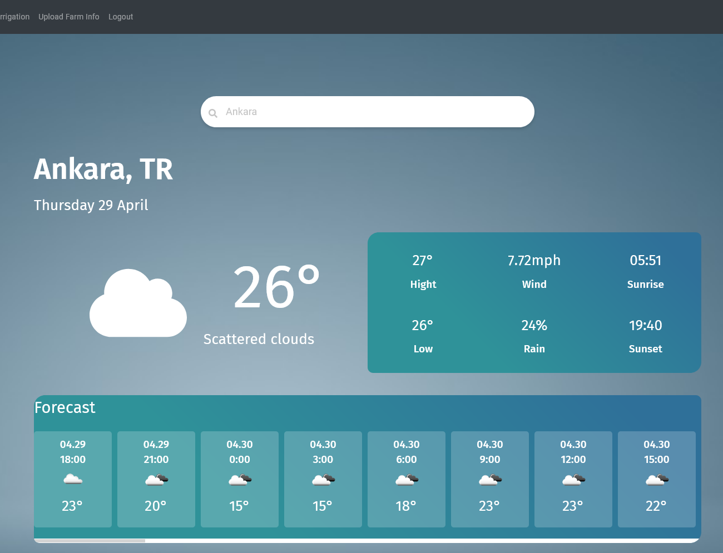

Figure 17: Search Weather Forecast Panel

If the City name is valid and found, the panel will show Hourly Forecast for the next 30 Hours, additionally the user will be able to see the current date, chance of rain, wind speed and lastly Sunset and Sunrise times for the day.

If the City is name is wrong or not found than the user is prompted with a message stating “**Sorry, the specified city was not found.** “

***Note:*** *This Searchable Weather Forecast only work with city names.*

# Irrigation

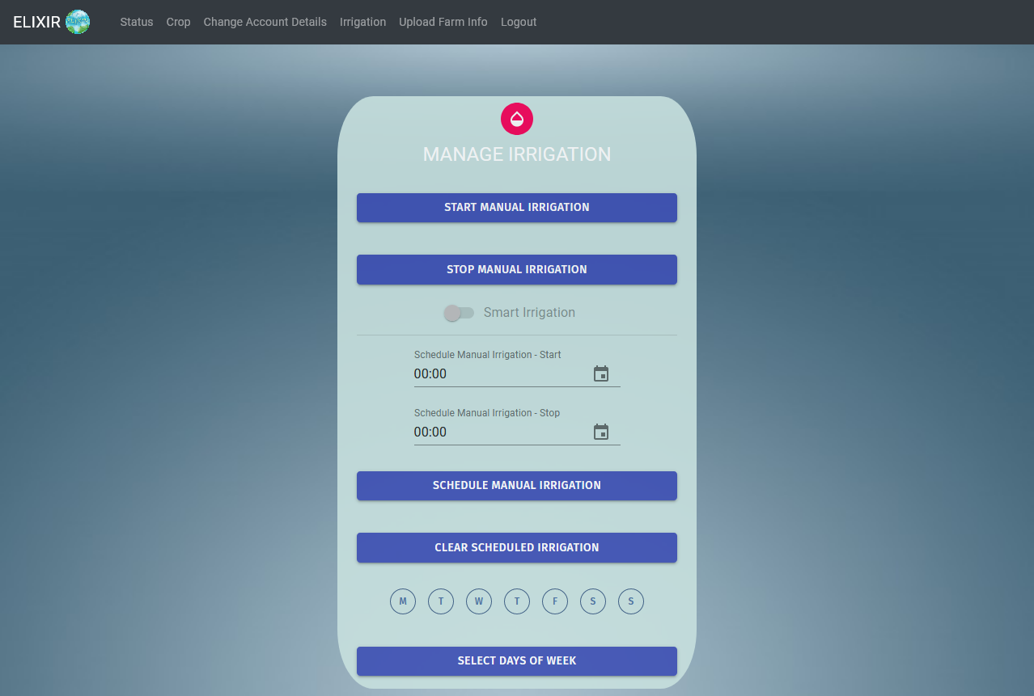To access the Irrigation page, use the **Irrigation** option located in the upper left part of the navigation bar. Then click to access it.

Figure 18: Manage Irrigation Panel

To **Start** your irrigation system, click on the **START MANUAL IRRIGATION** button.

To **Stop** your irrigation system, click on the **STOP MANUAL IRRAGATION** button.

## Smart Irrigation

The Smart Irrigation functionally can only be activated once a crop information has been uploaded for your farm.

The smart irrigation functionally is Elixir’s unique ability to automate irrigation of your farm. Once activated Elixir checks the following:

* + Temperature of the surroundings.
  + Humidity level of your crops.
  + Rain forecast and current rain checks.

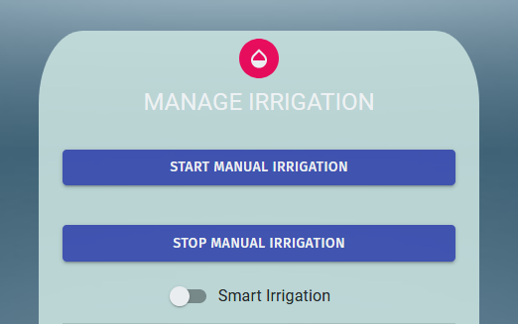

Figure 19: After Crop Info is Uploaded

Detailed information about Uploading Crop Information will be given in Section 5, Page 18.

Once **Crop Information** is uploaded and **Smart Irrigation** **is activated**. The user will be prompted with the Uploaded Information and give information of what is about to happen.

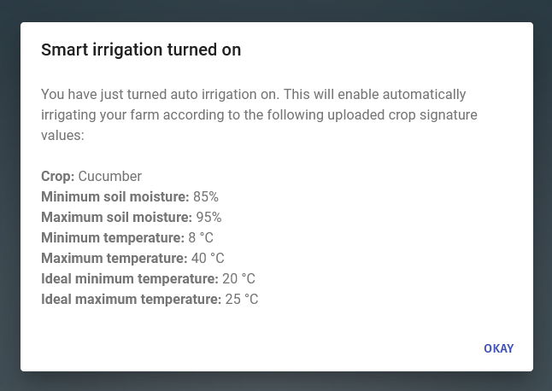

Figure 20: Smart Irrigation Prompt

***Important Note****:* ***Once Smart Irrigation is enabled, Scheduled Manual Irrigation functionally will NOT work.***

## Schedule Manual Irrigation

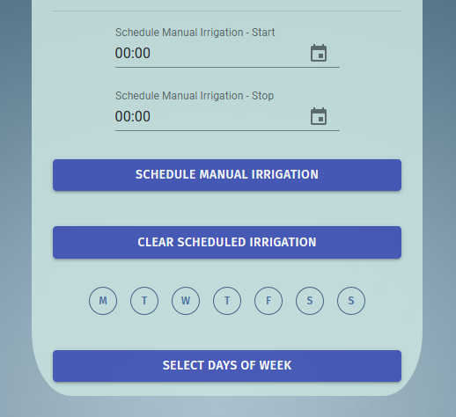Schedule functionality is used to simply schedule an irrigation with the given time and day.

Figure 21: Schedule Manual Irrigation Panel

To make a schedule, first the user will have to set a **Start** and **End** irrigation time. This can be done with either typing the time in a **24-hour format** or by clinking the **Calendar Icon** seen next to the time slot.

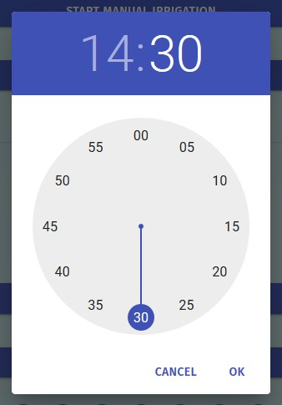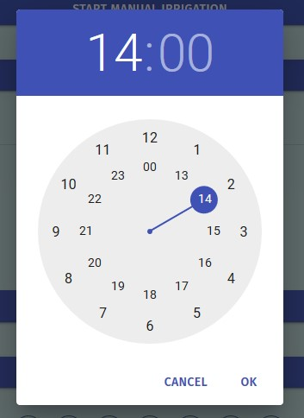

Figure 22: Select Hour Panel

Figure 23: Select Minute Panel

When the Calendar Icon is clicked, the user will be shown the **Hour Panel** first and once the hour has been selected the panel change to the **Minute Panel**.

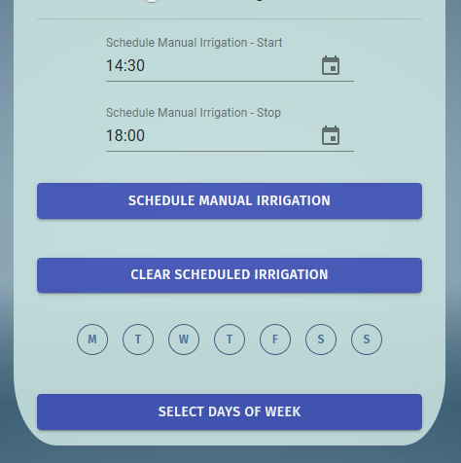

Figure 24: Schedule Manual Irrigation Panel - Hour

After the time slots have been selected, the user **MUST** select days of the week for the schedule to run. If a day has not been selected, then the user is prompted that that days are missing.

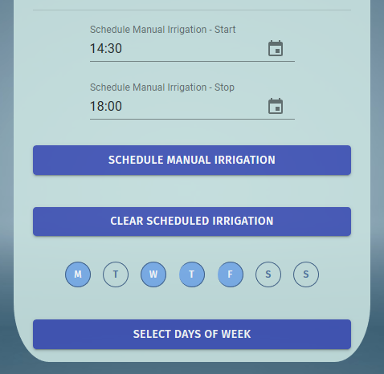

Figure 25: Schedule Manual Irrigation Panel - Days

After the user has selected the **Days of the week** for the schedule to run, the user **MUST** click the **Select Days of Week** button to **Verify** the says of the schedule after this the days are set.

Finally, the user clicks on the **Schedule Manual Irrigation** button to start the Scheduled irrigation. Once this button is pressed and if every step worked correctly than the user prompted with a short disclaimer.

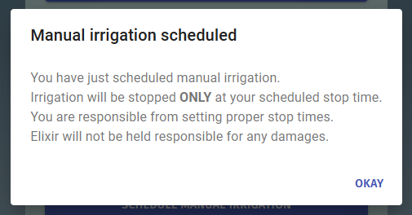

Figure 26: Schedule Manual Irrigation Successful Prompt

Once this message has been seen the user **Scheduled Irrigation will be activated.**

To clear a previous Schedule, click the **Clear Scheduled Irrigation** button.

To **Update** or make a C**hange** in the active schedule the user only needs to change the relevant information and click the corresponding button, lasty the user **MUST** click the **Schedule Manual Irrigation** button of the changes to be applied.

***Note:*** *As now of now Elixir only supports* ***ONE*** *schedule program.*

# Upload Farm Info

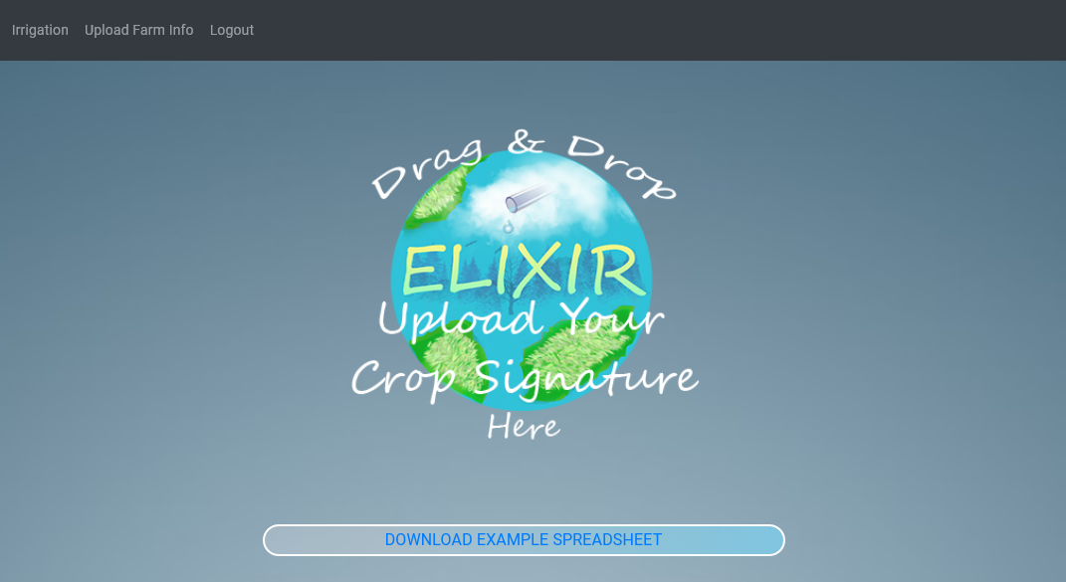To access the Irrigation page, use the **Upload Farm Info** option located in the upper left part of the navigation bar. Then click to access it.

Figure 27: Upload Crop Signature Panel

This panel is to upload your personalized **Crop Signature Information**, so that Elixir can use this information and enable the **Smart Irrigation** functionality.

To **Upload a Crop Signature** the user can **two** things,

* **Firstly**, clicking on the elixir logo will open a file explorer, so that the user can choose their signature.
* **Secondly**, the user can drag a file and drop is on the Elixir logo.

The user uploads within this panel. If any of these criteria is not met than the user will be prompted accordingly. To Upload this file, either format or create a new document in the following criteria,

* The document to be uploaded must be an **.xlsx** file.
* The **.xlsx** file must be in the following format,

|  |  |
| --- | --- |
| Name | Cucumber |
| SoilMoistureMinPercentage | 85 |
| SoilMoistureMaxPercentage | 95 |
| TempMinCelsius | 8 |
| TempMaxCelsius | 40 |
| IdealMinTempCelsius | 20 |
| IdealMaxTempCelsius | 25 |

The **“Name”** indicates the name of your crop.

**Soil Moisture Range:**

**“**SoilMoistureMinPercentage**”** is the **Minimum** **Soil Moisture** value that your crop can handle, this value must be between **0** and **100**.

**“**SoilMoistureMaxPercentage**”** is the **Maximum** **Soil Moisture** value that your crop can handle, this value must be between **0** and **100**.

**Temperature Range:**

**“**TempMinCelsius**”** is the **Minimum** **Temperature** value that your crop can handle, this value must be between -3**0** and **50 Celsius**.

**“**TempMinCelsius**”** is the **Maximum** **Temperature** value that your crop can handle, this value must be between -3**0** and **50 Celsius**.

**Ideal** **Temperature Range:**

**“**IdealMinTempCelsius**”** is the **Minimum** **Ideal** **Temperature** value that the crop needs in order to achieve its optimal growth rate and become more efficient.

**“**IdealMaxTempCelsius**”** is the **Maximum** **Ideal** **Temperature** value that the crop needs in order to achieve its optimal growth rate and become more efficient.

**Crop Signature File Example:**

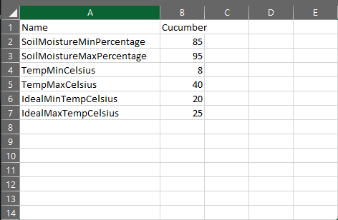

Figure 28: Crop Signature File Example

***Note:*** *To download a* ***Crop Signature File*** *example click here:* [*Tomato Signature*](https://drive.google.com/uc?export=download&id=1Wah886tBcE1RkqUoygNyMjIKriMhNznf)

***Important Note:*** *If any of these values (names or numbers) are not valid a prompt will be given the User indicating the problem.*

# Crop Panel

This page can only me seen after a Crop Signature is uploaded to Elixir. Check Section 5, Page 18 for more information.

To access the Crop Page, use the Crop option located in the upper left part of the navigation bar. Then click to access it.

In this page the user will be able to see their Crop Signature Information and the Crops daily gathered information Compliance to the given signature data. Meaning for each signature aspect, soil moisture, temperature and ideal temperature Elixir gives a compliance score to your crop to show if your current crop is in compliant with your given signature.

***Note:*** *All values are calculated according to the relevant data in your farm in the last 24 hours.*

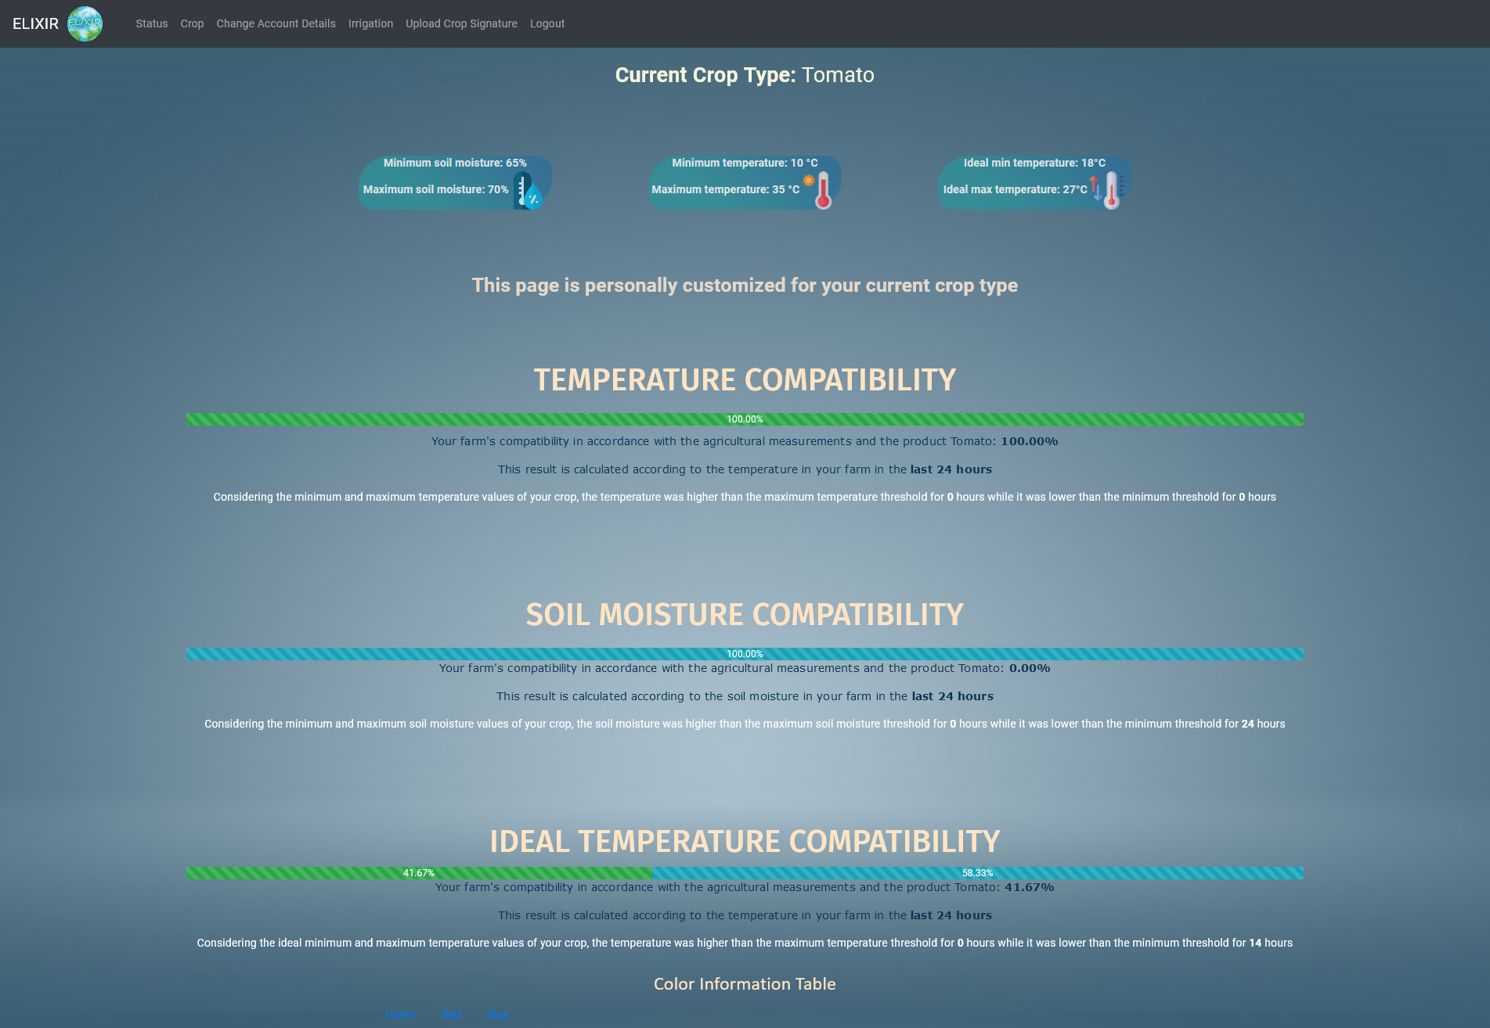

Figure 29: Main Crop Page

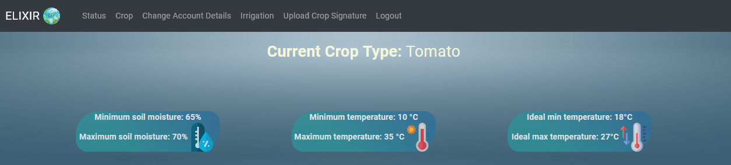This page has four different type of information, it shows your **Crop Signature, Temperature** **Compatibly**, **Solid** **Moisture** **Compatibly**, **Ideal** **Temperature** **Compatibility.**

Figure 30: Crop Signature

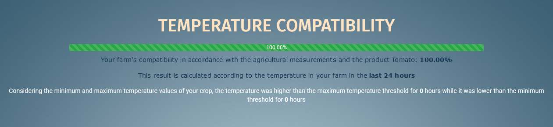**Temperature Compatibility:**

Figure 31: Temperature Compatibility

This panel displayed your farm's compatibility in accordance with the agricultural measurements and the product **Uploaded Crop.**

Counts the,

* Times, your temperature was higher than the maximum temperature threshold.
* Times, your temperature was lower than the minimum temperature threshold.

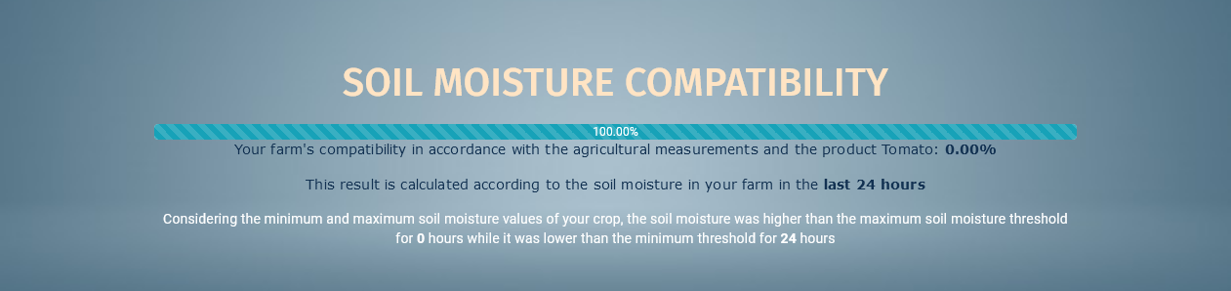

Figure 32: Soil Moisture Compatibility

**Soil Moisture Compatibility:**

This panel displayed your farm's compatibility in accordance with the agricultural measurements and the product **Uploaded Crop.**

Counts the,

* Times, your soil moisture was higher than the maximum soil moisture threshold.
* Times, your soil was lower than the minimum threshold.

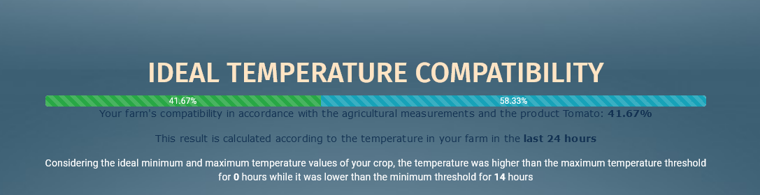

Figure 33: Ideal Temperature Compatibility

**Ideal Temperature Compatibility:**

This panel displayed your farm's compatibility in accordance with the agricultural measurements and the product **Uploaded Crop.**

Counts the,

* Times, your temperature was higher than the maximum temperature threshold.
* Times, your lower than the minimum threshold.

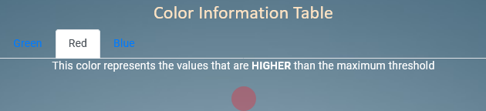

Figure 34: Colour Information

There are three colours in this table,

**Green**

* This colour represents the values that are **BETWEEN** the **minimum** and **maximum** threshold.

**Red**

* This colour represents the values that are **HIGHER** than the **maximum** threshold

**Blue**

* This colour represents the values that are **LOWER** than the **minimum** threshold