Elixir

Smart Irrigation and Agriculture System

User Manuel

*This manual can be used for Elixir Portal version 1.0.0 and newer.

Contents

1. General features 3

1.1. Access to Interface 3

1.2. Login 3

1.3. Navigation Bar 4

1.4. Logout 4

1.5. User Profile 4

2. Dashboard 6

3. Home Page 10

4. Irrigation 11

1.6. Smart Irrigation 11

1.7. Schedule Manuel Irrigation 13

5. Upload Farm Info 18

6. Crop Panel 19

List of Figures

Figure 1: Login Page 3

Figure 2: Sign in Panel 3

Figure 3: Navigation Bar 4

Figure 4: Logout Button 4

Figure 5: Access to Account Details 4

Figure 6: Options in Account Details 5

Figure 7: Dashboard 6

Figure 8: Sun Exposure 7

Figure 9: Table for Pesticide Suitability and Frost Risk 7

Figure 10: Information Charts 8

Figure 11: Chart Hover 8

Figure 12: Dark Mode for Status Page 9

Figure 13: Stress Table 9

Figure 14: Manage Irrigation Panel 11

Figure 15: After Crop Info is Uploaded 12

Figure 16: Smart Irrigation Prompt 12

Figure 17: Crop Signature File Example 19

# General features

## Access to Interface

Elixir is a web-based application. It can be accessed from <http://elixirapp.live/>

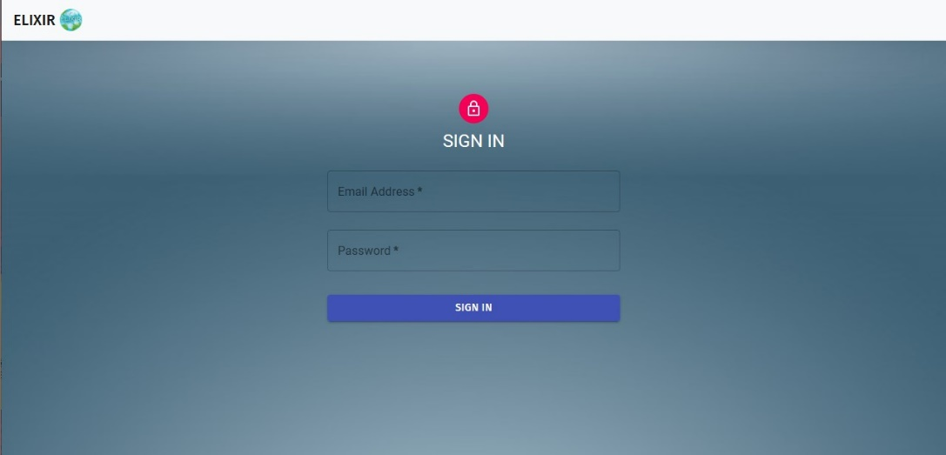***Note****: The browser recommended for Elixir is Chrome and Firefox, and the screen resolution is 1920 * 1080.*

Figure 1: Login Page

## Login

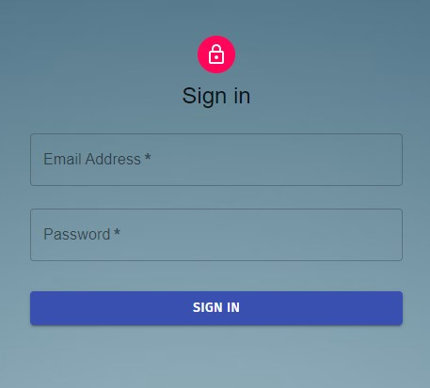The user must enter their **Email** and **Password** and click the **SIGN IN** button to access Elixir.

Figure 2: Sign in Panel

When you Sign in Elixir will got to the **Home Page** to show your general information. For more information about the home page check Section 3, Page 10.

***Note****: If the wrong* ***Email*** *or* ***Password*** *information are entered an error message will be given.*

***Note****: If these are correct than a simple message will prompt the user that the login is successful and the suer will Signed In*.

## Navigation Bar

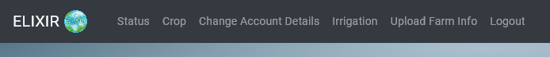After logging into the application, navigation bar can be displayed on the top side of the page. When a user wants to access a page through the navigation bar, they can click on the name of the module they want to access, then they will be directed to the relevant page.

Figure 3: Navigation Bar

***Note:*** *The Elixir Logo will take you to the home page.*

## Logout

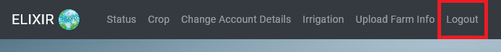To Logout from Elixir, use the **Logout** button option located in the upper most left part of the navigation bar.

Figure 4: Logout Button

## User Profile

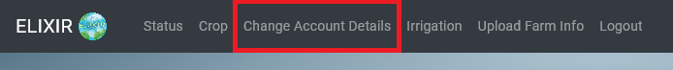To access the user profile page, use the **Change Account Details** option located in the upper right part of the navigation bar. Then click to access it.

Figure 5: Access to Account Details

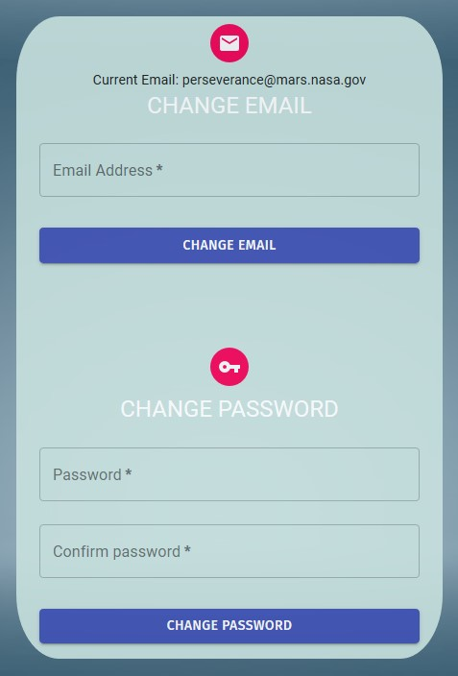

Figure 6: Options in Account Details

This section has two options **Change Email** and **Change Password.**

**Change Password:**

The user can change his/her password within this panel. To do this, enter the new password in the **Password** fields. In order to change the password, the following criteria must be met:

* Password must contain at least 8 characters.
* Password must contain at most 256 characters.

If these conditions are met the user will be able to change their passwords by clicking the **Change Password** button.

The password is not updated in the following situations and the user is warned:

* The new password does not meet the requirements.

***Important Note: Password and Confirm Password must not be empty and they must match to change the password.***

***Note****: Your initial password will be sent to your* ***Email******address,*** *that was given to the Admins of Elixir.*

***Note:*** *For security purposes the Admins do not know your password and the initial password that was set will be sent automatically.*

**Change Email:**

The user can change his/her **Email** within this panel. To do this, enter the new Email in the **Email** fields. In order to change the Email. In order to change the password, the following criteria must be met:

* Email must be a valid email address.

If these conditions are met the user will be able to change their mail by clicking the **Change Email** button.

The email is not updated in the following situations and the user is warned:

* Entered email is not valid email address.

# Dashboard

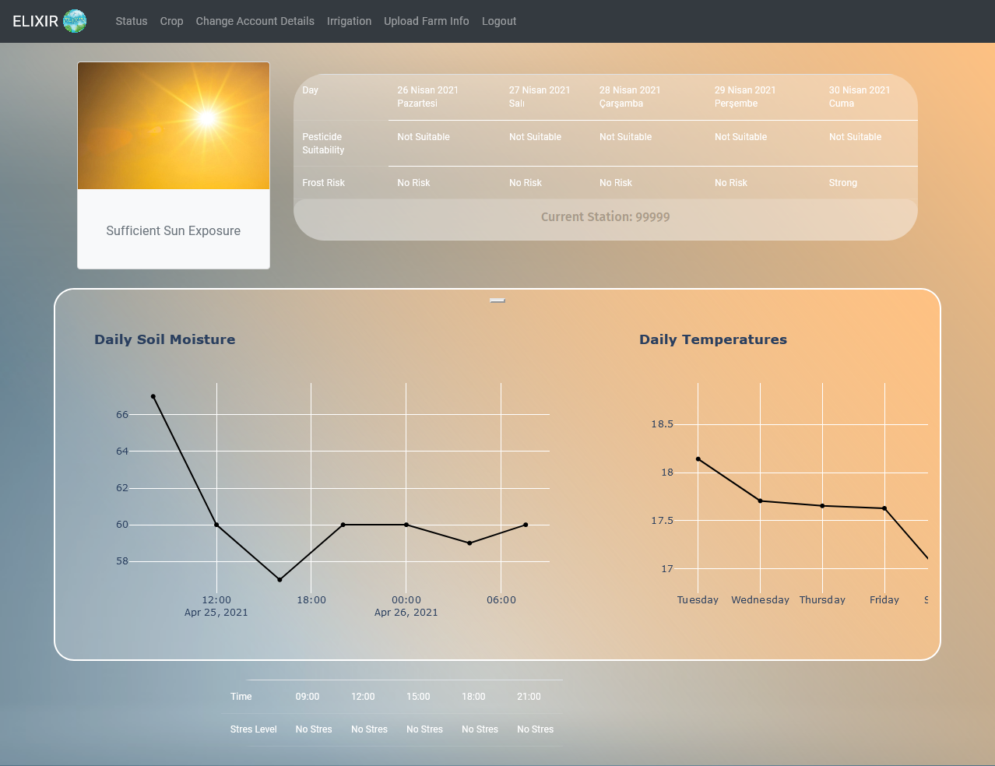Dashboard is an interface created to give general information to the user after logging to the system.

Figure 7: Dashboard

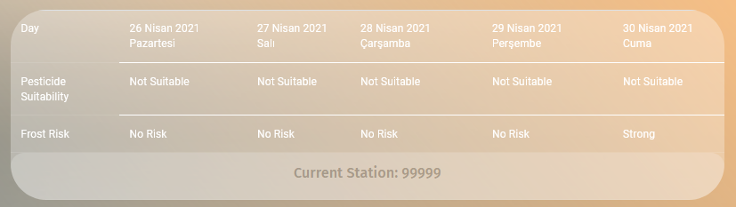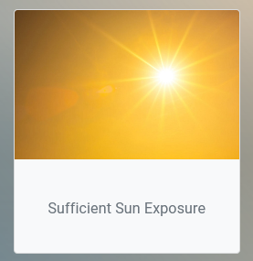This page shows the last **Current Temperature, Soil Moisture**, **Daily Temperature**, **Heat Stress Level**, **Frost Risk**, **Pesticide Suitability**, **Sun Exposure** and **Weather Forecast**. The user can click on the charts to see more detailed information about the shown values.

Figure 8: Sun Exposure

Figure 9: Table for Pesticide Suitability and Frost Risk

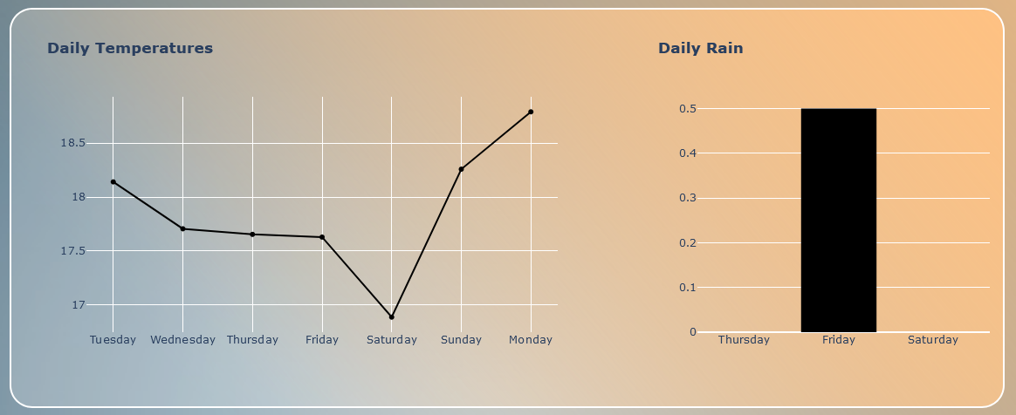

Figure 10: Information Charts

There are more than one Charts here. So, to move between them you can drag or click the buttons to change the chart.

*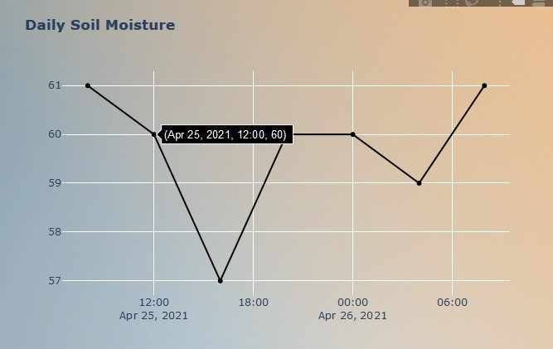****Note****: The charts visualize the respected data for the last 5 days.*

Figure 11: Chart Hover

***Note****: The user can hover above them for more info.*

Figure 12: Dark Mode for Status Page

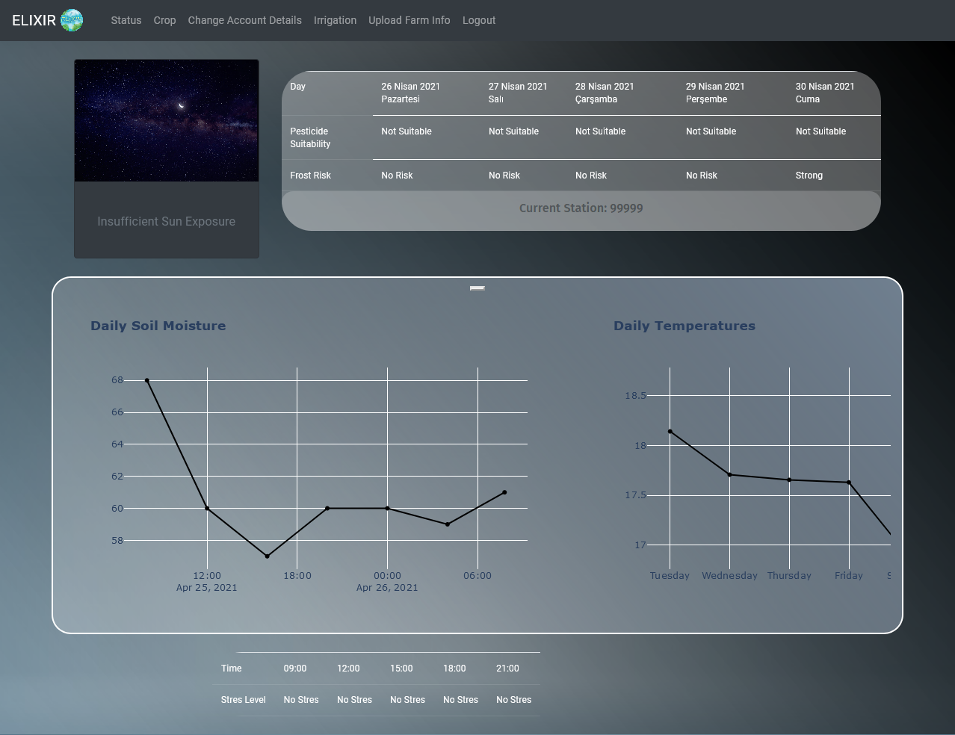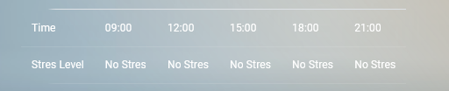This page also changes to dark mode, indicating that the Sun Exposure level is lower than expected.

Figure 13: Stress Table

# Home Page

This page opens automatically as you **Sign in** to Elixir.

To access the Home Page, use the **Elixir Logo** located in the upper most right part of the navigation bar. Then click to access it

Here the suer can see their **Farm Name**, **Irrigation Status** of your farm, **Current Temperature and Humidity** of your farm, A **Searchable Weather Forecast Panel** and lastly the date and time.

INSERT ALL PAGE IMAGE

CAPTION

To use the Weather Forecast Panel, start by typing the name of the city you want to check.

INSERT DEMO-1 IMAGE

CAPTION

INSERT DEMO-2 IMAGE

CAPTION

If the City name is valid and found, the panel will show Hourly Forecast for the next 30 Hours, additionally the user will be able to see the current date, chance of rain, wind speed and lastly Sunset and Sunrise times for the day.

If the City is name is wrong or not found than the user is prompted with a message stating “**Sorry, the specified city was not found.** “

***Note:*** *This Searchable Weather Forecast only work with city names.*

# Irrigation

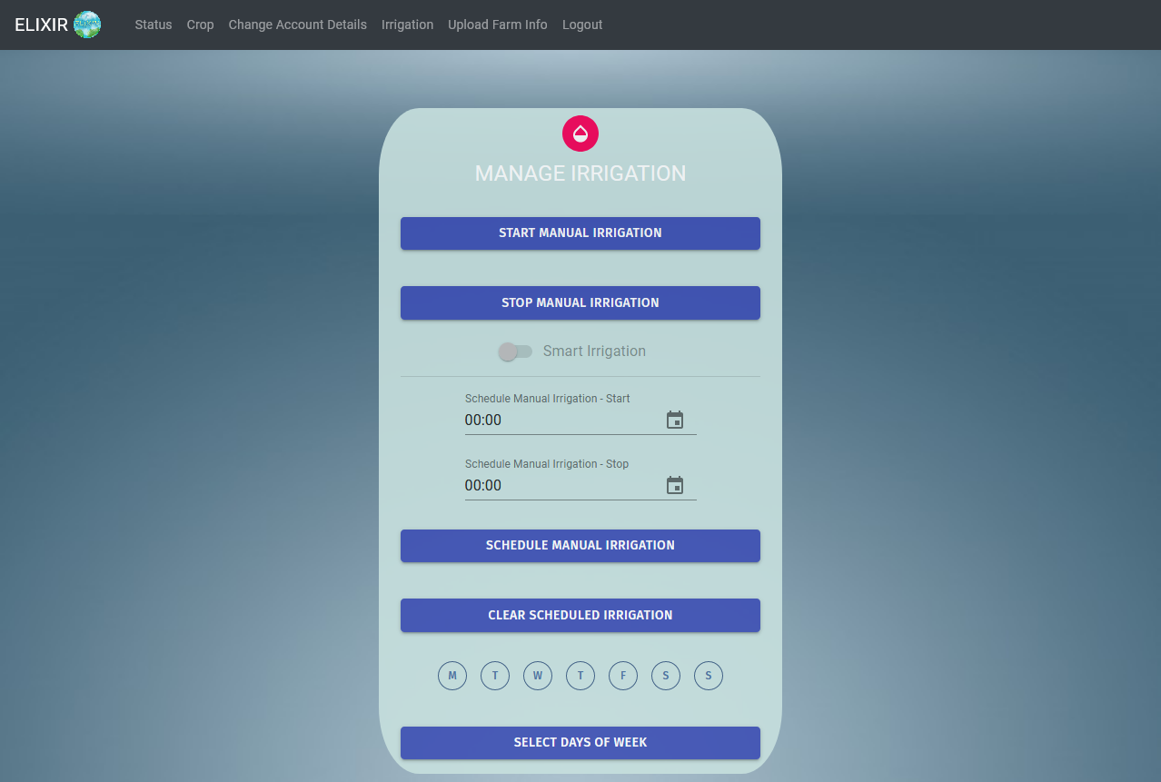To access the Irrigation page, use the **Irrigation** option located in the upper left part of the navigation bar. Then click to access it.

Figure 14: Manage Irrigation Panel

To **Start** your irrigation system, click on the **START MANUAL IRRIGATION** button.

To **Stop** your irrigation system, click on the **STOP MANUAL IRRAGATION** button.

## Smart Irrigation

The Smart Irrigation functionally can only be activated once a crop information has been uploaded for your farm.

The smart irrigation functionally is Elixir’s unique ability to automate irrigation of your farm. Once activated Elixir checks the following:

* + Temperature of the surroundings.
  + Humidity level of your crops.
  + Rain forecast and current rain checks.

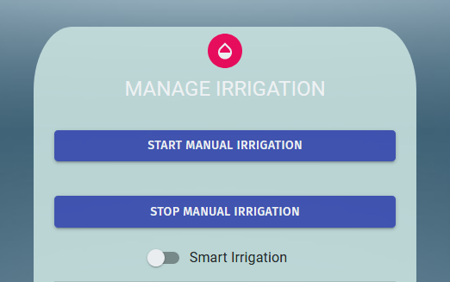

Figure 15: After Crop Info is Uploaded

Detailed information about Uploading Crop Information will be given in Section 5, Page 18.

Once **Crop Information** is uploaded and **Smart Irrigation** **is activated**. The user will be prompted with the Uploaded Information and give information of what is about to happen.

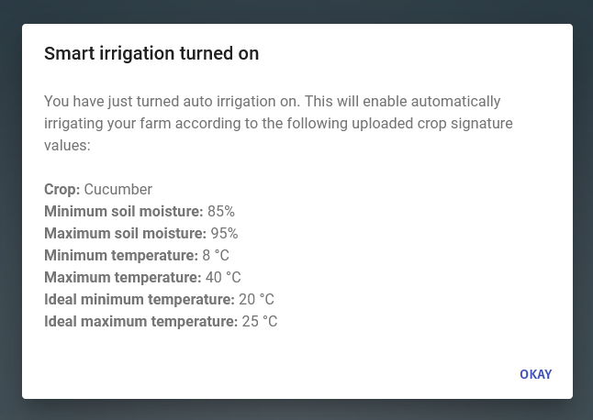

Figure 16: Smart Irrigation Prompt

***Important Note****:* ***Once Smart Irrigation is enabled, Scheduled Manuel Irrigation functionally will NOT work.***

## Schedule Manuel Irrigation

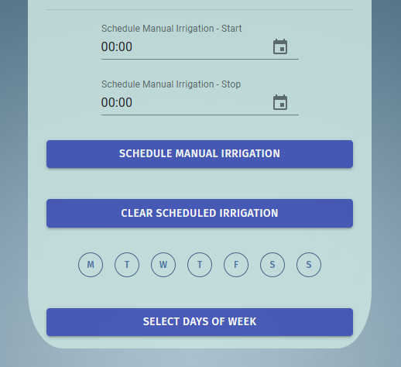Schedule functionality is used to simply schedule an irrigation with the given time and day.

Figure 17: Schedule Manuel Irrigation Panel

To make a schedule, first the user will have to set a **Start** and **End** irrigation time. This can be done with either typing the time in a **24-hour format** or by clinking the **Calendar Icon** seen next to the time slot.

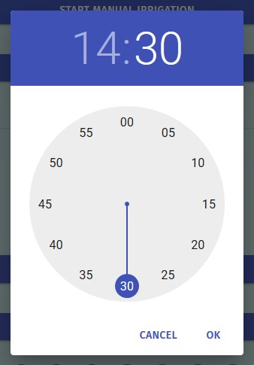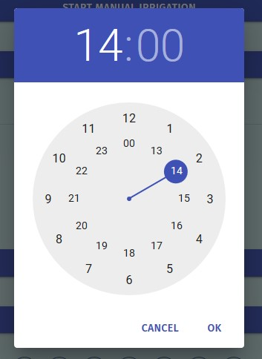

Figure 18: Select Hour Panel

Figure 19: Select Minute Panel

When the Calendar Icon is clicked, the user will be shown the **Hour Panel** first and once the hour has been selected the panel change to the **Minute Panel**.

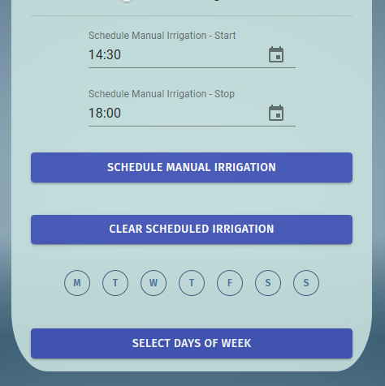

Figure 20:

After the time slots have been selected, the user **MUST** select days of the week for the schedule to run. If a day has not been selected, then the user is prompted that that days are missing.

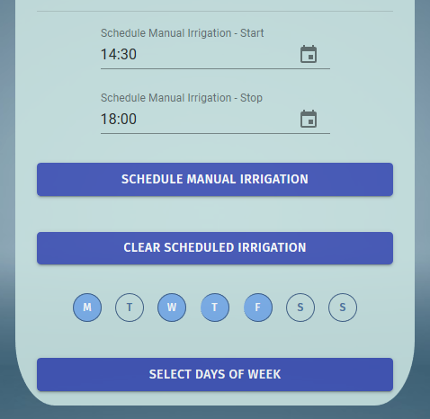

Figure 21:

After the user has selected the **Days of the week** for the schedule to run, the user **MUST** click the **Select Days of Week** button to **Verify** the says of the schedule after this the days are set.

Finally, the user clicks on the **Schedule Manuel Irrigation** button to start the Scheduled irrigation. Once this button is pressed and if every step worked correctly than the user prompted with a short disclaimer.

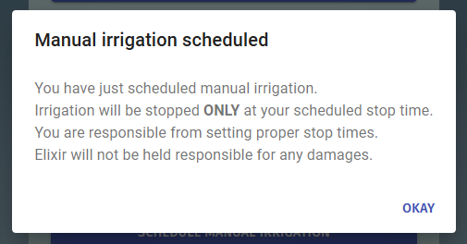Once this message has been seen the user **Scheduled Irrigation will be activated.**

Figure 22:

To clear a previous Schedule, click the **Clear Scheduled Irrigation** button.

To **Update** or make a C**hange** in the active schedule the user only needs to change the relevant information and click the corresponding button, lasty the user **MUST** click the **Schedule Manuel Irrigation** button of the changes to be applied.

***Note:*** *As now of now Elixir only supports* ***ONE*** *schedule program.*

# Upload Farm Info

To access the Irrigation page, use the **Upload Farm Info** option located in the upper left part of the navigation bar. Then click to access it.

INSERT FORO HERE

CAPTION

This panel is to upload your personalized **Crop Signature Information**, so that Elixir can use this information and enable the **Smart Irrigation** functionality.

EXLAIN WHAT IT DOES

The user upload within this panel. To do this, format or create a new document in the following criteria,

* The document to be uploaded must be an **.xlsx** file.
* The **.xlsx** file must be in the following format.

|  |  |
| --- | --- |
| Name | Cucumber |
| SoilMoistureMinPercentage | 85 |
| SoilMoistureMaxPercentage | 95 |
| TempMinCelsius | 8 |
| TempMaxCelsius | 40 |
| IdealMinTempCelsius | 20 |
| IdealMaxTempCelsius | 25 |

The **“Name”** indicates the name of your crop.

**Soil Moisture Range:**

**“**SoilMoistureMinPercentage**”** is the **Minimum** **Soil Moisture** value that your crop can handle, this value must be between **0** and **100**.

**“**SoilMoistureMaxPercentage**”** is the **Maximum** **Soil Moisture** value that your crop can handle, this value must be between **0** and **100**.

**Temperature Range:**

**“**TempMinCelsius**”** is the **Minimum** **Temperature** value that your crop can handle, this value must be between -3**0** and **50 Celsius**.

**“**TempMinCelsius**”** is the **Maximum** **Temperature** value that your crop can handle, this value must be between -3**0** and **50 Celsius**.

**Ideal** **Temperature Range:**

**“**IdealMinTempCelsius**”** is the **Minimum** **Ideal** **Temperature** value that the crop needs in order to achieve its optimal growth rate and become more efficient.

**“**IdealMaxTempCelsius**”** is the **Maximum** **Ideal** **Temperature** value that the crop needs in order to achieve its optimal growth rate and become more efficient.

**Crop Signature File Example:**

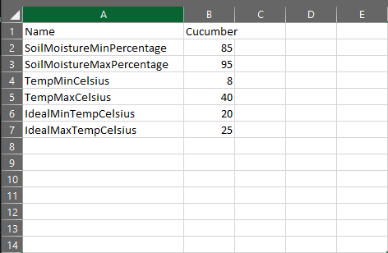

Figure 23: Crop Signature File Example

***Note:*** *To download a* ***Crop Signature File*** *example click here:* [*Tomato Signature*](https://drive.google.com/uc?export=download&id=1Wah886tBcE1RkqUoygNyMjIKriMhNznf)

***Important Note:*** *If any of these values (names or numbers) are not valid a prompt will be given the User indicating the problem.*

# Crop Panel

This page can only me seen after a Crop Signature is uploaded to Elixir. Check Section 5, Page 18 for more information.

To access the Crop Page, use the Crop option located in the upper left part of the navigation bar. Then click to access it.

In this page the user will be able to see their Crop Signature Information and the Crops daily gathered information Compliance to the given signature data. Meaning for each signature aspect, soil moisture, temperature and ideal temperature Elixir gives an compliance score to your crop to show if your current crop is in compliant with your given signature

Color Information table

Temperature Compatibility

IMAGE

INFORMATION

---

Soil Moisture Compatibility

IMAGE

INFORMATION

---

Ideal Temperature Compatibility

IMAGE

INFORMATION

---