

oneM2M
Technical Report
Document Number | TR-0025 V0.1.3
Document Name: | Application Developer Guide
Date: | 2016-01-20
Abstract: | Provides an use case for guiding application developers to develop applications using functionalities provided by an oneM2M service platform.
Template Version:23 February 2015 (Dot not modify)

This Specification is provided for future development work within oneM2M only. The Partners accept no liability for any use of this Specification.
The present document has not been subject to any approval process by the oneM2M Partners Type 1. Published oneM2M specifications and reports for implementation should be obtained via the oneM2M Partners' Publications Offices.

About oneM2M
The purpose and goal of oneM2M is to develop technical specifications which address the need for a common M2M Service Layer that can be readily embedded within various hardware and software, and relied upon to connect the myriad of devices in the field with M2M application servers worldwide.
More information about oneM2M may be found at: http//www.oneM2M.org
Copyright Notification
© 2016, oneM2M Partners Type 1 (ARIB, ATIS, CCSA, ETSI, TIA, TSDSI, TTA, TTC).
All rights reserved.
The copyright and the foregoing restriction extend to reproduction in all media.

Notice of Disclaimer & Limitation of Liability
The information provided in this document is directed solely to professionals who have the appropriate degree of experience to understand and interpret its contents in accordance with generally accepted engineering or other professional standards and applicable regulations. No recommendation as to products or vendors is made or should be implied.
NO REPRESENTATION OR WARRANTY IS MADE THAT THE INFORMATION IS TECHNICALLY ACCURATE OR SUFFICIENT OR CONFORMS TO ANY STATUTE, GOVERNMENTAL RULE OR REGULATION, AND FURTHER, NO REPRESENTATION OR WARRANTY IS MADE OF MERCHANTABILITY OR FITNESS FOR ANY PARTICULAR PURPOSE OR AGAINST INFRINGEMENT OF INTELLECTUAL PROPERTY RIGHTS. NO oneM2M PARTNER TYPE 1 SHALL BE LIABLE, BEYOND THE AMOUNT OF ANY SUM RECEIVED IN PAYMENT BY THAT PARTNER FOR THIS DOCUMENT, WITH RESPECT TO ANY CLAIM, AND IN NO EVENT SHALL oneM2M BE LIABLE FOR LOST PROFITS OR OTHER INCIDENTAL OR CONSEQUENTIAL DAMAGES. oneM2M EXPRESSLY ADVISES ANY AND ALL USE OF OR RELIANCE UPON THIS INFORMATION PROVIDED IN THIS DOCUMENT IS AT THE RISK OF THE USER.

Contents
Contents 3
1 Scope 5
2 References 5
2.1 Normative references 5
2.2 Informative references 5
3 Definitions and abbreviations 5
3.1 Definitions 5
3.2 Abbreviations 6
4 Conventions 6
5 Use case 6
6 Architecture 7
7 Procedures 8
7.1 Introduction 8
7.2 Call Flows 9
7.2.1 Application registration and Access control policy creation 9
7.2.2 Initial resource creation 10
7.2.3 Discovery of group resources 11
7.2.4 Discovery and retrieval of contentInstance resources 12
7.3 Remote control scenarios 14
7.3.1 Introduction 14
7.3.2 Single light lamp control 14
7.3.3 Multiple light lamps control 14
8 Implementation 15
8.1 Introduction 15
8.2 Assumptions 15
8.3 Addressing for Entities 16
8.4 Modelling for Light State Data 16
8.5 Resource Structure 16
8.5.1 Resource Structure of IN-CSE 16
8.5.2 Resource Structure of MN-CSE 17
8.6 Role of Entities 18
8.6.1 oneM2M service platform (IN-CSE) 18
8.6.2 Home gateway application (MN-AE) 19
8.6.3 Light applications (ADN-AE1 and ADN-AE2) 19
8.6.4 Smartphone application (IN-AE) 19
8.7 Implementation Procedures 19
8.7.1 Introduction 19
8.7.2 MN-CSE registration 19
8.7.3 Access control policy creation 20
8.7.4 Application entities registration 21
8.7.4.1 Light application ADN-AE1 21
8.7.4.2 Light application ADN-AE2 21
8.7.4.3 Home gateway application MN-AE 22
8.7.4.4 Smartphone application IN-AE 22
8.7.5 Containers creation 22
8.7.5.1 Create a container of ADN-AE1 22
8.7.5.2 Create a container of ADN-AE2 23
8.7.6 ContentInstances creation 23
8.7.6.1 Create a content instance of ADN-AE1 23
8.7.6.2 Create a content instance of ADN-AE2 24
8.7.7 Groups creation 24
8.7.7.1 Create a group for updating all light states 24
8.7.7.2 Create a group for retrieval of all latest light states 24
8.7.8 Subscriptions creation 25
8.7.8.1 Subscription to the content instance of ADN-AE1 25
8.7.8.2 Subscription to the content instance of ADN-AE2 25
8.7.9 Discovery 26
8.7.9.1 Introduction 26
8.7.9.2 Discovery of single light registered with MN-CSE 26
8.7.9.3 Discovery of groups located in MN-CSE 27
8.7.10 Latest content instances retrieval 27
8.7.10.1 Introduction 27
8.7.10.2 Retrieve the latest content instance of ADN-AE1 27
8.7.10.3 Retrieve the latest content instance of ADN-AE2 28
8.7.10.4 Retrieve a group of latest content instances for all light states 28
8.7.11 Light state modification 29
8.7.11.1 Introduction 29
8.7.11.2 Create a content instance under container of ADN-AE1 29
8.7.11.3 Create a content instance under container of ADN-AE2 30
8.7.11.4 Update the state of all lights using group fanout 30
8.7.12 Notifications 31
8.7.12.1 Introduction 31
8.7.12.2 Post a notification to ADN-AE1 31
8.7.12.3 Post a notification to ADN-AE2 31
9 Conclusion 32
Annex A: Reading Resources 33
Annex A.1 Introduction 33
Annex A.2 CSE resources 33
Annex A.2.1 IN-CSE 33
Annext A.2.2 MN-CSE 33
Annex A.3 Gateway device application MN-AE 34
Annex A.4. Light device applications 34
Annex A.4.1 ADN-AE1 34
Annex A.4.2 ADN-AE2 35
Annex A.5 Smartphone application IN-AE 35
Annex A.6 Access control policy 36
Annex A.7 Containers 36
Annex A.7.1 Container under ADN-AE1 36
Annex A.7.2 Container under ADN-AE2 37
Annex A.8 ContentInstances 37
Annex A.8.1 Latest contentInstance in ADN-AE1 37
Annex A.8.2 Latest contentInstance in ADN-AE2 38
Annex A.9 Subscriptions 38
Annex A.9.1 Subscription to container in ADN-AE1 38
Annex A.9.2 Subscription to container in ADN-AE2 39
Annex A.10 Groups 39
Annex A.10.1 Group1 39
Annex A.10.2 Group2 40
History 41

1 Scope
The present document provides a guide for application developers to develop applications using functionalities provided by any oneM2M compliant service platform with thescope of as follows:
- Objective of the use case,
- The architecture of the use case mapped into an oneM2M service platform,
- The execution procedures for implementation of the use case, and
- Implementation details of the use case.

2 References

2.1 Normative references
References are either specific (identified by date of publication and/or edition number or version number) or non-specific. For specific references, only the cited version applies. For non-specific references, the latest version of the reference document (including any amendments) applies.
The following referenced documents are necessary for the application of the present document.
Not applicable.

2.2 Informative references
The following referenced documents are not necessary for the application of the present document but they assist the user with regard to a particular subject area.
[i.1] oneM2M Drafting Rules
NOTE: Available at http://member.onem2m.org/Static_pages/Others/Rules_Pages/oneM2M-Drafting-Rules-V1_0.doc
[i.2] oneM2M TS-0001 (V1.12.0): "Functional Architecture".
[i.3] oneM2M TS-0004 (V1.5.0): "Service Layer Core protocol Specification”.
[i.4] oneM2M TS-0009 (V1.4.0): "HTTP Protocol Binding".
[i.5] oneM2M TS-0011: "Common Terminology".

3 Definitions and abbreviations

3.1 Definitions
For the purposes of the present document, the terms and definitions given in oneM2M TS-0011 [i.5] and the following apply.
NOTE: A term defined in the present document takes precedence over the definition of the same term, if any, in oneM2M TS-0011 [i.5].

M2M service provider domain: part of the M2M System that is associated with a specific M2M Service Provider
registrar CSE: CSE where an Application or another CSE has registered
resource: uniquely addressable entity in oneM2M architecture

3.2 Abbreviations
For the purposes of the present document, the following abbreviations apply:
ACP Access Control Policy
ADN Application Dedicated Node
ADN-AE AE which resides in the Application Dedicated Node
AE Application Entity
CoAP Constrained Application Protocol
CSE Common Services Entity
CSE-ID Common Service Entity Identifier
FQDN Fully Qualified Domain Name
HTTP HyperText Transfer Protocol
IN Infrastructure Node
IN-AE Application Entity that is registered with the CSE in the Infrastructure Node
IN-CSE CSE which resides in the Infrastructure Node
JSON JavaScript Object Notation
M2M Machine to Machine
Mca Reference Point for M2M Communication with AE
Mcc Reference Point for M2M Communication with CSE
MN Middle Node
MN-AE Application Entity that is registered with the CSE in Middle Node
MN-CSE CSE which resides in the Middle Node
PoA Point of Access
SP Service Provider
URI Uniform Resource Identifier
XML eXtensible Markup Language

4 Conventions
The key words "Shall", "Shall not", "May", "Need not", "Should", "Should not" in this document are to be interpreted as described in the oneM2M Drafting Rules [i.1].

5 Use case
This clause briefly describes the use case from perspective of service being provided by the oneM2M platform. The physical device components are introduced in the current section.
The described use case enables the remote control of lights via a smartphone or smart tab which embeds an application that gains access to a oneM2M service platform. The overview of the use case of remote lights control is shown in figure 5.1. The main components are introduced as follows:
- Light lamps shown in the current use case are deployed at a house and attached to a home gateway. The light lamps are able to interact with a oneM2M platform through a wireless access interface.
- The home gateway is configured to be able to search and connect light lamps into itself and to communicate with a oneM2M service platform in terms of exchanging and storing light lamps states between the light lamps and the oneM2M service platform.
- oneM2M service platform provides vertical application services targeted at different field domains, for instance, home, vehicle, and industry. The oneM2M service platform supports a group of common service functionalities such as registration, discovery, data management, group management, subscription/notification etc.
- The smartphone application is embedded into a smartphone and acts as a remote light controller with capabilities as the follows:
  - Discovery of light lamps deployed into the home gateway.
  - Sending commands to change light states i.e. ON and OFF.
  - Retrieval of light states.

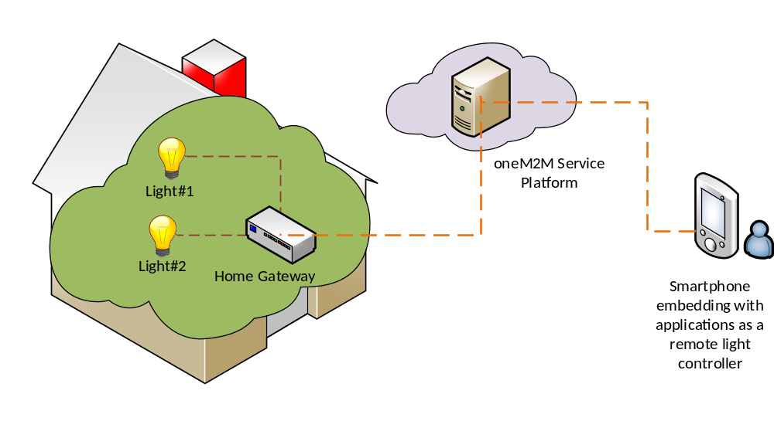
Figure 5.1: Overview of remote lights control use case

6 Architecture
This clause describes the architecture of the implemented use case with components represented by the oneM2M entity roles. For instance, a physical device can be modelled as an ADN-AE and the oneM2M service system can be modelled as an IN-CSE, etc.
The remote lights control use case shown in figure 5.1 can be mapped into the oneM2M functional architecture depicted in figure 6.1.
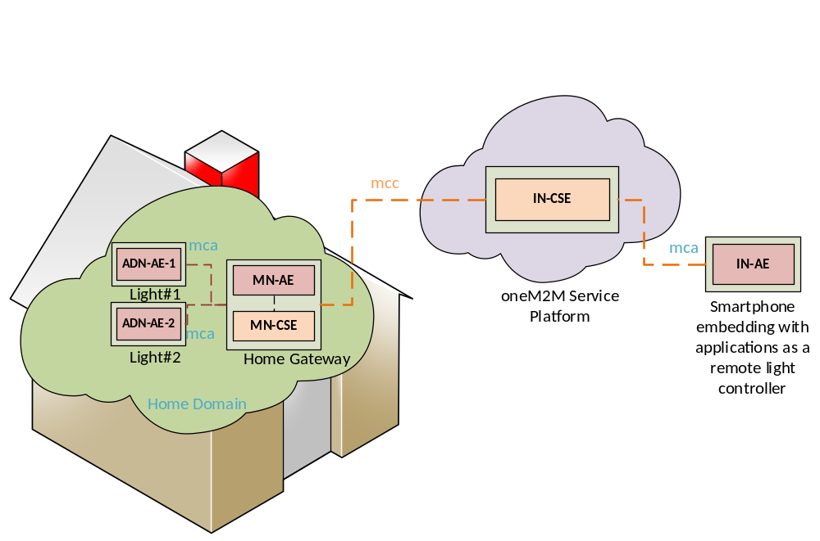
Figure 6.1: oneM2M functional architecture of remote lights control use case

In oneM2M functional architecture two entity roles are defined, one is AE and the other is CSE. Application dedicated devices e.g. light lamps are usually acted as an ADN-AE. Smartphone applications that are embedded into smartphone devices and able to communicate directly with oneM2M service platform can also be acted as an ADN-AE. oneM2M service system is acted as an IN-CSE and the home gateway plays a role of MN-CSE.
Two reference points, mca and mcc which are defined in the oneM2M functional architecture are used between AE and CSE and between two CSEs in the current use case, respectively. As figure 6.1 shows, the reference point used between any light application (ADN-AE-1 or ADN-AE-2) and home gateway MN-CSE is mca while that of between home gateway and oneM2M service platform is mcc.
In summary, applications used in the current use case are classified as follows:
- ADN-AE1: an application embedded in the light lamp Light#1 with capabilities to control light lamp Light#1 and interact with the home gateway MN-CSE through mca reference point;
- ADN-AE2: an application embedded in the light lamp Light#2 with capabilities to control light lamp Light#2 and interact with the home gateway MN-CSE through mca reference point;
- IN-AE: a smartphone application embedded in the smartphone device with capabilities to interact directly with the oneM2M service platform IN-CSE through mcc reference point and thereby remotely control light lamps Light#1 and Light#2;
- MN-AE: a gateway application embedded into the home gateway MN-CSE and interact with MN-CSE through mca reference point.

7 Procedures

7.1 Introduction
The deployment of oneM2M standard of present use case requires procedures that are classified as follows:
- Registration: The current procedure contains light lamps registration, gateway application registration, and accessControlPolicy resource creation for a selective access to data storage resources.
- Initial resource creation: The current procedure contains group resources creation, container resources creation with specific access control policies, content instance resources creation with initial light states, subscription resources creation for notifications.
- Discovery of container resource: all containers with a specific filter criteria can be discovered by the gateway application and provided as members of group resources.
- Discovery and retrieval lights states: all containers with a specific filter criteria could be discovered and retrieved using resource identities through a smartphone application which gains access to oneM2M service platform and content information could also be retrieved.
- Single light switch on/off: Any light that is discovered by and connected to the smartphone application is able to be switched on and off via a smartphone application.
- Multiple lights switch on/off: More than one lights that are discovered by and connected to the smartphone application are able to be switched on and off together via a smartphone application.

7.2 Call Flows

7.2.1 Application registration and Access control policy creation
Call flows regarding the registration phase depicted in figure 7.2.1-1 are ordered as follows:
- Gateway (MN-CSE) registers with the oneM2M service platform (IN-CSE).
- Gateway application (MN-AE) registers with the gateway (MN-CSE).
- Light applications (ADN-AE1 and ADN-AE2) register with the gateway (MN-CSE).
- Smartphone application (IN-AE) registers with the oneM2M service platform (IN-CSE) and then IN-CSE announces the smartphone application resource (IN-AE) to the gateway (MN-CSE).
- Gateway application (MN-AE) discovers the smartphone application (IN-AE) from gateway (MN-CSE) with specific filter criteria. The discovered IN-AE could be granted to access to the remote light control service containers.
- Gateway application (MN-AE) creates an accessControlPolicy resource granting all the entities playing roles in the current use case including ADN-AE1, ADN-AE2, MN-AE and IN-AE could access to the created container and content instance resources.
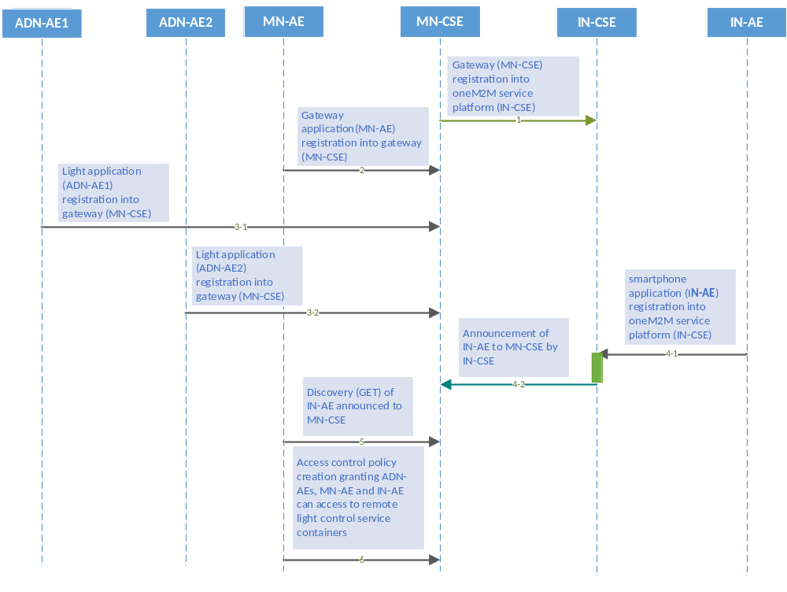
Figure 7.2.1-1: Registration phase call flows

7.2.2 Initial resource creation
Call flows regarding the initial resource creation phase depicted in figure 7.2.2-1 are ordered as follows:
- Gateway application (MN-AE) creates two group resources into gateway (MN-CSE), one for updating group light state named as group_for_light_state_update and the other one for retrieving group light state named as group_for_light_state_retrieval. The group members will be added from the list of discovered container resources through the discovery process initialized by MN-AE. These group resources are both created with the same access control policy.
- Two container resources are created in the gateway (MN-CSE) to store the light states under the registered light application ADN-AE1 and ADN-AE2, respectively. The containers are created using the same access control policy.
- Content Instance resources are created by light applications (ADN-AE1 and ADN-AE2) under each created container to represent the controlled light states.
- Subscription resource creation under the containers in the gateway (MN-CSE) so that subscribers i.e. light applications can be notified whenever there is new contentInstance is created by MN-AE or IN-AE.

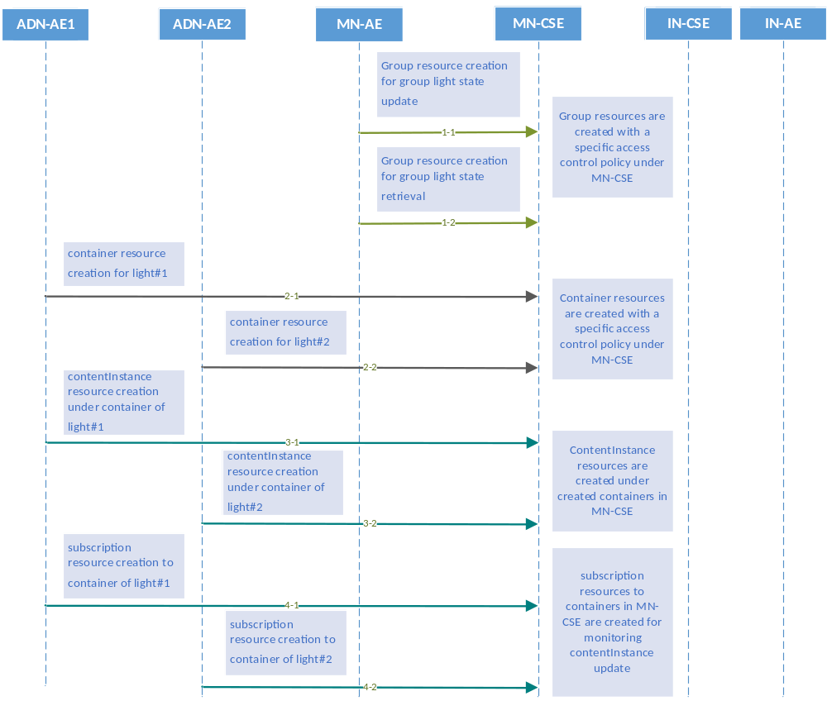
Figure 7.2.2-1: Initial resource creation phase call flows

7.2.3 Discovery of group resources
Call flows regarding the discovery and update of group resources phase depicted in figure 7.2.3-1 are ordered as follows:
- Gateway application (MN-AE) could periodically send a RETRIEVE request including the parameter filterUsage and specific filter criteria condition(s) as a query string for discovery of container resources stored in the MN-CSE of gateway. A group of filter criteria conditions for the discovery operation includes createdBefore, createdAfter, modifiedSince, unmodifiedSInce, label, creator, expireAfter, resourceType etc.
- Gateway (MN-CSE) responds with URIs of the discovered container resources, if any, to the gateway application (MN-AE) according to the filter criteria(s).
- Gateway application (MN-AE) could also send a POST request to update the list of the group members with the discovered containers providing URIs for contentInstance creation and latest contentInstance resource retrieval. The discovered member URIs are built in the previously created group resource group_for_light_state_update, and group_for_light_state_retrieval.
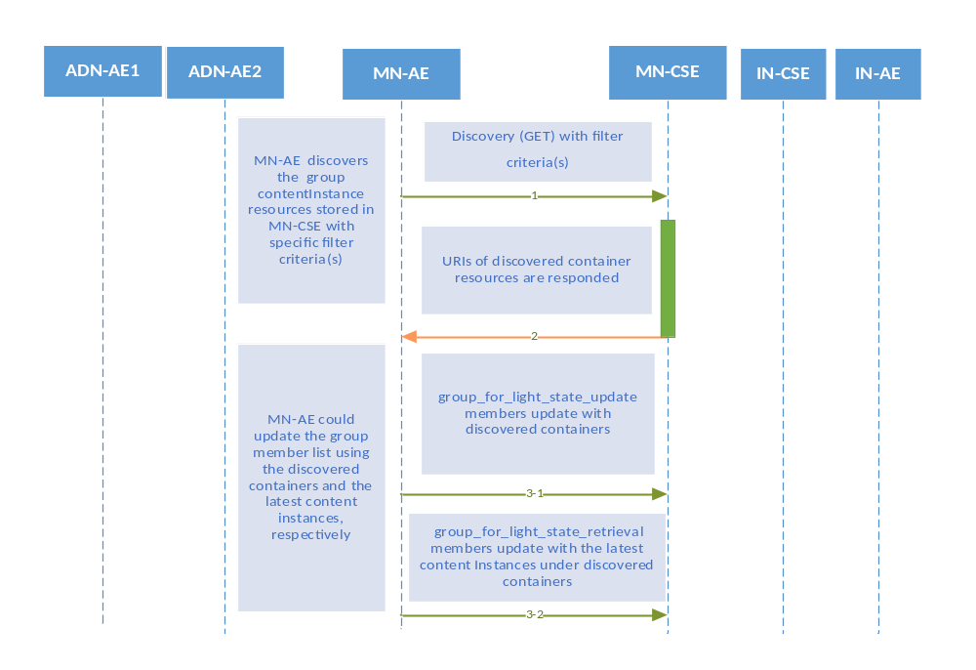
Figure 7.2.3-1: Discovery and group light state update phase call flows

7.2.4 Discovery and retrieval of contentInstance resources
Call flows regarding the discovery and retrieval of contentInstance resource phase depicted in figure 7.2.4-1 and 7.2.4-2 are ordered as follows:
- The smartphone application (IN-AE) periodically sends a RETRIEVE request including the parameter filterUsage and specific filter criteria condition(s) as a query string for discovery of container resources stored in the MN-CSE of gateway.
The IN-AE could also send a Discovery request to the MN-CSE for the discovery of the group resources located in the MN-CSE.
- The gateway (MN-CSE) responds IN-AE with URIs of the discovered container resources under ADN-AE1 and ADN-AE2, if any.
In the case that when IN-AE sends a Discovery request for the discovery of group resources, the MN-CSE responds IN-AE with the URIs of the discovered group resources located in the MN-CSE, if any.
- The IN-AE sends GET requests for retrieval of the latest contentInstance from each discovered single light container.
In the case of retrieval of a group of the latest content instance resource from the group group_for_light_state_retrieval, the IN-AE could send a fanOutPoint request to the discovered group URI of group_for_light_state_retrieval.
- The IN-AE is responded with the latest light state (s).
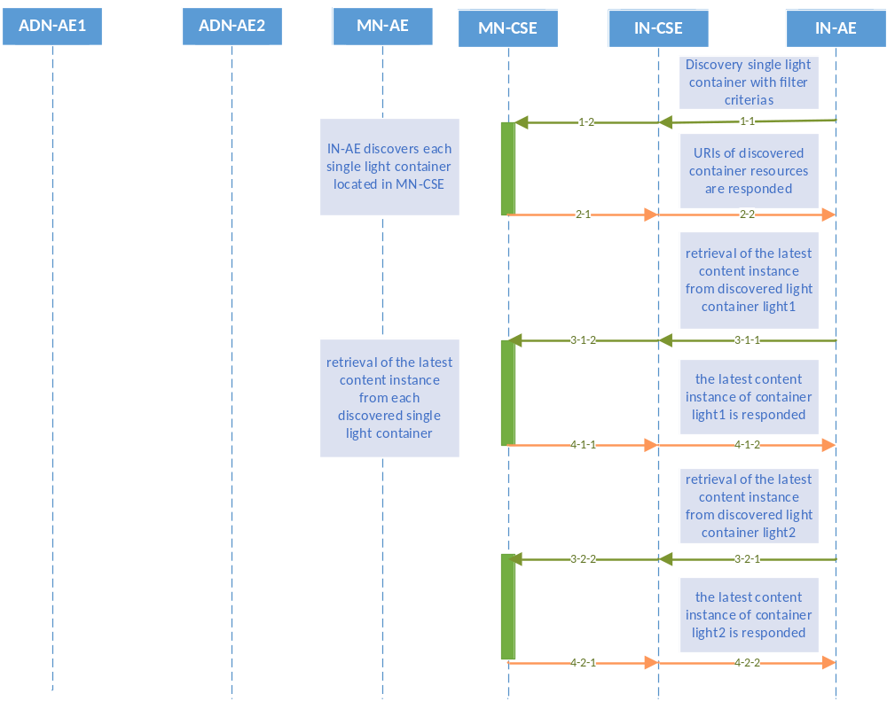
Figure 7.2.4-1: Discovery and single light retrieval phase call flows
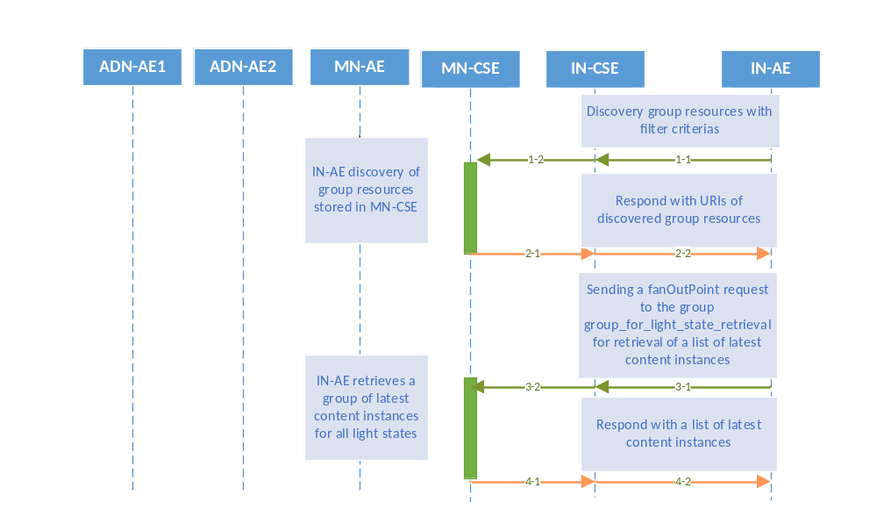
Figure 7.2.4-2 Discovery and a group of lights retrieval phase call flows

7.3 Remote control scenarios

7.3.1 Introduction
Light lamps are able to be controlled remotely through a smartphone embedded with an application gaining access to the oneM2M service platform especially when the smartphone and light bulbs are connected to different networks. Two scenarios are introduced in clauses 7.3.2 and 7.3.3.

7.3.2 Single light lamp control
Any single light lamp including Light#1 and Light#2 can be controlled remotely by a human user through a smartphone application (IN-AE). Call flows for single light lamp control depicted in figure 7.3.2-1 are ordered as follows:
- When the user updates the light lamp state on her/his smartphone, the IN-AE creates a new contentInstance representing a new light state under the targeted container of ADN-AE stored in the MN-CSE.
- If the contentInstance is created sucessfully, the MN-CSE sends a notification to the corresponsding ADN- AE.
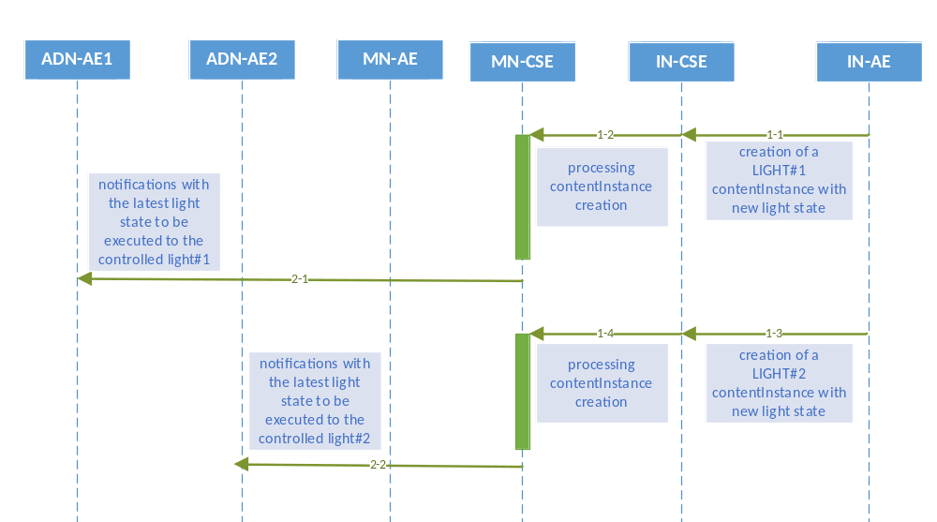
Figure 7.3.2-1: Single light remote control phase call flows

7.3.3 Multiple light lamps control
Multiple light lamps are enable to be controlled remotely at one time in order to facilitate the control process.
The light lamp remote control enable human users to control remotely multiple light lamps through a smartphone application (IN-AE) by sending a single light control command to the oneM2M service platform (IN-CSE). Call flows for multiple light lamps control depicted in figure 7.3.3-1 are ordered as follows:
- When the user updates a group of light lamp states on her/his smartphone, the IN-AE creates a group of new contentInstances representing a group of new light states under the targeted container stored in the MN-CSE.
- If the contentInstances are created sucessfully, the MN-CSE sends a group of notifications to the corresponsding each ADN-AEs.
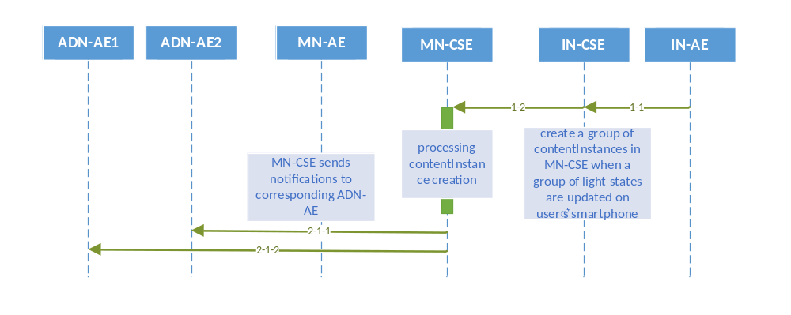
Figure 7.3.3-1: Multiple lights remote control phase call flows

8 Implementation

8.1 Introduction
Clasue 8 presents necessary procedures required for the implementation of the remote lights control use case, including assumption conditions met for the correct implementation of the current use case, and resource tree etc.

8.2 Assumptions
Assumptions are presented as below in order to ensure the remote lights control use case could be correctly implemented.
- All the applications are server capable;
- Devices and application entites are independently addressable with host names resolved by DNS network services;
- Host port number 8080 is reserved for oneM2M services;
- Security is not considered in the current use case;
- HTTP binding of oneM2M primitives is used in the current use case;
- XML serialization of oneM2M primitives is used in the current use case;
- All mandatory HTTP headers are presented in the HTTP requests while optional headers are selectively used in the current use case;
- All mandatory resource attributes for resources presented in the current use case are presented in the HTTP requests while optional resource attributes are selectively used in the current use case;
- The IN-CSE and MN-CSE participated in the current use case are deployed within the same oneM2M Service Provider domain;
- All AEs participated in the current use case are initially registered with CSEs and the identifier of the AEs are assigned by the Registrar CSE of the AE accordinlgy, starting with a character of ‘C’;
- All resources created in the current use case could be addressable with the oneM2M Resource Identifier form of Hierarchical address;
- Short names for the representation of the resources and attributes are used in the current use case;
- Default access control policy has already created under IN-CSE and it is used for MN-CSE registration with IN-CSE;
- All request originators send Blocking Requests for accessing resources located in CSEs.

8.3 Addressing for Entities
Each oneM2M entity including.AE and CSE could be addressable with correct host address that can be IP addresses or FQDN addresses resolved to IP addresses by DNS network services according to addressing rules specified in oneM2M standards.
All the entities presented in the current use case could be addressable with the following URIs.
- IN-CSE: /in-cse
- MN-CSE: /mn-cse
where the in-cse is SP-relative-CSE-ID of IN-CSE and the mn-cse is SP-relative-CSE-ID of the MN-CSE.

8.4 Modelling for Light State Data
The light state ON or OFF stored as the content of content instance resource is modelled as string inside the XML representation of the content instance resources, for example, <content>ON</content> or <content>OFF</content>, respectively.

8.5 Resource Structure
The development of an oneM2M application includes the design of the resource trees of service capability layers i.e. IN-CSE and MN-CSE in the current use case. The resource tree is constructed with child resources created according to the high level procedures presented in oneM2M application developer guide clause 7. All the child resources shown in the resource trees are mandatorily required in order to correctly implement the remote lights control use case.

8.5.1 Resource Structure of IN-CSE
The resource tree of IN-CSE starts with a CSEBase named in-cse depicted in figure 8.5.1-1.
The root CSEBase is composed of two direct child resources, a remoteCSE named mn-cse and an AE named in-ae. The sub-resources of mn-cse will be introduced in clause 8.5.2.
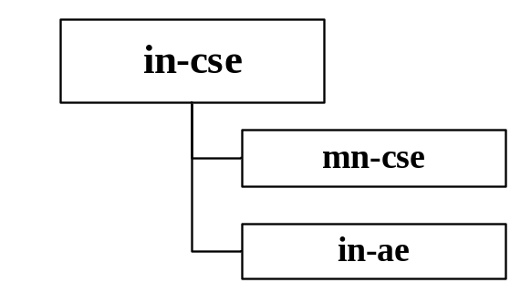
Figure 8.5.1-1: IN-CSE resource structure

8.5.2 Resource Structure of MN-CSE
The resource tree of MN-CSE starts with a remoteCSE named mn-cse depicted in figure 8.5.2-1.
The resource tree of MN-CSE is constructed with child resources as following:
- an accessControlPolicy named acp1,
- an ADN-AE named adn-ae1 which contains sub-resources of a container named light1 and multiple contentInstances,
- an ADN-AE named adn-ae2 which contains sub-resources of a container named light2 and multiple contentInstances,
- a MN-AE named mn-ae which contains two group resources,
- subscription resources presented as child resource of container light1 and light2, respectively, and
- two group resources named group1 and group2 are created with members of the containers created in MN-CSE and the latest content instances in all containers (i.e. container light1 and light2), respectively. Smartphone application users with granted access policy can send fanOutPoint requests containing created new content instances in order to update all the light states. All the latest light states can also be retrieved by sending a GET request to the group group2.
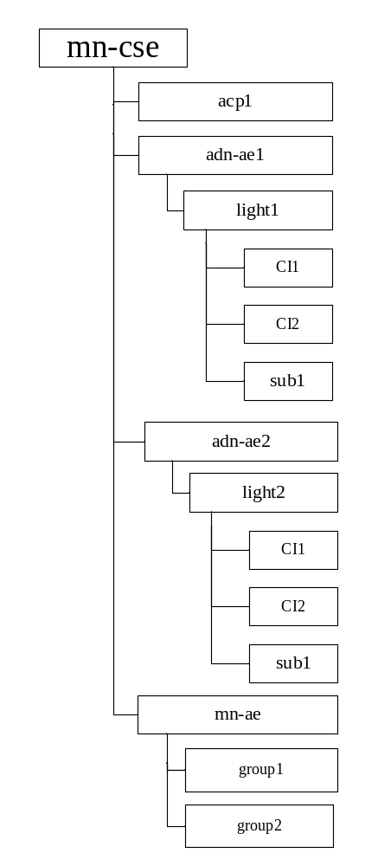
Figure 8.5.2-1: MN-CSE resource tree

8.6 Role of Entities

8.6.1 oneM2M service platform (IN-CSE)
The oneM2M service platform is modelled as an IN-CSE with representation of a root CSEBase resource in-cse. The CSEBase in-cse is responsible for
- handling the registration requests from smartphone application in-ae and home gateway mn-cse, respectively, and
- announcing in-ae to the remoteCSE mn-cse.

8.6.2 Home gateway application (MN-AE)
The home gateway application is modelled as a MN-AE which charges to
- initialize the home gateway device,
- create access control policy resource acp1 in the MN-CSE,
- register the home gateway application with MN-CSE,
- create the group resources with access control policy acp1 in the MN-CSE,
- discover device applications registered with the MN-CSE and group member resources located in the MN-CSE, and
- display all lights’ states.

8.6.3 Light applications (ADN-AE1 and ADN-AE2)
Both the light applications are modelled as ADN-AE which charges to
- initialize the light control device,
- register the light devices with MN-CSE,
- create container resources light1 and light2 with access control policy acp1, respectively,
- create subscription resources sub1 and sub2 under container light1 and light2, respectively, and
- create content instance resources under container light1 and light2 with initial light state, respectively.

8.6.4 Smartphone application (IN-AE)
The smartphone application is modelled as a IN-AE, which could directly communicate with oneM2M service platform IN-CSE and charges to
- initialize the smartphone light control application,
- register the smartphone application with IN-CSE,
- discover the containers light1 and light2,
- display the discovered light states,
- accept the light state modification commands from the smartphone application user,
- execute the light state modification commands for single and multiple lights.

8.7 Implementation Procedures

8.7.1 Introduction
The implementation procedures used in the current use case are mapped into HTTP Binding and XML serialization of oneM2M primitives according to the standard APIs describing the references points mca and mcc, as defined in oneM2M TS-0001 [i.2], oneM2M TS-0004 [i.3], the HTTP binding TS-0009 [i.4].
In addition, short name for the representation of the resources and attributes are used in the implementation procedures.

8.7.2 MN-CSE registration
The implementation procedure starts with the registration of MN-CSE with IN-CSE following procedure as below.
HTTP Request:

POST /~/in-cse/server?rcn=0 HTTP/1.1
Host: http://in.provider.com:8080
X-M2M-Origin: /mn-cse
Content-Type: application/vnd.onem2m-res+xml;ty=16
X-M2M-RI: incse/88643
<?xml version="1.0" encoding="UTF-8"?>
<m2m:csr xmlns:m2m="http://www.onem2m.org/xml/protocols" rn=”home_gateway”>
<csi>mn-cse</csi>
<cb>mn.provider.com/mn-cse</cb>
<rr>TRUE</rr>
<poa>http://mn.provider.com:8080</poa>
<cst>2</cst>
<acpi>/in-cse/acp-666957710</acpi>
</m2m:csr>

HTTP Response:

201 Created
X-M2M-RSC: 2001
X-M2M-RI: incse/88643
Content-Location: /in-cse/csr-299409504

8.7.3 Access control policy creation
When user creates the access control policy resource, user has to clearly specify the name of accessControlOriginator in acor field and the granted operations for the access control originator in the acop field.
The value of acop is set to 63 which indicates that the specified originator is granted to conduct CREATE, RETRIEVE, UPDATE, DELETE, DISCOVERY,and NOTIFY operations.
The creation of access control policy resource acp1 in MN-CSE could be implemented following procedure as below.
HTTP Request:

POST /~/mn-cse/home_gateway?rcn=0 HTTP/1.1
Host: http://mn.provider.com:8080
X-M2M-Origin: /mn-cse/Cgateway_ae
Content-Type: application/vnd.onem2m-res+xml;ty=1
X-M2M-RI: mncse/62948

<m2m:acp xmlns:m2m="http://www.onem2m.org/xml/protocols" rn=”gateway_acp”>

<pv>
<acr>
<acor>/in-cse/home_gateway /mn-cse/Cgateway_ae /mn-cse/Clight_ae1 /mn-cse/Clight_ae2 /in-cse/Csmartphone_ae</acor>
<acop>63</acop>
</acr>
</pv>
<pvs>
<acr>
<acor>/in-cse/home_gateway /mn-cse/Cgateway_ae /mn-cse/Clight_ae1 /mn-cse/Clight_ae2 /in-cse/Csmartphone_ae</acor>
<acop>51</acop>
</acr>
</pvs>
</m2m:acp>

HTTP Response:

201 Created
X-M2M-RSC: 2001
X-M2M-RI: mncse/62948
Content-Location: /mn-cse/acp-805496226

The access control policy resource can be used to grant those applications that are registered with MN-CSE the access rights to conduct specific operations and access to specific resources. The list of applications could be obtained with a discovery procedure using filter criteria conditions. For more details about the discovery procedure, please go to clause 8.7.9. Here it is required that the list of applications registered with MN-CSE before creating the access control policy resource has already been discovered.

8.7.4 Application entities registration

8.7.4.1 Light application ADN-AE1
The registration of ADN-AE1 with MN-CSE could be implemented following procedure as below. Note that the access control policy Identifier (unstructured CSE-relative resourceID) which is assigned to ADN-AE1 is /mn-cse/acp-805496226.
HTTP Request:

POST /~/mn-cse/home_gateway?rcn=0 HTTP/1.1
Host: http://mn.provider.com:8080
X-M2M-Origin: /C
Content-Type: application/vnd.onem2m-res+xml;ty=2
X-M2M-RI: mncse/92345
<?xml version="1.0" encoding="UTF-8"?>
<m2m:ae xmlns:m2m="http://www.onem2m.org/xml/protocols" rn=”light_ae1”>
<api>A01.com.company.lightApp1</api>
<rr>TRUE</rr>
<poa>http://192.168.0.10:9090</poa>
<acpi>/mn-cse/acp-805496226</acpi>
</m2m:ae>

HTTP Response:

201 Created
X-M2M-RSC: 2001
X-M2M-RI: mncse/92345
Content-Location: /mn-cse/ae-CAE340304071

8.7.4.2 Light application ADN-AE2
The registration of ADN-AE2 with MN-CSE could be implemented following procedure as below. Note that the access control policy Identifier (unstructured CSE-relative resourceID) which is assigned to ADN-AE2 is /mn-cse/acp-805496226.
HTTP Request:

POST /~/mn-cse/home_gateway?rcn=0 HTTP/1.1
Host: http://mn.provider.com:8080
X-M2M-Origin: /C
Content-Type: application/vnd.onem2m-res+xml;ty=2
X-M2M-RI: mncse/18346
<?xml version="1.0" encoding="UTF-8"?>
<m2m:ae xmlns:m2m="http://www.onem2m.org/xml/protocols" rn=”light_ae2”>
<api>A01.com.company.lightApp2</api>
<rr>TRUE</rr>
<poa>http://192.168.0.20:9090</poa>
<acpi>/mn-cse/acp-805496226</acpi>
</m2m:ae>

HTTP Response:

201 Created
X-M2M-RSC: 2001
X-M2M-RI: mncse/18346
Content-Location: /mn-cse/ae-CAE340304042

8.7.4.3 Home gateway application MN-AE
The registration of MN-AE with MN-CSE could be implemented following procedure as below. Note that the access control policy Identifier (unstructured CSE-relative resourceID) which is assigned to MN-AE is /mn-cse/acp-805496226.
HTTP Request:

POST /~/mn-cse/home_gateway?rcn=0 HTTP/1.1
Host: http://mn.provider.com:8080
X-M2M-Origin: /C
Content-Type: application/vnd.onem2m-res+xml;ty=2
X-M2M-RI: mncse/19347

<?xml version="1.0" encoding="UTF-8"?>
<m2m:ae xmlns:m2m="http://www.onem2m.org/xml/protocols" rn=”gateway_ae”>
<api>A01.com.company.gatewayApp</api>
<rr>FALSE</rr>
<acpi>/mn-cse/acp-805496226</acpi>
</m2m:ae>

HTTP Response:

201 Created
X-M2M-RSC: 2001
X-M2M-RI: mncse/19347
Content-Location: /mn-cse/ae-CAE340303271

8.7.4.4 Smartphone application IN-AE
The registration of IN-AE with IN-CSE could be implemented following procedure as below. Note that the access control policy Identifier (unstructured CSE-relative resourceID) which is assigned to IN-AE is /in-cse/acp-666957710.
HTTP Request:

POST /~/in-cse/server?rcn=0 HTTP/1.1
Host: http://mn.provider.com:8080
X-M2M-Origin: /C
Content-Type: application/vnd.onem2m-res+xml;ty=2
X-M2M-RI: incse/16346
<?xml version="1.0" encoding="UTF-8"?>
<m2m:ae xmlns:m2m="http://www.onem2m.org/xml/protocols" rn=”smartphone_ae”>
<api>A01.com.company.lightControlApp</api>
<rr>FALSE</rr>
<acpi>/in-cse/acp-666957710</acpi>
</m2m:ae>

HTTP Response:

201 Created
X-M2M-RSC: 2001
X-M2M-RI: incse/16346
Content-Location: /in-cse/ae-CAE340304178

8.7.5 Containers creation

8.7.5.1 Create a container of ADN-AE1
The creation of container resource for ADN-AE1 could be implemented following procedure as below.
HTTP Request:

POST /~/mn-cse/home_gateway/light_ae1?rcn=0 HTTP/1.1
Host: http://mn.provider.com:8080
X-M2M-Origin: /mn-cse/Clight_ae1
Content-Type: application/vnd.onem2m-res+xml;ty=3
X-M2M-RI: mncse/13345
<m2m:cnt xmlns:m2m="http://www.onem2m.org/xml/protocols" rn=”light”>
</m2m:cnt>

HTTP Response:

201 Created
X-M2M-RSC: 2001
X-M2M-RI: mncse/13345
Content-Location: /mn-cse/cnt-582759912

8.7.5.2 Create a container of ADN-AE2
The creation of container resource for ADN-AE2 could be implemented following procedure as below.
HTTP Request:

POST /~/mn-cse/home_gateway/light_ae2?rcn=0 HTTP/1.1
Host: http://mn.provider.com:8080
X-M2M-Origin: /mn-cse/Clight_ae2
Content-Type: application/vnd.onem2m-res+xml;ty=3
X-M2M-RI: mncse/62345
<m2m:cnt xmlns:m2m="http://www.onem2m.org/xml/protocols" rn=”light”>
</m2m:cnt>

HTTP Response:

201 Created
X-M2M-RSC: 2001
X-M2M-RI: mncse/62345
Content-Location: /mn-cse/cnt-582769893

8.7.6 ContentInstances creation

8.7.6.1 Create a content instance of ADN-AE1
The creation of content instance resource under container of ADN-AE1 with initial content OFF could be implemented following procedure as below.
HTTP Request:

POST /~/mn-cse/home_gateway/light_ae1/light?rcn=0 HTTP/1.1
Host: http://mn.provider.com:8080
X-M2M-Origin: /mn-cse/Clight_ae1
Content-Type: application/vnd.onem2m-res+xml;ty=4
X-M2M-RI: mncse/24345

<m2m:cin xmlns:m2m="http://www.onem2m.org/xml/protocols">
<con>OFF</con>
<cnf>text/plain:0</cnf>
</m2m:cin>

HTTP Response:

201 Created
X-M2M-RSC: 2001
X-M2M-RI: mncse/24345
Content-Location: /mn-cse/cin-394798749
Content-Type: application/vnd.onem2m-res+xml

8.7.6.2 Create a content instance of ADN-AE2
The creation of content instance resource under container of ADN-AE2 with initial content OFF could be implemented following procedure as below.
HTTP Request:

POST /~/mn-cse/home_gateway/light_ae2/light?rcn=0 HTTP/1.1
Host: http://mn.provider.com:8080
X-M2M-Origin: /mn-cse/Clight_ae1
Content-Type: application/vnd.onem2m-res+xml;ty=4
X-M2M-RI: mncse/22345

<m2m:cin xmlns:m2m="http://www.onem2m.org/xml/protocols">
<con>OFF</con>
<cnf>text/plain:0</cnf>
</m2m:cin>

HTTP Response:

201 Created
X-M2M-RSC: 2001
X-M2M-RI: mncse/22345
Content-Location: /mn-cse/cin-256599578

8.7.7 Groups creation

8.7.7.1 Create a group for updating all light states
The creation of group resource group1 in MN-AE could be implemented following procedure as below. The group resource is created with two initial member id 0 and 1.
HTTP Request:

POST /~/mn-cse/home_gateway/gateway_ae?rcn=0 HTTP/1.1
Host: http://mn.provider.com:8080
X-M2M-Origin: /mn-cse/Cgateway_ae
Content-Type: application/vnd.onem2m-res+xml;ty=9
X-M2M-RI: mncse/76905
<?xml version="1.0" encoding="UTF-8"?>
<m2m:grp xmlns:m2m="http://www.onem2m.org/xml/protocols" rn=”containers_grp”>
<mt>3</mt>
<mid>/mn-cse/cnt-582759912 /mn-cse/cnt-582769893</mid>
<mnm>10</mnm>
</m2m:grp>

HTTP Response:

201 Created
X-M2M-RSC: 2001
X-M2M-RI: mncse/76905
Content-Location: /mn-cse/grp-977978327

8.7.7.2 Create a group for retrieval of all latest light states
The creation of group resource group2 in MN-AE could be implemented following procedure as below. The group resource is created with two initial member id 0 and 1.
HTTP Request:

POST /~/mn-cse/home_gateway/gateway_ae?rcn=0 HTTP/1.1
Host: http://mn.provider.com:8080
X-M2M-Origin: /mn-cse/Cgateway_ae
Content-Type: application/vnd.onem2m-res+xml;ty=9
X-M2M-RI: mncse/12980
<?xml version="1.0" encoding="UTF-8"?>
<m2m:grp xmlns:m2m="http://www.onem2m.org/xml/protocols" rn=”lightstates_grp”>
<mt>4</mt>
<mid>/mn-cse/cnt-582759912/la /mn-cse/cnt-582769893/la</mid>
<mnm>10</mnm>
</m2m:grp>

HTTP Response:

201 Created
X-M2M-RSC: 2001
X-M2M-RI: mncse/12980
Content-Location: /mn-cse/grp-677974227

8.7.8 Subscriptions creation

8.7.8.1 Subscription to the content instance of ADN-AE1
When user creates a subscription resource, parameter notification content type (short for nct) is set to value 1 to indicate that all attributes of the subscribed resource will be notified to the subscriber.
ADN-AE1 creates a subscription resource including the notification URI set to the resource identifier of ADN-AE1 so that the ADN-AE1 could get notified whenever there are changes to the content instance of container in ADN-AE1 following procedures as below.
HTTP Request:

POST /~/mn-cse/home_gateway/light_ae1/light?rcn=0 HTTP/1.1
Host: http://mn.provider.com:8080
X-M2M-Origin: /mn-cse/Clight_ae1
Content-Type: application/vnd.onem2m-res+xml;ty=23
X-M2M-RI: mncse/67891

<?xml version="1.0" encoding="UTF-8"?>
<m2m:sub xmlns:m2m="http://www.onem2m.org/xml/protocols" rn=”lightstate_sub1”>
<enc>
<net>3</net>
</enc>
<nu>/mn-cse/ae-CAE340304071</nu>
<nct>1</nct>
</m2m:sub>

HTTP Response:

201 Created
X-M2M-RSC: 2001
X-M2M-RI: mncse/67891
Content-Location: /mn-cse/sub-856593979

8.7.8.2 Subscription to the content instance of ADN-AE2
When user creates a subscription resource, parameter notification content type (short for nct) is set to value 1 to indicate that all attributes of the subscribed resource will be notified to the subscriber.
ADN-AE2 creates a subscription resource including the notification URI set to the resource identifier of ADN-AE2 so that the ADN-AE2 could get notified whenever there are changes to the content instance of container in ADN-AE2 following procedures as below.
HTTP Request:

POST /~/mn-cse/home_gateway/light_ae2/light?rcn=0 HTTP/1.1
Host: http://mn.provider.com:8080
X-M2M-Origin: /mn-cse/Clight_ae2
Content-Type: application/vnd.onem2m-res+xml;ty=23
X-M2M-RI: mncse/29387

<?xml version="1.0" encoding="UTF-8"?>
<m2m:sub xmlns:m2m="http://www.onem2m.org/xml/protocols" rn=”lightstate_sub2”>
<enc>
<net>3</net>
</enc>
<nu>/mn-cse/ae-CAE340304042</nu>
<nct>1</nct>
</m2m:sub>

HTTP Response:

201 Created
X-M2M-RSC: 2001
X-M2M-RI: mncse/29387
Content-Location: /mn-cse/sub-856463728

8.7.9 Discovery

8.7.9.1 Introduction
The discovery functionality in oneM2M service platform could be implemented using RETRIEVE operation along with one or multiple filter criteria parameters.
In order to enable the retrieve operation for resource discovery, parameter filterUsage (short for fu) has to be presented in the RETRIEVE request as a query string.
In addition, parameter resource type (short for rty) could be used as filterCriteria condition for the discovery of single light and group light members. The parameter discovery result type (short for drt) is set to 2 to indicate that the format of elements of URIList is unstructured. The detailed discovery procedures are presented in clauses 8.7.9.2 and 8.7.9.3.

8.7.9.2 Discovery of single light registered with MN-CSE
The discovery of single light registered with MN-CSE could be implemented by in-ae following procedures as below.
HTTP Request:

GET /~/mn-cse/home_gateway?fu=1&rty=3&drt=2 HTTP/1.1
Host: http://in.provider.com:8080
X-M2M-Origin: /in-cse/Csmartphone_ae
X-M2M-RI: mncse/99882
Accept: application/xml

HTTP Response:

200 OK
X-M2M-RSC: 2000
X-M2M-RI: mncse/99882
Content-Type: application/xml

<?xml version="1.0" encoding="UTF-8"?>
<m2m:uril xmlns:m2m="http://www.onem2m.org/xml/protocols">
/mn-cse/cnt-582759912
/mn-cse/cnt-582769893
</m2m:uril>

User using smartphone application can retrieve a list of URIs representing containers registered with MN-CSE from the response message, e.g. /mn-cse/cnt-582759912 which is the URI of container created in ADN-AE1. The retrieved URIs of the discovered containers could be used for the group member update operations.

8.7.9.3 Discovery of groups located in MN-CSE
The discovery of groups located in MN-CSE could be implemented by in-ae following procedures as below.
HTTP Request:

GET /~/mn-cse/home_gateway?fu=1&rty=9&drt=2 HTTP/1.1
Host: http://in.provider.com:8080
X-M2M-Origin: /in-cse/Csmartphone_ae
X-M2M-RI: mncse/15001
Accept: application/xml
HTTP Response:

200 OK
X-M2M-RSC: 2000
X-M2M-RI: mncse/15001
Content-Type: application/xml

<?xml version="1.0" encoding="UTF-8"?>
<m2m:uril xmlns:m2m="http://www.onem2m.org/xml/protocols">
/mn-cse/grp-977978327
/mn-cse/grp-677974227
</m2m:uril>

User using smartphone application can retrieve a list of URIs representing group resources located in MN-CSE from the response message, e.g. /mn-cse/grp-977978327 which is the URI of group group1. The retrieved URIs of the discovered group resource could also be used for the group member update operations.

8.7.10 Latest content instances retrieval

8.7.10.1 Introduction
User could retrieve the latest light states via sending a latest content instance RETRIEVE request attached with a virtual resource latest (short for la).
User could also retrieve a group of latest light states via sending a group RETRIEVE request attached with a virtual resource fanOutPoint (short for fopt).

8.7.10.2 Retrieve the latest content instance of ADN-AE1
The latest content instance of container light in ADN-AE1 could be retrieved following procedures as below.
HTTP Request:

GET /~/mn-cse/home_gateway/light_ae1/light/la HTTP/1.1
Host: http://in.provider.com:8080
X-M2M-Origin: /in-cse/Csmartphone_ae
X-M2M-RI: mncse/11223
Accept: application/xml

HTTP Response:

200 OK
X-M2M-RSC: 2000
X-M2M-RI: mncse/11223
Content-Type: application/vnd.onem2m-res+xml

<?xml version="1.0" encoding="UTF-8"?>
<m2m:cin
xmlns:m2m="http://www.onem2m.org/xml/protocols" rn="cin-394798749">
<ty>4</ty>
<ri>cin-394798749</ri>
<pi>cnt-181049109</pi>
<ct>20150925T045938</ct>
<lt>20150925T045938</lt>
<et>20151107T154802</et>
<st>0</st>
<cnf>text/plain:0</cnf>
<cs>3</cs>
<con>OFF</con>
</m2m:cin>

8.7.10.3 Retrieve the latest content instance of ADN-AE2
The latest content instance of container light in ADN-AE2 could be retrieved following procedures as below.
HTTP Request:

GET /~/mn-cse/home_gateway/light_ae2/light/la HTTP/1.1
Host: http://mn.provider.com:8080
X-M2M-Origin: /in-cse/Csmartphone_ae
X-M2M-RI: mncse/22336
Accept: application/xml

HTTP Response:

200 OK
X-M2M-RSC: 2000
X-M2M-RI: mncse/22336
Content-Type: application/vnd.onem2m-res+xml

<?xml version="1.0" encoding="UTF-8"?>
<m2m:cin
xmlns:m2m="http://www.onem2m.org/xml/protocols" rn="cin-256599578">
<ty>4</ty>
<ri>cin-256599578</ri>
<pi>cnt-790965889</pi>
<ct>20150925T050515</ct>
<lt>20150925T050515</lt>
<et>20151107T154802</et>
<st>0</st>
<cnf>text/plain:0</cnf>
<cs>3</cs>
<con>OFF</con>
</m2m:cin>

8.7.10.4 Retrieve a group of latest content instances for all light states
A group of latest content instances could be achieved via sending a group RETRIEVE request following procedures as below.
HTTP Request:

GET /~/mn-cse/home_gateway/gateway_ae/lightstates_grp/fopt HTTP/1.1
Host: http://in.provider.com:8080
X-M2M-Origin: /in-cse/Csmartphone_ae
X-M2M-RI: mncse/55667
Accept: application/xml

HTTP Response:

200 OK
X-M2M-RSC: 2000
X-M2M-RI: mncse/55667
Content-Type: application/xml

<?xml version="1.0" encoding="UTF-8"?>
<m2m:agr
xmlns:m2m="http://www.onem2m.org/xml/protocols">
<m2m:rsp>
<rsc>2000</rsc>
<pc>
<m2m:cin rn="cin-394798749">
<ty>4</ty>
<ri>cin-394798749</ri>
<pi>cnt-181049109</pi>
<ct>20150925T045938</ct>
<lt>20150925T045938</lt>
<et>20151107T154802</et>
<st>0</st>
<cnf>text/plain:0</cnf>
<cs>3</cs>
<con>OFF</con>
</m2m:cin>
</pc>
<to>/in-cse/ae-CAE340304178</to>
<fr>/mn-cse/cnt-582759912/la</fr>
</m2m:rsp>
<m2m:rsp>
<rsc>2000</rsc>
<pc>
<m2m:cin rn="cin-256599578">
<ty>4</ty>
<ri>cin-256599578</ri>
<pi>cnt-790965889</pi>
<ct>20150925T050515</ct>
<lt>20150925T050515</lt>
<et>20151107T154802</et>
<st>0</st>
<cnf>text/plain:0</cnf>
<cs>3</cs>
<con>OFF</con>
</m2m:cin>
</pc>
<to>/in-cse/ae-CAE340304178</to>
<fr>/mn-cse/cnt-582769893/la</fr>
</m2m:rsp>
</m2m:agr>

8.7.11 Light state modification

8.7.11.1 Introduction
Once the smartphone application in-ae is registered with IN-CSE, the in-ae could be granted for accessing resources including containers located in IN-CSE so that smartphone application users could send light control commands for modifying the light states.
When smartphone application user makes a change on the light state via the smartphone user interface, the in-ae performs a new content instance creation procedure carrying the new state.
The modification of single light state could be implemented by creating a new content instance resource for the specific container with access control policy acp1 (gateway_acp) while the modification of all light states could be implemented by creating a new content instance resource for each member of group (lightstates_grp) with access control policy acp1 (gateway_acp). The implementation of the latter case is to create a <fanOutPoint> resource with the content of new content instance resource for the group1 lightstates_grp so that the content of all members of the group1 could be updated together.

8.7.11.2 Create a content instance under container of ADN-AE1
HTTP Request:

POST /~/mn-cse/home_gateway/light_ae1/light?rcn=0 HTTP/1.1
Host: http://mn.provider.com:8080
X-M2M-Origin: /in-cse/Csmartphone_ae
Content-Type: application/vnd.onem2m-res+xml;ty=4
X-M2M-RI: mncse/11123

<m2m:cin xmlns:m2m="http://www.onem2m.org/xml/protocols">
<con>ON</con>
<cnf>text/plain:0</cnf>
</m2m:cin>
HTTP Response:

201 Created
X-M2M-RSC: 2001
X-M2M-RI: mncse/11123
Content-Location: /mn-cse/cin-789356234

8.7.11.3 Create a content instance under container of ADN-AE2
HTTP Request:

POST /~/mn-cse/home_gateway/light_ae2/light?rcn=0 HTTP/1.1
Host: http://mn.provider.com:8080
X-M2M-Origin: /in-cse/Csmartphone_ae
Content-Type: application/vnd.onem2m-res+xml;ty=4
X-M2M-RI: mncse/12222

<m2m:cin xmlns:m2m="http://www.onem2m.org/xml/protocols">
<con>ON</con>
<cnf>text/plain:0</cnf>
</m2m:cin>
HTTP Response:

201 Created
X-M2M-RSC: 2001
X-M2M-RI: mncse/12222
Content-Location: /mn-cse/cin-237896783

8.7.11.4 Update the state of all lights using group fanout
HTTP Request:

POST /~/mn-cse/home_gateway/gateway_ae/lightstates_grp/fopt HTTP/1.1
Host: http://mn.provider.com:8080
X-M2M-Origin: /in-cse/Csmartphone_ae
Content-Type: application/vnd.onem2m-res+xml
X-M2M-RI: mncse/33344

<?xml version="1.0" encoding="UTF-8"?>
<m2m:cin xmlns:m2m="http://www.onem2m.org/xml/protocols">
<con>ON</con>
<cnf>text/plain:0</cnf>
</m2m:cin>

HTTP Response:

200 OK
X-M2M-RSC: 2000
X-M2M-RI: mncse/33344
Content-Type: application/xml

<?xml version="1.0" encoding="UTF-8"?>
<m2m:agr
xmlns:m2m="http://www.onem2m.org/xml/protocols">
<m2m:rsp>
<rsc>2001</rsc>
<rqi>ae/33344</rqi>
<pc/>
<to>/in-cse/ae-CAE340304178</to>
<fr>/mn-cse/cnt-582759912</fr>
</m2m:rsp>
<m2m:rsp>
<rsc>2001</rsc>
<rqi>ae/33344</rqi>
<pc/>
<to>/in-cse/ae-CAE340304178</to>
<fr>/mn-cse/cnt-582769893</fr>
</m2m:rsp>
</m2m:agr>

8.7.12 Notifications

8.7.12.1 Introduction
Each time a content instance is created under container of ADN-AE, then a latest notification containing the whole created content instance is posted to the targeted subscriber i.e. AE application adn-ae1 or adn-ae2, that can actuate into the light the new state received as notification, respectively.

8.7.12.2 Post a notification to ADN-AE1
HTTP Request:

POST / HTTP/1.1
Host: http://192.168.0.10:9090
X-M2M-Origin: /mn-cse
X-M2M-RI: notif/12345
Content-Type: application/vnd.onem2m-ntfy+xml

<?xml version="1.0" encoding="UTF-8"?>
<m2m:sgn
xmlns:m2m="http://www.onem2m.org/xml/protocols">
<nev>
<rep>
<cin>
<con>ON</con>
<cnf>text/plain:0</cnf>
</cin>
<rss>201</rss>
</rep>
</nev>
<sur>
/mn-cse/sub-856593979
</sur>
</m2m:sgn>

HTTP Response:

200 OK
X-M2M-RSC: 2000
X-M2M-RI: notif/12345

8.7.12.3 Post a notification to ADN-AE2
HTTP Request:

POST / HTTP/1.1
Host: http://192.168.0.20:9090
X-M2M-Origin: /mn-cse
X-M2M-RI: notif/12346
Content-Type: application/vnd.onem2m-ntfy+xml

<?xml version="1.0" encoding="UTF-8"?>
<m2m:sgn
xmlns:m2m="http://www.onem2m.org/xml/protocols">
<nev>
<rep>
<cin>
<con>ON</con>
<cnf>text/plain:0</cnf>
</cin>
<rss>201</rss>
</rep>
</nev>
<sur>
/mn-cse/sub-856463728
</sur>
</m2m:sgn>

HTTP Response:

200 OK
X-M2M-RSC: 2000
X-M2M-RI: notif/12346

9 Conclusion
A remote light control use case is proposed to control remotely light lamps using smartphone application which is granted to access the oneM2M service platform resources. The current use case is done by following the high level procedures such as registration of smart devices, gateway with the oneM2M service platform, container and content instances creation, group resource creation, content instance retrieveal, content instances subscription and notifications etc.
The practice of current remote lights control use case mapping into an oneM2M service platform leads to serveral attention points as follows.
- JSON serialization and CoAP binding of oneM2M primitives are intended to be covered in other use cases;
- The current use case will be updated to oneM2M Release 2.0.

Annex A:
Reading Resources

Annex A.1 Introduction
The information of resources created during each call flow of current use case can be retrieved via smartphone application IN-AE initiates a RETRIEVE request to the target resources as following.

Annex A.2 CSE resources

Annex A.2.1 IN-CSE
HTTP Request:

GET /~/in-cse/server HTTP/1.1
Host: http://in.provider.com:8080
X-M2M-Origin: /mn-cse/Cgateway_ae
X-M2M-RI: incse/12345
Accept: application/xml

HTTP Response:

200 OK
X-M2M-RSC: 2000
Content-Type: application/vnd.onem2m-res+xml

<?xml version="1.0" encoding="UTF-8"?>
<m2m:cb
xmlns:m2m="http://www.onem2m.org/xml/protocols" rn="server">
<ty>5</ty>
<ri>/in-cse</ri>
<ct>20150925T045938</ct>
<lt>20150925T045938</lt>
<acpi>/in-cse/acp-666957710</acpi>
<cst>1</cst>
<csi>in-cse</csi>
<srt>1 2 3 4 5 9 14 15 16 17 23</srt>
<poa>http://in.provider.com:8080/</poa>
</m2m:cb>

Annext A.2.2 MN-CSE
HTTP Request:

GET /~/in-cse/server/home_gateway HTTP/1.1
Host: http://mn.provider.com:8080
X-M2M-Origin: /in-cse/Csmartphone_ae
X-M2M-RI: incse/12346
Accept: application/xml

HTTP Response:

200 OK
X-M2M-RSC: 2000
Content-Type: application/vnd.onem2m-res+xml

<?xml version="1.0" encoding="UTF-8"?>
<m2m:csr xmlns:m2m="http://www.onem2m.org/xml/protocols" rn="home_gateway">
<ty>16</ty>
<ri>csr-299409504</ri>
<pi>/in-cse</pi>
<ct>20150925T045938</ct>
<lt>20150925T045938</lt>
<et>20171005T105550</et>
<acpi>/in-cse/acp-666957710</acpi>
<poa>http://mn.provider.com:8080/</poa>
<cb>mn.provider.com/mn-cse</cb>
<csi>/mn-cse</csi>
<rr>TRUE</rr>
</m2m:csr>

Annex A.3 Gateway device application MN-AE
HTTP Request:

GET /~/mn-cse/home_gateway/gateway_ae HTTP/1.1
Host: http://mn.provider.com:8080
X-M2M-Origin: /in-cse/Csmartphone_ae
X-M2M-RI: mncse/12347
Accept: application/xml

HTTP Response:

200 OK
X-M2M-RSC: 2000
Content-Type: application/vnd.onem2m-res+xml

<?xml version="1.0" encoding="UTF-8" standalone="yes"?>
<m2m:ae xmlns:m2m="http://www.onem2m.org/xml/protocols" rn="gateway_ae">
<ty>2</ty>
<ri>ae-CAE340303271</ri>
<pi>/mn-cse</pi>
<ct>20150925T052438</ct>
<lt>20150925T052438</lt>
<et>20171005T105550</et>
<acpi>/mn-cse/acp-805496226</acpi>
<api>A01.com.company.gatewayApp</api>
<aei>CAE340303271</aei>
<rr>FALSE</rr>
</m2m:ae>

Annex A.4. Light device applications

Annex A.4.1 ADN-AE1
HTTP Request:

GET /~/mn-cse/home_gateway/light_ae1 HTTP/1.1
Host: http://mn.provider.com:8080
X-M2M-Origin: /mn-cse/Cgateway_ae
X-M2M-RI: mncse/12347
Accept: application/xml

HTTP Response:

200 OK
X-M2M-RSC: 2000
Content-Type: application/vnd.onem2m-res+xml

<?xml version="1.0" encoding="UTF-8" standalone="yes"?>
<m2m:ae xmlns:m2m="http://www.onem2m.org/xml/protocols" rn=”light_ae1”>
<ty>2</ty>
<ri>ae-CAE340304071</ri>
<pi>/mn-cse</pi>
<ct>20150925T052455</ct>
<lt>20150925T052455</lt>
<et>20171005T105550</et>
<acpi>/mn-cse/acp-805496226</acpi>
<api>A01.com.company.lightApp1</api>
<aei>CAE340304071</aei>
<rr>TRUE</rr>
</m2m:ae>

Annex A.4.2 ADN-AE2
HTTP Request:

GET /~/mn-cse/home_gateway/light_ae2 HTTP/1.1
Host: http://mn.provider.com:8080
X-M2M-Origin: /mn-cse/Cgateway_ae
X-M2M-RI: mncse/12348
Accept: application/xml

HTTP Response:

200 OK
X-M2M-RSC: 2000
Content-Type: application/vnd.onem2m-res+xml

<?xml version="1.0" encoding="UTF-8" standalone="yes"?>
<m2m:ae xmlns:m2m="http://www.onem2m.org/xml/protocols" rn=”light_ae2”>
<ty>2</ty>
<ri>ae-CAE340304042</ri>
<pi>/mn-cse</pi>
<ct>20150925T052542</ct>
<lt>20150925T052542</lt>
<et>20171005T105550</et>
<acpi>/mn-cse/acp-805496226</acpi>
<api>A01.com.company.lightApp2</api>
<aei>CAE340304042</aei>
<rr>TRUE</rr>
</m2m:ae>

Annex A.5 Smartphone application IN-AE
HTTP Request:

GET /~/in-cse/server/smartphone_ae HTTP/1.1
Host: http://in.provider.com:8080
X-M2M-Origin: /mn-cse/Cgateway_ae
X-M2M-RI: incse/12349
Accept: application/xml

Resonse status:

200 OK
X-M2M-RSC: 2000
Content-Type: application/vnd.onem2m-res+xml

Resonse message:

<?xml version="1.0" encoding="UTF-8" standalone="yes"?>
<m2m:ae xmlns:m2m="http://www.onem2m.org/xml/protocols" rn=”smartphone_ae”>
<ty>2</ty>
<ri>ae-CAE340304178</ri>
<pi>/in-cse</pi>
<ct>20150925T052622</ct>
<lt>20150925T052622</lt>
<et>20171005T105550</et>
<acpi>/in-cse/acp-666957710</acpi>
<api>A01.com.company.lightControlApp</api>
<aei>CAE340304178</aei>
<rr>FALSE</rr>
</m2m:ae>

Annex A.6 Access control policy
HTTP Request:

GET /~/mn-cse/home_gateway/gateway_acp HTTP/1.1
Host: http://mn.provider.com:8080
X-M2M-Origin: /mn-cse/Cgateway_ae
X-M2M-RI: mncse/12350
Accept: application/xml

HTTP Response:

200 OK
X-M2M-RSC: 2000
Content-Type: application/vnd.onem2m-res+xml

<m2m:acp xmlns:m2m="http://www.onem2m.org/xml/protocols" rn=”gateway_acp”>
<ty>1</ty>
<ri>acp-805496226</ri>
<pi>/mn-cse</pi>
<ct>20150925T050238</ct>
<lt>20150925T050238</lt>
<et>20171005T105550</et>
<pv>
<acr>
<acor>/in-cse/home_gateway /mn-cse/Cgateway_ae /mn-cse/Clight_ae1 /mn-cse/Clight_ae2 /in-cse/Csmartphone_ae</acor>
<acop>63</acop>
</acr>
</pv>
<pvs>
<acr>
<acor>/in-cse/home_gateway /mn-cse/Cgateway_ae /mn-cse/Clight_ae1 /mn-cse/Clight_ae2 /in-cse/Csmartphone_ae</acor>
<acop>51</acop>
</acr>
</pvs>
</m2m:acp>

Annex A.7 Containers

Annex A.7.1 Container under ADN-AE1
HTTP Request:

GET /~/mn-cse/home_gateway/light_ae1/light HTTP/1.1
Host: http://mn.provider.com:8080
X-M2M-Origin: /mn-cse/Cgateway_ae
X-M2M-RI: mncse/12351
Accept: application/xml

HTTP Response:

200 OK
X-M2M-RSC: 2000
Content-Type: application/vnd.onem2m-res+xml

<?xml version="1.0" encoding="UTF-8" standalone="yes"?>
<m2m:cnt xmlns:m2m="http://www.onem2m.org/xml/protocols" rn="light">
<ty>3</ty>
<ri>cnt-582759912</ri>
<pi>/mn-cse/ae-CAE340304071</pi>
<ct>20150925T052955</ct>
<lt>20150925T052955</lt>
<et>20171005T105550</et>
<acpi>/mn-cse/acp-805496226</acpi>
<st>0</st>
<cni>1</cni>
<cbs>3</cbs>
</m2m:cnt>

Annex A.7.2 Container under ADN-AE2
HTTP Request:

GET /~/mn-cse/home_gateway/light_ae2/light HTTP/1.1
Host: http://mn.provider.com:8080
X-M2M-Origin: /mn-cse/Cgateway_ae
X-M2M-RI: mncse/12352
Accept: application/xml

HTTP Response:

200 OK
X-M2M-RSC: 2000
Content-Type: application/vnd.onem2m-res+xml

<?xml version="1.0" encoding="UTF-8" standalone="yes"?>
<m2m:cnt xmlns:m2m="http://www.onem2m.org/xml/protocols" rn="light">
<ty>3</ty>
<ri>cnt-582769893</ri>
<pi>/mn-cse/ae-CAE340304042</pi>
<ct>20150925T053135</ct>
<lt>20150925T053135</lt>
<et>20171005T105550</et>
<acpi>/mn-cse/acp-805496226</acpi>
<st>0</st>
<cni>1</cni>
<cbs>3</cbs>
</m2m:cnt>

Annex A.8 ContentInstances

Annex A.8.1 Latest contentInstance in ADN-AE1
HTTP Request:

GET /~/mn-cse/home_gateway/light_ae1/light/la HTTP/1.1
Host: http://mn.provider.com:8080
X-M2M-Origin: /mn-cse/Cgateway_ae
X-M2M-RI: mncse/12353
Accept: application/xml

HTTP Response:

200 OK
X-M2M-RSC: 2000
Content-Type: application/vnd.onem2m-res+xml

<?xml version="1.0" encoding="UTF-8"?>
<m2m:cin
xmlns:m2m="http://www.onem2m.org/xml/protocols" rn="cin-394798749">
<ty>4</ty>
<ri>cin-394798749</ri>
<pi>/mn-cse/cnt-582759912</pi>
<ct>20150925T053225</ct>
<lt>20150925T053225</lt>
<et>20171005T105550</et>
<st>0</st>
<cnf>text/plain:0</cnf>
<cs>2</cs>
<con>ON</con>
</m2m:cin>

Annex A.8.2 Latest contentInstance in ADN-AE2
HTTP Request:

GET /~/mn-cse/home_gateway/light_ae2/light/la HTTP/1.1
Host: http://mn.provider.com:8080
X-M2M-Origin: /mn-cse/Cgateway_ae
X-M2M-RI: mncse/12354
Accept: application/xml

HTTP Response:

200 OK
X-M2M-RSC: 2000
Content-Type: application/vnd.onem2m-res+xml

<?xml version="1.0" encoding="UTF-8"?>
<m2m:cin
xmlns:m2m="http://www.onem2m.org/xml/protocols" rn="cin-256599578">
<ty>4</ty>
<ri>cin-256599578</ri>
<pi>/mn-cse/cnt-582769893</pi>
<ct>20150925T053425</ct>
<lt>20150925T053425</lt>
<et>20171005T105550</et>
<st>0</st>
<cnf>text/plain:0</cnf>
<cs>2</cs>
<con>ON</con>
</m2m:cin>

Annex A.9 Subscriptions

Annex A.9.1 Subscription to container in ADN-AE1
HTTP Request:

GET /~/mn-cse/home_gateway/light_ae1/light/lightstate_sub1 HTTP/1.1
Host: http://mn.provider.com:8080
X-M2M-Origin: /mn-cse/Cgateway_ae
X-M2M-RI: mncse/12355
Accept: application/xml

HTTP Response:

200 OK
X-M2M-RSC: 2000
Content-Type: application/vnd.onem2m-res+xml

<?xml version="1.0" encoding="UTF-8" standalone="yes"?>
<m2m:sub xmlns:m2m="http://www.onem2m.org/xml/protocols" rn=”lightstate_sub1”>
<ty>23</ty>
<ri>sub-856593979</ri>
<pi>/mn-cse/cnt-582759912</pi>
<ct>20150926T052955</ct>
<lt>20150926T052955</lt>
<et>20171005T105550</et>
<acpi>/mn-cse/acp-805496226</acpi>
<enc>
<net>3</net>
</enc>
<nu>/mn-cse/ae-CAE340304071</nu>
<nct>1</nct>
</m2m:sub>

Annex A.9.2 Subscription to container in ADN-AE2
HTTP Request:

GET /~/mn-cse/home_gateway/light_ae2/light/lightstate_sub2 HTTP/1.1
Host: http://mn.provider.com:8080
X-M2M-Origin: /mn-cse/Cgateway_ae
X-M2M-RI: mncse/12356
Accept: application/xml

HTTP Response:

200 OK
X-M2M-RSC: 2000
Content-Type: application/vnd.onem2m-res+xml

<?xml version="1.0" encoding="UTF-8" standalone="yes"?>
<m2m:sub xmlns:m2m="http://www.onem2m.org/xml/protocols" rn=”lightstate_sub2”>
<ty>23</ty>
<ri>sub-856463728</ri>
<pi>/mn-cse/cnt-582759912</pi>
<ct>20150926T053055</ct>
<lt>20150926T053055</lt>
<et>20171005T105550</et>
<acpi>/mn-cse/acp-805496226</acpi>
<enc>
<net>3</net>
</enc>
<nu>/mn-cse/ae-CAE340304042</nu>
<nct>1</nct>
</m2m:sub>

Annex A.10 Groups

Annex A.10.1 Group1
HTTP Request:

GET /~/mn-cse/home_gateway/gateway_ae/containers_grp HTTP/1.1
Host: http://mn.provider.com:8080
X-M2M-Origin: /in-cse/Csmartphone_ae
X-M2M-RI: mncse/12357
Accept: application/xml

HTTP Response:

200 OK
X-M2M-RSC: 2000
Content-Type: application/vnd.onem2m-res+xml

<?xml version="1.0" encoding="UTF-8"?>
<m2m:grp xmlns:m2m="http://www.onem2m.org/xml/protocols" rn="containers_grp">
<ty>9</ty>
<ri>grp-977978327</ri>
<pi>/mn-cse/ae-CAE340303271</pi>
<ct>20151004T045954</ct>
<lt>20151004T045954</lt>
<et>20171005T105550</et>
<acpi>/mn-cse/acp-805496226 /mn-cse/acp-805496226</acpi>
<mt>3</mt>
<cnm>2</cnm>
<mnm>10</mnm>
<mid>/mn-cse/cnt-582759912 /mn-cse/cnt-582769893</mid>
<mtv>true</mtv>
<csy>1</csy>
<fopt>/mn-cse/grp-977978327/fopt</fopt>
</m2m:grp>

Annex A.10.2 Group2
HTTP Request:

GET /~/mn-cse/home_gateway/gateway_ae/lightstates_grp HTTP/1.1
Host: http://mn.provider.com:8080
X-M2M-Origin: /in-cse/Csmartphone_ae
X-M2M-RI: mncse/12358
Accept: application/xml

HTTP Response:

200 OK
X-M2M-RSC: 2000
Content-Type: application/vnd.onem2m-res+xml

<?xml version="1.0" encoding="UTF-8"?>
<m2m:grp xmlns:m2m="http://www.onem2m.org/xml/protocols" rn="lightstates_grp">
<ty>9</ty>
<ri>grp-677974227</ri>
<pi>/mn-cse/ae-CAE340303271</pi>
<ct>20151004T044954</ct>
<lt>20151004T044954</lt>
<acpi>/mn-cse/acp-805496226 /mn-cse/acp-805496226</acpi>
<et>20171005T105550</et>
<mt>4</mt>
<cnm>2</cnm>
<mnm>10</mnm>
<mid>/mn-cse/cnt-582759912/la /mn-cse/cnt-582769893/la</mid>
<mtv>true</mtv>
<csy>1</csy>
<fopt>/mn-cse/grp-677974227/fopt</fopt>
</m2m:grp>

History
This clause shall be the last one in the document and list the main phases (all additional information will be removed at the publication stage).
Publication history
V.0.0.0 | <dd Mmm yyyy> | <Milestone>

Draft history (to be removed on publication)
V.0.0.1 | 01-09-2015 | First draft
V 0.0.2 | 03-11-2015 | - Implements the agreed contributions from TST#19  TST-2015-0191R02-oneM2M_application_developer_guide_skeleton  TST-2015-0192R02-oneM2M_application_developer_guide_TR_use_case  - Implements the agreed contributions from TST#19.2  TST-2015-0193R02-oneM2M_application_developer_guide_TR-high_level_procedures  TST-2015-0210-oneM2M_application_developer_guide_TR-implementation  TST-2015-0211-oneM2M_application_developer_guide_TR-implementation_procedures  - Added “introduction” clauses when needed to solve “hanging paragraph” issues, according to oneM2M drafting rules.
V 0.1.0 | 15-11-2015 | - Implements the agreed contributions from TST#20  TST-2015-0224-TR-0025 Application developer guide V0.0.2  TST-2015-0235R01-TR-0025 implementation procedures update  TST-2015-0237-Application Developer Guide – Section 5 Use case and Section 6 Architecture  Document TST-2015-0238R01-Application Developer Guide – Section 8 Implementation
V 0.1.1 | 26-11-2015 | - Implements the agreed contributions from TST#20.1  TST-2015-0244R01-oneM2M Application developer guide TR0025-implementation update  TST-2015-0223R03-oneM2M Application developer guide TR-Conclusion&Annex  Added informative references, Definitions and abbreviations sections
V 0.1.2 | 12-01-2016 | Editorial changes following Edithelp review
V 0.1.3 | 20-01-2016 | - Implements the agreed contributions from TST#21  TST-2016-0019-TR-0025_Application_Developer_Guide

