# Communication between Client and Admin using a broker

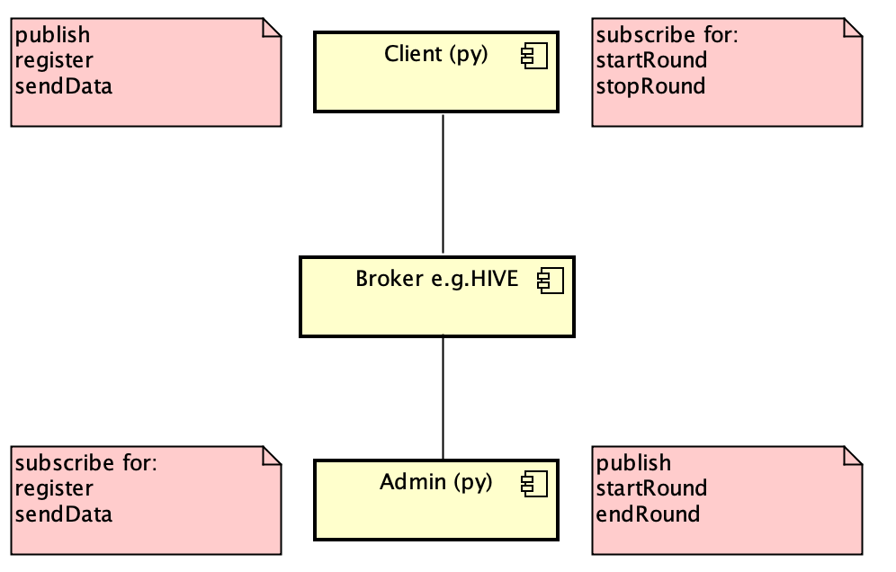

JSON objects

JSON objects

Communication via publish and subscribe

Payload of Messages = clientData-Objects as JSON

class **clienData** is a very rough model and not complete but only a prototype

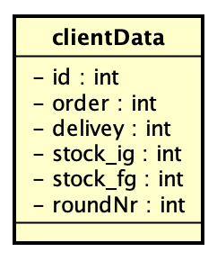

Example for a serialized clientData-Object as JSON-object:

{"roundNr": 1, "id": "1", "stock_fg": 10, "order": 0, "delivery": 0, "stock_ig": 10}

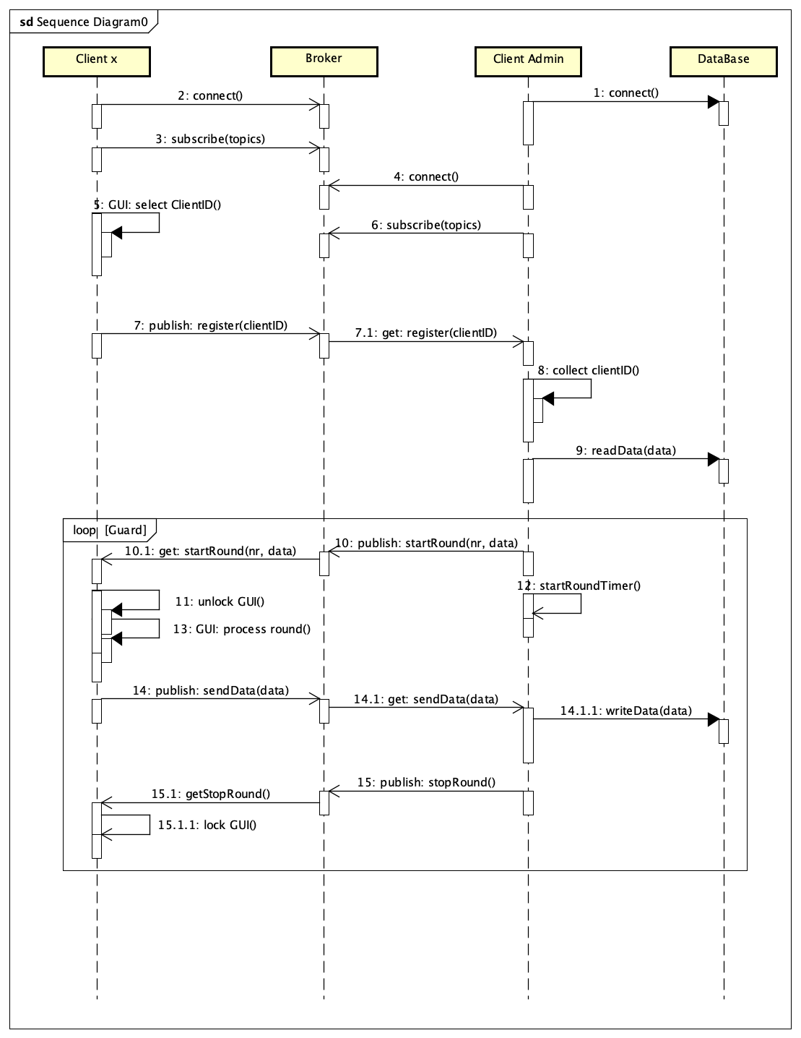

# Using the Prototype

simplifying it is assumed that the admin is simulated by any interactive MQTT client (e.g. the MQTT-WebClient for HIVE), which can send the messages accordingly

## Start mqtt-Client to simulate Admin and connect to broker (HIVE):

<http://www.hivemq.com/demos/websocket-client/>

* Connect
* Subsrcibe for topics:
  + **sendData**
  + **register**

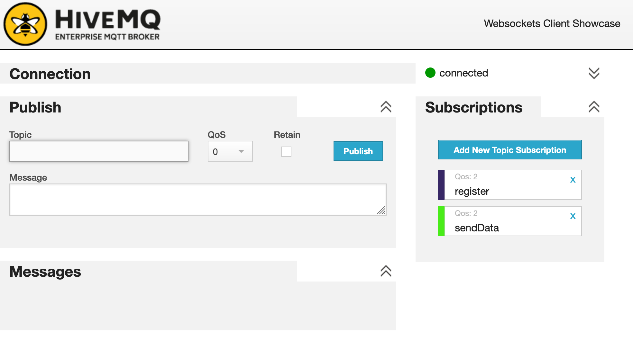

## Start Clientx, select Id and connect to server

* + Start mqttTestClient.py
  + input Id -> press connect-Button

**Client publish:**

Topic: **register**

Content: {"roundNr": 0, **"id": "1"**, "stock_fg": 0, "order": 0, "delivery": 0, "stock_ig": 0}

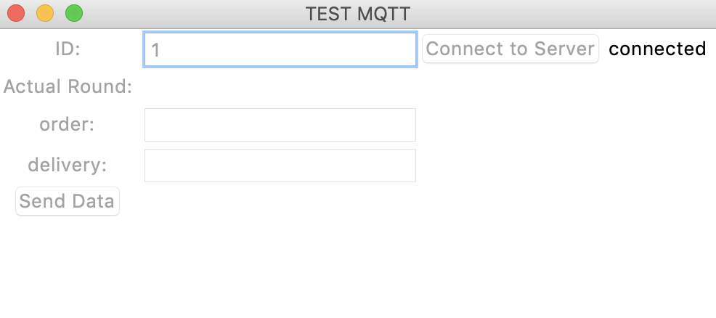

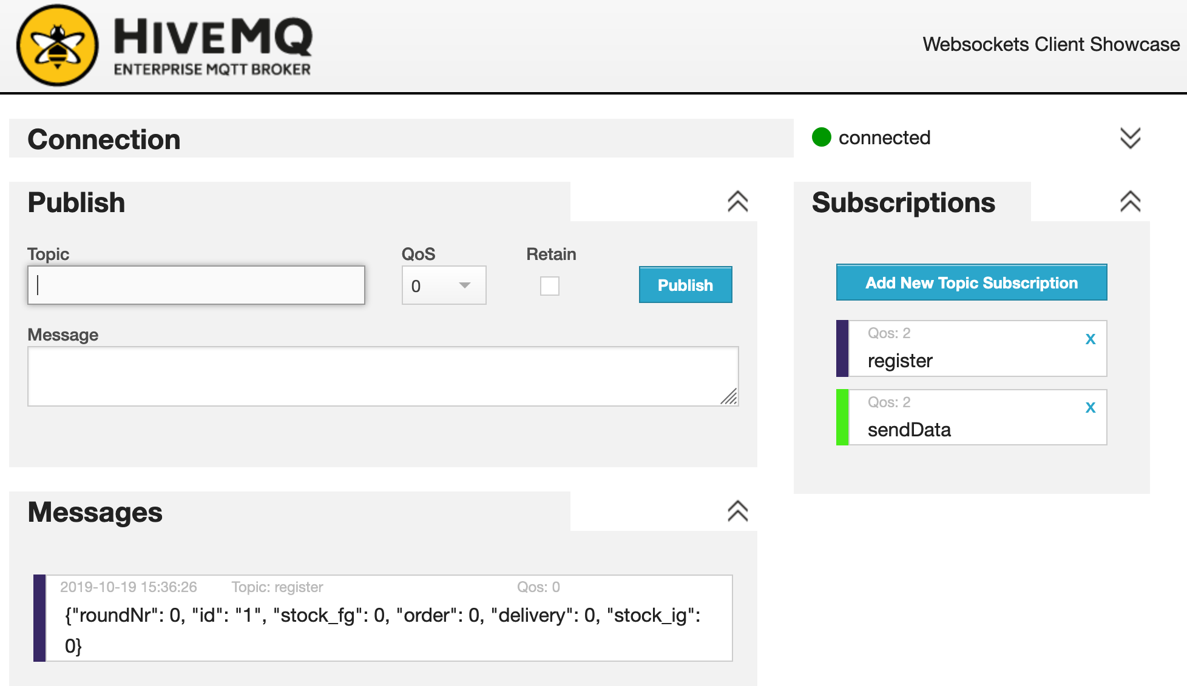

## Start Round:

* + Type in webClient (simulate the publishing messages by admin) a JSON-String containing all relevant data for client x
    - Z.B. for Client 1 (id=1) and Round 1:
    - stock_fg=10 / stock_ig=10 / client_id=1

Admin publish:

Topic: **startRound**

Payload: **{"roundNr": 1,** "id": "1", "**stock_fg": 10**, "order": 0, "delivery": 0, **"stock_ig": 10**}

Hint: you can copy the payload from the register-message

According to the number of clients, the admin has to publish the startRound-Message for every Client

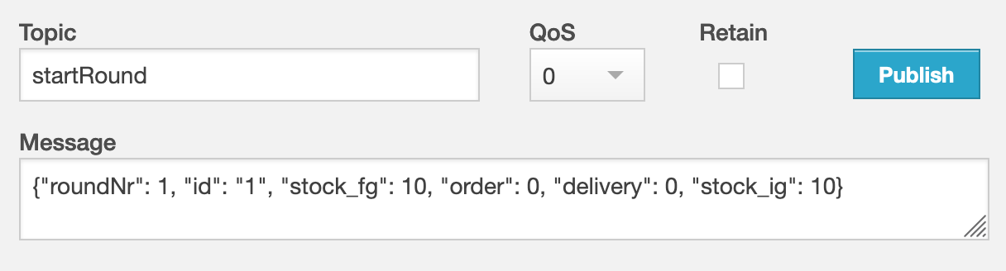

Client x receives message and enables GUI

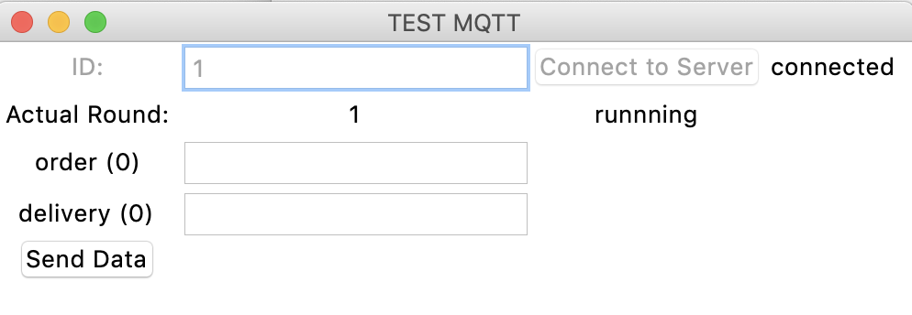

## Play Round

* + In the GUI of Client you can type values for order and delivery and press the send-button to publish the Information to broker
    - E.g. order=20, delivery=30

Client publish:

Topic: **sendData**

Content: **{"roundNr": 1, "id": "1",** "stock_fg": 10, **"order": "20",** "**delivery": "30"**, "stock_ig": 10}

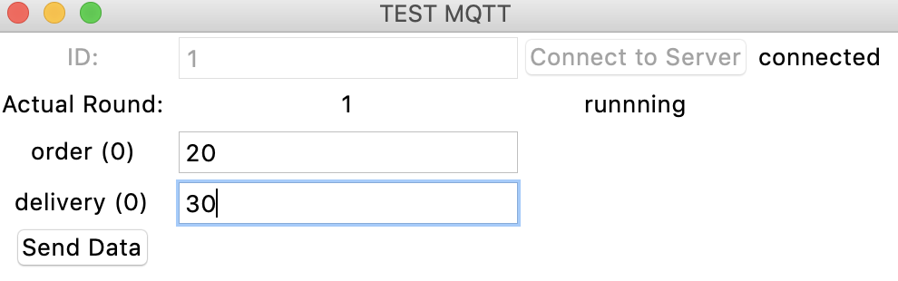

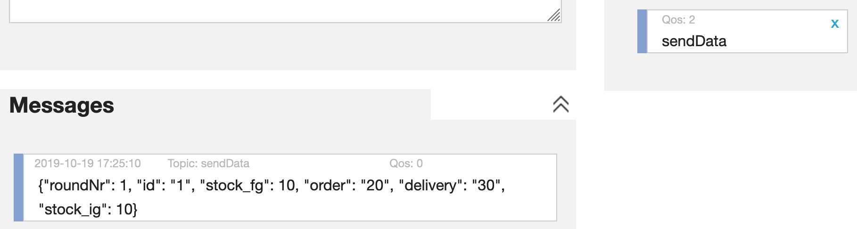

## Stop Round

* + Admin Publish:
    - topic=stopRound
    - content –
  + 🡪 disable GUI and wait for next round

