**Mobile and Pervasive Computing**

CNT5517 - Section 1G92 & CIS4930 - Section 1376

Professor Sumi Helal

Spring 2016

IoT Term Project Proposal

**Smart Space Assistant/Mapper (Suggestions?)**

Group 1: IoThingers

**Team Members:**

Rahul Bobhate, Hiranava Das, Sharique Hussain, Hamza Karaachiwala, Suryansh Singh.

iothingers@googlegroups.com

1. Project Summary

We often enter a large public space with certain questions on our mind. Do I know somebody here? If yes, where are they? If I know where they are, how can I get there? Alternatively, we would be interested in knowing if there is an area in this space that I would want to go to. Maybe I would want to mingle with a group of people having matching likes or dislikes? Or possibly find a group of people having the same nationality? In a diverse cultural setting such as the University of Florida, we believe everyone would identify with one of these problems.

So where should we be digging for this kind of information. The answer is now obvious in this era of ubiquitous computing - the large public space itself! If it is “smart”, the space contains the answers to all these questions. The space can know which people are present in it. Subsequently, it can know the attributes or characteristics of these people. It can also approximately keep track of where each person is.

In our project, we intend to design a smart space which solves certain problems pertaining to discovering people in a large public space. GPS and location tracking can bring you within a certain broader area, but it will not work differently for different contexts or different use cases. It also cannot identify a semantically grouped set of users within a space. In other words, it is not “smart” data. Its co-ordinates do not have meaning attached to it. Using contextual data from Google Beacon and processing user data on the cloud, we can provide meaningful answers to a user entering a public space. These would include and not be limited to –

1. Are any of my friends already present in this space?
2. If yes, then where are they approximately located?
3. How do I get to a particular section of the space?
4. Could I find a group of people whom I can easily mingle with?

If we were to map this vision to the Marston Library at the University of Florida, we could define our setup as –

1. Google Beacon informs every user that they have just entered Marston
2. Marston would have its own cloud service representation
3. An Android service on the user’s phone would register with the Marston cloud service
4. The cloud service would then identify any current user contacts present in Marston and inform the user about the same
5. Alternatively, the user could query the service in case of specific requirements – locating a study group or simply if the library has a printer
6. If not one of the above, making new friends is always difficult for some people. This system can aid people in finding like-minded groups that can be easy to approach (read same nationality or same hometown/or even similar music interests as an icebreaker)

2. Value Preposition (Potential Impact)

This is a step in making a physical public space smart and knowledgeable about certain information that a user would often need to know about that space. The reader will easily be able to relate with this difficulty as he or she most certainly would have looked for such answers before. It saves the hassle of whipping out your phone and having to make multiple calls and text messages. As soon as you enter the space, you are automatically notified of where you can go and what you can hope to experience from the space. The ability to discover the right person at the right time is always a very valuable asset to have (and also a very profitable angle if professional services are advertised)

3. Can your team pull this off?

Our team is extremely skilled with a diverse skill set and background. One of us is fresh out from college while one brings to the team four years of industrial experience. That gives us a range of approaches to problem solving. All the team members have gained industrial experience in different domains and bring a variety of principles and values that would tremendously aid the progress of this project. This outstanding range of skills makes us confident that we can achieve our goals within this project.

|  |  |  |
| --- | --- | --- |
| **Name** | **Skill Set** | **Motivation** |
| Rahul Bobhate  (Cloud Guy) | Java, OSGi, Azure, Linux, Android, REST, Cloud services | Have experienced the power of the cloud and would want to leverage it for an IoT solution |
| Hiranava Das  (ECE Guy) | Java,J2EE, C, C++, OSGi, Linux, Android, Web services, SOA, Sensor circuits, Microcontroller, Robotics | Have worked on sensors and microcontrollers to make smart decisions. The age of Internet of Things makes Pervasive computing and Physical web really exciting. |
| Sharique Hussain (Systems Guy) | C, C++, Java, Android | Want to build cool products in IoT. |
| Hamza Karachiwala (Services Guy) | C# .NET, Azure, Java, Android, REST | Everything should be a service, looking forward to make a space one too. |
| Suryansh Singh (Sensor Guy) | Java, Android | Interest in combining Android Application in IoT |

4. Risk Analysis

The technologies that we plan to employ for this project are relatively new. We have skilled members in our team having experience with embedded devices. But the new hardware has the potential to be complex. Despite this uncertainty about devices, we are confident that the tools we have identified are cut out for this task. We may certainly come across some technical limitations which will need workarounds. Also, the developer community will be comparatively sparse which means we might encounter problems that have not been faced before. Mobile application development and cloud resource management have a learning curve which some of us within the team will need to undergo. While these are issues that would definitely be obstacles that increase our development efforts, we are confident that none would be a blocker that cannot be overcome by our team.

5. Which Google Technology will be used in this project, and how?

1. **Google Beacon** – Beacon helps us in registering the users in a space. It can provide a user with the exact space identifier, which can be picked by a service running on the user’s phone and updated via a cloud service representing that physical space. Seamless registration without any hassles.
2. **Brillo / Weave** – Sensors that keep track of users, working in tandem to identify the location of a specific user in a space. (Can be replaced with Beacon Tentative)
3. **Google Venue MapMaker** - To create a one-time map of the indoor space.
4. **Google Cloud Services?** (Where we host the service? Tentative)
5. **TensorFlow** (ML for people matching? Tentative)
6. **Android** – The mobile application will target the Android platform. Of course this means that along with utilizing the OS support for mobile apps, we will be using the feature-rich Android Studio offering from Google to develop our application.

In order to better estimate the number of devices we may require for this project, we begin by using the Floor Plan of Marston. We will attempt to place devices according to our use case –

Beacon – **6 beacons** to cover the entire floor space to triangulate the location of a user as accurately as possible

Brillo Board – **3 Brillo boards** for

1. Maintain the foot fall in the library
2. An alternate location tracking method
3. Connectivity with the Cloud to send data

Cloud service - Google App Engine or any cloud service provider account

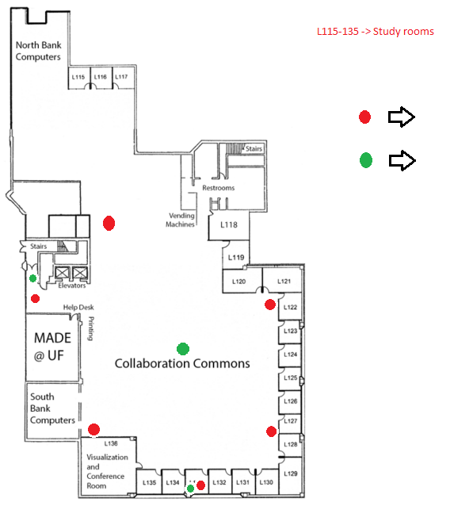

Brillo

Beacon