DESIGN

# Introduction

The design of the system includes multiple sensors, which are temperature sensors for keeping track of the engine temperature, accelerometers sensors for detecting potholes and for accident detection, gas sensors (carbon monoxide, nitrogen dioxide etc.) for pollution monitoring.

# 2 Architecture Design

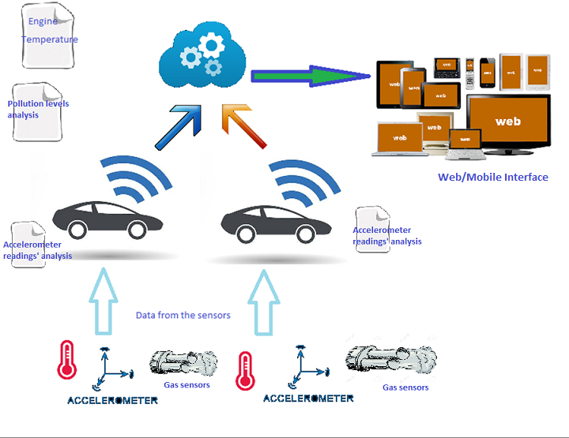

# 3 Graphical User Interface

## Web Interface for Service Center:

The service center staff are informed about the breakdown vehicles so that they can immediately send help to the vehicle. They can also obtain the general history of the particular vehicle, which will further help in diagnosing the problem with the vehicle well in advance.

## Mobile Interface for the Vehicle Drivers:

The Vehicle drivers receive warnings/alerts to get the vehicle serviced when the engine temperature of their vehicle reaches the warning temperature. This way, they can avoid their vehicle breaking down in the middle of the roads, amidst heavy traffic.

## Web Interface for authorities in charge of managing potholes in the city

The authorities, example BBMP, are informed about the locations of various potholes in the city, the number of times the pothole is encountered by commuters in a day and the intensity of potholes. They will get this information from the web interfaces that are designed for their use.

Web Interface for authorities for pollution monitoring

The web interface provided for the pollution monitoring authorities helps them to view the levels of various gases that are emitted by the monitored vehicles. Levels of carbon monoxide, nitrogen dioxide etc. can be viewed, along with the information of whether the vehicle has been warned to arrange to have these levels controlled. Also, the authorities are notified of all the vehicles that have not got serviced despite the warning, so that they can take further steps to alert the vehicle driver/owner to service the vehicle.

## Mobile Interface for vehicle Drivers:

The vehicle drivers receive warnings/ alerts to get the vehicle serviced when the levels of pollutants emitted by their vehicles cross a set threshold, the alert consists of the levels of various pollutants and the due date before which the vehicle must be serviced.

## Web interface for hospital staff

The web interface for the hospital staff to view the location and time of accident, so that the services can be dispatched to attend to the accident victims.

## Mobile Interface for vehicle owners/drivers

The emergency contact (relatives/friends) of the vehicle driver receives notification of the accident through message or email. The vehicle driver can use the interface provided to register a contact as emergency contact, who will receive notification.

# 4 Class diagram

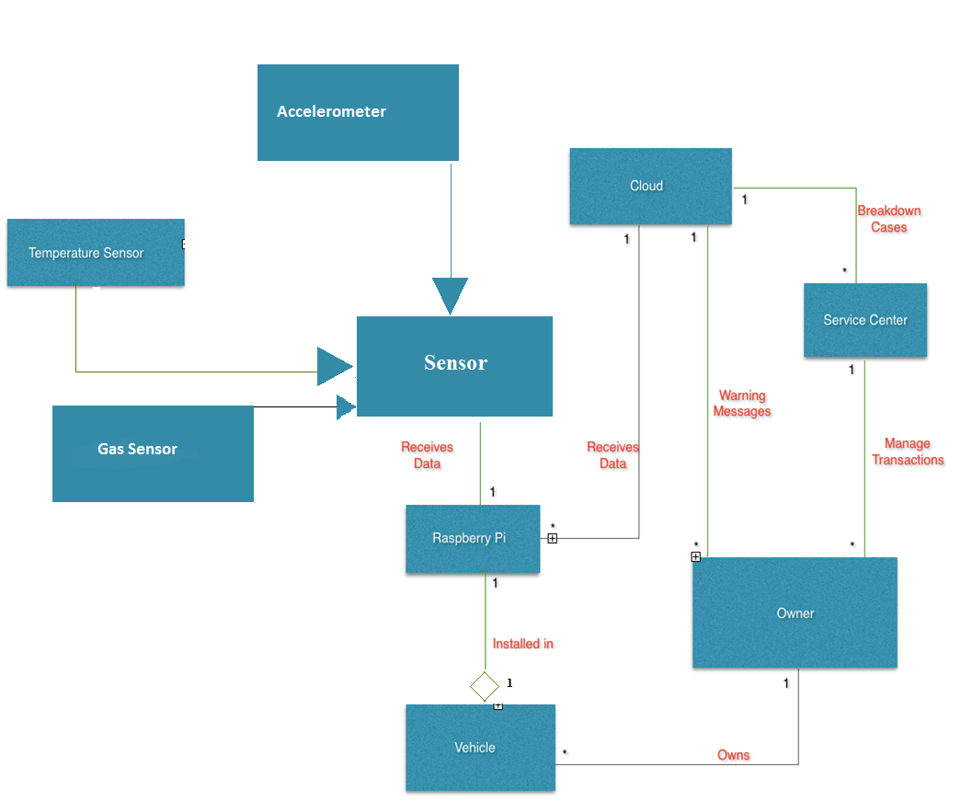

# 5 Sequence Diagram



6 Data Flow Diagram



# 7 References

[1]http://tf.nist.gov/seminars/WSTS/PDFs/10_Cisco_FBonomi_ConnectedVehicles.pdf : The Smart and Connected Vehicle and the Internet of Things

[2]J. A. Stankovic, “Research directions for the Internet of Things,” IEEE Internet Things J., vol. 1, no. 1, pp. 3–9, Feb. 2014.

[3] Mell, P., & Grance, T. (2009, 7 10). The NIST Definition of Cloud Computing, http://www.nist.gov/itl/cloud/upload/cloud-def-v15.pdf

[4] Kazi Masudul Alam, Mukesh Sainiy, and Abdulmotaleb El Saddik, “Towards Social Internet of Vehicles: Concept,

Architecture and Applications”,IEEE 2015

[5] http://www.mouser.com/applications/galileo-2-raspberry-pi-2/ : Intel Galileo2 vs. Raspberry Pi2

[6]https://www.sap.com/bin/sapcom/fr_ca/downloadasset.2014-10-oct-31-20.ceo-perspective-the-interrnet-of-things-for-the-automotive-industry-pdf.html : CEO Perspective: The Internet of Things for the Automotive Industry