Bitcoin Market Integration and Macroeconomic Sensitivity:
A Time-Varying Parameter VAR Model

Weekly Data: July 2014 – May 2025
Six-Variable System: EPU, VIX, DXY, S&P 500, Gold, Bitcoin

Abstract
This paper examines the time-varying relationship between Bitcoin (BTC) and a set of macroeconomic and financial variables — Economic Policy Uncertainty (EPU), the CBOE Volatility Index (VIX), the US Dollar Index (DXY), the S&P 500, and Gold — using a six-variable Time-Varying Parameter Vector Autoregression (TVP-VAR) model with Stochastic Volatility estimated on weekly data spanning July 2014 to May 2025. The model is identified via a Cholesky decomposition of the time-varying covariance matrix, and inference is conducted through Bayesian Markov Chain Monte Carlo methods (30,000 draws, 15,000 burn-in).

The Forecast Error Variance Decomposition (FEVD) reveals that Bitcoin's return variance is dependent upon itself through the sample, with the VIX contributing the largest external share (up to 25%) especially during the COVID-19 crisis of 2020. Point-in-time and continuous Impulse Response Functions demonstrate that Bitcoin's sensitivity to financial stress, as indicated by VIX, strengthened from the Retail Era (2017) through the COVID Crisis (2020) and has remained elevated but moderate in the Maturity Era (2024). The S&P 500 co-movement exhibits a structural regime change post-2022, transitioning from positive to negative. Gold presents a stable, modest positive relationship throughout the sample, while EPU and DXY effects are weak and time-varying. These findings support a narrative of progressive but incomplete financial integration: Bitcoin has evolved from an isolated asset into a volatility-sensitive risk asset that retains substantial idiosyncratic variance.

1. Introduction
Since its inception in 2009, Bitcoin has evolved into one of the world's most discussed financial assets. Yet fundamental questions about its nature remain: Is it a speculative instrument decoupled from traditional financial markets? A digital safe haven store of value analogous to gold? Or an increasingly integrated component of the global financial system sensitive to the same macroeconomic forces that drive conventional asset prices?

The challenge in answering these questions lies in Bitcoin's extraordinary transformation over the sample period examined in this paper. The asset has passed through at least three distinct market regimes: a Retail Era (pre-2018) dominated by idiosyncratic speculative forces; a Crisis Era (2020) in which Bitcoin's correlation with traditional risk assets surged during the COVID-19 liquidity shock and a Maturity Era (post-2022) characterised by institutional participation, the launch of spot Bitcoin ETFs, and growing integration with macrofinancial conditions.

This paper is inspired by Panagiotidis, Stengos, and Vravosinos (2019), who examine the effects of stock market returns, exchange rates, gold, oil, central bank rates, and internet search intensity on bitcoin returns using standard VAR and Factor-Augmented VAR (FAVAR) models. Employing Granger causality tests, factor analysis, and principal component analysis to manage a large set of candidate variables, they find a significant interaction between bitcoin and traditional stock markets, a weaker relationship with foreign exchange markets and the macroeconomy, and a diminishing role for popularity measures such as Google and Wikipedia search trends. This paper builds on their work by allowing the transmission mechanism to vary continuously over time via a TVP-VAR-SV specification, enabling us to trace how bitcoin's sensitivity to macroeconomic financial shocks has evolved across different market regimes, something that static VAR and FAVAR models are not designed to capture.

This paper contributes to the literature on cryptocurrency market integration by providing a TVP-VAR analysis of Bitcoin's dynamic relationships with five key macro-financial variables: the Economic Policy Uncertainty Index (EPU), the CBOE Volatility Index (VIX), the US Dollar Index (DXY), the S&P 500 equity index, and the Gold ETF (GLD). Using Bayesian MCMC methods on weekly data from July 2014 to May 2025, we estimate time-varying Forecast Error Variance Decompositions (FEVD) and Impulse Response Functions (IRF) to characterise how these relationships have evolved across the three market eras.

The remainder of the paper is structured as follows. Section 2 describes the data and methodology. Section 3 presents the empirical results across FEVD, point-in-time IRFs, continuous IRF timelines, and cumulative IRFs. Section 4 discusses the economic interpretation of the findings. Section 5 concludes.

2. Data and Methodology

2.1 Data
The analysis uses six weekly time series spanning July 18, 2014 to May 27, 2025, yielding approximately 553 weekly observations before accounting for the training sample. All price-based series are obtained as end-of-week closing prices (last observation of each week) and transformed into continuously compounded log-returns prior to estimation.

Table 1: Variable Descriptions and Data Sources
Variable | Description | Source | Role in Model
BTC | Bitcoin / USD | Yahoo Finance (BTC-USD) | Endogenous – response variable
VIX | CBOE Volatility Index | Yahoo Finance (^VIX) | Financial market fear/uncertainty
S&P 500 | S&P 500 Index | Yahoo Finance (^GSPC) | US equity market benchmark
GOLD | SPDR Gold Shares ETF | Yahoo Finance (GLD) | Safe-haven / inflation hedge
DXY | US Dollar Index | Yahoo Finance (DX-Y.NYB) | US dollar strength
EPU | Economic Policy Uncertainty Index | FRED (USEPUINDXD) | Macro policy uncertainty

Raw daily data are downloaded from Yahoo Finance and the Federal Reserve Economic Data (FRED) API. Forward-filling (last observation carried forward) is applied to handle non-synchronous trading calendars across the series. The daily merged panel is then sampled at the weekly frequency by taking the last observation of each week, ensuring all variables share a common time index.

2.2 The TVP-VAR-SV Model
The empirical framework is a Time-Varying Parameter Vector Autoregression with Stochastic Volatility (TVP-VAR-SV), as developed by Primiceri (2005) and implemented in the bvarsv package in R (Krueger, 2015). The model is specified as:

yₜ = cₜ + A₁,ₜ yₜ₋₁ + A₂,ₜ yₜ₋₂ + εₜ, εₜ ~ N(0, Σₜ)

where yₜ is the 6×1 vector of log-returns at time t, A₁,ₜ and A₂,ₜ are time-varying coefficient matrices (lag order p = 2, selected by information criteria), cₜ is a time-varying intercept vector, and Σₜ is a time-varying covariance matrix that follows a stochastic volatility process.

The time-varying parameters evolve as random walks:

βₜ = βₜ₋₁ + νₜ, νₜ ~ N(0, Q)

where βₜ stacks all time-varying coefficients. The covariance matrix Σₜ is decomposed via a time-varying Cholesky factorisation, AₜΣₜAₜᵀ = Hₜ, where Hₜ is a diagonal matrix of stochastic volatilities. The ordering of variables in the Cholesky decomposition follows a causal ordering from macro uncertainty (EPU) through financial volatility (VIX), the dollar (DXY), equity markets (S&P 500), and commodity markets (Gold), to Bitcoin, reflecting the identifying assumption that Bitcoin responds contemporaneously to all other shocks but does not contemporaneously drive them.

2.3 Estimation
The model is estimated via Bayesian MCMC using the bvarsv package. The sampler runs for 30,000 iterations with a burn-in of 15,000 draws. A training sample of τ = 120 weeks (approximately 2.3 years) is used to initialise the prior distributions on the time-varying parameters, following standard practice in the TVP-VAR literature. All variables are standardised (zero mean, unit variance) prior to estimation to facilitate prior calibration and numerical stability.

Convergence is assessed via Geweke (1992) diagnostic z-statistics and inefficiency factors computed from the posterior draws. Post-estimation, the data are scaled back to original units for interpretation of impulse responses.

2.4 Impulse Response Functions and FEVD
Structural impulse responses are computed using the time-varying Cholesky factor Pₜ = chol(Σₜ)ᵀ as the impact matrix, yielding orthogonalised impulse responses. At each time t, the companion form of the VAR is constructed and iterated forward to produce the sequence of impulse response matrices Θℎ,ₜ = Φℎ,ₜPₜ, where Φℎ,ₜ is the h-step-ahead moving average coefficient matrix.

Point-in-time IRFs at three representative dates — June 2017 (Retail Era), March 2020 (COVID Era), and March 2024 (Maturity Era) — are estimated with Bayesian uncertainty bands by drawing 1,000 samples from the posterior distribution of the time-varying coefficients at each target date. The 68% and 95% credible intervals are reported, consistent with conventional practice in structural VAR inference.

Continuous IRF timelines are constructed by computing the one-step-ahead (h=1) impulse response at every observation in the estimation sample, yielding a time series of instantaneous sensitivities. Cumulative IRFs summing the response over H = 12 weeks are also reported, both as point-in-time snapshots across the three eras and as continuous timelines.

The time-varying FEVD is computed using the standard decomposition of the H = 24-week forecast error variance. At each time t, the share of Bitcoin's forecast error variance attributable to each structural shock is extracted from the diagonal elements of the cumulated squared impulse response matrices.

3. Empirical Results

3.1 Forecast Error Variance Decomposition
The time-varying FEVD results (Figures 1–6) reveal a consistent finding: Bitcoin's return variance is overwhelmingly driven by its own idiosyncratic shocks throughout the sample period. The BTC self-contribution (Figure 6) ranges from approximately 60% to 100%, with the lowest values concentrated in the 2020–2022 period when external macroeconomic shocks had their greatest influence.

Among external variables, VIX displays the highest macro impact with a contribution reaching up to 25% during 2020–2022 (Figure 2). The S&P 500 contributes a much smaller share of up to 8%, with some elevation post-2020 (Figure 4). EPU, DXY, and Gold each explain less than 2.5% of Bitcoin's forecast error variance (Figures 1, 3, and 5), suggesting that policy uncertainty and safe-haven dynamics are not primary determinants of Bitcoin's variance at the weekly horizon.

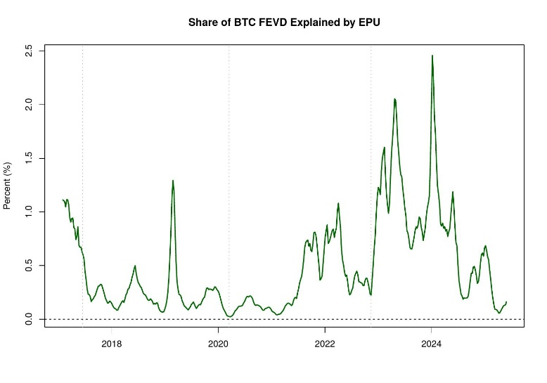
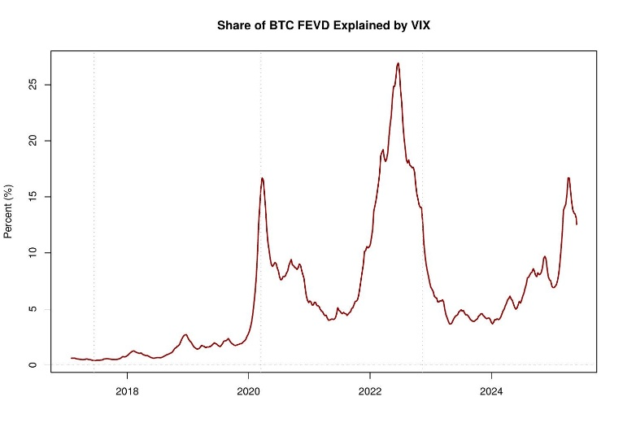

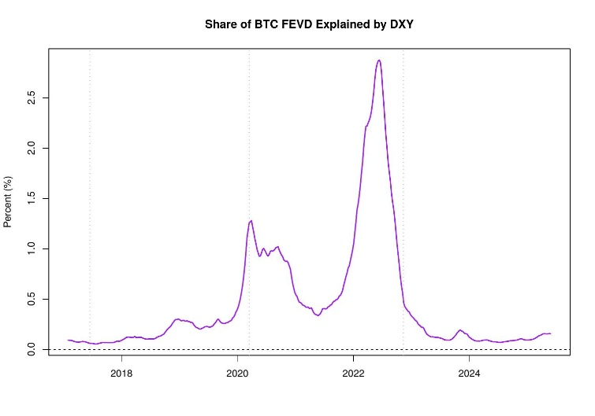
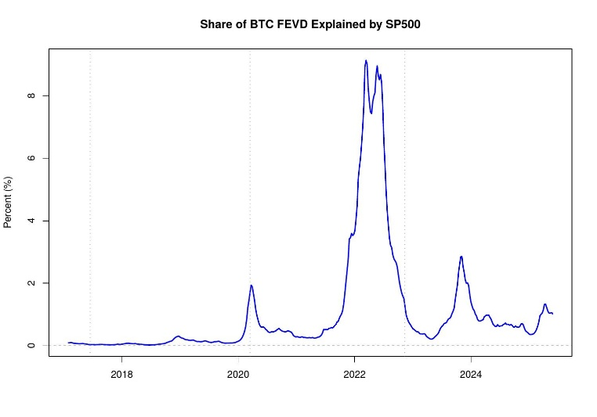

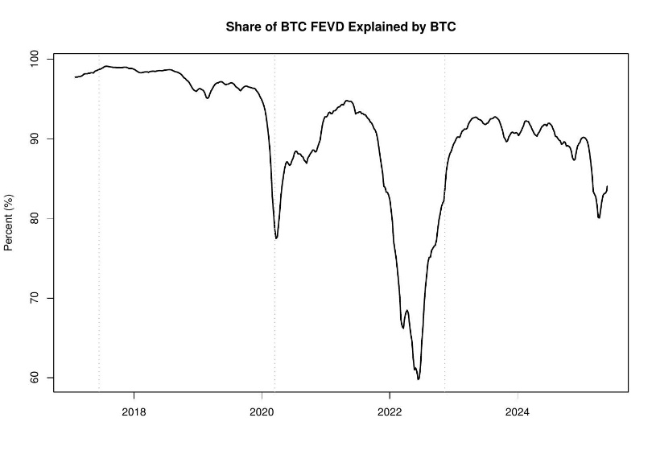
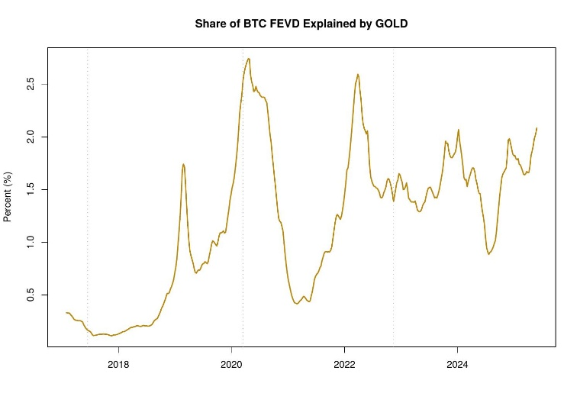

3.2 Point-in-Time Impulse Response Functions
3.2.1 Response to EPU Shocks
Figure 7 presents the point-in-time IRFs for Bitcoin's response to an EPU shock across the three market eras. In the Retail Era (2017), the response is weakly negative with wide credible bands that encompass zero at all horizons, indicating statistical insignificance. During the COVID Era (2020), the response tightens around zero with narrower bands, suggesting that heightened policy uncertainty did not generate a meaningful Bitcoin response during this period. In the Maturity Era (2024), the bands widen considerably, reflecting increased parameter uncertainty about the EPU-Bitcoin relationship.
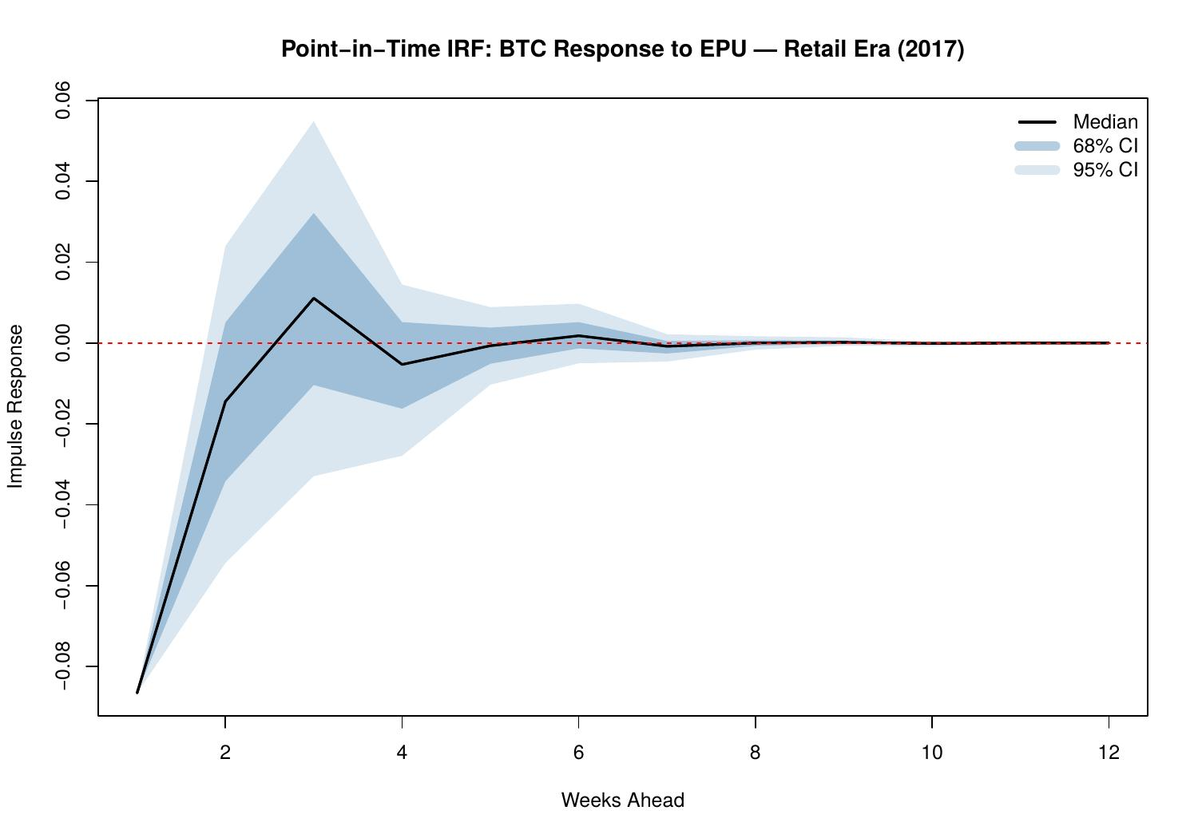

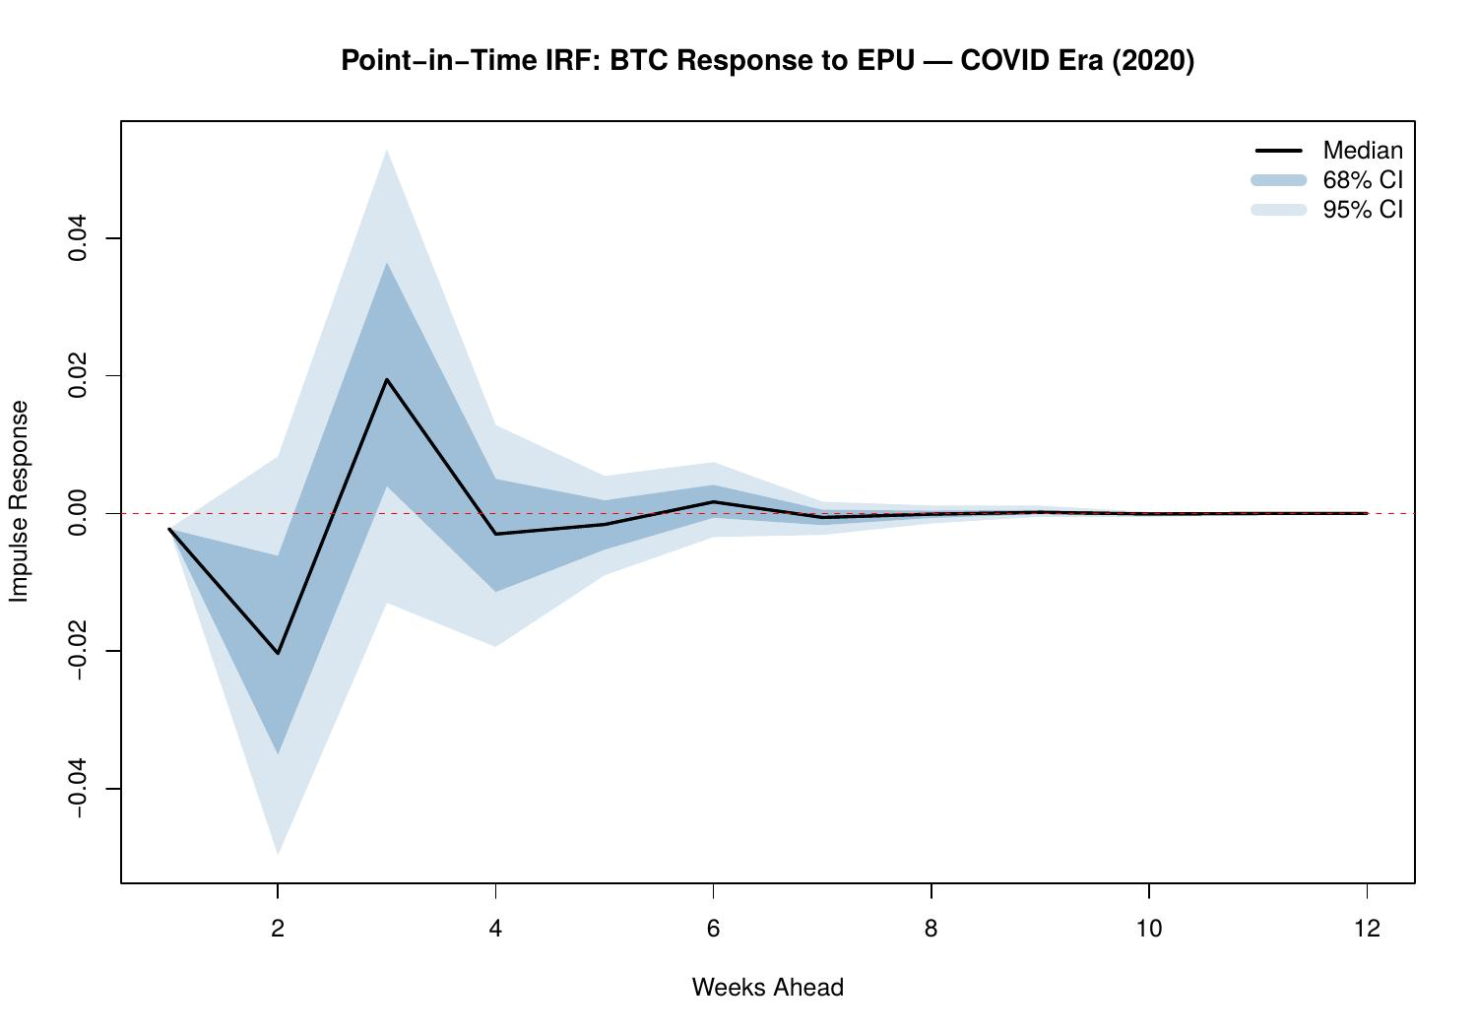
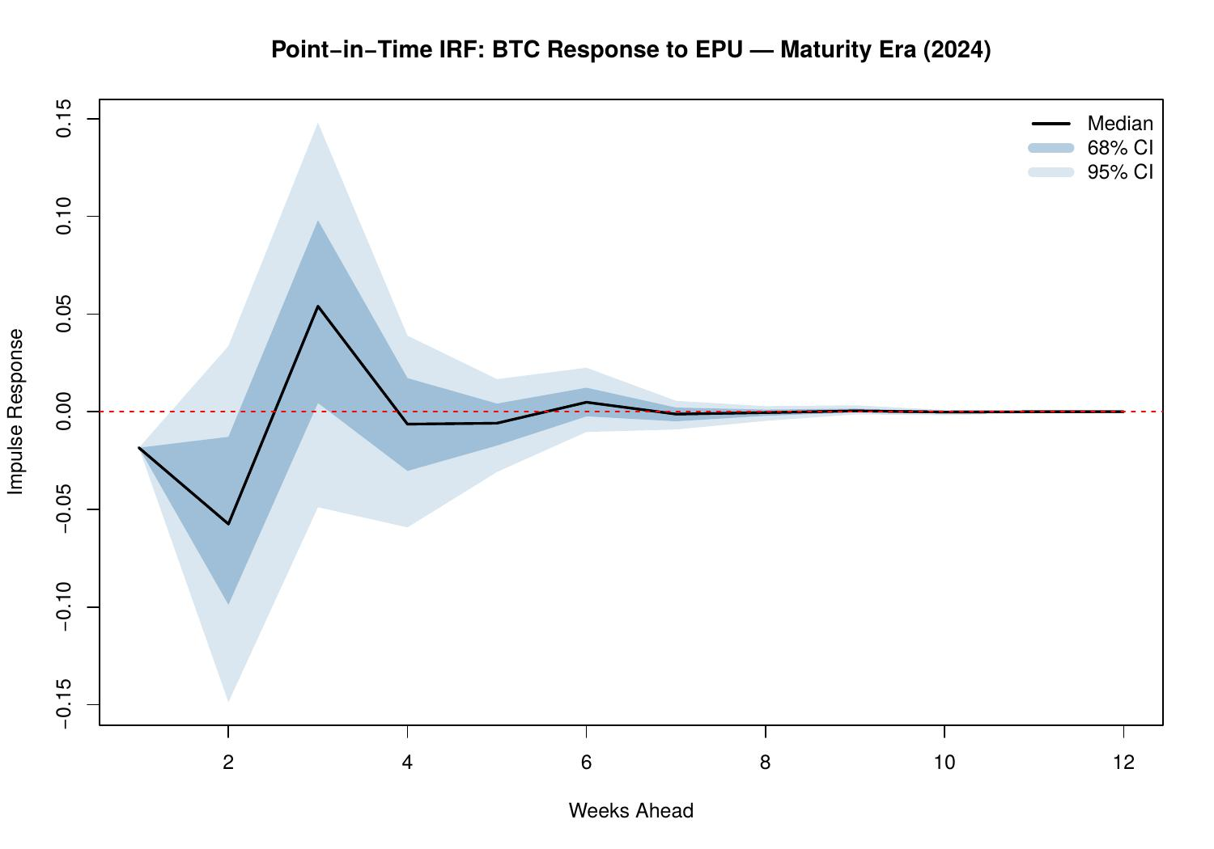
3.2.2 Response to VIX Shocks
The VIX IRFs (Figures 10–12) provide the most economically compelling results in the paper. In the Retail Era (2017), the response is negative but statistically weak, with bands encompassing zero. Bitcoin was not yet integrated with financial market volatility sentiment. The picture changes dramatically for the COVID Era (2020): the median response reaches approximately -0.2 to -0.4, and the 68% credible interval lies entirely below zero for the first 2 weeks. Bitcoin crashed alongside equity markets during the March 2020 liquidity panic, exhibiting clear risk-off behaviour.

By the Maturity Era (2024), the negative response persists but lessens (median approximately -0.05 to -0.10), with bands remaining skewed below zero. This pattern, from VIX-independence (2017) to strong risk-off correlation (2020) to moderate but persistent sensitivity (2024), constitutes strong evidence for progressive financial market integration.

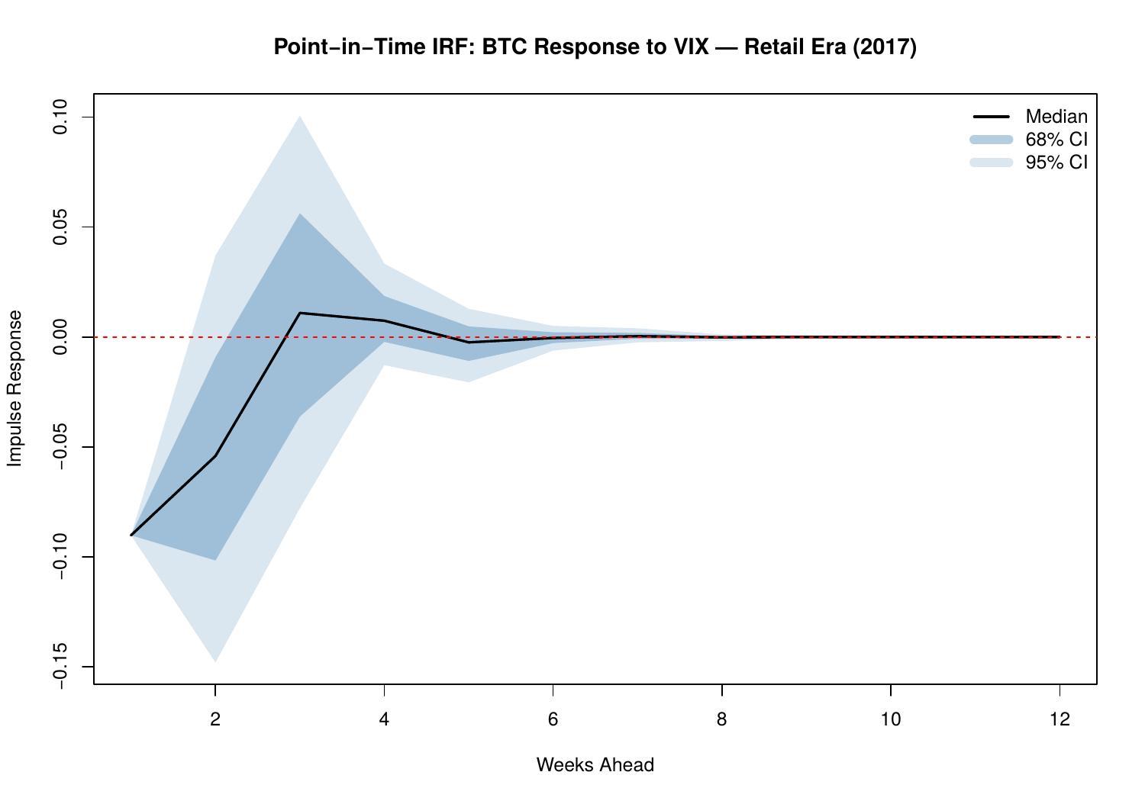
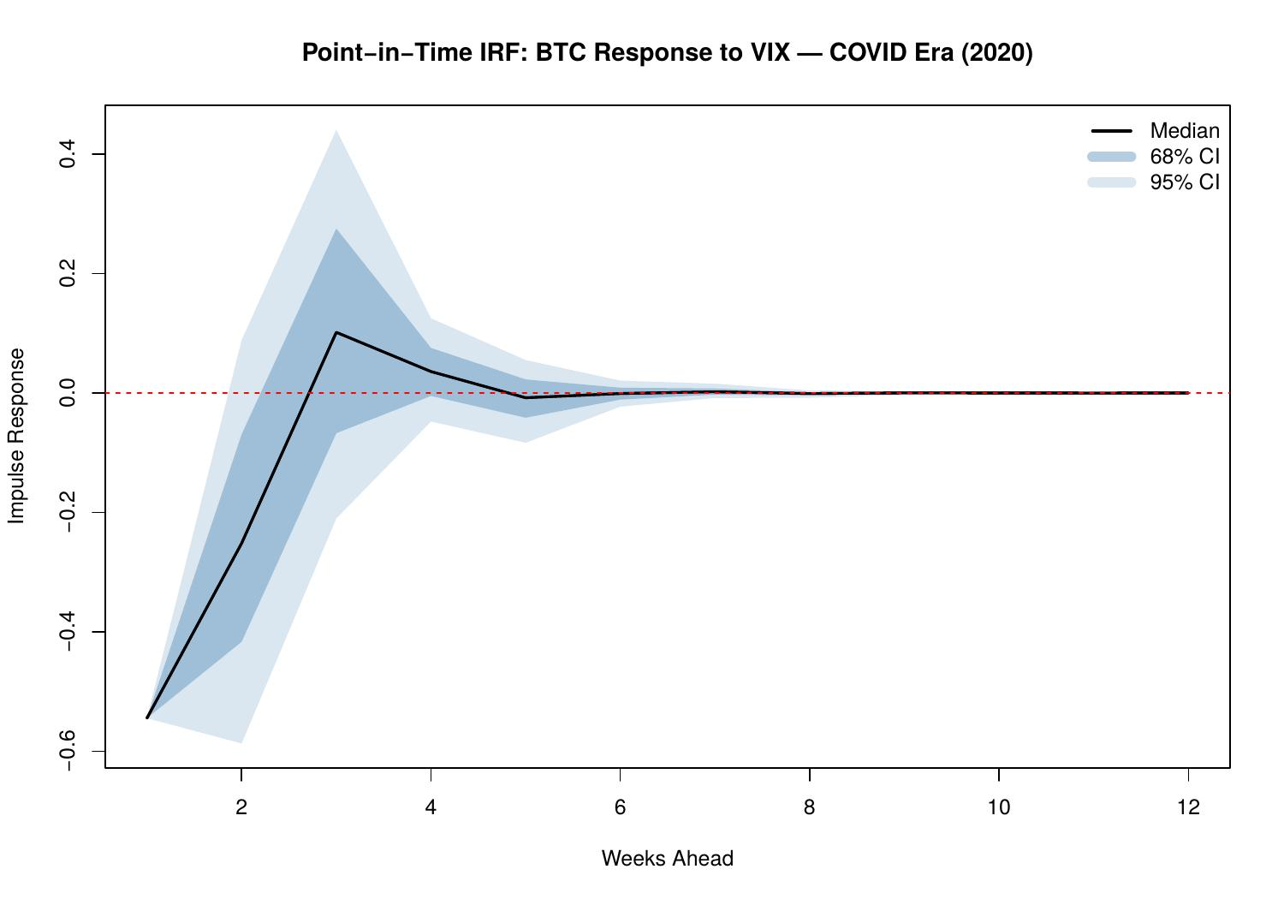
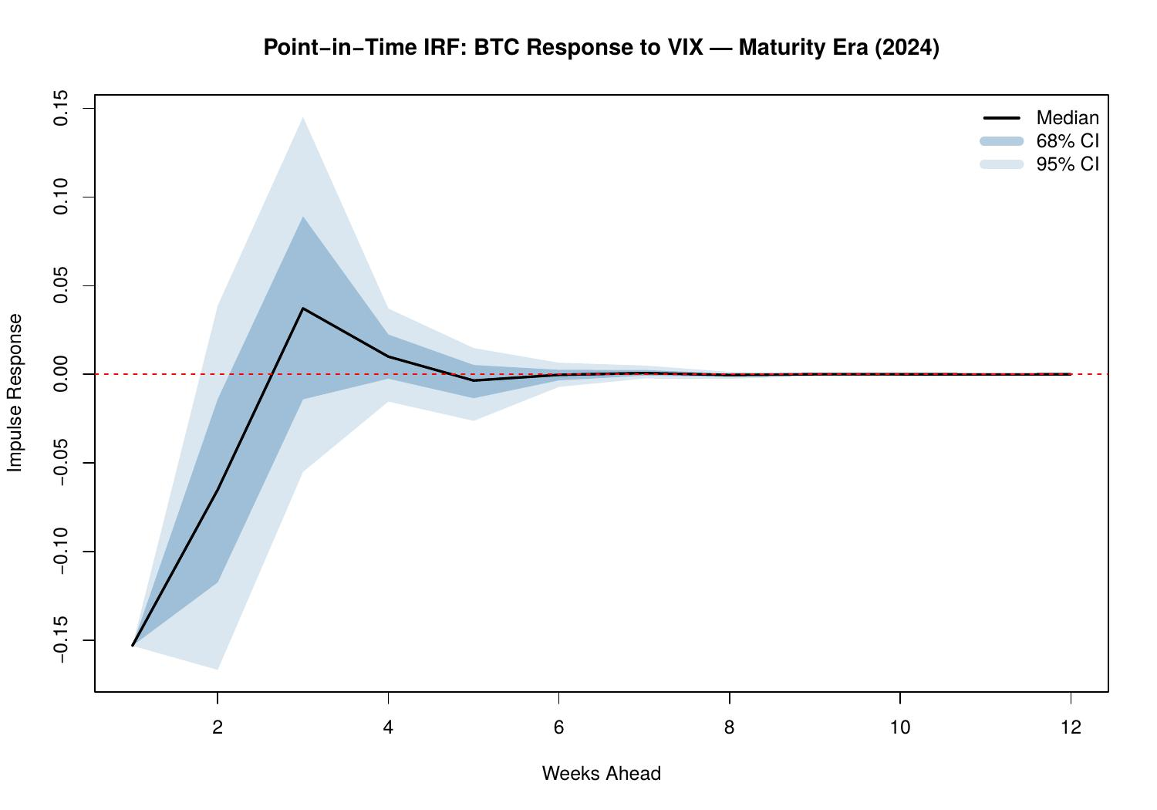
3.2.3 Response to DXY Shocks
The DXY IRFs (Figures 13–15) reveal a non-monotonic pattern across eras. In the Retail Era, the response is weak and imprecisely estimated with bands encompassing zero. During the COVID Era, the median turns positive at short horizons, an apparently counterintuitive result (stronger dollar associated with higher BTC response) that likely reflects the March 2020 liquidity squeeze in which both the dollar and Bitcoin experienced correlated movements before the Federal Reserve's emergency liquidity injections. By the Maturity Era, the response is near-zero with symmetric bands, suggesting no stable directional DXY-Bitcoin relationship at the weekly structural horizon.

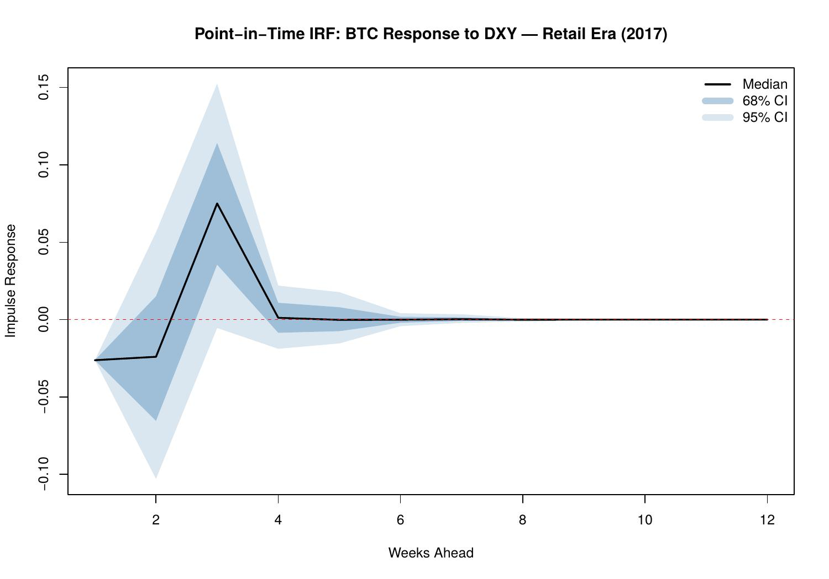
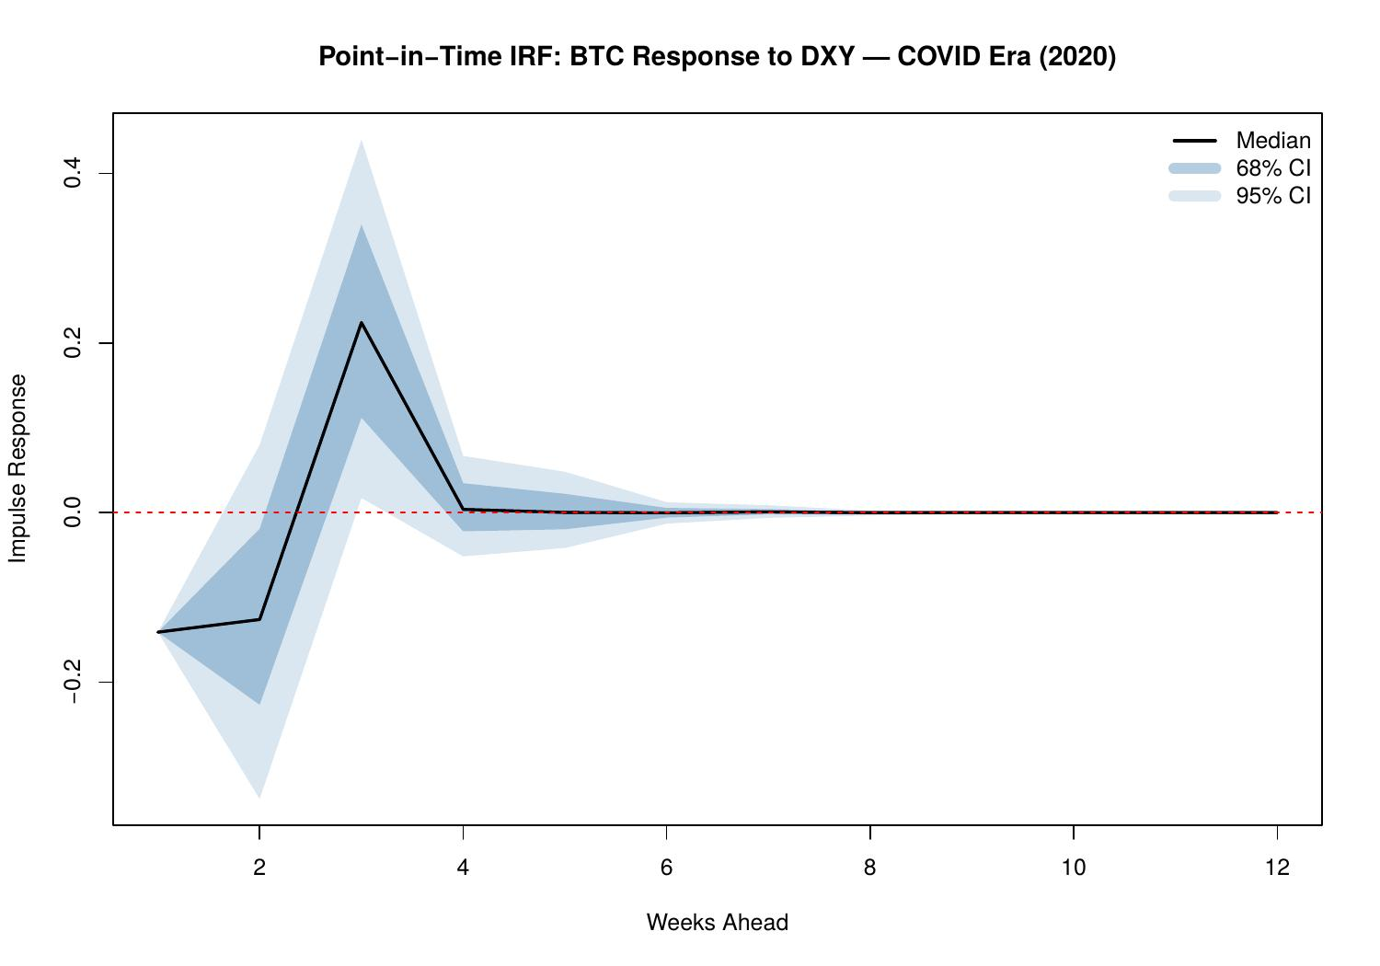
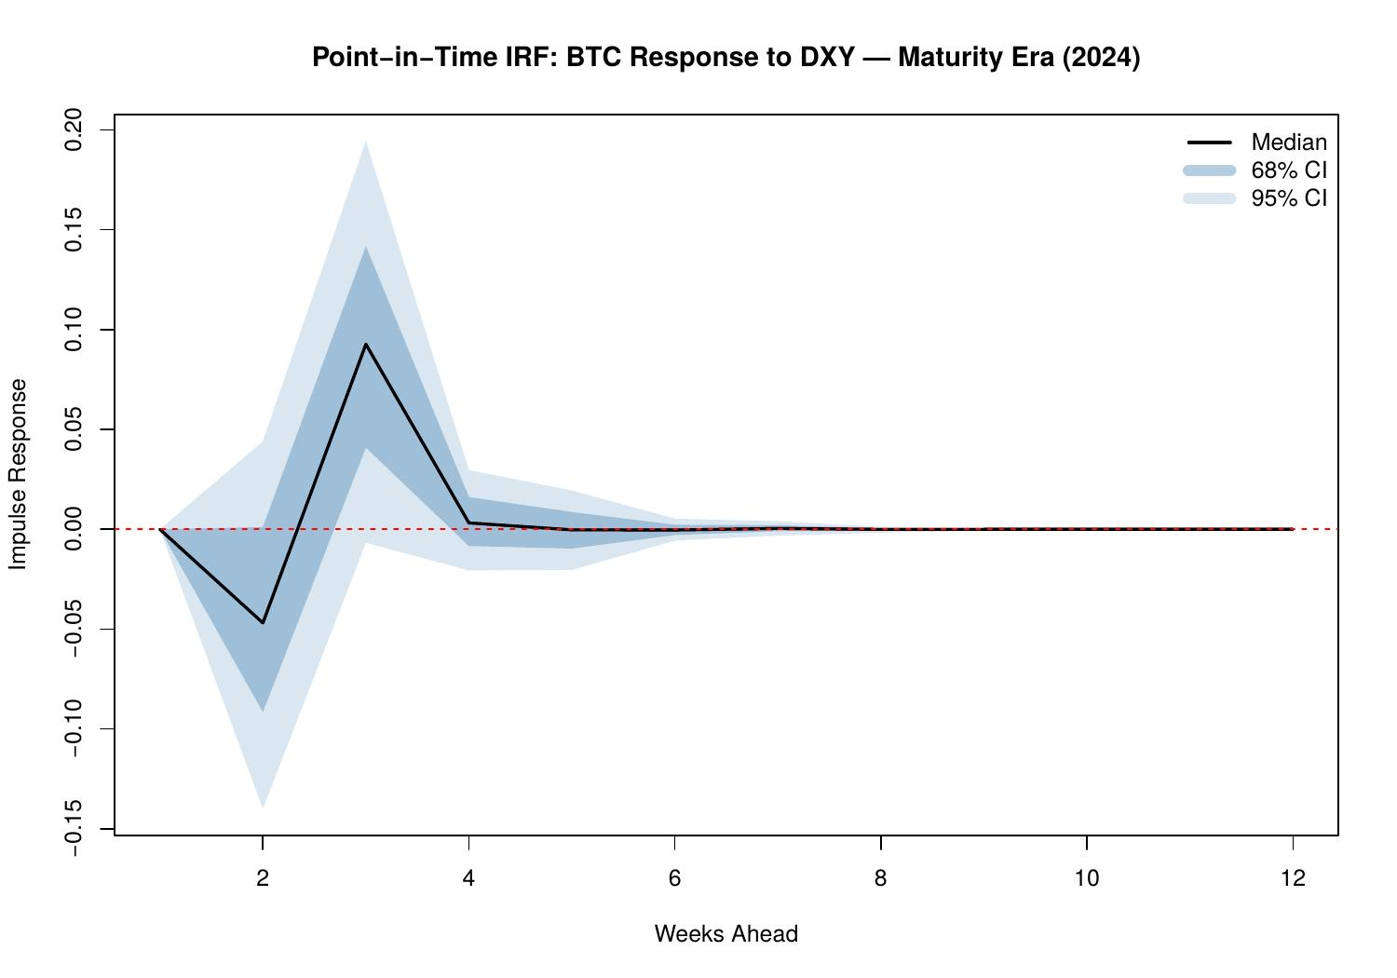
3.2.4 Response to S&P 500 Shocks
The S&P 500 IRFs (Figures 16–18) document a clear structural evolution. In 2017, the response is negligible, Bitcoin and US equities were essentially uncorrelated. The COVID Era shows a positive and statistically meaningful response (median ~0.05–0.15, with the 68% CI excluding zero for two weeks), consistent with Bitcoin being swept into the broader risk-on/risk-off dynamic during the institutional entry period. Strikingly, by 2024 the response is near-zero with tight bands, suggesting that the equity-Bitcoin co-movement visible around 2020–2021 has partially deteriorated as Bitcoin’s maturation progressed.

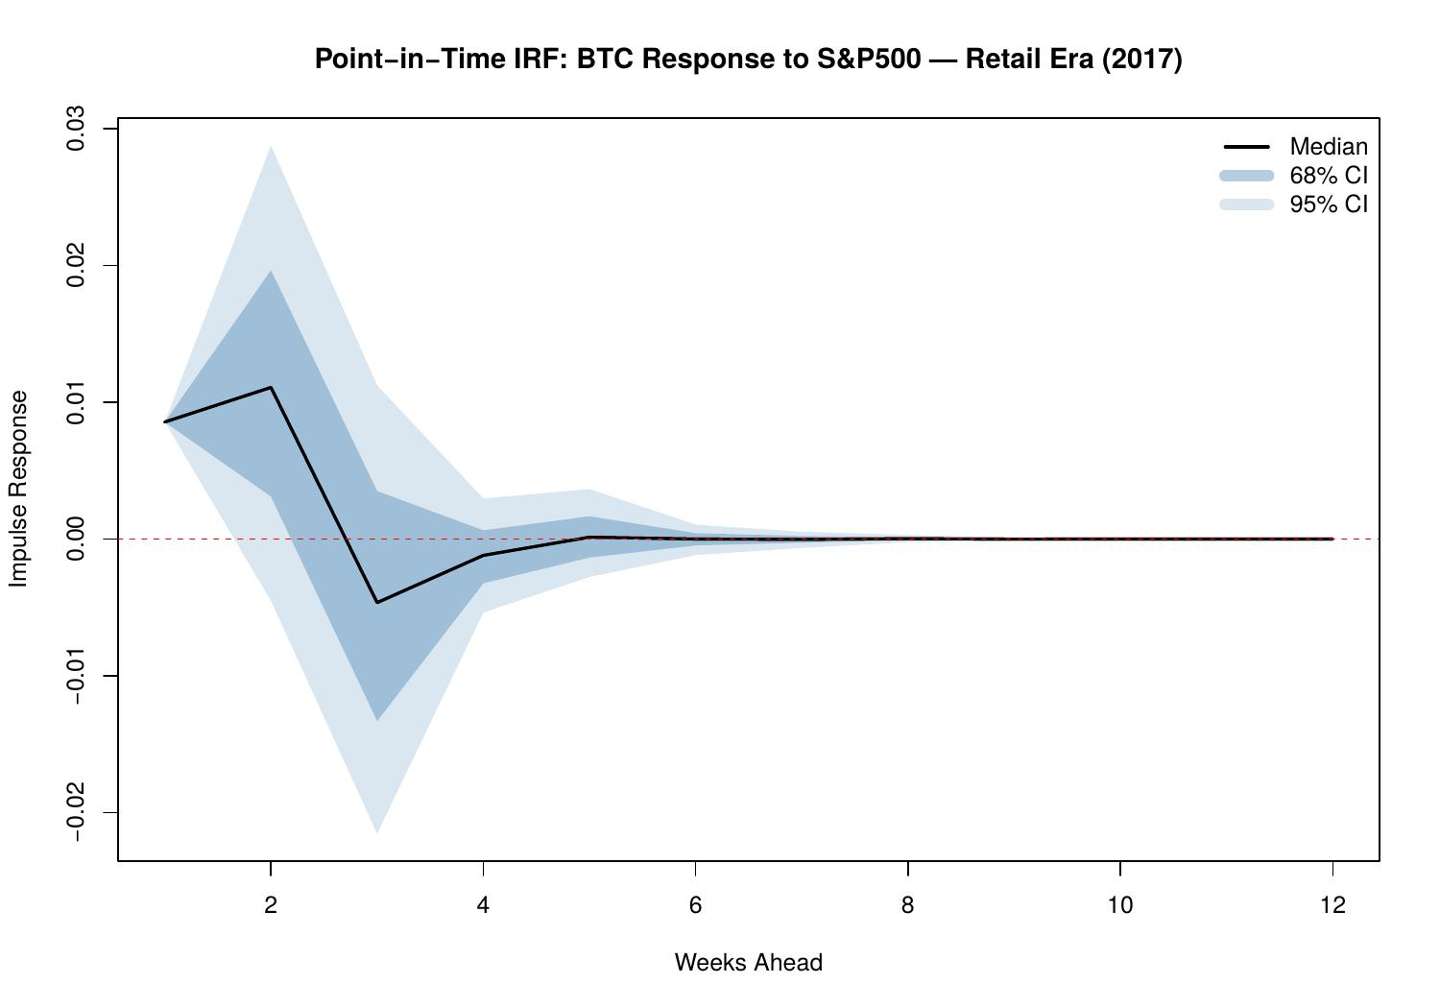
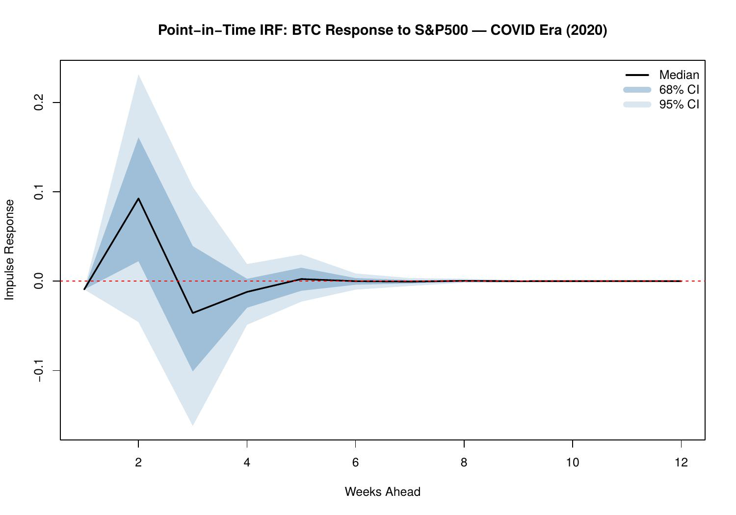
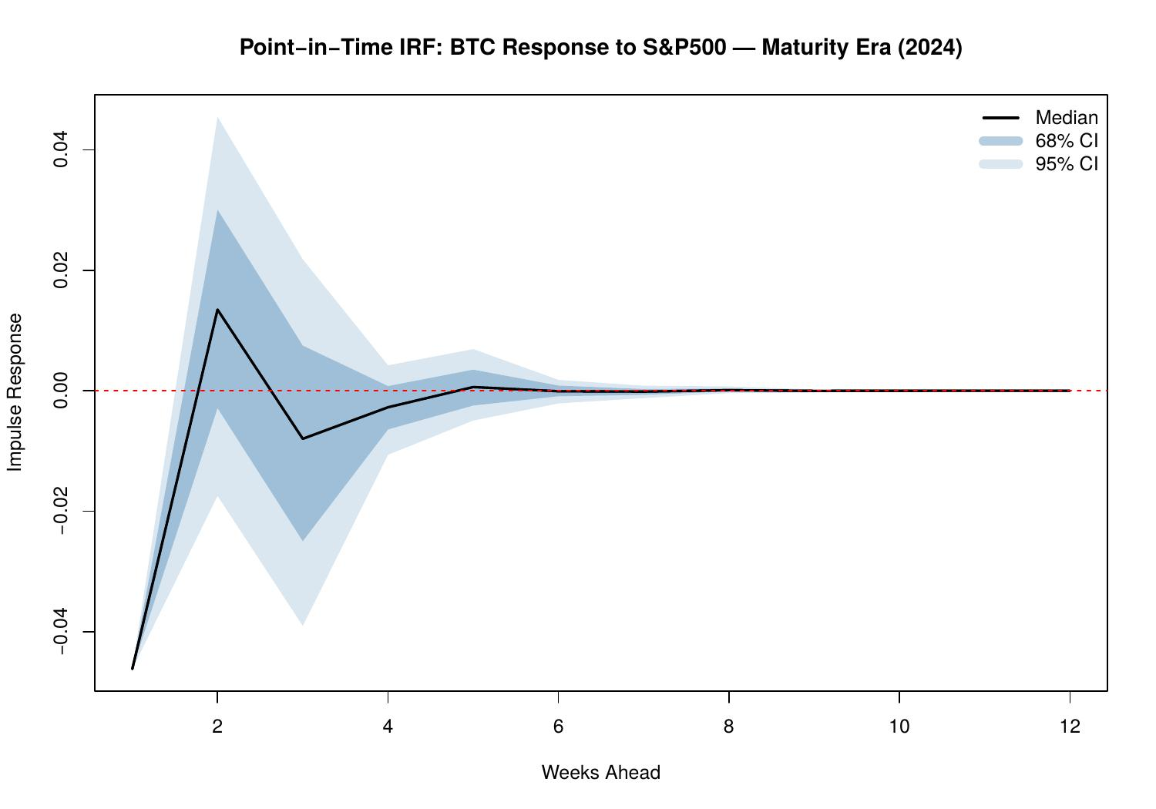
3.2.5 Response to Gold Shocks
The Gold IRFs (Figures 19–21) are broadly consistent with a modest, time-varying safe-haven or inflation-hedge co-movement. The 2017 and 2024 responses encompass zero in the 68% CI bands and are statistically indistinguishable from zero. The COVID Era shows a positive response (bands skewed above zero at short horizons), consistent with both assets benefiting from the inflation narrative following aggressive monetary stimulus.

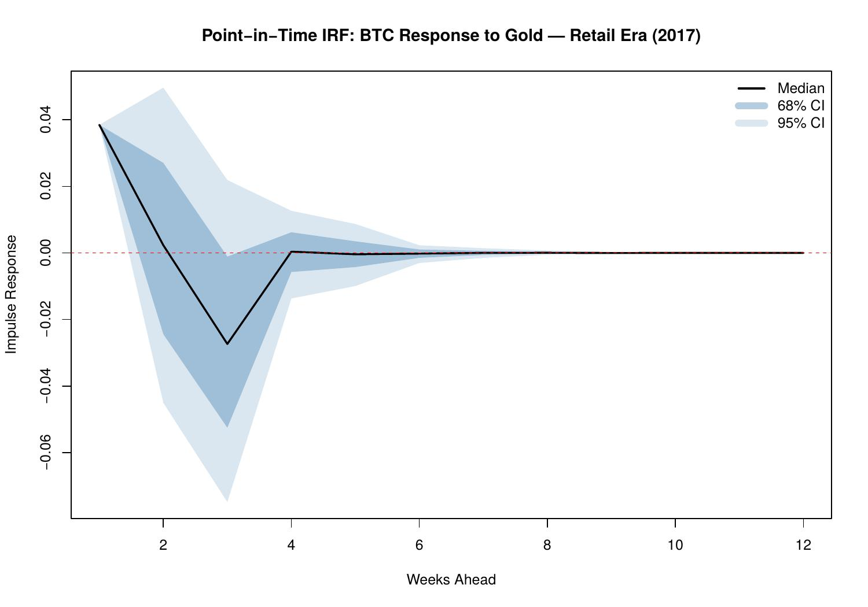
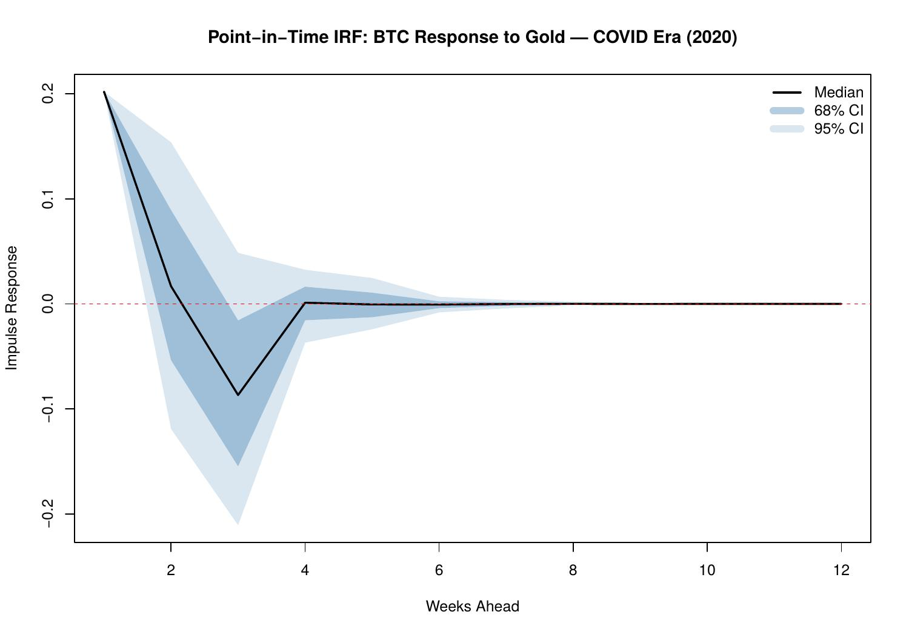
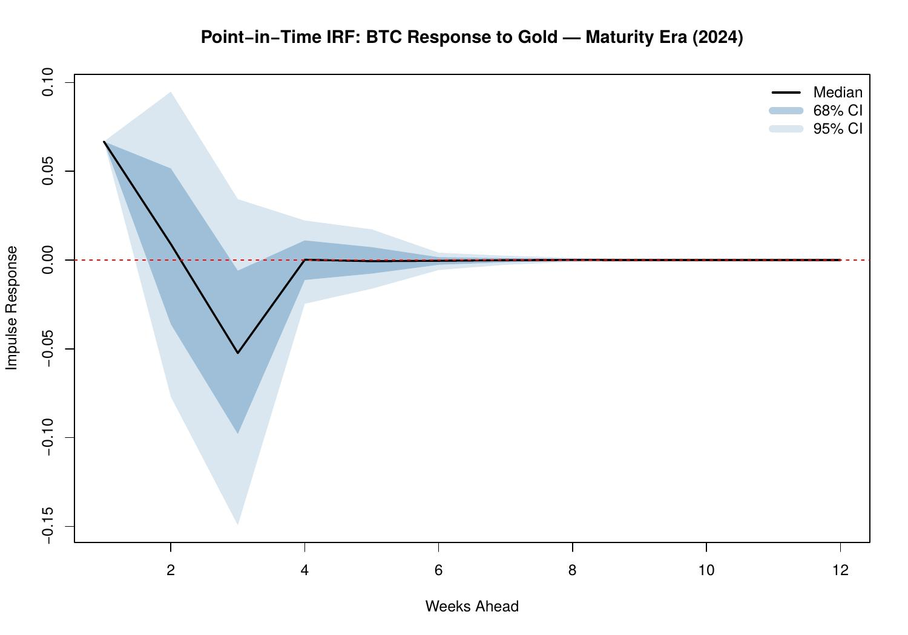

3.3 Continuous IRF Timelines (h = 1)
The continuous IRF timelines (Figures 22–26) trace how Bitcoin's instantaneous one-week sensitivity to each shock evolved across the full 2017–2024 estimation window. These plots are particularly informative because they reveal regime changes, trend shifts, and structural breaks in the transmission mechanism that point-in-time snapshots can only partially capture.

Figure 23 (VIX) is the most striking: the one-week response to a VIX shock is persistently and strongly negative throughout the entire sample, with the 68% credible band lying entirely below zero. The effect deepens markedly around 2020–2022, consistent with the institutional adoption phase in which Bitcoin became increasingly sensitive to financial market stress. Figure 25 (S&P 500) shows a mostly positive response through 2022 followed by a drift toward zero or negative values, corroborating the regime change identified in the point-in-time IRFs.

Figure 26 (Gold) reveals a consistently positive h=1 response throughout the sample — a stable, modest positive co-movement that persists across all market regimes. This suggests a common underlying driver (likely inflation expectations or dollar weakness) linking Gold and Bitcoin at short horizons. Figure 24 (DXY) is consistently negative at h=1 across the full sample, a stronger dollar is associated with a negative BTC response.

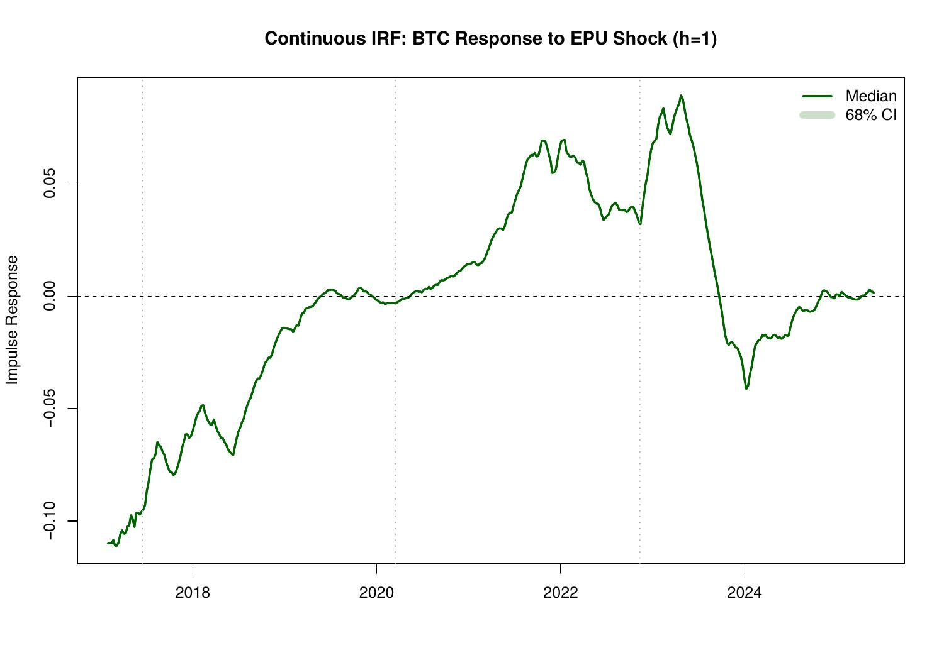
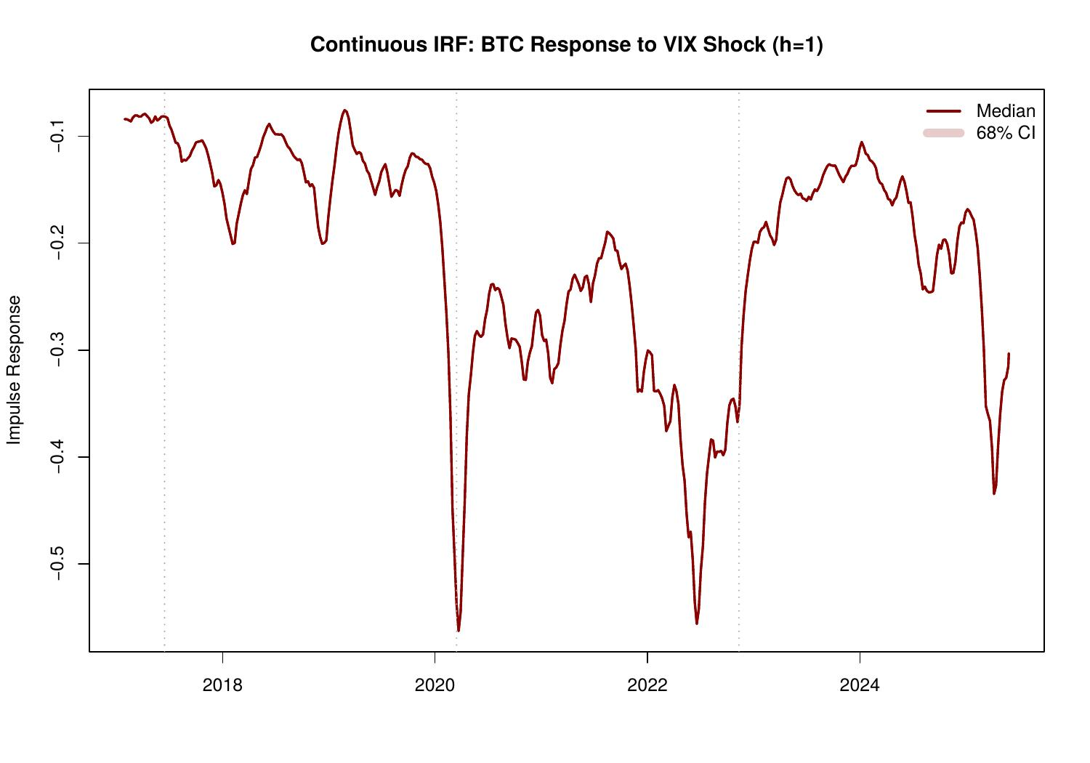
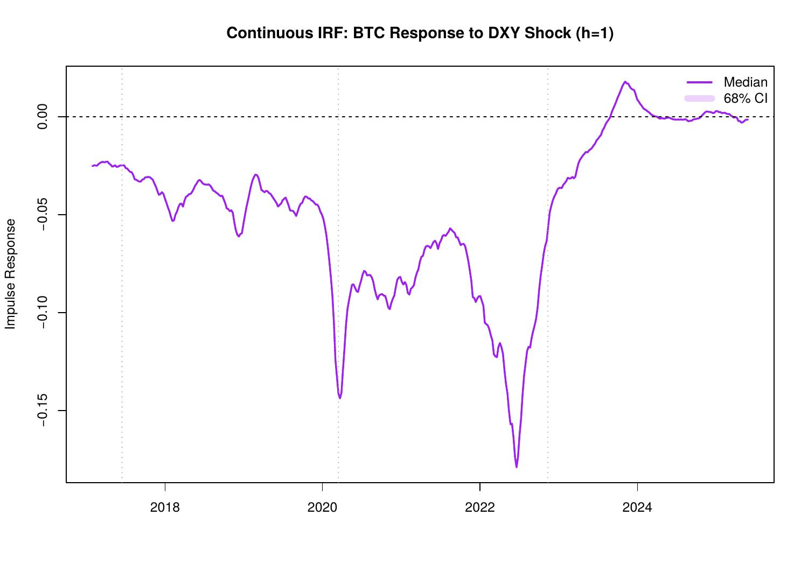

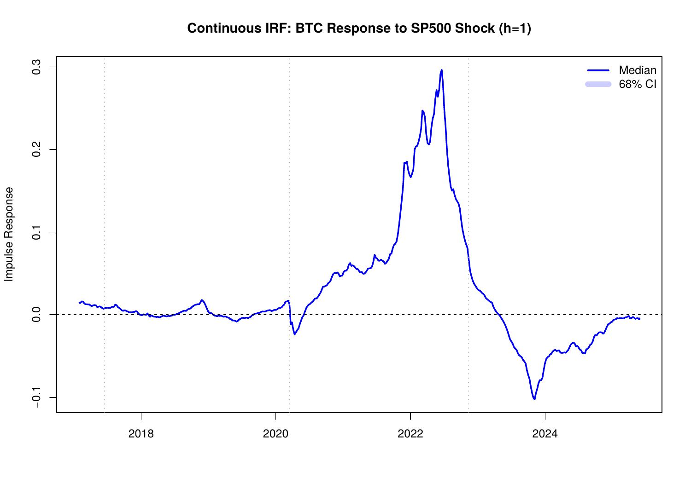
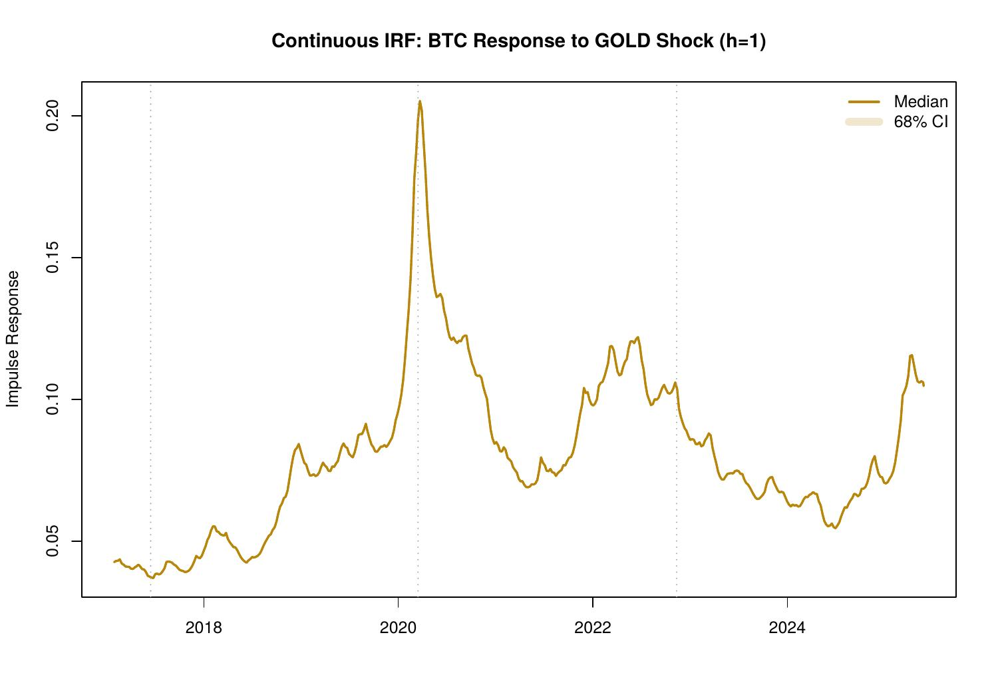

3.4 Cumulative Impulse Response Functions
3.4.1 Point-in-Time Cumulative IRFs
The cumulative IRFs sum the impulse response over H = 12 weeks, providing a measure of the total dynamic effect of a structural shock on Bitcoin. These cumulative measures are particularly useful for policy interpretation, as they capture the full price adjustment path rather than only the instantaneous impact.

The cumulative VIX IRFs (Figures 30–32) confirm and amplify the findings from the standard IRFs. The cumulative response is negative in all three eras, and the 68% CI is entirely below zero in both the COVID Era (cumulative median approximately -0.8 to -1.0) and the Maturity Era (approximately -0.2 to -0.3). The magnitude of the COVID-era effect is notably larger than either the Retail or Maturity era. The Retail Era cumulative VIX effect (approximately -0.25) is precisely estimated with the 68% CI excluding zero, suggesting that even in 2017, a sustained VIX elevation had a negative cumulative impact on Bitcoin.

The cumulative EPU effects (Figures 27–29) show a clearly negative and precisely estimated response in 2017 (68% CI below zero), near-zero in 2020, and ambiguous in 2024. The cumulative S&P 500 effects (Figures 36–38) document a complete regime reversal: positive cumulative responses in 2017 and 2020 give way to a negative cumulative response in 2024, with the 68% CI lying below zero by the Maturity Era. The cumulative Gold effect (Figures 39–41) is near-zero in 2017, positive in 2020, and ambiguous in 2024, consistent with a COVID-era inflation hedge narrative that has since dissipated.

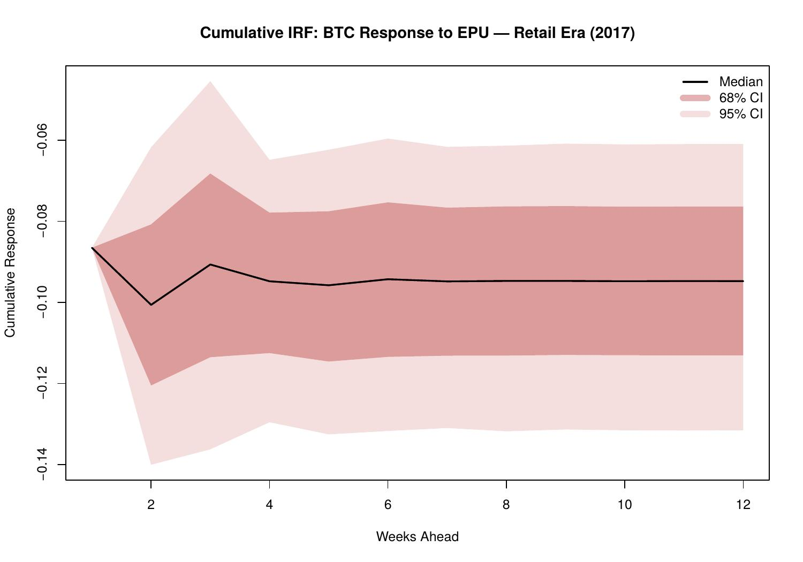
. 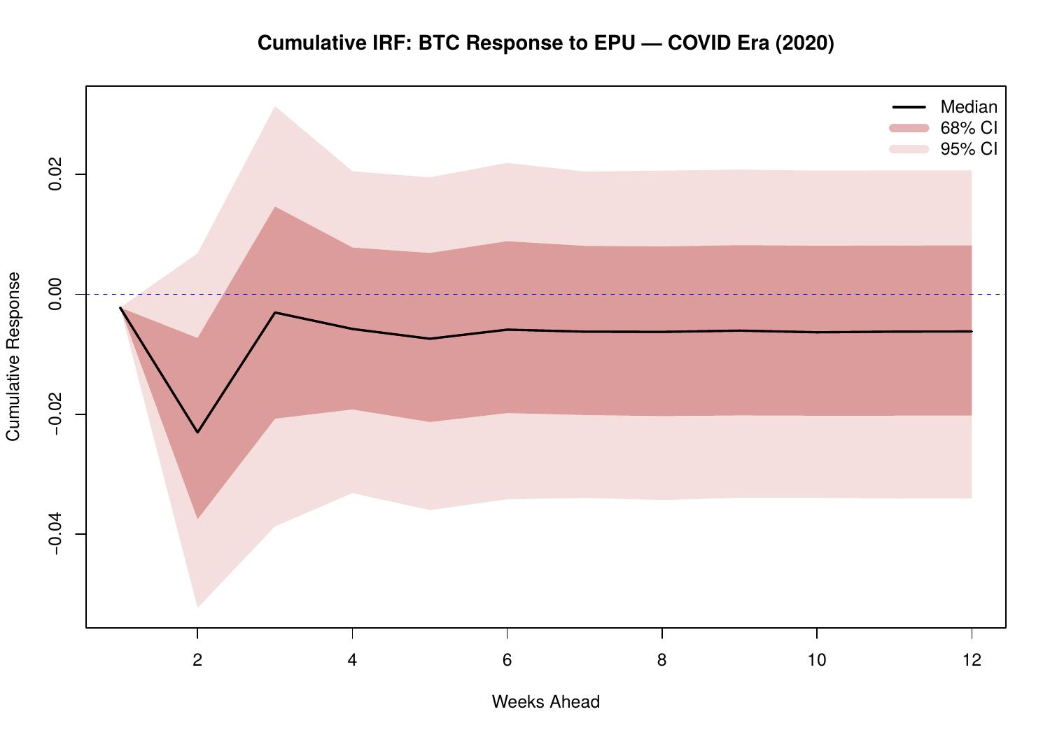

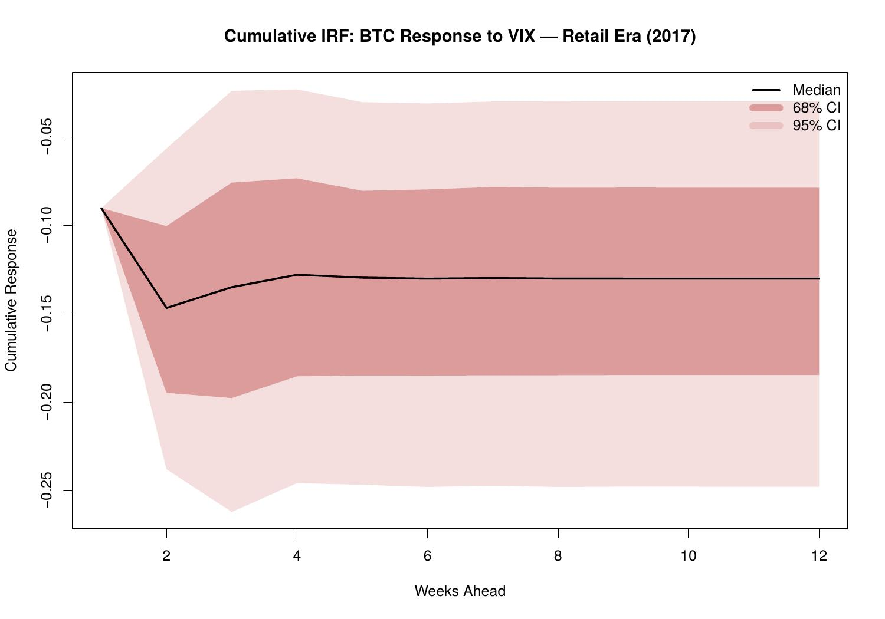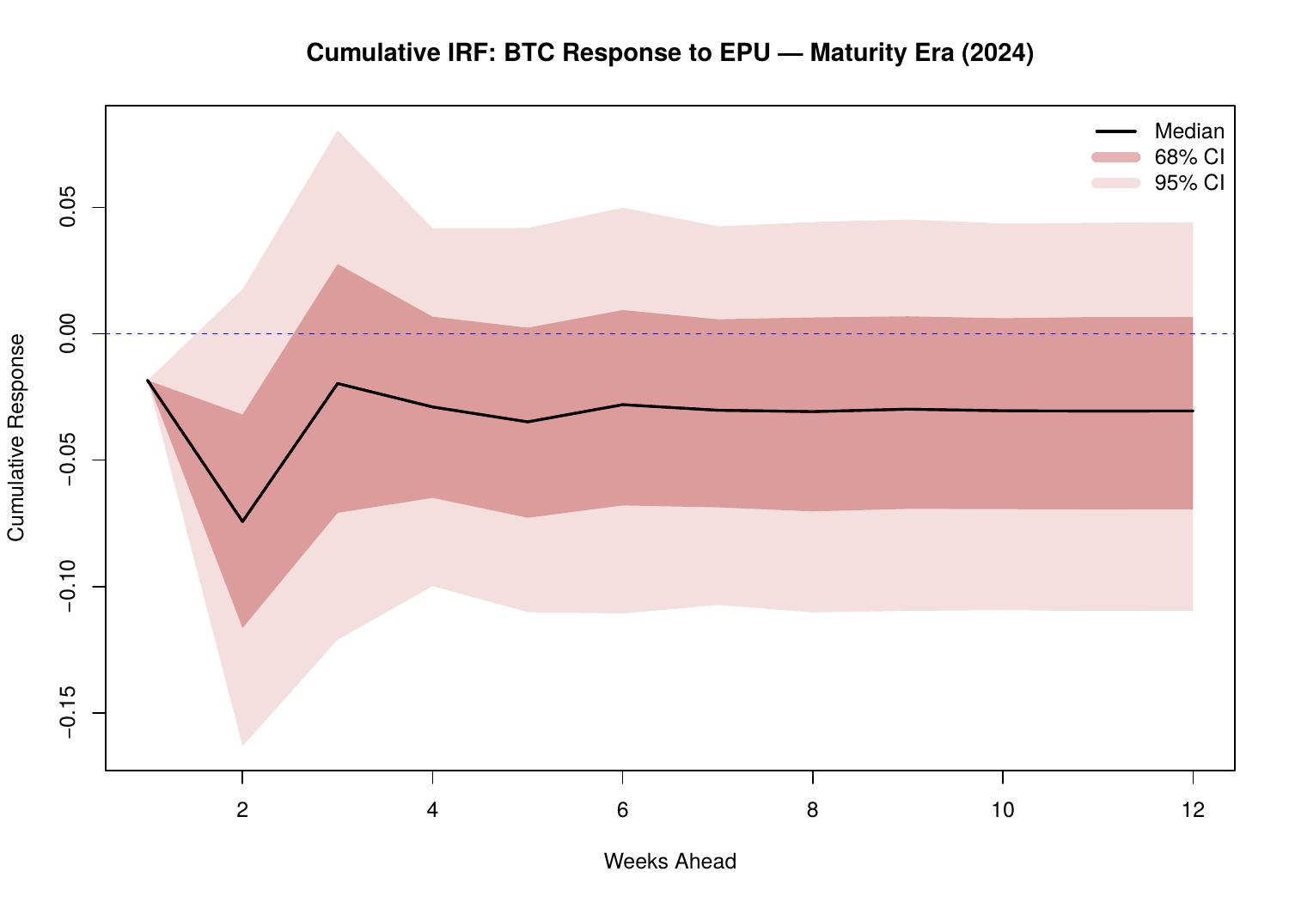

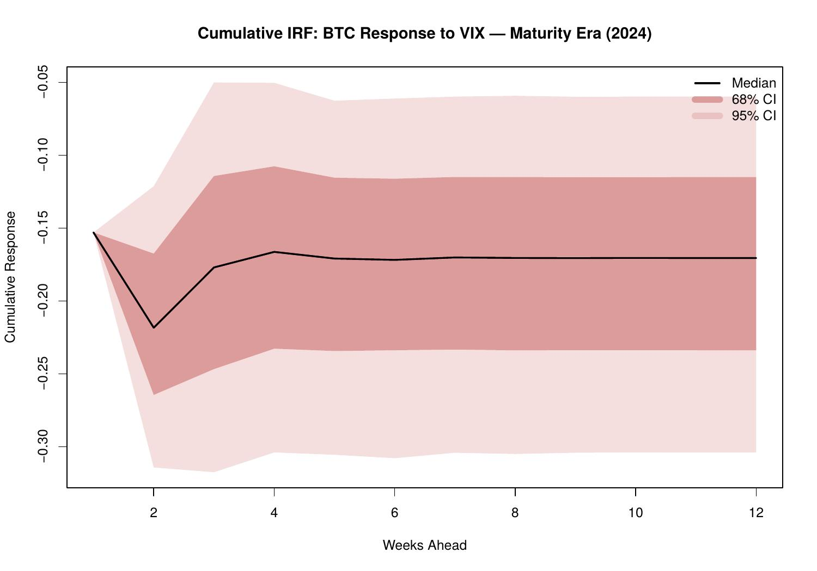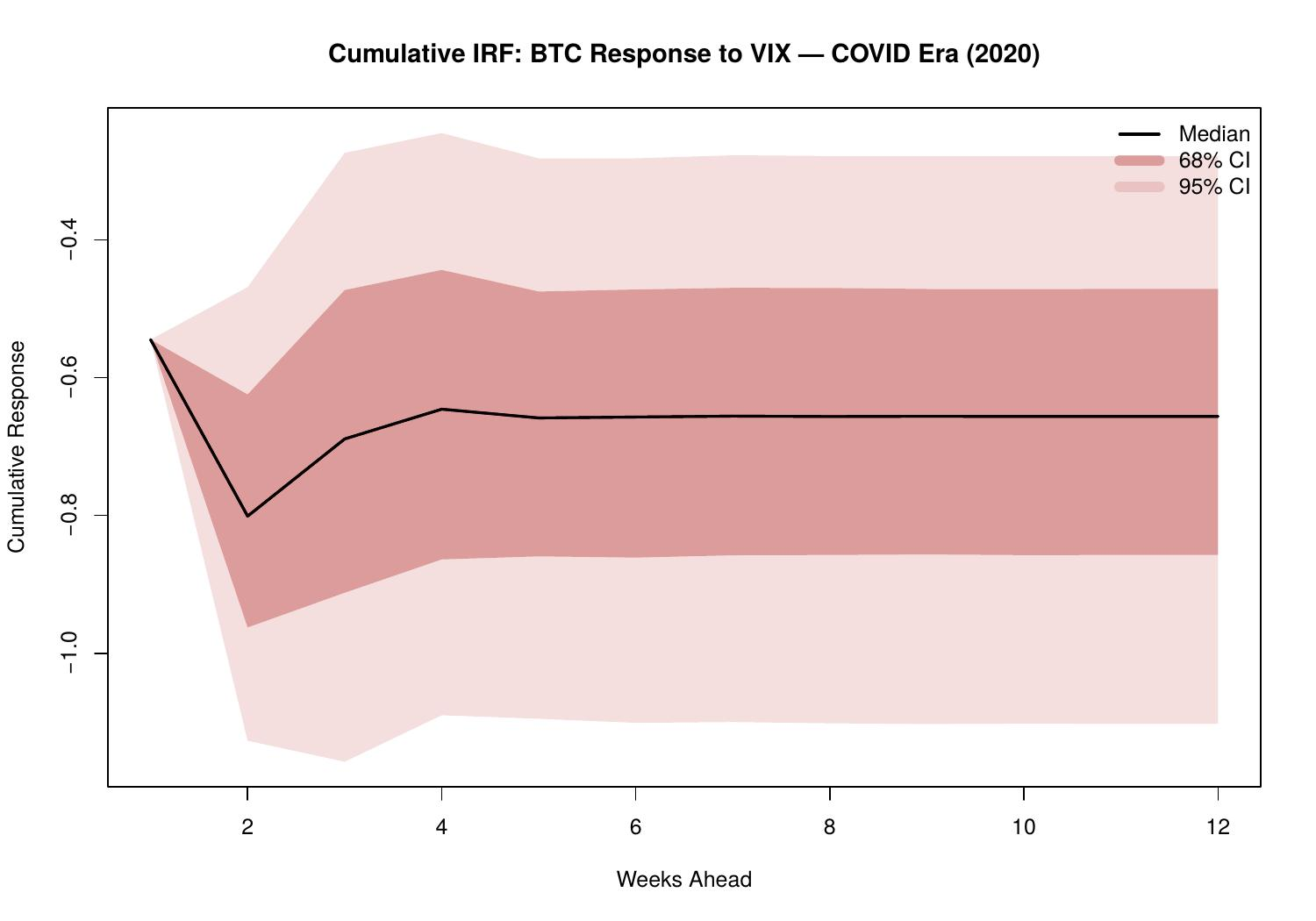

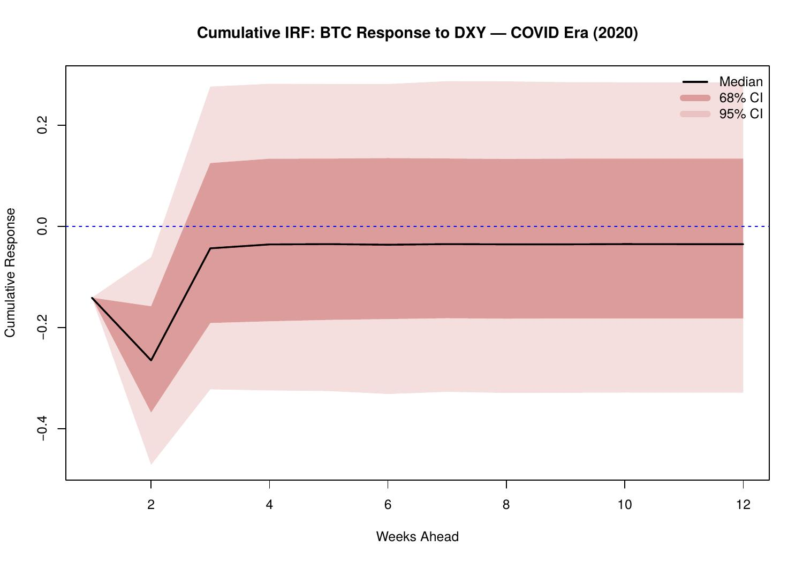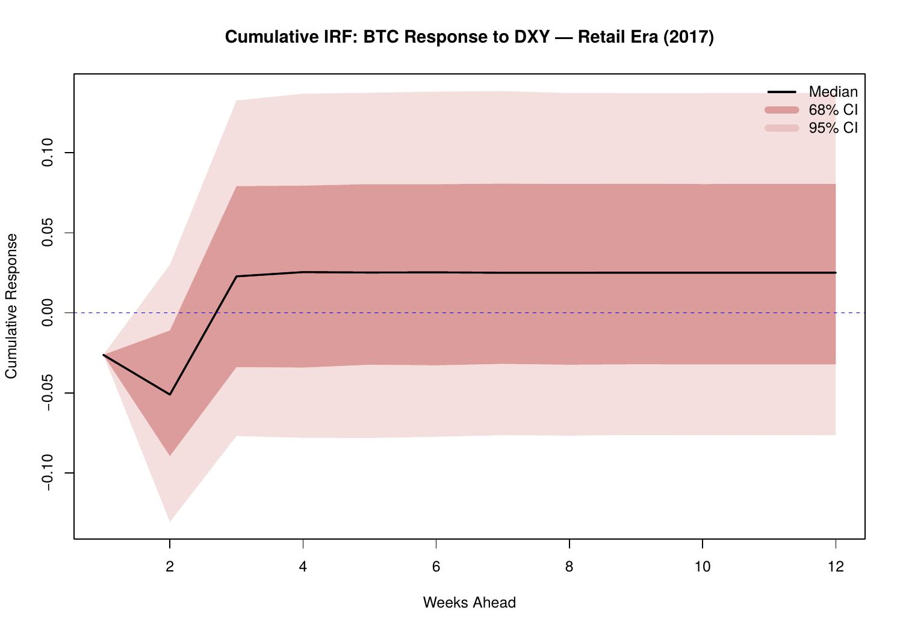

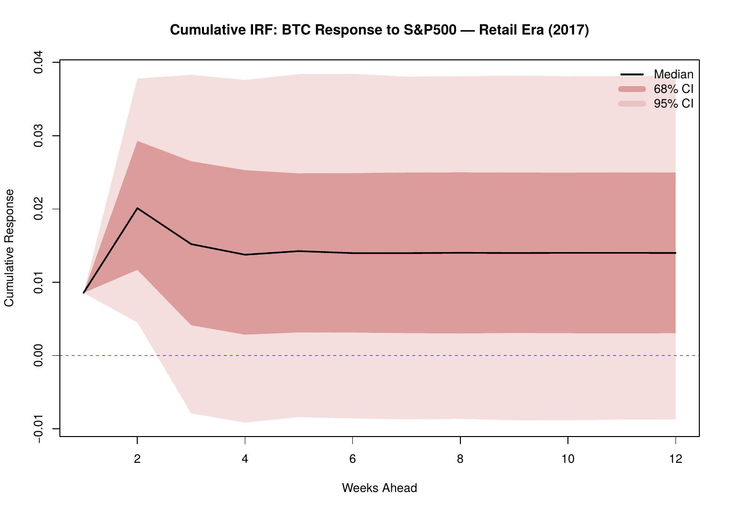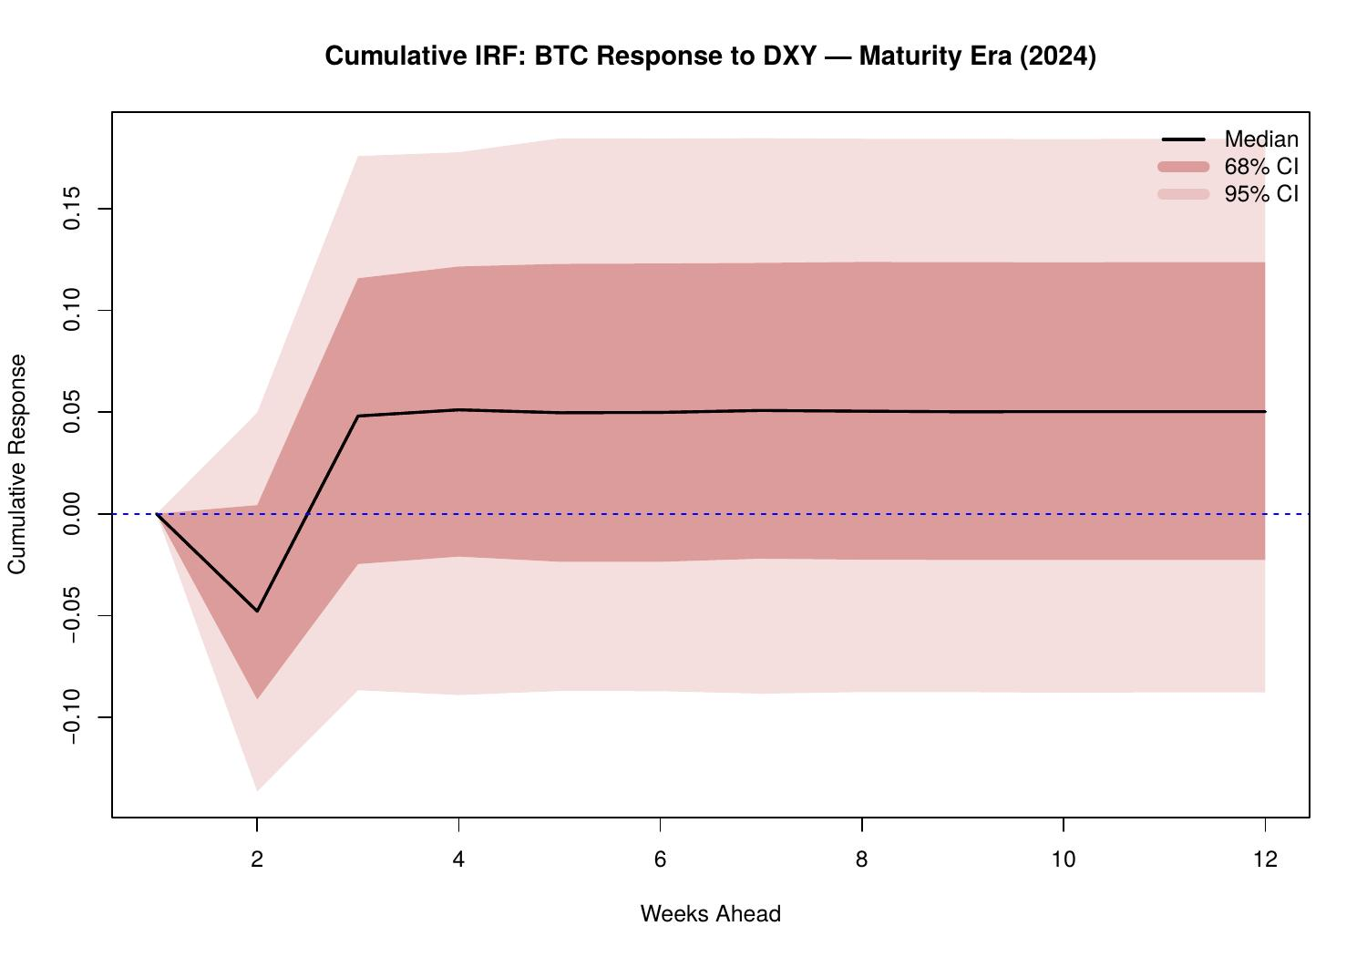

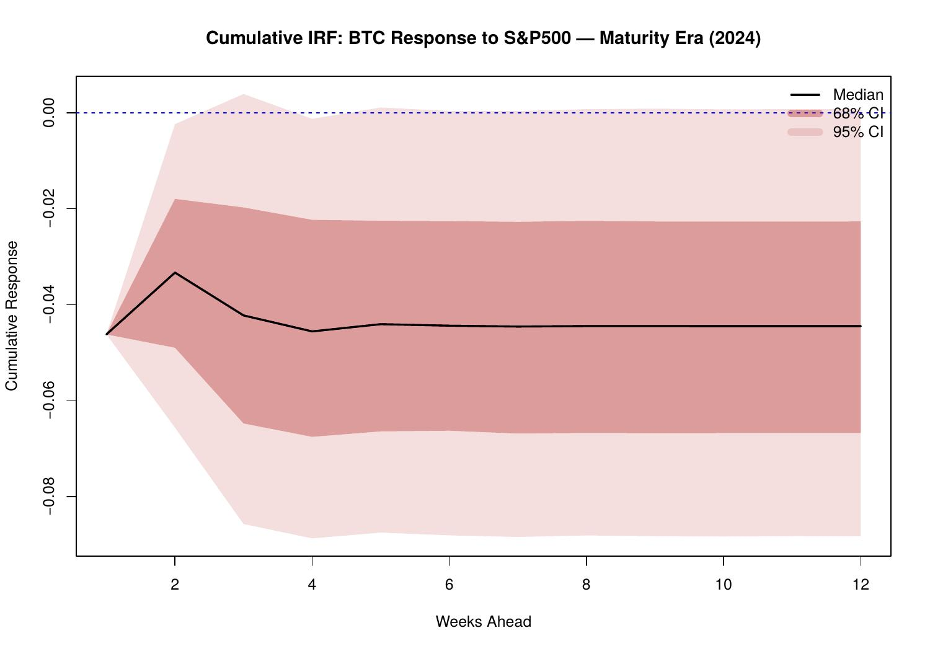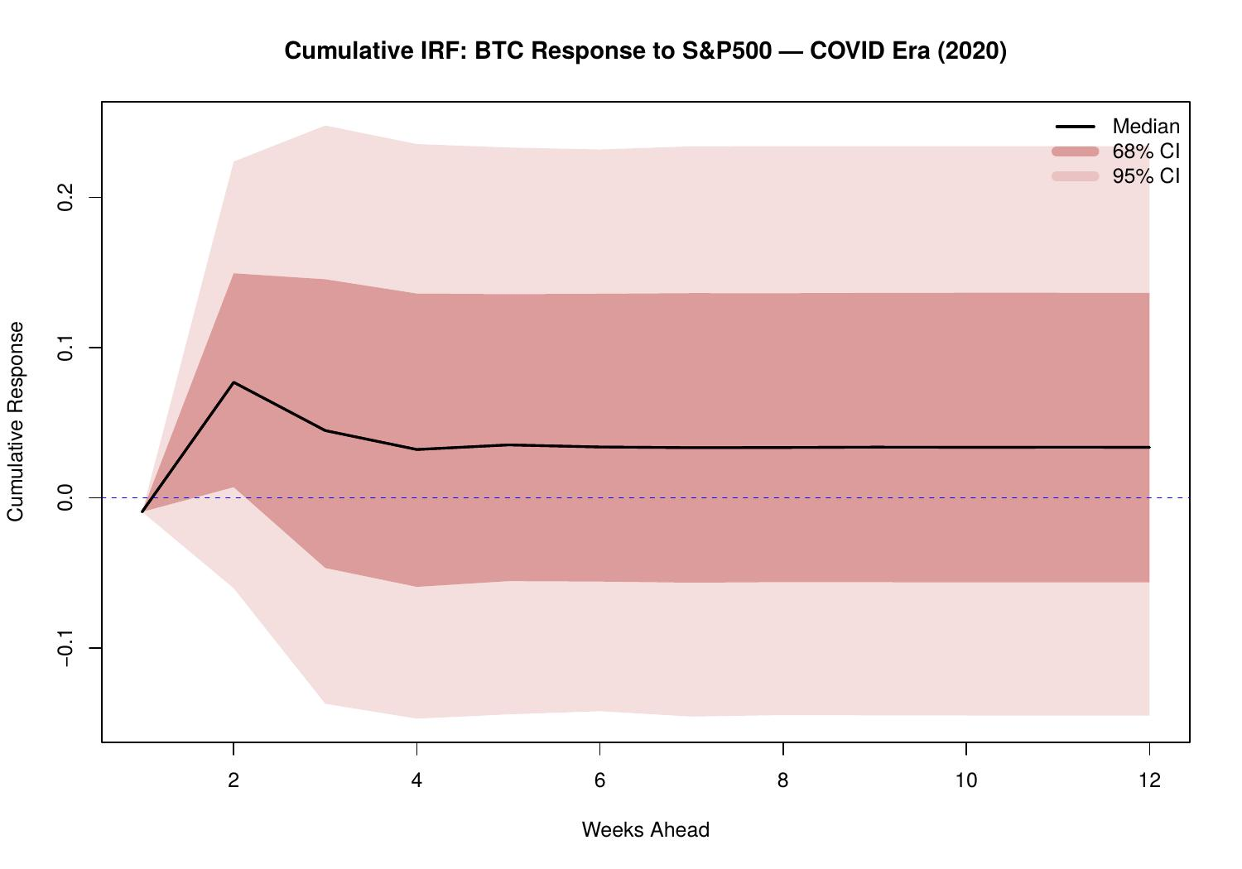

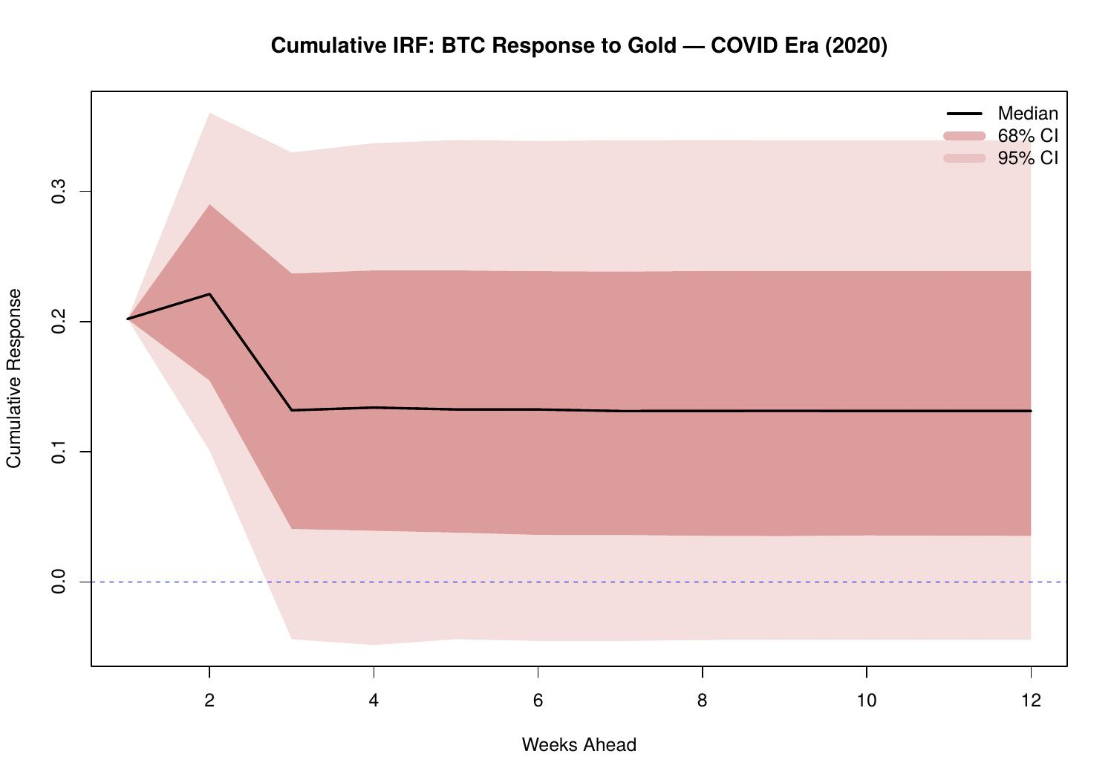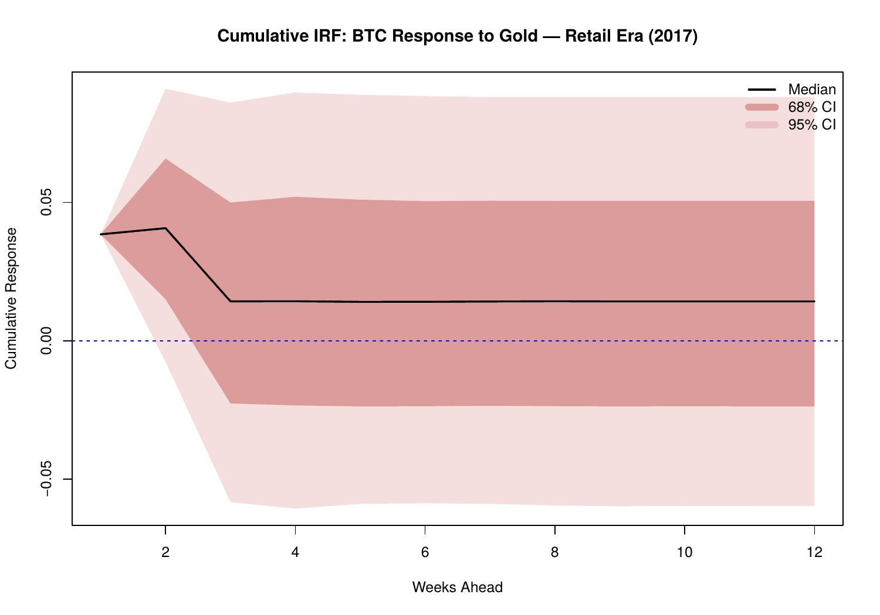

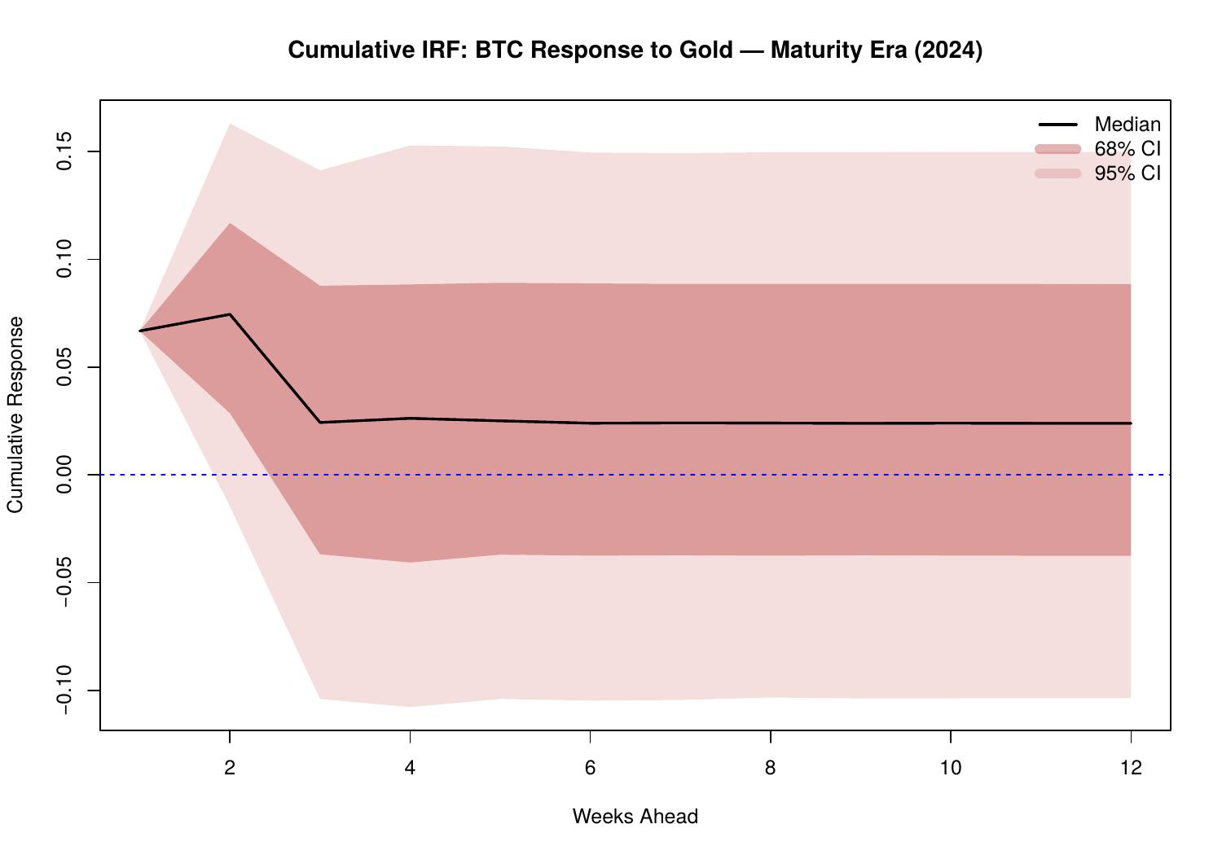
3.4.2 Continuous Cumulative IRF Timelines (H = 12)
The continuous cumulative IRF timelines (Figures 42–46) trace the total 12-week accumulated Bitcoin response to each shock across time. These plots synthesise all of the preceding findings into a single time series representation of structural sensitivity.

Figure 43 (VIX) is the most economically significant: the cumulative 12-week response deepens dramatically around 2020, reaching -0.6 to -0.7 at the trough, and remains elevated (around -0.3) through the Maturity Era. This confirms that the COVID shock represented a genuine and persistent structural break in Bitcoin's relationship with financial market volatility. Figure 45 (S&P 500) shows the positive-to-negative transition clearly: the cumulative response is positive through 2022 then drifts negative, with the sign change coinciding approximately with the onset of Federal Reserve tightening and the FTX collapse.

Figure 46 (Gold) shows a persistently positive cumulative effect (0.05–0.15) throughout the sample, the most stable cross-asset relationship in the model. Figure 44 (DXY) stays around zero with a notable dip during 2020, recovering afterwards. Figure 42 (EPU) is generally negative but modest, confirming that policy uncertainty has a small but consistent negative effect on Bitcoin's 12-week cumulative return path.

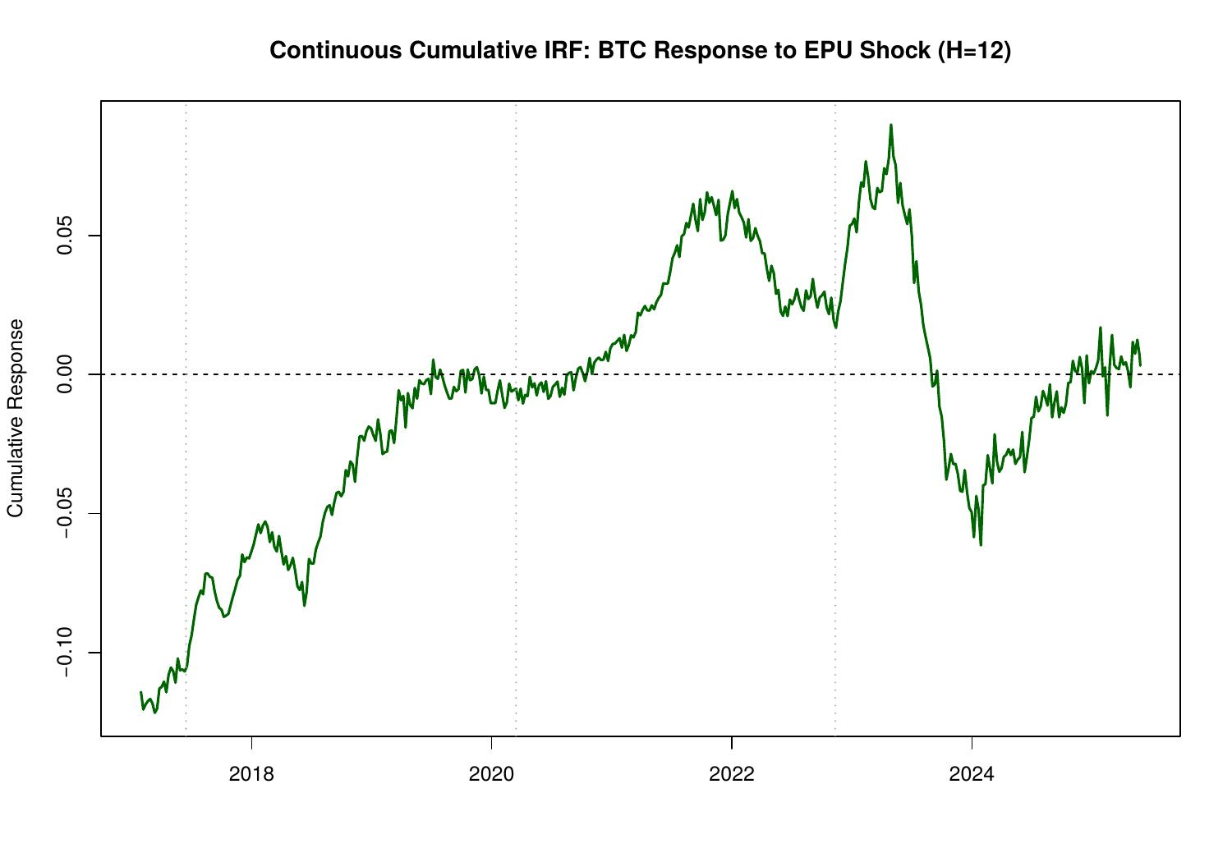
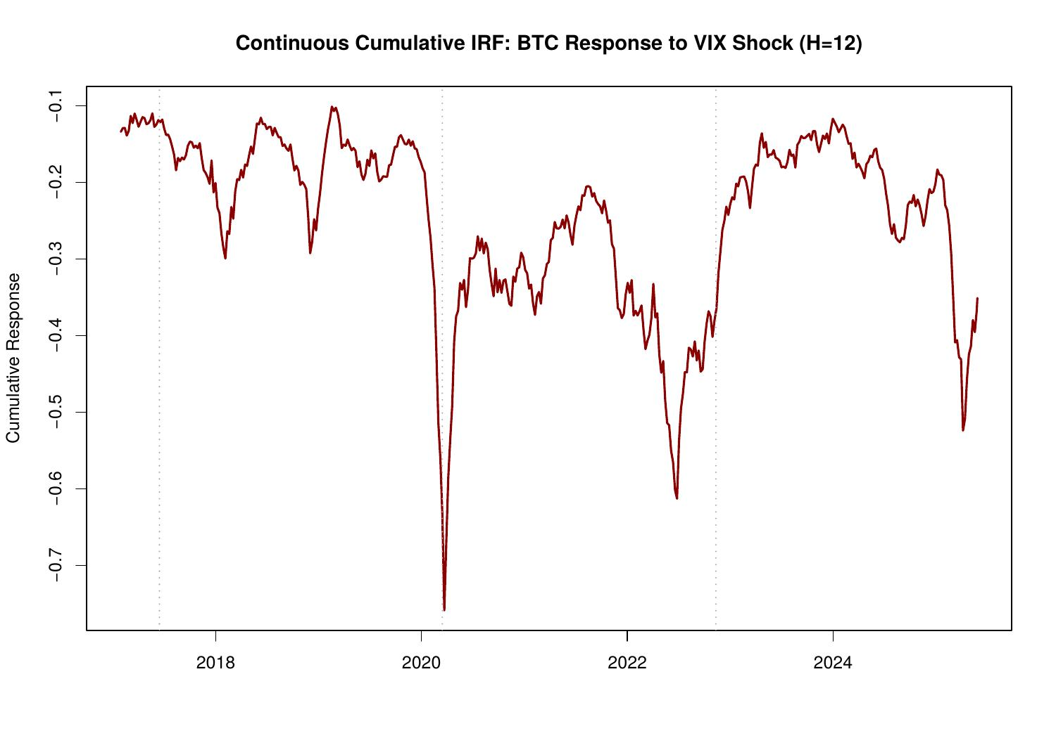
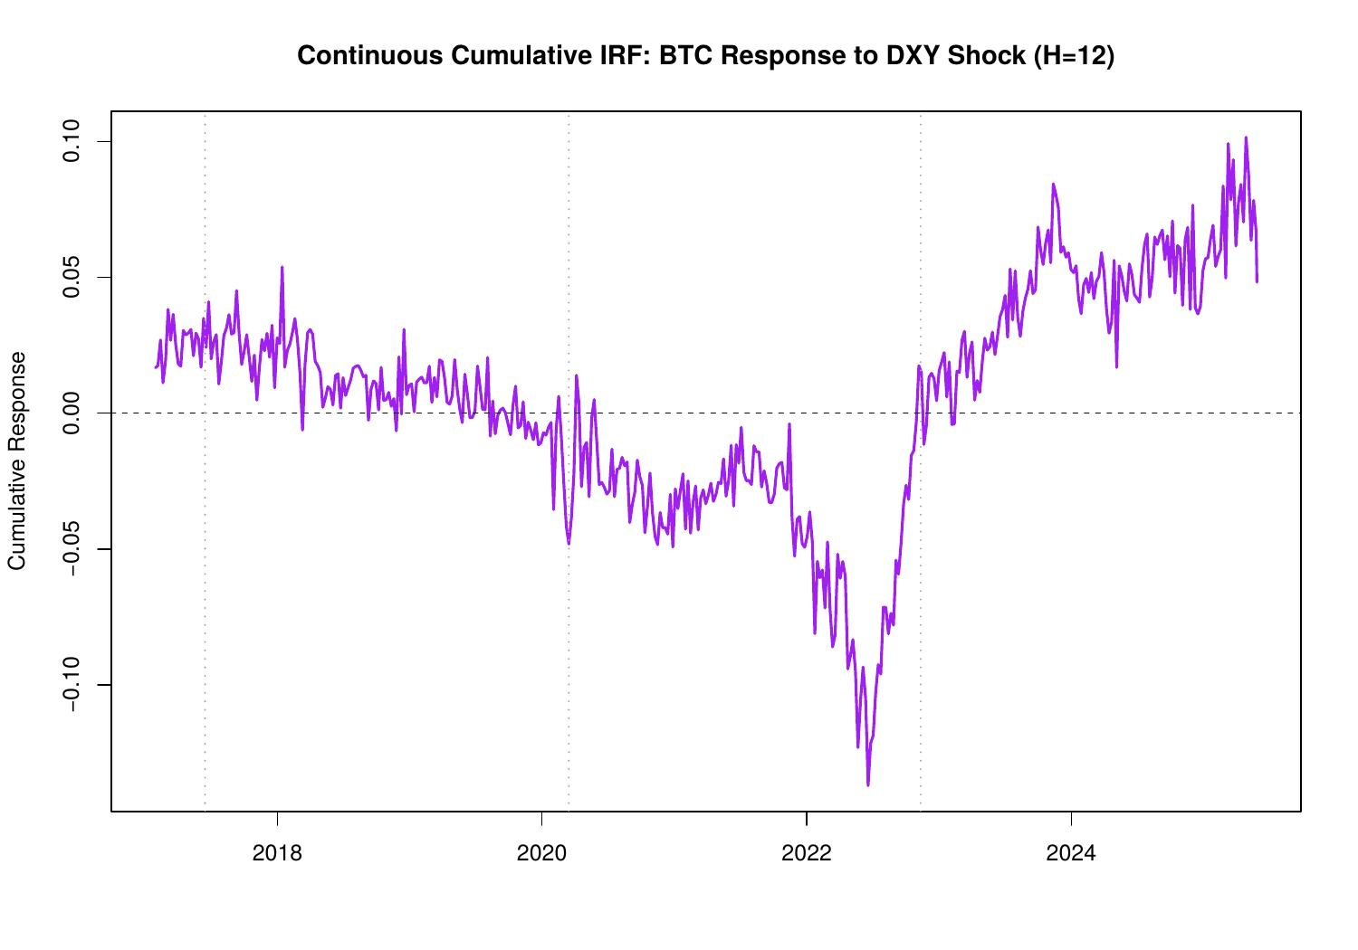
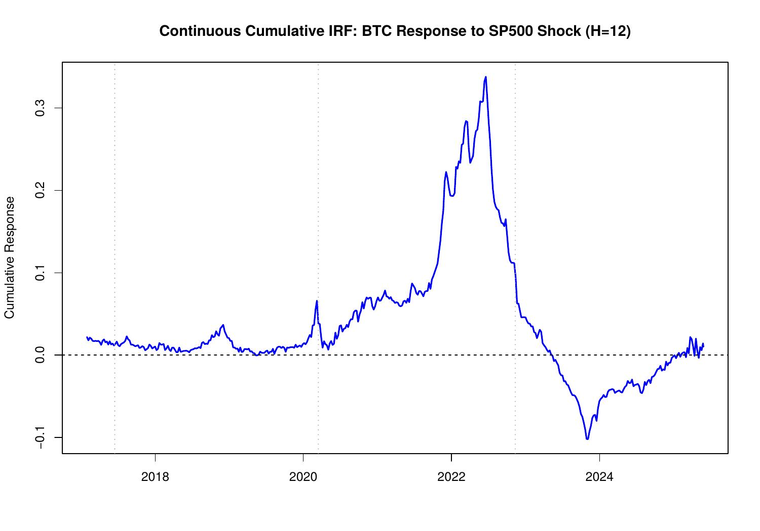
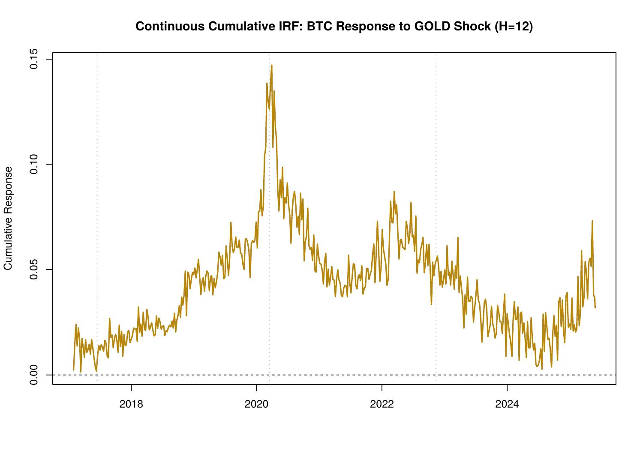

4. Discussion

4.1 The Three-Era Framework
The results are organised around a three-era narrative that the TVP-VAR framework is well-suited to capture. In the Retail Era (pre-2018), Bitcoin was genuinely isolated from mainstream financial markets. FEVD attributions to all external variables were minimal, IRF responses were mostly statistically insignificant and Bitcoin's dynamics were dominated by its own idiosyncratic supply-demand cycles, halving events, and exchange infrastructure shocks. This is consistent with the early literature characterising Bitcoin as a speculative bubble detached from fundamentals.

The COVID Crisis Era (2020) represents the most dramatic and consequential structural break identified in the analysis. The simultaneous collapse of equity markets and Bitcoin in March 2020 pulled Bitcoin into the global risk-off dynamic for the first time in a statistically robust sense. The VIX FEVD contribution surged, the VIX IRF turned strongly negative with tight credible bands, and the cumulative VIX response reached its sample maximum of approximately -1.0. This period coincided with rapid institutionalisation: the entry of publicly-listed companies (MicroStrategy, Tesla) and hedge funds into the Bitcoin market created direct channels through which financial market stress could propagate.

The Maturity Era (post-2022) shows a more complex picture. VIX sensitivity has moderated relative to 2020 but remains elevated relative to 2017, Bitcoin has retained some degree of financial market integration. The S&P 500 relationship, however, has undergone a complete sign reversal in the cumulative IRF, possibly reflecting the changing composition of Bitcoin holders.

4.2 VIX as the Primary External Driver
The consistent dominance of VIX across all four sets of results,FEVD, point-in-time IRF, continuous IRF, and cumulative IRF, deserves particular emphasis. The finding that the h=1 continuous IRF to VIX lies entirely below zero with the 68% CI throughout the 2017–2024 sample, and that the cumulative effect deepened post-2020 and remained elevated, makes VIX the most robustly identified external driver of Bitcoin in this model.

4.3 The Gold-Bitcoin Relationship
The stable, positive h=1 continuous IRF to Gold shocks represents one of the more intriguing findings in the paper. The positive Gold-Bitcoin co-movement appears to be a persistent feature of the data across all three eras. This suggests a common underlying factor, likely related to inflation expectations, dollar weakness, or a generalised demand for assets outside the traditional banking system.

4.4 Limitations
Several limitations of this analysis warrant acknowledgement. First, the Cholesky identification scheme imposes a recursive causal ordering that, while economically motivated, may not capture all contemporaneous interactions.
Second, the model omits several potentially relevant variables, including on-chain metrics (hash rate, active addresses), stablecoin flows, regulatory events, and Bitcoin-specific supply shocks (halving events).

5. Conclusion
This paper has employed a six-variable TVP-VAR model with stochastic volatility to examine the evolving relationship between Bitcoin and five key macro-financial variables over a 11-year weekly sample from July 2014 to May 2025. The time-varying framework is essential for capturing the dramatic structural changes that Bitcoin has undergone across its Retail, Crisis, and Maturity eras.

The central finding is unambiguous: VIX is the dominant external driver of Bitcoin's return dynamics, and its influence has grown persistently since 2020. The FEVD contribution of VIX reaches up to 25%, the continuous h=1 IRF to VIX is negative throughout the full sample with tight credible bands and the cumulative 12-week response deepened sharply during COVID and has remained elevated. Bitcoin has evolved from a VIX-independent speculative asset in 2017 into a moderately VIX-sensitive risk asset in 2024 a finding with direct implications for portfolio risk management.

Gold presents the most stable cross-asset relationship: a persistent, modest positive co-movement that spans all three eras, consistent with a common inflation or dollar-weakness factor but inconsistent with strong-form digital gold substitution. The S&P 500 relationship displays a structural regime change, transitioning from positive co-movement during the institutional entry period to a mildly negative relationship in the Maturity Era. EPU and DXY effects are weak across regimes.

Taken together, the evidence supports a narrative of progressive but incomplete financial integration. Bitcoin retains substantial idiosyncratic variance, its own shock still explains 60–100% of its forecast error variance, but the channels through which financial market stress transmits to Bitcoin are now empirically identifiable and economically meaningful, particularly through the VIX.

Summary of Key Findings

Table 2: Summary of TVP-VAR Results by Variable
Driver | FEVD Share | Direction | Strongest Era | Stability / Notes
VIX | Up to 25% | Negative | COVID 2020 | Robust, persistent throughout sample
S&P 500 | Up to 8% | Positive → Negative | 2020–2022 | Regime change post-2022
Gold | <2.5% | Positive | COVID era | Stable but small
DXY | <2.5% | Negative (h=1) | No clear peak | Weak, ambiguous
EPU | <2.5% | Negative | 2017 Retail Era | Fades over time

References
Antonakakis, N., Chatziantoniou, I., & Gabauer, D. (2020). Refined measures of dynamic connectedness based on time-varying parameter vector autoregressions. Journal of Risk and Financial Management, 13(4), 84.
Baker, S. R., Bloom, N., & Davis, S. J. (2016). Measuring economic policy uncertainty. The Quarterly Journal of Economics, 131(4), 1593–1636.
Baur, D. G., Hong, K., & Lee, A. D. (2018). Bitcoin: Medium of exchange or speculative assets? Journal of International Financial Markets, Institutions and Money, 54, 177–189.
Bouri, E., Molnar, P., Azzi, G., Roubaud, D., & Hagfors, L. I. (2017). On the hedge and safe haven properties of Bitcoin: Is it really more than a diversifier? Finance Research Letters, 20, 192–198.
Dyhrberg, A. H. (2016). Bitcoin, gold and the dollar – A GARCH volatility analysis. Finance Research Letters, 16, 85–92.
Geweke, J. (1992). Evaluating the accuracy of sampling-based approaches to the calculation of posterior moments. In J. M. Bernardo et al. (Eds.), Bayesian Statistics 4 (pp. 169–193). Oxford: Clarendon Press.
Krueger, F. (2015). bvarsv: Bayesian Analysis of a Vector Autoregressive Model with Stochastic Volatility and Time-Varying Parameters. R package version 1.1.
Panagiotidis, T., Stengos, T., & Vravosinos, O. (2019). The effects of markets, uncertainty and search intensity on bitcoin returns. International Review of Financial Analysis, 63, 220–242.
Primiceri, G. E. (2005). Time varying structural vector autoregressions and monetary policy. The Review of Economic Studies, 72(3), 821–852.
Sims, C. A. (1980). Macroeconomics and reality. Econometrica, 48(1), 1–48.
Urquhart, A. (2016). The inefficiency of Bitcoin. Economics Letters, 148, 80–82.

