IBE Secure E-mail

Medvei Mirabela

Popescu Ioana

Avram Dan

Abstract:
The lack of widespread adoption of conventional PKI systems is a persuasive argument for their excessive complexity. Identity-based systems offer some significant advantages over PKI, especially in their increased user-friendliness, though they do not come without some drawbacks. For its advocates, IBC provides a better compromise between security and complexity than previous systems. In spite of its weaknesses, the high level of research being conducted in this field is a testimony of its potential to overcome some of the current problems plaguing cryptographers.
This paper describes an implementation of an IBE Secure Email system using PBC (Pairing-Based Cryptography) library. Using Identity Based Encryption the requirement of certificates of server side is eliminated.

TODO write about what we managed to do mention PBC
- INTRODUCTION

One significant impediment to the widespread adoption of public-key cryptography is its dependence on a public-key infrastructure that is shared among its users. Before secure communications can take place, both sender and receiver must generate encryption and signature keypairs, submit certificate requests along with proof of identity to a Certificate Authority (CA), and receive CA-signed certificates, which they can then use to authenticate one another and exchange encrypted messages. This process can be both time-consuming and error-prone, and is especially prohibitive for novice computer users. Frequently, individuals who can already receive encrypted email are still unable to send secure messages to others due to lack of preparedness, limited interoperability, device limitations or lack of technical competence on the receiving end. Given the need to communicate and the complexity of PKI-based cryptography, correspondence that could benefit from additional security is frequently conducted in the clear. Identity-based cryptography (IBC) seeks to reduce these barriers by requiring no preparation on the part of the message recipient. Although it provides some advantages over PKI-based approaches, it is not without its drawbacks.

The concept of identity-based cryptography (IBC) was introduced by Adi Shamir, in 1984, and its primary innovation was its use of user identity attributes, such as email addresses or phone numbers, instead of digital certificates, for encryption and signature verification. This feature significantly reduces the complexity of a cryptography system by eliminating the need for generating and managing users' certificates. It also makes it much easier to provide cryptography to unprepared users, since messages may be encrypted for users before they interact with any system components.
- OVERVIEW OF CRYPTOGRAPHIC OPERATIONS

IBC relies on a trusted third party called the Private Key Generator (PKG). Before operation can begin, the PKG must generate a public/private keypair (denoted pkPKG and skPKG in the following figures) and make pkPKG available to users of its services. These keys are called the “master” public key and master private key, respectively.

The process of encryption and decryption proceeds as follows (fig. 1):

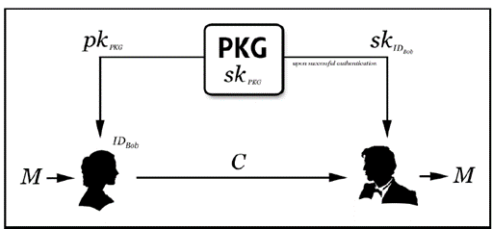
Figure 1 - Alice encrypting a message for Bob using Identity-Based Encryption [1]
- Alice wants to send a plaintext message M to Bob using Bob’s identity ID_{Bob} and the PKG's public key pk_{PKG} to encrypt M, obtaining ciphertext message C. IDBob and pkPKG were both already known to Alice before beginning the encryption process, so she requires no prior coordination or preparation on Bob's part to encrypt a message for him.

- Bob receives C from Alice. In most implementations it is assumed that C comes with plaintext instructions for contacting the PKG to get
the private key required to decrypt it. Bob authenticates with the PKG, essentially sending it sufficient proof that ID_{Bob} belongs to him, upon which the PKG transmits Bob's private key skIDBob to him over a secure channel. If ID_{Bob} were based on an email address, for example, the PKG could send a nonce to this email address, the successful return of which might provide an acceptable level of assurance that the owner of ID_{Bob} was the one who had contacted the PKG. This nonce could be returned via an SSL hypertext link which presented Bob with a secure link for downloading his private key. For a higher level of assurance, Bob could be required to present his credentials in person and receive a compact disc containing sk_{IDBob}.
3. Bob decrypts C using his private key sk_{IDBob} to recover plaintext message M.

One variation of the process described above is that the PKG can decrypt C for Bob and transmit it to him securely upon authentication. This is sometimes used to increase the user-friendliness of the decryption process, and it calls to attention an inherent weakness of IBC that research is currently striving to overcome: the fact that all private keys must be escrowed by the PKG.
1. Alice authenticates with the PKG and receives her private key sk_{IDAlice}.
2. Using her private key sk_{IDAlice}, Alice generates a signature σ for M and transmits it to Bob, perhaps along with encrypted message C above.
3. After receiving M and σ from Alice, Bob checks whether σ is a genuine signature on M using Alice's identity ID_{Bob} and the PKG's public key pk_{PKG}. If it is, he returns “Accept”. Otherwise, he returns “Reject”. Note that Bob doesn't need to have any type certificate for Alice.
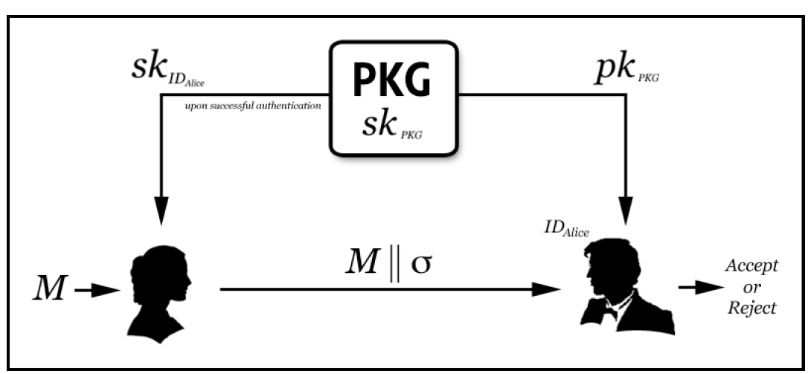
Figure 2 - Alice signing a message for Bob using Identity-Based Signature [1]

Security of identity-based cryptography
The vast majority of proposed identity-based cryptography schemes, and certainly all of those discovered so far that are computationally efficient, are based on mathematical functions called bilinear nondegenerate maps. A bilinear nondegenerate map is a function pairing elements from one cyclic group to another of the same prime order, where the discrete log problem is hard in the first group [2].
The security of identity-based cryptography is based on the assumption that the particular bilinear maps chosen are one-way functions, meaning it is easy to calculate their result given a pair of operands but hard to calculate the inverse. This property is often referred to as the Bilinear Diffie-Hellman Assumption, since the Bilinear Diffie-Hellman problem is reducible (algorithmically equivalent) to the discrete-log or inverse operation for these bilinear maps [1].
Pros and Cons of IBC
Some of the advantages of IBC have already been explained, but here is a summary [1]:
1. No preparation is required on the part of the recipient to receive an encrypted message. This is arguably the most compelling feature of IDC.
2. No need to managing a public key infrastructure, including CRL management.
3. IBC's inherent key escrow feature means decryption and signature can take place on the server. While this is a disadvantage (especially in IDS because it eliminates non-repudiation in most cases), it also makes certain other features possible that are not possible in PKI-based systems where the signer is in possession of his/her private key, such as:
i. “Chameleon” signatures, in which only the designated recipient is capable of asserting a signature's validity.
ii. Improved user-friendliness by having the PKG handle cryptographic operations for the user and requiring no client-side installation. This can be especially powerful in the case where an enterprise wants to adopt a policy whereby all messages of a certain sensitivity level are automatically encrypted and/or signed. An administrator can specify the policies that govern whether a message will be signed or encrypted using tools like a keyword search of the message content, a time range, or a regular expression match on the sender or recipient, and email users do not need to modify their behavior. [1]
iii. If users do not have to receive their private key, it can be kept on the PKG, which often has a much higher level of security than a user's workstation.
4. No PKI means less public information about your enterprise need be revealed to those who do not have a need to know. Each application or person connecting to an enterprise's certificate database could theoretically discover a great deal of information about a company's infrastructure or hierarchy.[1]
The most notable disadvantage of IBC is its inherent key escrow property. While it has already been noted that this can be an advantage in some cases, most IDC adopters would like to be able to decide whether or not they want this feature. It should be noted that many organizations already employ encryption key escrow, to be able to recover a user's encrypted data in the event his or her private key is lost. This should be taken into account when analyzing the security of IBC systems. The practical difference, therefore, between IBC and most PKI systems is that PKI systems do not escrow users' signature keys. This allows for better non-repudiation, which is an essential feature of digital signature schemes. A number of IBC variants are also being developed that eliminate or mitigate the key escrow feature, including certificate-based encryption, secure key issuing cryptography and certificateless cryptography. [1] In secure key issuing, for example, the PKG's level of trust is reduced by spreading the master keys across multiple PKGs. While this increases the system's security, it also decreases performance. Another key of discussion regarding IBC is non-repudiation propriety. In IBC systems, the level of non-reputation is tied to the level of trust that the PKG is not signing messages or is only signing messages at the user's request. An observation would be that even PKI systems don't provide for a perfect level of non-repudiation, since there is always a time frame before a compromised key is reported to the CA.
Moreover, IBC in its most basic form also lacks key revocation. Suppose, for example, that Bob's private key is compromised. The key was associated with his public email address, which has been serving as his public key. Does Bob need to change email addresses now that his private key has been compromised? Even worse, suppose Bob's private key is associated with some type of biometric data. Does Bob forever lose the ability to use his thumbprint, for example, as his identity, because his private key was compromised? A simple solution to this problem was proposed by Boneh and Franklin [4], who suggested that the ID component could be concatenated with a validity timestamp. This would mean that the public key would only be valid until the timestamp expired, which would place a limit on the amount of damage that could be done by a key security breach.
One other important drawback of IBC systems is the high level of assurance required in the PKG. Since the PKG holds all private keys, it requires a higher level of assurance and availability than a CA. CAs may be kept disconnected from a network, but the PKG must be available to send users their private keys, further increasing its vulnerability to attack. For this reason, extra care must be taken to secure PKGs above and beyond the high level of security already required for CAs.
- RELATED WORK

Identity based encryption with equality test (IBEET) was proposed in [3] as a viable solution, in which users can delegate a trapdoor to the server and the server then searches on user outsourced encrypted data to determine whether two different ciphertexts are encryptions of the same plaintext.

Boneh and Franklin, along with other researchers, developed a C++/based IBE implementation published under an MIT-style license, called the “Stanford IBE System”.

Shamus Software also developed another C++-based cryptographic library called “MIRACL” which follows Boneh and Franklin's IBE scheme.

The most notable commercial implementation of IBE is published by Voltage Security, Inc. [8] They offer plug-ins for a number of popular mail clients, including Microsoft Outlook. Proofpoint, Inc. has licensed Voltage's software to provide value-addons, such as policy-based automatic outbound email encryption.
- PBC LIBRARY

The PBC (Pairing-Based Cryptography) library [5] is a free C library (released under the GNU Lesser General Public License) built on the GMP library that performs the mathematical operations underlying pairing-based cryptosystems. The PBC library is designed to be the backbone of implementations of pairing-based cryptosystems, thus speed and portability are important goals. It provides routines such as elliptic curve generation, elliptic curve arithmetic and pairing computation. The main author of the PBC library is Ben Lynn, but there are many who have contributed, including Hovav Shacham, Matt Steiner, Joe Cooley, Rob Figueiredo, Roger Khazan, Dmitry Kosolapov, John Bethencourt, Paul Miller, Michael Cheng, Ian Goldberg, Adam Aviv, Adam McLaurin, and Michael Adjedj. Thanks to the GMP library, despite being written in C, pairings times are reasonable. On a 1GHz Pentium III:
- Fastest pairing: 11ms
- Short pairing: 31ms

Examples of how to build pairing-based cryptosystems using the PBC library are:
- Boneh-Lynn-Shacham short signatures
- Hess identity-based signatures
- Joux tripartite Diffie-Hellman
- Paterson identity-based signatures
- Yuan-Li identity-based authenticated key agreement
- Zhang-Kim identity-based blind/ring signatures
- Zhang-Safavi-Naini-Susilo signatures

PBC library is used in the following projects:

- SSARES: Secure searchable Automated Remote Email Storage by Adam Aviv
- QED library: Queries on Encrypted Data by Filip Paun and Tanvi Vyas
- Ciphertext-Policy Attribute-Based Encryption by John Bethencourt, Amit Sahai and Brent Waters.
- Crypt: PBC Perl Module by Paul Miller.
- The PBC_bce library - the Boneh-Gentry-Waters broadcast encryption. Written by Matt Steiner.
- Function Encryption - encryption enriched with access policies.
- The PBC_sig library - various signature schemes that require the pairing, including:
  - Boneh-Boyen short signatures
  - Boneh-Boyen-Shacham short group signatures
  - Boneh-Lynn-Shacham short signatures
  - Cha-Cheon identity-based signatures
- IMPLEMENTATION

To prove the utility of the mentioned library we developed a “Proof Of Concept” application, which uses the API documented in [5].

The application consists of a “third party” which signs messages sent via gmail client, and gives the necessary parameters to the receiving party in order for it to verify the signature attached to the email.

The use case is described in the following scenario:
- Alice wishes to sign a message. To do this, she generates her private and public keys as follows:
  - Let x be a random element of Z_r be chosen as private key.
  - Corresponding public key is g^x, where g is a random element of G_2 chosen as system parameter.
  - Alice hashes the message to an element G1, called h, and outputs the signature as h^x.
- To check the message, Bob requires system parameter g, Alice’s public key, and last but not least, message hash h, which he will generate upon receiving the message.
- After loading all the parameters, Bob applies the pairing, called e, and checks if e(h, g^x) = e(sigma, g)

So the implementation consists of initialising the parameters needed, which are g, public key, private key, h, signature and auxiliary needed for verification. Then randomly generating private key and system parameter, and finally calculating all the parameters mentioned. After doing so, the trusted third party, will share the system parameter to Bob’s disposal. Alice’s public key is acquired, the hash of the message and signature are contained in the message.

The verification executable uses the system parameter shared by the trusted third party and checks the signature from the message. The mail is sent and received via gmail with curl, using a public smtp server.

- EXPERIMENTAL RESULTS AND DISCUSSION

Each time the script is ran, it will generate new email text, from which it will send to the third party, which will hash the message, generate private key, public key and finally sign the message, so Alice will send the mail via curl.

The signature verifies every time, so this means that the structures implemented in the API do not have undefined behaviour regardless the message generated.

However, the pbc library is simply built over the GMP library, and only performs the mathematical operations underlying cryptosystems based on pairing.

It is abstract enough so there is no need for the programmer to actually understand eliptic curves or much number theory to use this library.

There are, however a few vulnerabilities exposed to this specific library:

Here we are listing a few of them, rest of them being documented at [6]:

1. A use-after-free can easily be occurred in function _pbcM_sp_query in map.c which is part of the static library libpbc.a. [7]

Since in C language there is no actual way to check if the a memory location is still valid, the memory that has been freed is reallocated validly to another pointer. Some of the consequences can be corruption of data, to execution of arbitrary code, which leads to undefined behaviour.

2. A Segfault signal can be raised in wiretype_decode in context.c. [8]

The kind of run time error that can occur is buffer overflow. In the case of performing read or write operations on outside the intended boundary of the buffer, it can cause read or write operations to be performed on other internal program data. Some other internal program data, can also be a return address, which will cause the program to jump to an alternate instruction pointer and execute alternate code. This is also the main idea on Return Oriented Programming type of attack.[9]
- CONCLUSION

TO DO..

- REFERENCES

[1] An Introduction to Identity-based Cryptography, CSEP 590TU ▪ March 2005 ▪ Carl Youngblood

[2] Bilinear Pairings http://rooster.stanford.edu/~ben/maths/ep/pairing.php

[3] Efficient and secure identity-based encryption scheme with equality test in cloud computing

[4] D. Boneh and M. Franklin, Identity-Based Encryption from the Weil Pairing, Proceedings of CRYPTO 2001, LNCS 2139, pages 213–229, Springer-Verlag,2001. http://crypto.stanford.edu/~dabo/papers/ibe.pdf.

[5] PBC (Pairing-Based Cryptography) library https://crypto.stanford.edu/pbc/

[6] https://www.cvedetails.com/vulnerability-list/vendor_id-18622/product_id-47289/version_id-257162/Pbc-Project-PBC-2017-03-02.html

[7]https://www.cvedetails.com/cwe-details/119/cwe.html

[8] https://www.cvedetails.com/cve/CVE-2018-14742/

[9] Shacham, Hovav; Buchanan, Erik; Roemer, Ryan; Savage, Stefan. "Return-Oriented Programming: Exploits Without Code Injection". Retrieved 2009-08-12.

