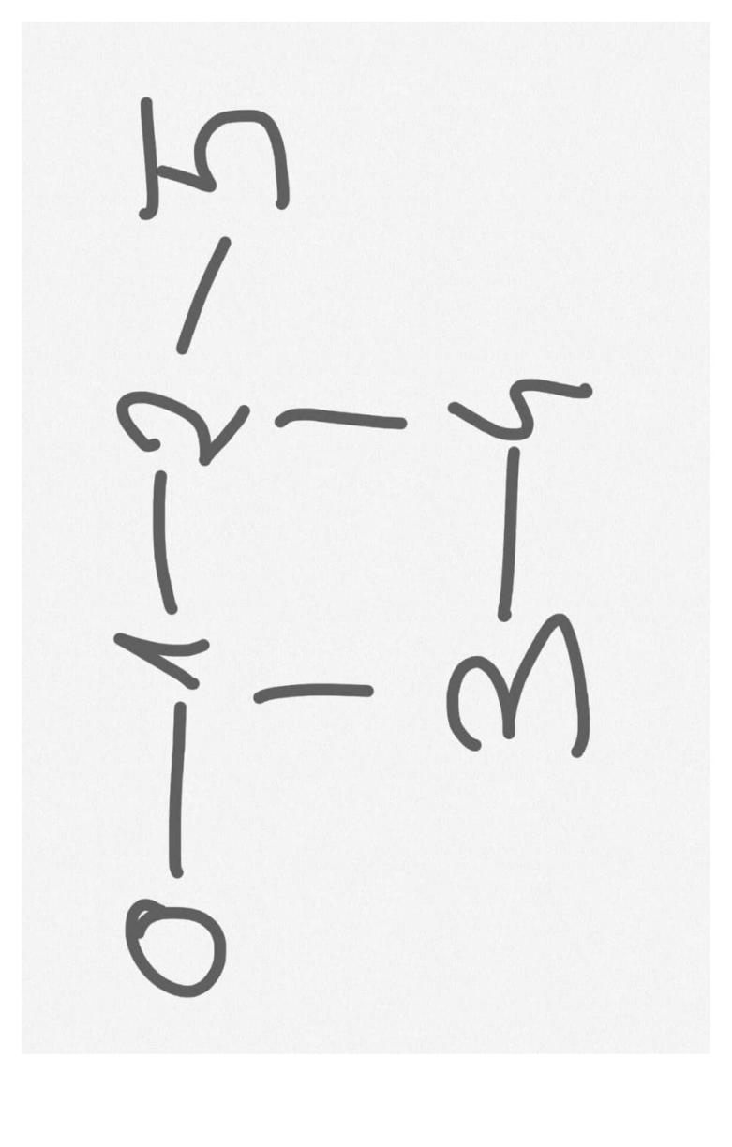

6 6

0 1

1 2

1 3

2 4

2 5

3 4

Vertex cover result: [0, 2, 3]

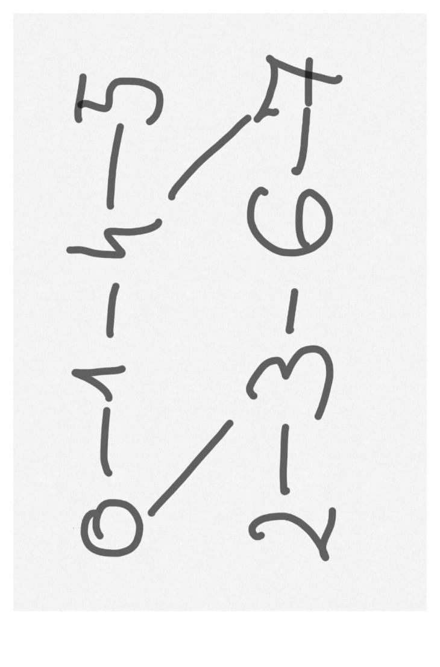

8 8

0 1

0 3

1 4

2 3

3 6

4 5

4 7

6 7

Vertex cover result: [0, 2, 4, 6]