**ALL OF US APPLICATION – PROJECT DOCUMENTATION**

**Programming for Mobile Devices**

* ***Abstract***

This report contains information about the purpose and general use of the app, as well as the category of users that this app is suitable for and comparisons to other apps that serve the same purpose.

I chose to make an app for people that want to do good to the environment and to other people in general. The app takes the user to the websites of organizations that gather volunteers for projects like planting trees, cleaning polluted areas or humanitarian projects.

* ***Purpose***

Since I always found myself preoccupied with environmental issues and the well-being of people around me, I thought that this project is a great opportunity to develop an app that encourages other people to take action. The app is destined for people that want to do good but don’t really know how or where to contribute.

* ***Users***

‘Allofus’ is truly designed for *all of us* – anyone can use it with no previous professional qualification or specialized knowledge. It is most suitable for people who have enough time and dedication to participate in physical work programs and maybe a stable budget, since one of the purposes of this application is to encourage people to donate.

* ***My contribution***

People that want to ‘make the world a better place’ can, of course, search on the internet and find all the information they need, but I believe this app makes it much easier to learn and act because all information is gathered together. Also, the websites I chose to display offer multiple choices for the user.

* ***Introduction***

The app redirects the user to the websites of foundations that organize different projects. There is a list of categories: ‘Tree Planting’, ‘Environment Cleanup’, ‘Animal Care’, ‘Petitions’ and ‘Humanitarian Projects’. For each category, there is a website where the user can find multiple projects on the selected topic.

Here are some applications that serve similar purposes:

**GIVELIVELY**

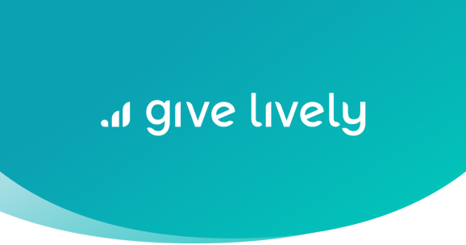

This platform offers free donation buttons, event ticketing, fundraising pages, text-to-give and peer-to-peer fundraising solutions for progressive nonprofits. The organization charge ZERO fees because they are funded by the Soros Foundation, the only costs are those that come from Credit Card processors. [GiveLively](https://www.givelively.org/text-to-donate?gclid=EAIaIQobChMI-JbC9uLl2wIVQkOGCh3MjA7HEAMYAiAAEgInq_D_BwE) allows organizations to collect donations from text (SMS) messages. So far, they’ve helped over 4,000 nonprofits raise money at $0 charge to their members.

**GIVEGAB**

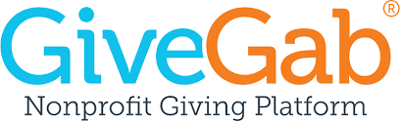

GiveGab is all about making volunteering a fun social experience. The app connects you with more than 400,000 nonprofits based on your interests and profile. It also lets you log your volunteer hours and post pictures, which other volunteers can see on the app’s newsfeed, “The Gab.”

**PLANT FOR THE PLANET**

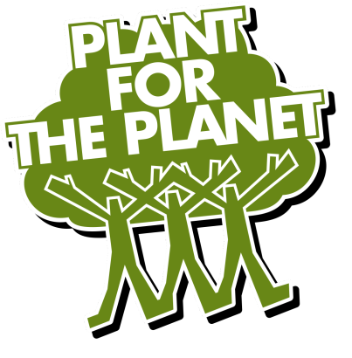

The [Plant-for-the-Planet app](https://www.trilliontreecampaign.org/) aims to connect and inspire individuals and Tree planting organizations all over the world to plant 1 trillion trees. Users can plant trees and register them; they can donate funds to tree planting organizations etc. As of Sep 20th, the app has recorded 13.48 Billion trees planted.

* **Functionality**

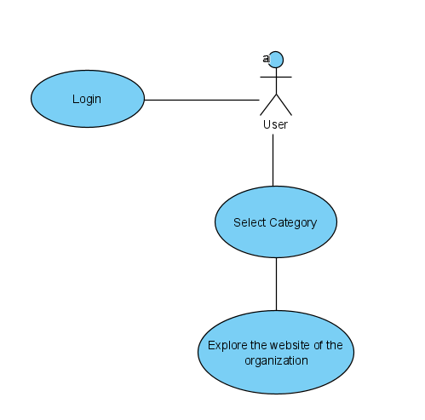

* **App Tour from User’s Point of View**

The app opens in MainActivity as seen bellow. The user can choose to login to the platform by pressing on the button on the left or continue unregistered and move on to the categories screen.

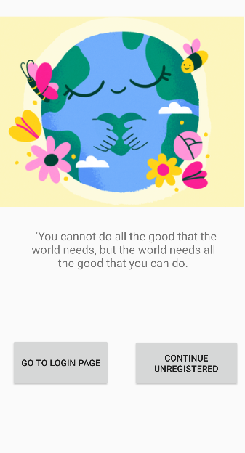

The user can choose any of the categories listed on this screen and access the site of an organization specialized on the selected topic. The content of the website is loaded inside the application via webviews.

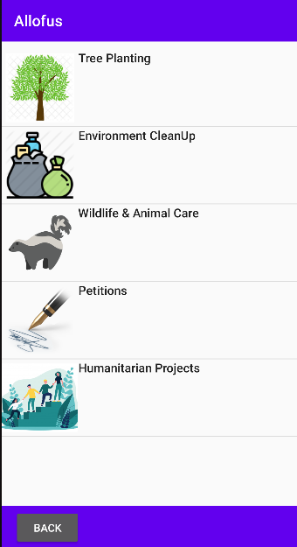

For example, if the user clicks on ‘Tree Planting’ section (either on the icon or on the text), the content of the Trees for Cities organization’s site will be loaded inside the app.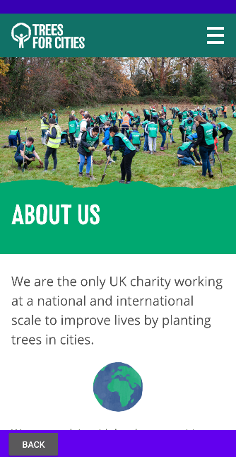

* **Future Work**

I plan to extend the application such that it displays multiple websites for each category and provide more general facts to read about each topic.

* **References:**
* <https://www.youtube.com/watch?v=qw58u5jm2rc>
* <https://www.youtube.com/watch?v=R21YgEjSwPk>
* <https://www.youtube.com/watch?v=6U8-_G5yjwA&t=3s>
* <https://developer.android.com/guide/webapps/webview>
* <https://www.youtube.com/watch?v=VUPM387qyrw>
* <https://www.youtube.com/watch?v=q2XA0Pe2W04&t=674s>